Project ID: 2021-1-CZ01-KA220-SCH-000034484
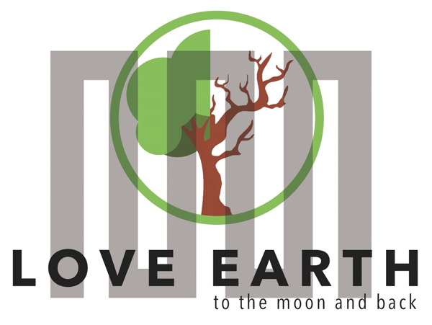
COURSE FOR ENVIRONMENTAL EDUCATION
e-Modules: Teaching Learning activities and their technology enhanced material set to develop
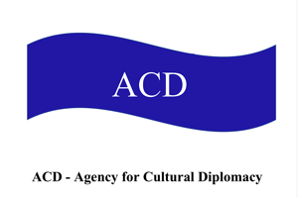

Thematic Units for Week-Long Workshop Sessions:
Inquiry-Based Integrated Learning Workshop Series
on the Intersection of Arts, Science, and Policy"

M3: Engaging in Climate Protection; #littering;

COURSE AUTHOR:
©Tatjana Christelbauer MA (TC) ACD Team, Austria

DISCLAIMER
Funded by the European Union. Views and opinions expressed are however those of the author(s) only and do not necessarily reflect those of the European Union or the European Education and Culture Executive Agency (EACEA). Neither the European Union nor EACEA can be held responsible for them.
COURSE SHARING LICENSE CC BY-NC-SA = 
Canonical URL: https://creativecommons.org/licenses/by-nc-nd/4.0/

MODULE 3: Weather & Climate
LESSON: Engaging in climate protection, littering.
SUBJECTS: Environmental Ethics, Language, Policy Learning,

Engaging in Climate Protection, including the social climate:
#littering, sensorial awareness

- Introductory guide on Climate Protection
Climate protection is a crucial measure to slow down climate change and limit its impacts on our environment and society. It encompasses various actions and initiatives aimed at reducing greenhouse gas emissions, promoting renewable energies, improving energy efficiency, and encouraging sustainable practices. Important measures include population control, reduction of air and car traffic, and the abolition or restriction of livestock farming. Climate protection is connected with environmental, nature, and animal protection.

What does climate protection involve?
• Reducing greenhouse gas emissions • Promoting renewable energies • Improving energy efficiency • Sustainable land use and agriculture • Encouraging eco-friendly transportation • reduction of carbon dioxide, which significantly contributes to global warming • Protecting and restoring ecosystems.

  - Climate Protection in Austria: Facts
What causes the most CO2 in Austria?
The biggest emitters of greenhouse gases are the energy and industry sectors, transportation, agriculture, and buildings. In 2022, the total emissions of the energy and industry sector amounted to 32.6 million tons of CO2 equivalent, and those of transportation to 20.6 million tons of CO2 equivalent.

Key climate goals in Austria: • Reducing greenhouse gas emissions • Expanding renewable energies • Improving energy efficiency in buildings, industry, and transportation • Promoting sustainable agriculture and land use • Protecting natural habitats and biodiversity from the effects of climate change

  - How can blind youths contribute?
• Raising awareness: Educate yourself about climate change and its impacts.
• Activism: Participate in environmental actions and advocate for climate protection.
• Consumer behavior: Make conscious choices when purchasing products and services that support climate protection.
• Education: Learn more about sustainable practices and share your knowledge with others.

Guiding questions for the Climate Summit workshop:
What does climate protection mean to you personally?
What role does solidarity play in the fight against climate change?
How can we strengthen empathy and unity to collectively support climate protection?
What conflicts might arise regarding climate protection, and how can we resolve them constructively?
What activities can we undertake in our school to promote climate protection?
What climate goals should be specifically set for blind and visually impaired youths?
How can we ensure that blind and visually impaired youths are fully included in the climate protection process?

Ideas for school activities: • Organizing informational events on climate change and climate protection • Implementing projects to reduce energy consumption in the school • Planting trees and establishing a school garden to promote biodiversity • Organizing litter collection campaigns and recycling programs • Setting up an environmental club that regularly addresses climate protection and plans activities

Some activities for a school garden workshop that could be easier accessible and interesting for blind and visually impaired youths through opportunities to experience and enjoy the school garden in various ways, engaging their senses and fostering creativity:

°Planting an air-purifying plant: Start the workshop with students planting an air-purifying plant in a special container or pot. Choose plants like pothos, which filter pollutants from the air and improve air quality. Students can explore the plant with their hands and smell the leaves.

°Creating a sensory garden: Set up an area in the school garden specifically designed for blind and visually impaired youths. Use plants with different textures, scents, and heights that students can explore with their hands. Include aromatic herbs like lavender or mint and plants with interesting leaf structures.

°Sound installation: Create a sound installation in the school garden to engage the students’ senses. Hang wind chimes or small bells in various spots that produce gentle sounds when touched. This allows students to explore the garden through hearing.

°Aromatherapy corner: Establish a corner in the school garden where various fragrant plants grow, which students can explore and smell. Provide signs with the names of the plants in Braille or large, high-contrast letters to help blind and visually impaired students identify them.

°Creative painting with natural materials such as Hundertwasser have done: Collect different natural materials like flower petals, leaves, twigs, and stones from the school garden. Invite students to create artistic works using these materials, such as making mandalas or painting pictures on the ground. This allows students to express themselves artistically and connect with nature.

Find more ideas on United Nations webpage: https://www.un.org/sustainabledevelopment/takeaction/

- Engaging in Climate Protection: Littering
Littering refers to the act of throwing away or leaving waste (e.g., drink cans, PET bottles, take-away packaging, newspapers, cigarette butts, filled dog waste bags) in nature or public spaces without using the provided disposal options (e.g., trash bins).

Educational materials (in German) bei Umweltbildung.at: https://www.umweltbildung.at/neu-kartenset-und-broschuere-zu-littering/

The collected glass and plastic items can be gathered for recycling, transforming them into new products and conserving resources. Here are some creative and innovative container ideas suitable for and shared by blind and visually impaired youth, potentially equipped with sound features:

Sound recycling station: A recycling station with bins for glass, plastic, and other materials, each equipped with a sound that plays when an item is deposited. This can help blind and visually impaired youths identify the correct bins for recycling.

Tactile bins: Bins with different textures and surfaces, enabling youths to distinguish them by touch. For example, glass bins could be smooth, while plastic bins have a ribbed surface.

Voice-activated recycling boxes: Recycling boxes with voice control that provide instructions on where to throw the item. For example, a box might say, "Please place plastic bottles here."

Musical recycling station: A recycling station where depositing items produces a musical tone. Each bin could have a different tone, offering an interactive and entertaining experience.

Scented bins: Bins with different scents to make the recycling process multisensory. For example, the glass bin could smell like fresh air, while the plastic bin has a recycled plastic scent.

Task for teachers:
Create a plan with your students, what activities for Climate Protection (including the social climate) you can start now. Collect needing materials, find a space, document your action step-by-step while recording the story, taking photos, making poster or using a sound-based tools and platforms such as podcast, sound cloud, ..
Appoint weekly or monthly ambassadors from your classroom for taking care and notes about the performance of your action. Evaluate on a weekly or on a monthly rate. Make a notebook. Share your results as a good practice with relevant educational platforms, such as Umweltbildung.at in Austria, exchange with another schools, organize a meeting to the topic, extend your action.

- Social Climate protection
What is meant by social climate and what are the connections between social climate and climate goals in Austria?
The social climate refers to how people interact with each other and how society responds to social issues. In relation to the climate goals in Austria, this means that a positive social climate helps to promote acceptance of environmentally related measures and strengthen the cooperation of all parties involved to achieve ecological sustainability.

Promoting inclusion as a social climate goal is crucial to ensure that all members of society, regardless of their ethnicity, social status, or abilities, can participate in the fight against climate change (see SDG 4, SDG 10, SDG 13). This means that all voices must be heard, including those of people with disabilities such as blind youth (SDG 4, 5).
One way to strengthen the economic sustainability pillar with education and art is to promote projects and initiatives that use education and art as tools to raise awareness of environmental issues.

For example, blind high school students from Vienna have created artworks that address environmental issues and draw attention to the impacts of climate change. They have created climate action posters and have proposed environmental – and human friendly activities at school, which also support the health and wellbeing, and have presented their works during the Climate Biennale event at school. They participated in international virtual workshops and discussions on sustainability topics, during the ERASMUS+ project LeMOON.
Their experiences and ideas has contributed to the overall project content with relevant insights and shared diverse perceptions, which could widen the spectrum of knowledge and innovative ideas. (SDG 4, 11, 17).

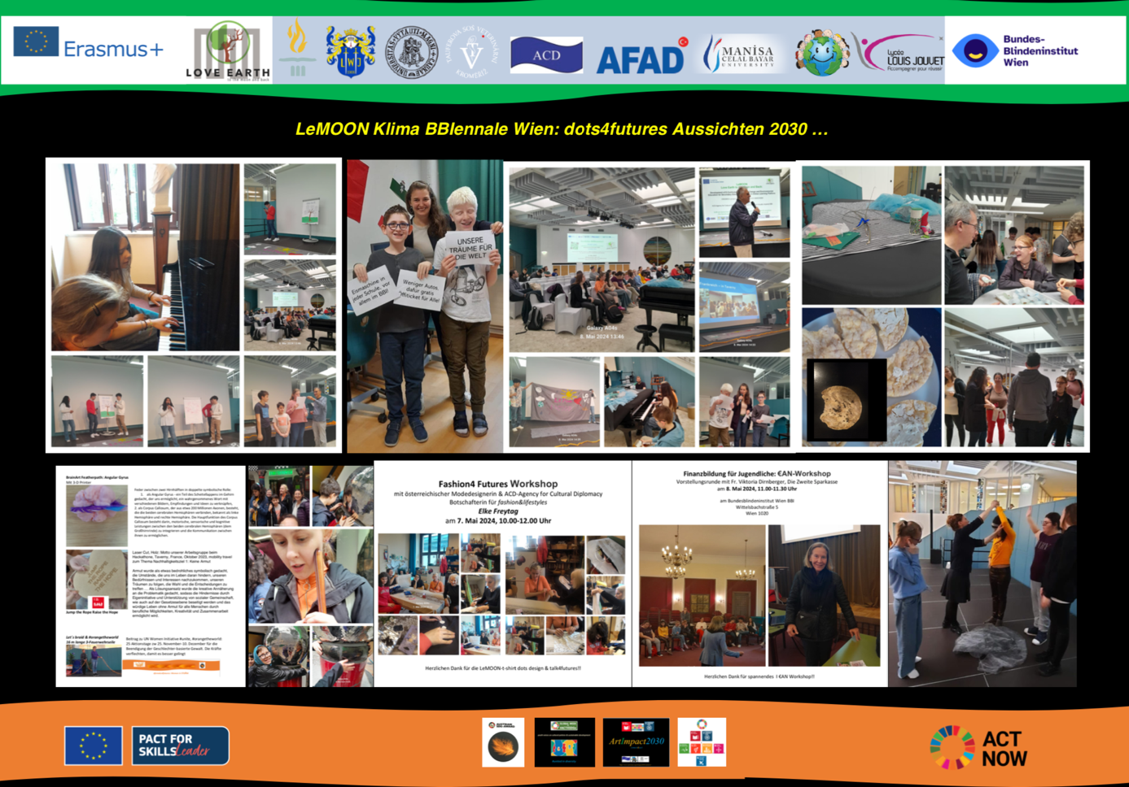

- References and documents on climate goals, and climate protection in Austria EU and globally:

Climate Goal UN SDG13: https://sdgs.un.org/goals/goal13
Austrian Climate Change act: https://www.bmk.gv.at/en/topics/climate-environment/climate-protection/austrian-climate-change-act.html#:~:text=The%20Climate%20Change%20Act%20(Klimaschutzgesetz,the%20EU%20emissions%20trading%20scheme.
Austrian Climate Protection Act: The Climate Protection Act establishes the legal framework for climate protection in Austria, including specific targets for reducing greenhouse gas emissions. https://www.bmk.gv.at/en/topics/climate-environment/climate-protection/austrian-climate-change-act.html
Integrated National Energy and Climate Plan (NECP) for Austria: EU doc. Pdf: https://energy.ec.europa.eu/system/files/2020-03/at_final_necp_main_en_0.pdf
European Green Deal: The European Green Deal is a comprehensive strategy of the European Union to promote sustainable growth and combat climate change. It includes measures to reduce greenhouse gas emissions, promote renewable energies, and encourage sustainable agriculture and mobility.
European Climate Law: The European Climate Law sets the goal of reducing the EU’s greenhouse gas emissions to net zero by 2050 and serves as a legal framework for implementing the European Green Deal. https://climate.ec.europa.eu/eu-action/european-climate-law_en

