Project ID: 2021-1-CZ01-KA220-SCH-000034484


COURSE FOR ENVIRONMENTAL EDUCATION
e-Modules: Teaching Learning activities and their technology enhanced material set to develop


Thematic Units for Week-Long Workshop Sessions:
Inquiry-Based Integrated Learning Workshop Series
on the Intersection of Arts, Science, and Policy"

M4: Arts4health: Save the Rain arts meditation workshop

COURSE AUTHOR:
©Tatjana Christelbauer MA (TC) ACD Team, Austria

DISCLAIMER
Funded by the European Union. Views and opinions expressed are however those of the author(s) only and do not necessarily reflect those of the European Union or the European Education and Culture Executive Agency (EACEA). Neither the European Union nor EACEA can be held responsible for them.
COURSE SHARING LICENSE CC BY-NC-SA = 
Canonical URL: https://creativecommons.org/licenses/by-nc-nd/4.0/

MODULE 4 arts4health, Environmental Activism

LESSON: Save the Rain art meditation workshop

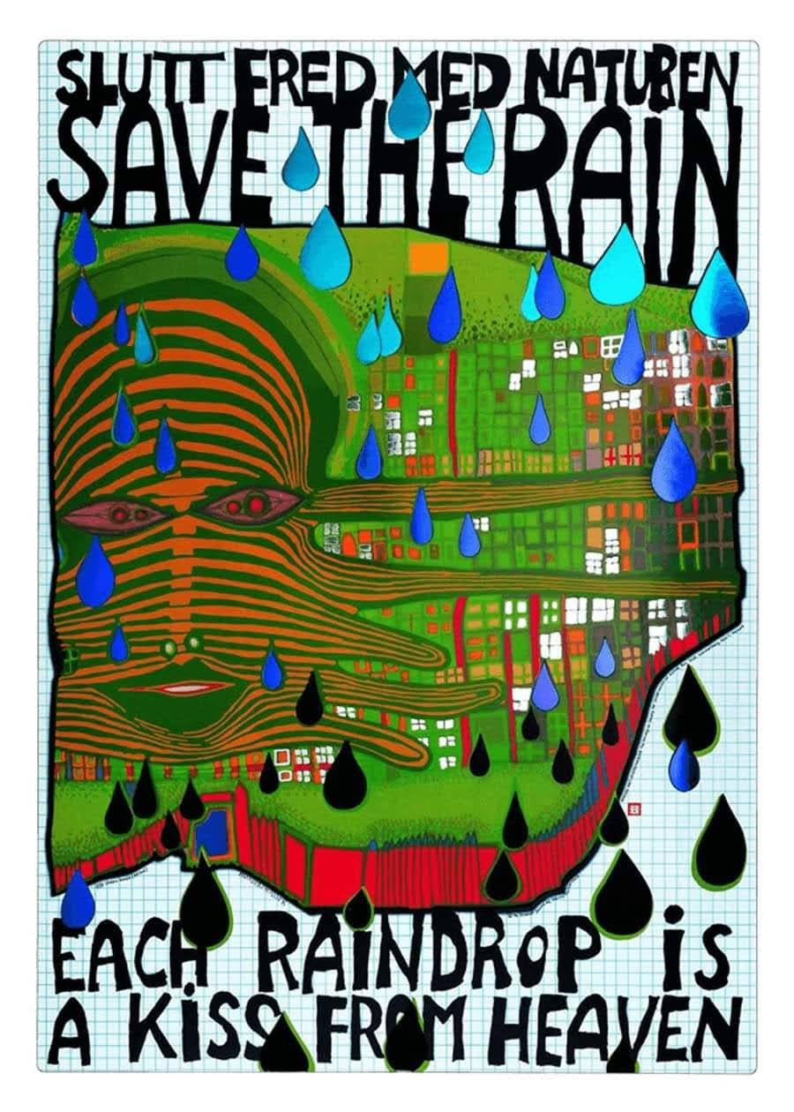
Image nr 14: Hundertwasser “Each Raindrop is a Kiss from Heaven”
690 A SAVE THE RAIN - EACH RAINDROP IS A KISS FROM HEAVEN, Offset print in 6 colors with metal embossing in 4 colors, 1983© 2019 NAMIDA AG, Glarus, Switzerland

°Workshop Session
”Each Raindrop is a Kiss from Heaven”
Hundertwasser´s environmental activism, arts & health

Introductory guide
In 1983, in cooperation with the Norwegian Ministry of the Environment, Hundertwasser designed a poster for the Norges Naturvernforbund (Norwegian Nature Conservation Association) as part of the campaign "Acid Precipitation - effects on forests and fish" with the idea of ​​drawing attention to the threat to nature from "acid rain" that damages nature and the environment and causes forest dieback. The full sentence on the poster reads: “Save the Rain. Each Raindrop is a Kiss from Heaven.” The poster was presented on Norwegian television on October 13, 1983. For this poster, Hundertwasser received the "Ekoplagát 84" award in 1984.

Open questions for research and discussion, tasks for artistic engagement:
What environmental challenges may have an impact on your health and wellbeing
Drawing from the WHO report on "Art & Health 2019," how do artistic practices contribute to physical and mental health? In what ways can dance be a powerful tool for improving overall wellbeing, both individually and collectively?
What else can be supportive for health and wellbeing? How is health care regulated in terms of opportunities to get a cure?

Explore: Complete the quote of Hundertwasser with your sensation of the raindrops:
“Each raindrop is … Create an art poster using collected notes on raindrop and make photographs of dance movement sequences inspired by the rain and its impact on human health and the environment.

Hundertwasser promoted health & well-being in his art & architecture. In the Austrian province of Styria, in Bad Blumau, Hundertwasser designed unique thermal SPA. With its healing spring, the Rogner Bad Blumau has the strongest and most mineralized thermal spring in the entire thermal and volcanic region which provides multisensorial experiences and architecture in harmony with the laws of nature.
A favorable place to visit.

Exchange: Discuss environmental challenges from your experience in your local community and its impact on health & well-being. Support some local and global campaign that resonates with your values. Sign the petition, create an art project with local and international partners that will support the awareness raising and bring impactful results. Research about how health care is regulated, and how is natural environment included (or not) in wellbeing-care?

Create, connect, compose: Instructions for the Environmental Challenge Poster
Collaborate in groups or individually to create an environmental challenge-poster that highlights the challenges in your local community/dance school and add your responses on how dance arts can help improve conditions and /or help raise awareness on addressed environmental issues.

Source: https://hundertwasser.com/oekologie/690_a_apa106_save_the_rain_-_each_raindrop_is_a_kiss_from_heaven_1742
Rogner Spa Bad Blumau designed by Hundertwasser Webpage: https://www.blumau.com/en/arrive-and-discover/architecture.html , https://www.austria.info/en/culture/artists-and-masterpieces/friedensreich-hundertwasser-artist-in-harmony-with-nature

