Project ID: 2021-1-CZ01-KA220-SCH-000034484
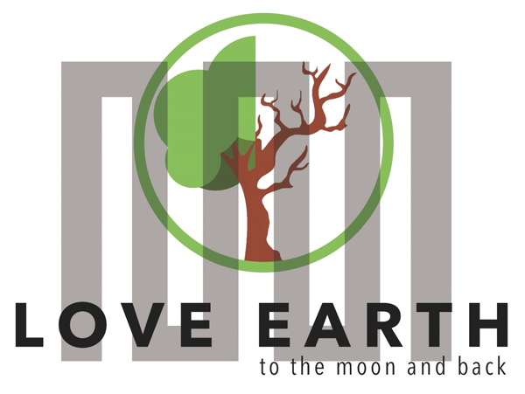

COURSE FOR ENVIRONMENTAL EDUCATION
e-Modules: Teaching Learning activities and their technology
enhanced material set to develop
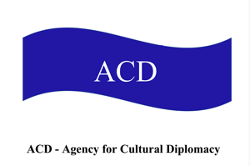

Thematic Units for Week-Long Workshop Sessions:
Inquiry-Based Integrated Learning Workshop Series
on the Intersection of Arts, Science, and Policy"

M4&6: Salt ^ Salz. Health, Nutrition, Responsible Consumption

COURSE AUTHOR:
©Tatjana Christelbauer MA (TC)
ACD Team, Austria

DISCLAIMER
Funded by the European Union. Views and opinions expressed are however those of the author(s) only and do not necessarily reflect those of the European Union or the European Education and Culture Executive Agency (EACEA). Neither the European Union nor EACEA can be held responsible for them.
COURSE SHARING LICENSE CC BY-NC-SA = 
Canonical URL: https://creativecommons.org/licenses/by-nc-nd/4.0/

MODULE 4&6:
LESSON: Salt ^ Salz. Health, Nutrition, responsible Consumption
SUBJECTS: Ethics, Health & Wellbeing, Chemistry, Psychology, Arts, Policy Learning, English, Science Diplomacy, ..

Content

- Introduction
  - What is SALT?
- The Health Risks of Uncontrolled Salt Consumption
  - Engaging with self-reflective questions about the salt consumption
  - Group Presentation and Discussion
  - EXTENSION: Action Plan, evaluation, Dissemination, Project
- Task for further research:
  - Salt in arts, mythology, culinary … ; Salt taxation
  - Research Task for Extended Exploration of the meaning and use of Salt in culture and arts

- References from scientific research and policy regulations related to salt consumption, health impacts, and the use of taxation as a tool for public health

- Good practices with ERASMUS+ LeMOON project team with contribution of representatives from the Yunus Emre Institute Vienna and Institut français
Vienna: workshop Session for the European Day of Languages EDL24
“Languages for peace: Feather, Salt & Drops” Metaphoric LangugaeWeb

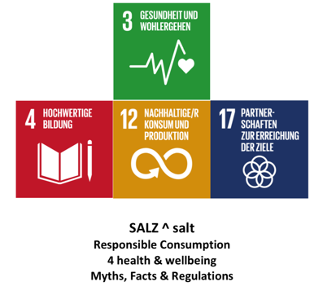

Image: T. Christelbauer: assembling the UN Sustainable Development Goals in the context of the lesson

Salt ^Salz. Health, Nutrition, responsible Consumption

The lesson aims to raise awareness about the dangers of excessive salt intake and to effectively communicate scientific evidence and policy insights to individuals, corporations, and various sectors, ultimately fostering healthier lifestyles, involving blind and non-blind youth and adults.

1 Introduction

Salt (´Salz´ in German language) is a vital natural resource that has been used by humans for thousands of years. It is essential for life, helping to balance fluids in the body and support nerve and muscle function. Salt is typically harvested from salt mines or by evaporating seawater. The chemical formula for common table salt is NaCl, which stands for sodium chloride. Salt comes in various forms for consumption, such as table salt, sea salt, and rock salt. In this lesson, we briefly introduce the salt from Austria, France, Iceland, and Turkey, which was presented during the ERASMUS+ LeMOON project activities:
Bad Ischl Salt, Austria:
Bad Ischl salt has a long tradition, with salt mining there dating back to 1563. It contains various minerals such as magnesium, calcium, and potassium, providing essential nutrients to the body.
Bad Ischl salt is particularly valued for its purity and mild flavor, making it ideal for everyday cooking. Additionally, it is considered highly beneficial for health, as it is free from additives and naturally sourced. It tastes “crumbly and grainy” (description by. a blind student by salt tasting workshop)

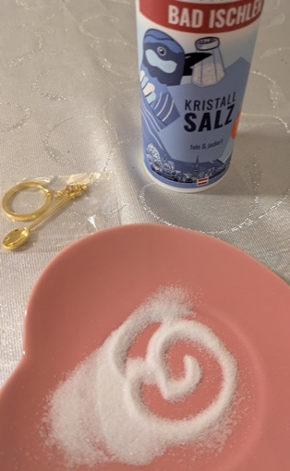
Image: mini salt spoon, Bad Ischl Salt

Black Lava Salt (Iceland)
Icelandic Black Lava Salt is a unique, volcanic sea salt harvested from geothermal waters around Iceland. Infused with activated charcoal from volcanic lava, it not only provides striking black crystals but also contains essential minerals like magnesium, calcium, and potassium, which contribute to its rich flavor. The activated charcoal adds detoxifying properties, making it popular for both culinary and health purposes. Its mildly smoky taste and crunchy texture make it a favorite for finishing dishes, adding both flavor and visual appeal. The salt has been brought by ERASMUS+ Project LeMOON team member form Iceland as a gift.
It tastes “as a coffee and puppy in one, with a herbal note”.
(Description by a blind student by salt tasting workshop)

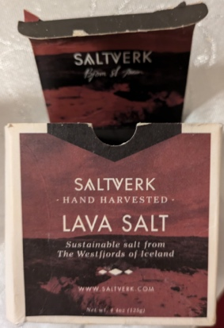
Guérande Salt (France)
Guérande salt has been traditionally harvested in the salt marshes of the Loire-Atlantique region of France since the Iron Age. Known for its grayish hue, it is rich in minerals like magnesium, calcium, and potassium, which contribute to its moist texture and balanced briny flavor. This hand-harvested sea salt is prized by chefs worldwide for its delicate, unrefined taste and versatility in culinary applications. Guérande salt also contains trace elements that enhance its nutritional value, making it a gourmet favorite. It tastes “sweet-herbal, soft and almost hairy”. (Description by blind student by salt tasting workshop)

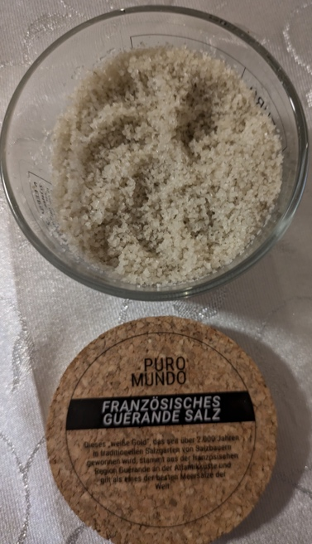

Çankırı Salt (Turkey)
Çankırı salt has been mined for over 5,000 years in the Çankırı region of Turkey and is renowned for its purity and health benefits. It contains about 80 different minerals, nearly identical to those found in the human body, including potassium, magnesium, calcium, and iron. This mineral-rich composition gives Çankırı salt a smooth, mild flavor, making it a popular choice for both cooking and therapeutic uses. Its natural balance of minerals is believed to support overall well-being and is often recommended as a healthier alternative to refined salts. It tastes “silky & rough, cold taste”. (Description by a blind teacher)

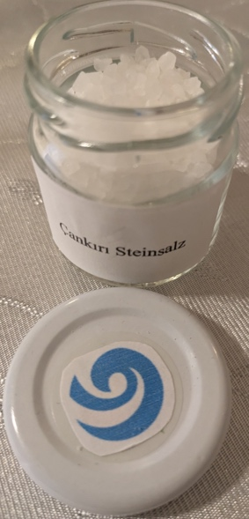

Image: Çankırı salt for salt tasting sequence donated by director of the Yunus Emre Institute Vienna, as this salt cannot be found out of the Turkey

2. The Health Risks of Uncontrolled Salt Consumption

Excessive salt intake is linked to a range of health issues, particularly affecting the cardiovascular system and vision. High salt consumption is a major risk factor for hypertension, increasing the risk of heart disease and stroke.
According to scientific research, uncontrolled salt consumption is a significant public health concern, directly linked to cardiovascular diseases, hypertension, and impairments in vision. These health issues extend beyond physical well-being, as chronic illness can lead to stress, anxiety, and decreased quality of life, thereby impacting mental health.

The World Health Organization (WHO) and the European Union (EU) emphasize reducing salt intake as a key strategy for improving public health outcomes, including mental health. Excessive salt consumption can exacerbate stress and anxiety due to its impact on blood pressure and cardiovascular health. One in seven young people aged 10-19 years suffers from a mental disorder, representing 13% of the global burden of disease in this age group (source: WHO)

How much attention do you pay to the amount of salt in the foods you eat daily, and how might this impact your overall health?
What are some small changes you could make to reduce your salt intake, and how do you think these changes could benefit your well-being?
Have you ever considered where the salt you consume comes from and how its production affects the environment?

  - Guiding questions for engagement questions for your students to reflect on their salt consumption and related habits:

Flavor Detective Activity:
Think about a typical meal you had in the past week. Write down the main ingredients and identify which ones were salty, sweet, or sour. Afterward, reflect on how you felt after eating that meal.
Did you notice any patterns in your salt consumption? Were there particular times or types of meals where you craved more salt?
Share your findings and discuss how your flavor preferences might influence your salt intake.

Sweat and Salt Reflection:
Recall a time when you were physically active, like during a sport or a workout.
Did you notice any changes in your salt cravings or your need for salty foods afterward?
Create a simple log for the next week where you track your physical activity and any changes in your salt consumption or cravings. At the end of the week, analyze if there’s a connection between your physical activity, sweating, and your salt intake.

Emotional Exploration:
Think about a time when you felt particularly stressed or emotional.
Did you find yourself reaching for salty snacks more often than usual?
Create a mood tracker for a few days where you record your emotional state and any snacks you consume, noting whether they are salty, sweet, or sour.
At the end of the tracking period, review your entries and consider whether there’s a relationship between your emotional state and your salt consumption.

The Role of Physical Training in Salt Regulation
Physical training and regular exercise play a crucial role in maintaining a healthy balance of salt in the body. During physical activity, the body generates heat, leading to sweating as a natural cooling mechanism. Sweat contains various electrolytes, including sodium (salt), which is essential for maintaining fluid balance, nerve function, and muscle performance. Through sweating, the body can regulate its salt levels, preventing excess buildup, which can be beneficial for overall health. Regular physical activity not only helps in maintaining a healthy weight and cardiovascular health but also supports the body’s natural processes in managing salt levels.
Understanding the type, duration, and purpose of physical activity can help individuals optimize their exercise routines to better support their health goals. Additionally, considering the relationship between diet and physical practice highlights the importance of nutrition in achieving and maintaining fitness and well-being. By integrating physical activity with mindful dietary choices, students and teachers can support their body's natural processes, including the regulation of salt through sweating, leading to improved health outcomes.

Reflect on Form of your Physical Practice, time spent on physical activity, it´s purpose and related diet:
What type of physical activity or exercise do you engage in most frequently? On average, how much time do you spend on physical activity or exercise each day?
What is your primary motivation for engaging in regular physical activity?
Do you follow a specific diet to support your physical activity? If so, what is the focus of your diet?

Create a Presentation: Review your notes and logs from the self-reflection activities. Summarize your observations related to your salt consumption patterns, physical activity, emotional states, and any connections you’ve noticed. Prepare a brief presentation (5-7 minutes) based on your findings.
Your presentation may include:

    - Key Observations: Highlight significant patterns or insights from your self-reflection activities.
    - Personal Examples: Think about specific examples from your experiences that illustrate your points, share them in your presentation.
    - Connections: Discuss any connections you found between salt consumption and factors such as physical activity, emotional states, or meal preferences.

  - Group Presentation and Discussion
Objective: To share personal insights from the self-reflection activities, exchange experiences with peers, and discuss strategies for responsible salt consumption. Conclude with a personal reflection. Write down one actionable change you plan to make in your salt consumption based on the discussion. Share this change with your fellow learners.

Following all presentations, engage in a group discussion. Consider these guiding questions:

What common patterns did you notice across different presentations?
How do your personal experiences compare with those of your peers?
What strategies or tips did you find effective for managing salt intake?
What challenges do you face when trying to consume salt responsibly?

  - EXTENSION: Action Plan, evaluation, Dissemination, Project Partnerships

As a group, brainstorm and discuss actionable strategies for responsible salt consumption.
Create a list of practical tips and share them with your fellow learners.
Consider including:
° Tips for reducing salt intake without compromising flavor.
° Ideas for healthier snack alternatives.
° Methods for tracking and managing salt consumption.
° Ideas for reducing salt intake due to taxation, without compromising the economic balance

DISSEMINATE, Share:
Write a brief reflection report summarizing the group discussion and action plan. Include any new insights gained from your peers and how you plan to apply these strategies to your own eating habits.
Share your presentation materials and reflection report together with the Action Plan with relevant entities in your local community, government, EU portals and similar platforms for health-related issues and responsible consumption of salt and other natural resources.

- ADDITIONAL GUIDE for EXTENDED ACTIVITIES

  - To effectively communicate the dangers of excessive salt consumption and promote healthier habits, here are some further ideas for activities:

Arts-Based Activities:
Sensorial forms such as tactile art, music, and performance, which can support and enable barrier-free engaging in creation of campaigns to help convey the scientific evidence surrounding salt consumption in ways that resonate with diverse audiences, making complex information more understandable and impactful.

Use AI Tools and Assistive Technologies:
AI-powered tools and assistive technologies will enhance the accessibility and reach of the campaign. For example, AI can create personalized dietary recommendations based on individual health data, while assistive technologies like screen readers and braille displays ensure that information is accessible to all, including those with visual impairments.

Educational Workshops and Interactive Sessions, Partnership with Public Health Organizations:
Organize Workshops with experts in nutrition and mental health to communicate the risks of high salt consumption. Collaborate with public health bodies, such as the WHO and EU agencies, to align the initiative with ongoing salt reduction campaigns. This will ensure that our efforts are supported by the latest scientific research and policy recommendations.

Guide for creative workshop: "Salt" Word Map
Explore the different ways the word "salt" is used in language. You may start by brainstorming words and phrases that contain "salt" (like saltwater, saltiness, or salty attitude). Then, organize these words into categories, such as food-related terms, scientific terms, expressions, and geographical names. For each word, you may write a brief definition or explanation and use it in a creative sentence or story.
Finally, you present your word map, sharing any interesting patterns or meanings you discovered with your fellow learners and teachers. This task will enhance your vocabulary and deepen your understanding of the various uses and meanings of "salt" in language and a greater appreciation for the versatility of words. This exercise also encourages creativity and critical thinking, as you will need to think about how these words are used and what they mean in different scenarios.
Corporate Engagement:
Engage with corporations, particularly in the food industry, to promote the reduction of salt in food products. This could include incentivizing companies to reformulate their products to contain less salt and to clearly label products that are high in sodium.

Community and Educational Outreach:
Partner with schools, community centers, and healthcare providers to disseminate information on the importance of reducing salt consumption. This could include integrating salt reduction messages into existing public health campaigns and educational curricula.

Policy Advocacy:
Use the results of your project to advocate for stronger public health policies on salt reduction at both national and international levels. This could include pushing for stricter regulations on food including salt.

  - Research Task for Extended Exploration of the meaning and use of Salt in culture and arts

The aim of this research task is to encourage you to explore and understand the multifaceted role of salt beyond its basic function as a seasoning. Salt has a rich history and cultural significance that spans across various domains, including arts, culinary traditions, and literature. By investigating these areas, you will gain a deeper appreciation for how salt is intertwined with human culture and experience.

Explore the significance of salt in different areas such as arts, culinary traditions, and literature. Investigate how salt is symbolized across various cultures. For your research, consider the following questions:

Symbolism in Arts and Literature: Salt often appears in various forms of artistic expression and literature, symbolizing concepts such as preservation, purity, and transformation. By researching its use in these contexts, you’ll see how salt can convey deeper meanings and themes in creative works. This exploration can enrich your understanding of how everyday substances are used symbolically in art and literature.

How has salt been represented in paintings, sculptures, or films? Find examples of artworks where salt plays a central role.
Identify poems, stories, or folklore where salt carries a symbolic meaning. What does salt represent in these works?

Culinary Traditions, Role in Cooking: Salt is a fundamental ingredient in cooking, essential for flavor enhancement and food preservation. Exploring different culinary traditions will help you see how salt is used in diverse cuisines around the world, highlighting its role in both historical and contemporary cooking practices.

What are some traditional dishes or preservation methods that rely on salt, and how is salt used differently around the world?

Cultural Symbolism & Significance Across Cultures: Salt holds symbolic and practical importance in many cultures. From ancient rituals to modern-day customs, understanding these aspects will help you appreciate how deeply embedded salt is in human history and society. It can also reveal how different cultures value and use salt, providing insight into their traditions and values.

How do different cultures view salt symbolically? For instance, consider its symbolic meaning and use in rituals, such as a sign of hospitality, or as a symbol of purity and preservation.

Historical and Economic Impact, Salt taxation: Salt has played a significant role in history, from trade routes to economic development. Investigate how its impact on historical events and economic systems can provide a broader perspective on its importance.
For example, introducing a tax on salt-rich products could be an effective strategy to discourage excessive consumption and generate revenue to support public health initiatives. This revenue could be directed towards funding awareness campaigns, research, and community health programs aimed at reducing salt intake. However, it is crucial to carefully balance this approach to avoid unintended economic consequences.
While taxing salt-rich products can positively influence public health, taxing salt production could have broader economic implications. Salt is a staple in many industries, and increasing production costs could affect food prices, manufacturing, and employment, particularly in regions heavily reliant on salt production. Therefore, it is essential to find a balanced solution that protects public health without disproportionately harming the economy. This might involve a gradual implementation of taxes, exemptions for certain industries, or reinvestment of tax revenues into sectors impacted by such measures.

Salt Taxation: Gandhi's Salt March (Salt Protest) - 1930
The Salt March of 1930, led by leader of the Indian independence movement and pioneer of the philosophy and strategy of non-violence Mahatma Gandhi, was one of the most significant actions in the fight for India's independence from British colonial rule. The British government had a monopoly on salt production and distribution and imposed high taxes on salt, a vital commodity. This tax particularly burdened the poorer sections of the Indian population. To protest against this unfair taxation, Gandhi marched for 24 days (over 380 kilometers) from Sabarmati to Dandi, where he symbolically collected salt from the sea. Gandhi’s philosophy of “satyagraha,” sought to reveal truth and confront injustice through nonviolence.
These historical document and event illustrate how salt has been not only a vital commodity but also a central element in the economy, politics, and society. The taxation of salt often had far-reaching social and political consequences.

Read more about Ghandi´s Salt March:
Sources: https://www.gandhiforchildren.org/gandhi-dandi-salt-satyagraha/, https://www.history.com/news/gandhi-salt-march-india-british-colonial-rule ,
YouTube: https://www.youtube.com/watch?v=lDuF17-29UU

What were the primary objectives of Gandhi’s Salt March, and how did this act of civil disobedience challenge British colonial rule in India? Why was salt chosen as the focal point of Gandhi's protest?

Discuss the symbolic significance of salt in the context of the Salt March and its impact on mobilizing Indian citizens against colonial taxation. Describe the key events of the march and its immediate outcomes. Investigate how salt taxation or regulation affects public health, economic disparities, and local economies today.

Document Findings: Create a summary of your findings, including key examples and insights. Highlight interesting uses of salt and its symbolic meanings in the chosen contexts.
Present Insights: Prepare a brief presentation or written report to share your findings with the class. Be sure to explain the significance of salt in each context and reflect on what you’ve learned about its broader cultural, artistic, and practical roles.

  - References from scientific research and policy regulations related to salt consumption, health impacts, and the use of taxation as a tool for public health

  - Scientific Research on Salt Consumption and Health

He, F. J., & MacGregor, G. A. (2009).
"A comprehensive review on salt and health and current experience of worldwide salt reduction programmes."
Journal of Human Hypertension, 23(6), 363-384. This review discusses the evidence linking high salt intake to hypertension and cardiovascular diseases, as well as the effectiveness of various salt reduction programs around the world.
https://pubmed.ncbi.nlm.nih.gov/19110538/

European Society of Cardiology Vol. 22, N° 3 - 16 Feb 2022:
Salt and hypertension: current views by Dr. Ghada Sayed Youssef https://www.escardio.org/Journals/E-Journal-of-Cardiology-Practice/Volume-22/salt-and-hypertension-current-views

Smith-Spangler, C. M., Juusola, J. L., Enns, E. A., Owens, D. K., & Garber, A. M. (2010).
"Population strategies to decrease sodium intake and the burden of cardiovascular disease: a cost-effectiveness analysis." This analysis assesses the cost-effectiveness of various population-level strategies to reduce sodium intake, including taxation, and their potential impact on reducing cardiovascular disease.
Annals of Internal Medicine, 152(8), 481-487.
https://www.acpjournals.org/doi/10.7326/0003-4819-152-8-201004200-00212
Bibbins-Domingo, K., et al. (2010).
"Projected effect of dietary salt reductions on future cardiovascular disease."
New England Journal of Medicine, 362(7), 590-599. This study projects the health benefits and economic savings of reducing dietary salt intake in the population, demonstrating the long-term value of salt reduction policies.
https://www.nejm.org/doi/full/10.1056/NEJMoa0907355

Dr. Paolo Colombiani: “Salz ist kein Bösewicht (in German): https://fitforlife.ch/fit-for-sports/ffs-ernaehrung/salz-ist-kein-boesewicht/

  - Policy Regulations and Guidelines
World Health Organization (WHO). (2016).
"SHAKE the salt habit: The SHAKE Technical Package for Salt Reduction."
WHO Guidelines provides a framework for countries to implement salt reduction strategies, including taxation, food reformulation, and public education.
https://www.paho.org/en/documents/shake-salt-habit-shake-technical-package-salt-reduction
European Commission. (2019).
"EU Salt Reduction Framework."
European Commission – Public Health. This document outlines the EU’s framework for reducing salt consumption across member states, focusing on public awareness, food industry engagement, and regulatory measures.
https://ec.europa.eu/health/ph_determinants/life_style/nutrition/documents/salt_initiative.pdf
  - Weblinks, articles:
Care Optics article on Foods that improve/maintain my eye health:
https://www.careoptics.co.uk/salt-awareness-week-eye-health
WHO: Sodium Reduction: https://www.who.int/news-room/fact-sheets/detail/salt-reduction
Knowledge for Policy: Health Promotion and Disease Prevention Knowledge Gateway
https://knowledge4policy.ec.europa.eu/health-promotion-knowledge-gateway/dietary-saltsodium_en#:~:text=The%20daily%20reference%20intake%20for,g%20or%20per%20100%20ml
  - Salt Taxation and Public Health

World Health Organization (WHO). (2017).
"Fiscal policies for diet and prevention of noncommunicable diseases."
WHO Technical Report. This report discusses the use of fiscal policies, such as taxes on unhealthy foods including salt-rich products, to improve diets and prevent noncommunicable diseases.
https://iris.who.int/bitstream/handle/10665/376763/9789240091016-eng.pdf?sequence=1
"Taxes on Unhealthy Foods and Drinks: A Health Policy Perspective."
World Bank Policy Research Working Paper. This paper analyzes the impact of taxes on unhealthy foods and drinks, including salt, on public health and provides recommendations for policymakers considering such measures.
https://www.worldbank.org/en/topic/nutrition/brief/health-taxes

  - Videos, Podcasts:
Salt matters on YouTube: https://www.youtube.com/watch?v=6U4GH-g-Z6E
Benefits and Risks of Salt Production NEJM Group on youTube: https://www.youtube.com/watch?v=ev9HS0iHlro
Why is too much salt bad for you? British heart Foundation on youTube: https://www.youtube.com/watch?v=uM8yQNZ0x10
Dance Podcast - The Power of Dance - Episode 6 Dance for Health
https://www.youtube.com/watch?v=2Gr8rh10xto

- Annex:
Good practices with ERASMUS+ LeMOON project team with contribution of representatives from the Yunus Emre Institute Vienna and Institut français
Vienna: workshop Session for the European Day of Languages EDL24
“Languages for peace: Feather, Salt & Drops” Metaphoric LangugaeWeb

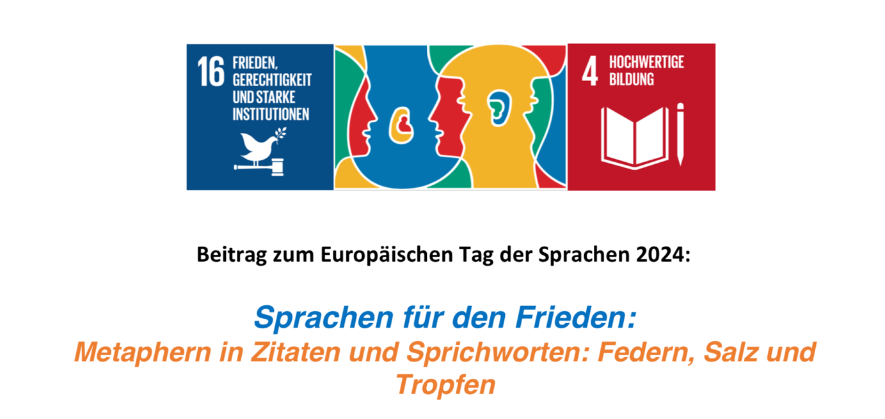

On the occasion of the annual European Day of Languages (EDL),
on September 19, 2024, from 11:00 to 11:30 a.m., at the Federal Institute for the Blind (BBI) in Vienna, Wittelsbachstraße 5, 1020,
the EDL workshop was held with BBI teaching staff, students, and our guests from the Institut Français d'Autriche and the Yunus Emre Institute, as part of the ERASMUS+ project LeMOON and the multiple event LeMOON Klima BBIennale, 2nd session.

The ERASMUS+ LeMOON project team had already celebrated Europe's linguistic diversity together in 2022 and 2023. During this year's workshop session, we followed the approach of sustainable development in communication within a multilingual, inclusive setting.
With the title "Languages for Peace: Feathers, Salt, and Drops," we approached the theme with metaphors used as symbolic linguistic figures in practical exercises to counteract the growing acts of violence in communication, be it hate speech, cyberbullying, or other forms of violence.
Following the question,
"How can languages support the practice of peace rooted in communication cultures, and how can our understanding of peace communication be enhanced by understanding the symbolic meaning of individual components of our language to prevent so-called hate speech and other forms of violence?" the creative linguistic journey was guided.

By linking terms, forms, and modes of communication, sayings, and quotes from various languages, we attempted a form of linguistic hospitality in which the messages, expressed in multiple forms were connected, and thus gained relevance in a communal context without losing the authenticity of individual languages.

The aim of these activities was to explore how, in line with the European Union's motto "United in Diversity," we could share common values in a multilingual setting and how the symbolism of individual metaphors (here symbolically linked with "feather," "salt," and "drop") in written and spoken communication can help us practice the sensitive use of these resources, "speaking/writing plainly," while becoming more aware of the meaning of specific details.

In this workshop, we learned how to make our communication gentle and empathetic through the metaphorical symbolism of feathers, how to deepen conversations through the appropriate "salt" dosage—used symbolically to refine, emphasize, and clarify statements—and how to shape individual "speaking drops" more mindfully before they fall and possibly cause harm. We practiced how to avoid harm, in both- real and digital spaces.
We practiced how to avoid harm and communicate mindfully with the idea of #stayinlove—even when things get uncomfortable, through quiet responses, critical remarks, or uncomfortable messages. #stayinlove is connected to the concept "Stay in Love," which is anchored in the social pedagogy of the Austrian reform educator Margarete Schörl in her educational approach to humanity.

How is the symbolism of the feather, salt, and drops represented and applied in other languages?

We looked for proverbs and quotes in various languages that symbolically include "feather," "salt," and/or "drop." In addition to the original language, the quotes and proverbs were translated into German, English, and other languages spoken by the participating guests.
The terms feather, salt, and drop were also printed in Braille-script on memo-cards.
This tactile memory sequence expanded the sensorial experience.

In preparation for the workshop, it was recommended to (non-blind) participants to explore digital tool for translations of the key terms (feather, salt, drop) using the Braille-script, and extend their learning journey with some new tool, which was developed by the French teacher Louis Braille and was first introduced in 1924.
The Braille-script was a revolutionary innovation for education of blind and visually impaired people, as the script made reading and writing accessible for them.
Weblink: Translate into Braille: https://www.brailletranslator.org/

Possible commonalities in the symbolism of various languages were sought. The collection of quotes, proverbs, and individual terms "feather, salt, drop" was interwoven on a Language Web poster, photographed, and digitally shared as our collective contribution to peace practice in communication via social media pages.
Our chosen quotes and other creative designs will be carried forward to future workshops and used as much as possible for peace practice in communication.

Some of our collected quotes:
Honoré de Balzac: "Jealousy is like salt: a little of it seasons the roast, but too much makes it completely inedible."
Yunus Emre: "I am the incomparable pearl that does not see the sea, I am the drop in which the whole sea hides."
Friedensreich Hundertwasser: "Each raindrop is a kiss from heaven" (This idea was symbolically applied in the workshop, taken from its original context, the environmental action "Save the Rain".

Photo memory from our workshop

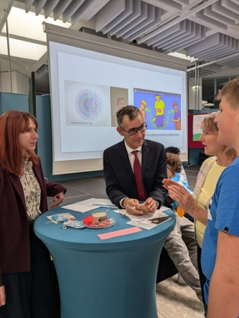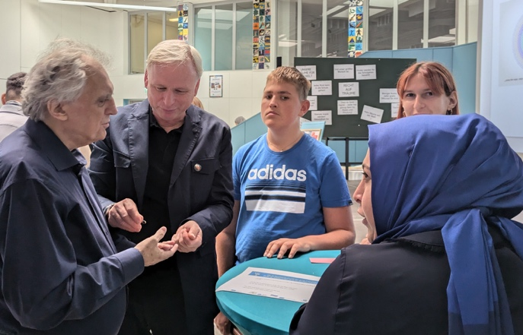
Images:
Representatives from the French Cultural Institute Austria (left), Director of the Yunus Emre Institute Vienna, French & Turkish salt for tasting, quotes in French and in Turkish for creative language learning & Braille-tactile cards memory
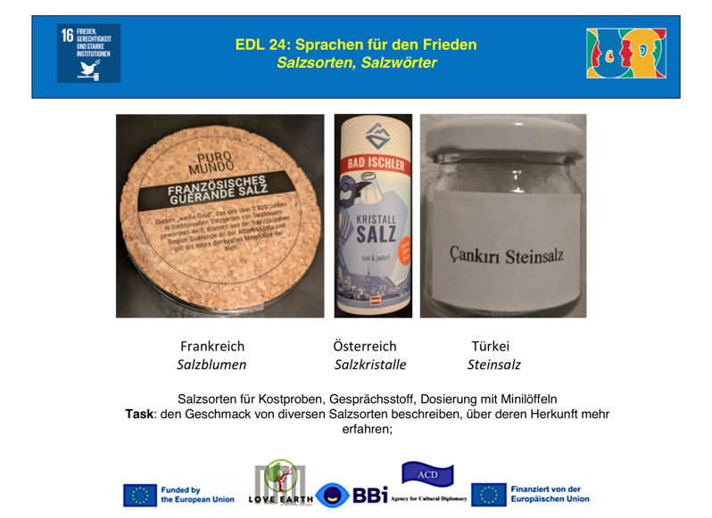

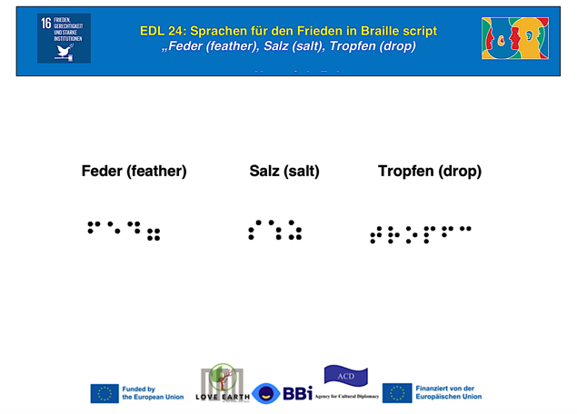

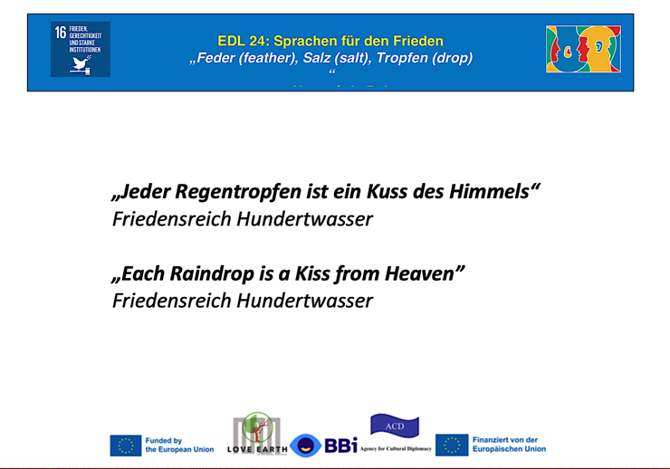

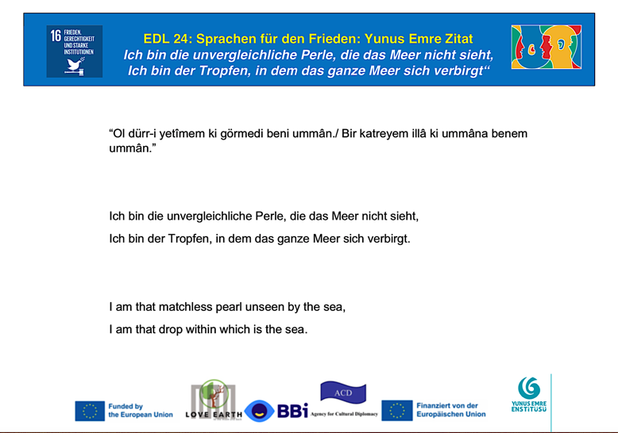

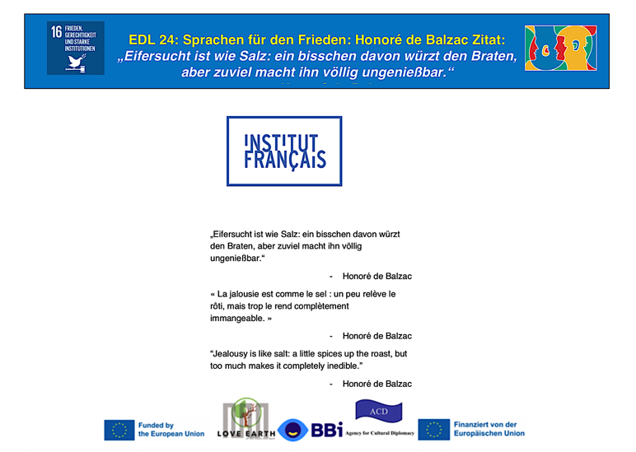

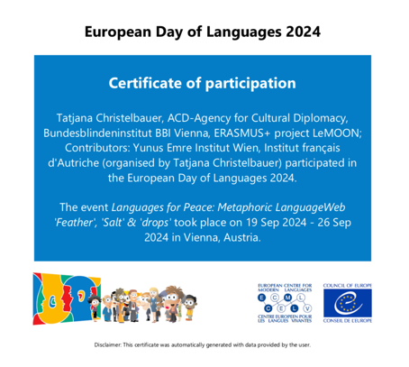

Read more about the Sustainable Development Goals (UN SDGs) in the M1 lesson in this course and following the weblink to the UN webpage: https://sdgs.un.org/goals
Further sources: WGHO: https://healthpolicy-watch.news/who-issues-sharp-call-to-european-countries-to-mandate-reduced-salt-in-processed-foods-to-save-lives/ ; Salt Intake of Children and Adolescents: Influence of Socio-Environmental Factors and School Education (Poland) https://www.mdpi.com/2072-6643/16/4/555 HEALTHLINE: https://anon.healthline.com/; EU Youth Portal: https://youth.europa.eu/strategy/health-wellbeing_en; EU youth Forum https://www.youthforum.org/news/european-commissions-mental-health-initiative
Sources: Cardiovascular and other effects of salt consumption Francesco P Cappuccio https://www.ncbi.nlm.nih.gov/pmc/articles/PMC4089690/ ; Main Sources, Socio-Demographic and Anthropometric Correlates of Salt Intake in Austria: https://www.ncbi.nlm.nih.gov/pmc/articles/PMC5872729/
Sources for more informations: https://www.britannica.com/topic/Braille-writing-system ; Short video on YouTube: https://www.youtube.com/shorts/fYpBTOFeNHI ; Louis braille for Kids: Good night stories on YouTube: https://www.youtube.com/watch?v=bVDbF_4IxYA

