Project ID: 2021-1-CZ01-KA220-SCH-000034484
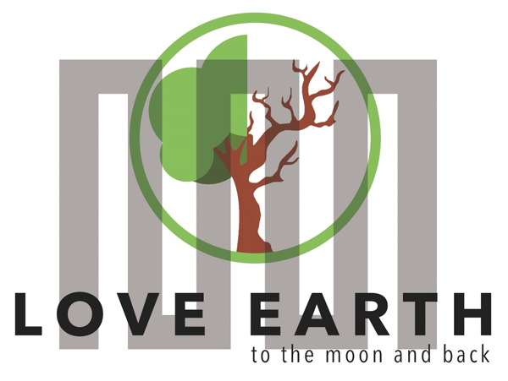

COURSE FOR ENVIRONMENTAL EDUCATION
e-Modules: Teaching Learning activities and their technology enhanced material set to develop

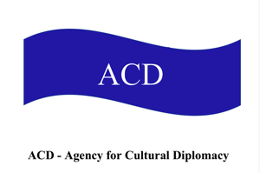

M6: Responsible Consumption. Fashion4Futures

COURSE AUTHOR
©Tatjana Christelbauer MA (TC)
ACD Team Austria

DISCLAIMER
Funded by the European Union. Views and opinions expressed are however those
of the author(s) only and do not necessarily reflect those of the European Union or the European Education and Culture Executive Agency (EACEA). Neither the European Union nor EACEA can be held responsible for them.
COURSE SHARING LICENSE CC BY-NC-SA = 
Canonical URL: https://creativecommons.org/licenses/by-nc-nd/4.0/

MODULE: 6 Responsible Consumption

LESSON: Fashion4Futures

Guiding insights for week-long workshops

Subjects: Social Science, English, Ethics, Arts, Design, Fashion

Fashion4Futures
Sustainable Consumption, Creative Design
Author: Tatjana Christelbauer MA, ACD/AT
Module6, Lesson: Responsible Consumption
Part: Fashion. Guiding insights for week-long workshops

Subjects: Social Sciences, Ethics, Arts, English, …

CONTENT:

- Introductory: Fashion 4 Sustainable Development. Environmental protection in the fashion Industry
- Hundertwasser fashion & The Second Skin; Second Hand Clothes, responsible consumption; guide for creative design workshops and charity fashion show
- Insights from the workshop with the Austrian fashion designer Elke Freytag

- Environmental Protection in the Fashion Industry
Entry guide
Questions designed to encourage young people to think about their attitudes and decisions regarding fashion and clothing and to become aware of how their actions can influence environmental protection.
Questions for Personal Reflection on the Topic "Fashion, Lifestyle":
- What does personal style mean to you, and how does it influence your clothing choices?
- What fashion styles are you familiar with, and how would you describe your style: sporty, elegant, alternative, etc.?
- What criteria are important to you when deciding what to buy? Do you consider price, quality, comfort, or trends?
- Is sustainability and environmental protection a factor in your consumption behavior?
- How do you identify environmentally related criteria when shopping for your clothes?
- What are your thoughts on the importance of redesign and self-created pieces with fabric scraps?
- Do you think this can help boost your self-confidence? Why, or why not?
- What role do trends play in your clothing choices? Do you follow trends, or do you prefer timeless pieces?
- How do you think our clothing choices and consumption behavior impact environmental protection?
The fashion industry is one of the largest industries worldwide, with a significant impact on our environment and society. Currently, about 10% of global greenhouse gas emissions are caused by fashion production, more than the emissions from all flights and shipping combined. In addition to pollution from chemicals and waste, unfair working conditions, and financial exploitation of workers in many production countries are also in focus. The throwaway culture of Fast Fashion significantly contributes to these problems, leading to constant trend changes and the quick disposal of clothing. However, there are also positive developments, such as the increased use of recycled materials, sustainable production methods, and fair-trade practices. In this context, it is important for us as consumers to rethink our purchasing behavior and make conscious decisions. Choosing sustainable fashion and environmentally friendly lifestyles can help reduce the negative impacts of the fashion industry and have a positive influence on the environment and the living conditions of people in the production chain.
´The EU generates 12.6 million tonnes of textile waste per year. Clothing and footwear accounts for 5.2 million tonnes of waste, equivalent to 12 kg of waste per person every year. The Commission is proposing rules to make producers responsible for the full lifecycle of textile products and to support the sustainable management of textile waste across the EU. This initiative will accelerate the development of the separate collection, sorting, reuse and recycling sector for textiles in the EU, in line with the EU Strategy for Sustainable and Circular Textiles. Increasing the availability of used textiles is expected to create local jobs and save money for consumers in the EU and beyond, while alleviating the impacts of textile production on natural resources.
According to UNESCO Courier, ´The number of people who said sustainability was an important factor when purchasing clothes rose to sixty-nine per cent in 2021´. Why it matters? The aim of this task is to raise awareness about the dangers of the throwaway culture supported and promoted by fast fashion, as well as environmentally harmful trends such as sandblasting jeans, long production journeys, and the working conditions of people in the fashion industry both domestically and abroad. Reflect on personal behavior, such as how you decide what to buy to wear, what criteria you follow, and why redesign and self-created pieces with fabric scraps, small details like buttons, and ribbons can boost self-confidence and contribute to environmental protection.
ENGAGE: Read more facts about on the webpage of the Fashion Revolution Switzerland, a movement committed to ensuring that fashion becomes a means of positive change and can develop in balance with people, the environment and economics (in German/French/Italian): https://www.fashionrevolution.ch/fakten
Tasks for Deepening Understanding of the Topic:
- Read the text by following this link: Fashion Revolution
- Choose 3-5 key aspects that contribute to environmental destruction and/or pollution.
- Choose 3-5 key aspects that relate to social issues, highlighting unfair working conditions and other relevant injustices in the current fashion industry worldwide, as well as in Austria. Find further relevant Reports and data from your country.
- Search for and share good examples of green initiatives in the fashion industry that support and promote sustainability goals.
- Create your personal fashion ID by reflecting on your consumption behavior and approach to fashion.
Let´s repeat together, to mark what matters, how and why:
Quiz:
These quiz questions aim to raise awareness about the environmental and social impacts of the fast fashion industry and encourage participants to consider more sustainable alternatives.
Question: What percentage of global greenhouse gas emissions is caused by the fashion industry according to estimates? a) 5% b) 10% c) 20% d) 30% Answer: b) 10%
Question: Which of the following environmental problems is primarily caused by the fast fashion industry? a) Overfishing of the oceans b) Deforestation c) Plastic pollution in the oceans d) Air pollution from industrial emissions Answer: c) Plastic pollution in the oceans
Question: In which regions are working conditions in fashion production often inadequate, and workers exploited? a) Europe and North America b) South America and Africa c) Asia and Oceania d) Middle East and Central America Answer: c) Asia and Oceania
Question: How many tons of clothing are discarded worldwide each year instead of being recycled or reused? a) Over 1 million tons b) Over 5 million tons c) Over 10 million tons d) Over 20 million tons Answer: d) Over 20 million tons
Question: Which of the following materials is commonly used in the fast fashion industry but leads to significant environmental pollution due to pesticide and water usage? a) Cotton b) Hemp c) Linen d) Bamboo Answer: a) Cotton
EXTEND experiences, present your insights: Create a poster with collected facts, make a digital format, and develop a survey list or a fashion campaign to raise awareness about fashion-related environmental issues and best practices.
Read More About Relevant Initiatives for Sustainable Fashion and Environmentally Friendly Lifestyles:
Fashion Revolution, https://www.commonobjective.co/#eff , Sustainable Apparel Coalition, Ethical Fashion Forum, Greenpeace Detox Campaign
Further leading weblinks to articles on Fashion for the Blind: SeeFeel Consultation for the Blind and Visually Impaired , Fashion for the Visually Impaired , Fashion & Design for the Blind , Designer Creates Clothing for the Blind , Inclusion & Sustainability , Clothing Choices for the Blind/Visually Impaired , Looking Good Without Looking , Elementary School Age Self-Care: Clothing Choices & Care

- Hundertwasser´s eco-friendly fashion:
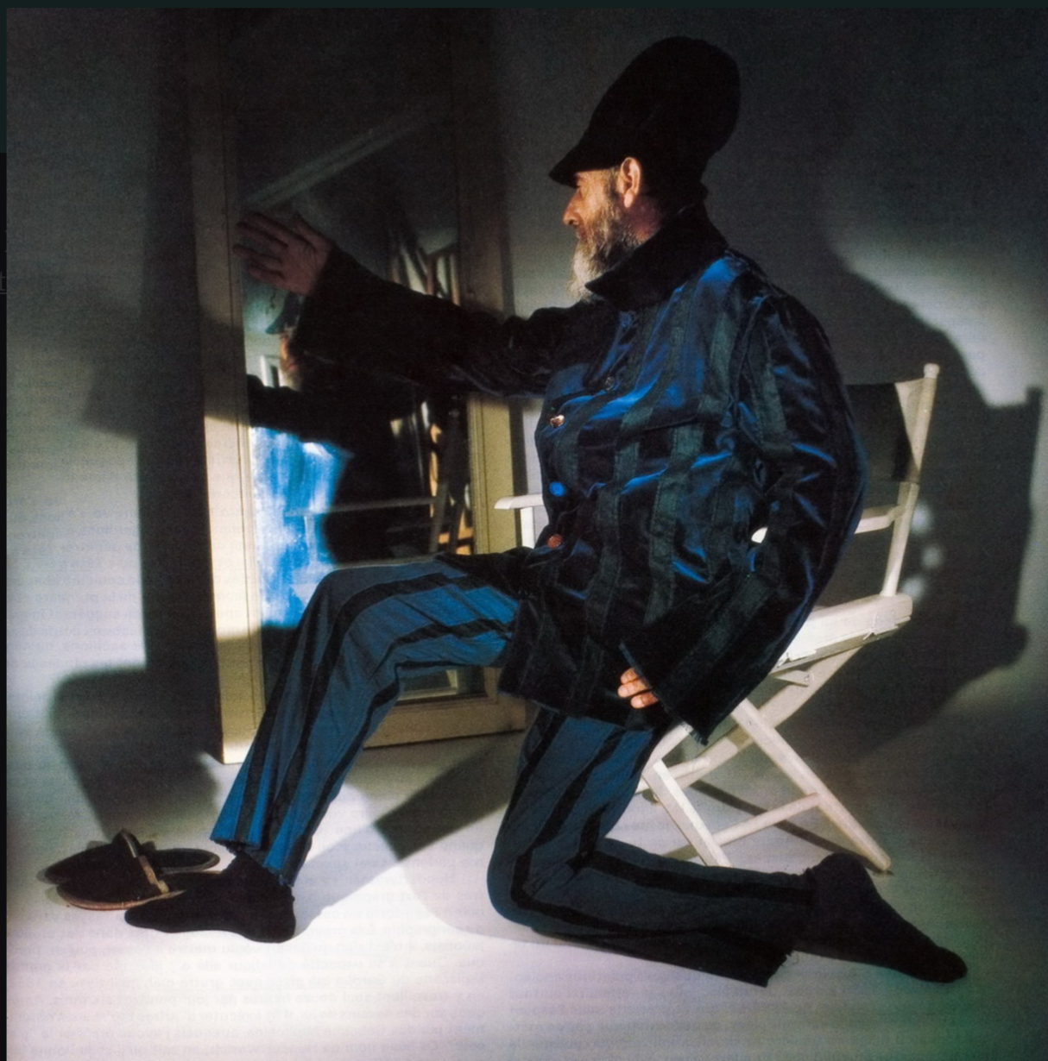
Image: Hundertwasser, self-designed suit
The Second Skin

Austrian painter, environmental activist, and architect Friedensreich Hundertwasser advocated for environmental protection and sustainable living in various forms and fields. His passion for nature and unconventional style were reflected not only in his paintings and architectural designs but also in his everyday life, including his sensitivity to personal lifestyle. This included a keen awareness of details, such as clothing choices. Hundertwasser not only designed clothing but also saw it as an expression of his art and beliefs. His approach to eco-friendly fashion design was characterized by a return to natural materials and traditional craftsmanship. He preferred biodegradable fabrics like cotton and linen and opposed the use of synthetic materials that harm the environment.
Inspired by the unique clothing style of French artist René Brô, whom he met on a trip to Italy in 1949, Hundertwasser began making trousers and shoes for himself. Later, he designed clothes and hats for sewing, as well as sweaters and socks for knitting. In the Studio Gianni Bugli /Milano, Italy, you can find Pullover (jaquard knit) inspired by Hundertwasser´s artwork 663 SWEET SEA COLONY ON THE SALT SEA VOYAGE - EGG COLONY OF ZWOLLE
  - “Patterns, symbols, diversity: stripes ”
A distinctive feature of Hundertwasser´s fashion was the striped pattern, often found in his paintings. This pattern was not only aesthetically pleasing but also held symbolic meaning. It represented the diversity and irregularity of nature and contrasted with the geometric order of the modern world. Hundertwasser "bent" the striped patterns, creating interruptions and irregularities in their rhythm in his paintings, architecture, and clothing creations. He declared the straight line as "uncreative."
Stripes are one of the most timeless and versatile patterns in the fashion world and are valued by many designers for their symbolic meaning and aesthetic impact. Hundertwasser used stripes as motifs and in his fabric creations. His stripes contrasted with the geometric order of the modern world and symbolized the uniqueness and beauty of the natural environment. He also associated stripes with themes such as freedom, individuality, and harmony between people and nature. Overall, stripes are connected with a variety of values, cultures, traditions, and messages. They can evoke associations with maritime adventures, timeless elegance, artistic freedom, or even political statements, depending on how they are used and by whom.
In a time dominated by fast fashion and mass production, Hundertwasser's striped patterns remind us of the beauty and uniqueness of the natural world. He was a forerunner of the later known "Creative Clothings Movement". On an invitation of the French magazine VOGUE, Paris, he designed a suit and wrote an essay on fashion. Both the suit and the essay were published in VOGUE no. 631 of November 1982. What is your favorite pattern? What does it express, when you think it symbolically? Make research, find out more about patterns, colors and other details of your favorite clothes. Exchang ewith your fellow learners. Make together a presentation about diverse patterns and colors, and their symbolical meaning. Learn to understand their use in diverse cultures.
° Read more about the Color Diplomacy in the MODULE 6 lesson
  - The Second Skin
Hundertwasser summarized his thoughts on fashion in the Manifesto "On the Second Skin" (1982/1983), in which he railed against conformity, fashion, and clothing that is anonymous, average, and symmetrical.
"Clothing is forever, just like art. Clothing must become art again and stop being just fashion." (Hundertwasser, 1982)

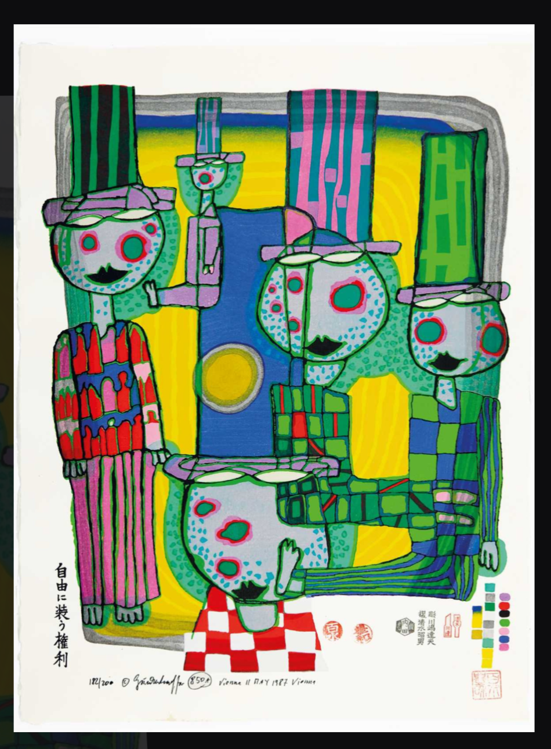
850 A
THE SECOND SKIN
DIE ZWEITE HAUT
LA DEUXIEME PEAU
JIYU NI YOSOOU KENRI

Woodcut 5 in the portfolio JOY OF MAN

Engage, explain: Read the Hundertwasser's commentary on the work “The Second Skin”, mark some key terms and explain the relational aspects among clothing and human rights as promoted by Hundertwasser, from your point of view:
A free person wears free clothing. When a person's second skin is uniform, manufactured by lifeless machines, or dictated by fashion, it is as if a foreign body is forced upon the person, and they become ill, just as if something is wrong with their first skin. This is a long-standing civilization disease that manifests in the discomfort of each individual. This discomfort condenses into a damage of self-respect and a slavery of the soul with all the frightening consequences for our society. Therefore, the right to individual external appearance of every person, the right of each individual to wear different clothing, must not only be tolerated but firmly anchored in human rights. (…)
"If the second skin becomes ill or standardized or does not suit the person, then the person, the organism underneath, will also become ill. (...) "Factory-made clothing takes us further and further away from the creative design of our own clothing, which is not just something worn on the outside. For clothes make people. This is not just a saying; it is a fact, the truth." (Hundertwasser, 1982)
Extend your perception: find motives, colors, and patterns, describe the artwork in detail as for the blind, create a “Fashion story” inspired by the artwork.
Now, read the title in all the given languages, pronounce, interpret the meaning in a way you “feel” the second skin when thinking it in various languages. This exercise may inspire you for exploring imaginative diversity by the shift into another language, such as it is explored and explained by Wor(l)ding methodfor multilingual language plays, that may enable multiple sensorial experiences through articulatory phonetic. What appears in your mind when thinking cloths as “Die Zweite Haut”? Do you think on a particular part of your clothes? What part? And what appears in your mind when you think your clothes as “The Second Skin”? How it feels when translated into Japanese? Read and pronounce, find help by Google translator, or some other useful tool. Make notes about clothes or other images appearing in your mind when thinking them in diverse languages. Exchange your experiences with your colleagues. Get inspired for some group activity on the topic of clothes as “The Second Skin”, translate the title in some another language, reflect on your imagery if it changes.
How it matters? It is a creative task for exploring playful imagination in a multilingual setting. The linguistic aspect relates to variety and to diversity of lifestyles, expressed through clothes.
In a world marked by consumption and waste, Hundertwasser's eco-friendly fashion design reminds us that fashion can be more than just clothing—it can convey a message of sustainability and respect for our diverse environments.

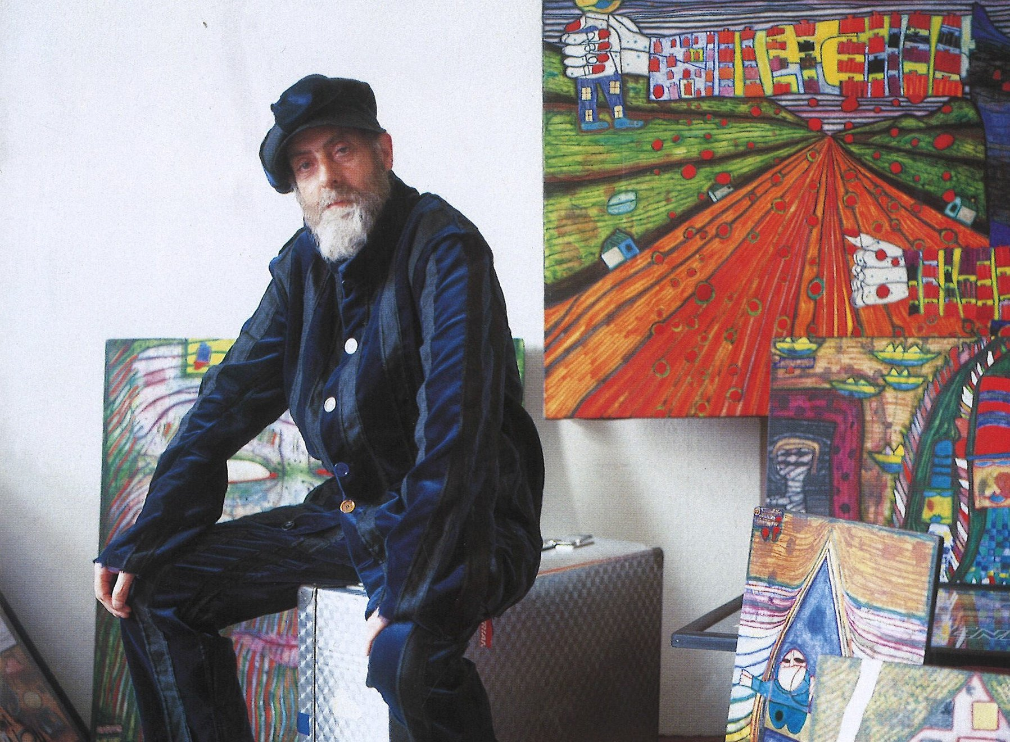
Photo: Hundertwasser in a self-designed reversible suit for French Vogue, photo by Pedro Kramreiter: Source: Hundertwasser Art Center on Fb: https://www.facebook.com/photo/?fbid=3054288121322875&set=a.823232551095121

  - From the Second Skin to Second Hand: Extend your experience, with a “Second Hand Fashion”
Introduction to Second-Hand Fashion
Second-hand fashion, or pre-owned clothing, has evolved from a niche market to a significant component of the global fashion industry. Historically, it gained prominence during the Great Depression as a practical solution for those facing economic hardships, and its popularity surged during the 1960s and 1970s with the rise of vintage fashion and countercultural movements. The charity purpose of second-hand fashion lies in its ability to provide affordable clothing options while supporting charitable causes, such as through thrift stores and donation drives that fund social programs.
Economically, second-hand fashion contributes significantly by reducing the demand for new clothing production, which can lower environmental impact and decrease resource consumption. The economic impact is also seen in job creation within the second-hand retail sector and the support for local charities. In terms of sustainable development, second-hand fashion aligns with goals of responsible consumption and production (SDG 12) by extending the life cycle of garments and minimizing waste. Overall, it represents a practical and impactful approach to fostering sustainability and addressing economic inequalities. On the other hand, according to UNESCO, the second-hand clothing market is one of the most dynamic in the world – representing a third of global imports - but still suffers from a lack of recycling channels, with 40% of these garments ending up in landfill sites, or even in oceans and rivers.
EU perceives the ´Second hand as a sustainability in a nutshell.´ Both the EU Green Deal (2019) and the EU Circular Economy Action Plan (2020) focus on textiles. In 2021, the EU is set to adopt an EU Textiles Strategy. EU Member States are adapting national laws to EU rules. Currently, the Commission is proposing rules to make producers responsible for the full lifecycle of textile products and to support the sustainable management of textile waste across the EU. This initiative will accelerate the development of the separate collection, sorting, reuse and recycling sector for textiles in the EU, in line with the EU Strategy for Sustainable and Circular Textiles.
ENGAGE: How is your experience with Second Hand Clothes? What role plays online shopping in your daily life and how it may influence consumer behaviors? Where was the clothes you are purchasing being produced? How are the working conditions of people employed in this sector and what an impact makes the fashion industry on environment? What is meant by the term “fast fashion?
Make research, read the critical articles on the UNESCO Webpage and the Uganda independent, discuss with your fellow learners what you find critical and what would you propose to improve the current actions. https://courier.unesco.org/en/articles/ethical-fashion-rising-trend-or-empty-rhetoric and: https://www.independent.co.ug/african-fashion-takes-off-unesco-report-at-lagos-fashion/
    - Task: Explore your creativity & design for greater purposes, get inspired by Hundertwasser
Phase 1: Exploring Hundertwasser’s Vision with your creations
Hundertwasser believed that creativity and individuality should shine through in everything we do. His manifesto, "The Second Skin," celebrates the idea that our clothing should reflect our personality and break free from conventional norms. Think about how you can channel Hundertwasser’s vibrant and eclectic style into your own fashion creations.
Phase 2: Re-Designing Old Clothes
Your mission is to breathe new life into old clothing. Choose garments that you no longer wear and think about how you can transform them into something entirely new and exciting. Consider how Hundertwasser's use of bold patterns, unusual forms, and vivid colors can inspire your redesign. Experiment with different techniques to alter the shape, texture, and appearance of the clothes, making them a unique reflection of your creativity.
Phase 3: Creating with Unusual Materials
Alternatively, you may opt to create a fashion product using unconventional materials, such as it is currently done by transforming plastic into high quality sewing threads in Uganda. Look around for items that are usually discarded or overlooked and imagine how they can be repurposed into stylish and innovative clothing or accessories. Keep in mind Hundertwasser’s emphasis on nature and organic forms. Let these materials guide your design process and think about how they can be integrated into a harmonious and functional piece.
Phase 4: Detailing and Final Touches
As you finalize your designs, pay close attention to the details. Hundertwasser’s work often features intricate patterns, rich textures, and playful color schemes. Incorporate these elements into your creations to make them truly stand out. Reflect on how the colors, patterns, and details of your design can express individuality and personal style, making each piece a unique work of art. Let your imagination free and embrace the spirit of transformation.
    - Present, connect&act: Organizing a Charity Fashion Show, following the 3 Pillars of Sustainability
Guiding insights for your inspiration:
To conclude your creative fashion journey, you can organize a Fashion Show with a charitable twist. This event will showcase your redesigned and newly created garments and accessories, and it will serve a meaningful purpose.
Task Details:
The Importance of Charity and Its Connection to Hundertwasser’s Ideas
Why Charity Matters
Engaging in charitable activities fosters a sense of unity and collective purpose, as individuals come together to make a positive impact. This collective effort can lead to meaningful changes, whether it’s through providing immediate aid, supporting long-term projects, or enhancing the overall quality of life for those in need. By supporting charitable causes, we address pressing needs within our communities and beyond, helping to improve the conditions and prosperity.
Connecting Charity to Hundertwasser’s Ideas:
Friedensreich Hundertwasser was an advocate for individuality, environmental stewardship, and the well-being of all people. His work and philosophy emphasize several key principles that align with the values of charity:
Responsible Consumption: Hundertwasser advocated for a mindful approach to the use of resources. Responsible consumption involves making thoughtful choices about how we use and dispose of materials. In the context of fashion, this means rethinking our approach to clothing—such as by re-designing old garments or using unconventional materials to create new items. By promoting responsible consumption, students can contribute to a more sustainable fashion industry and reduce waste.
Respect for Nature and the Environment: Hundertwasser’s art and ideas celebrate the natural world, urging us to live in harmony with it. Charitable activities that involve planting trees or improving green spaces reflect this respect for nature. By contributing to environmental projects, such as planting trees or enhancing school grounds, students can help create a more sustainable and beautiful world, mirroring Hundertwasser’s vision of a harmonious coexistence with nature.
Community and Individual Well-Being: Hundertwasser believed in creating spaces that uplift and benefit everyone. Charitable efforts aimed at optimizing the learning environment or supporting those in need, such as refugees or emerging school funds, resonate with his belief in improving communal well-being. By enhancing educational spaces or providing support to those facing challenges, students contribute to a better environment for everyone, aligning with Hundertwasser’s ethos of communal care and support.
Creativity and Innovation: Hundertwasser celebrated creativity and the breaking of conventional norms. A charity project that involves innovative solutions or creative approaches—such as organizing a fashion show to raise funds—reflects this spirit of ingenuity. It allows students to use their talents and creativity for a purpose that benefits the broader community, demonstrating how art and design can be a force for positive change.
Empathy and Connection: At its core, charity fosters empathy and a sense of shared humanity. Hundertwasser’s work often emphasized the importance of connecting with others and appreciating diverse perspectives. By participating in charitable activities, students learn to empathize with others’ needs and work together toward a common goal, embodying Hundertwasser’s values of compassion and interconnectedness.
Connecting your design & event to Sustainable Development Goals (SDGs):
To deepen the impact of your project, identify which Sustainable Development Goals (SDGs) your activities relate to and explain how they connect with the three pillars of sustainability: environmental, social, and economic. By aligning your project with the SDGs and sustainability pillars, your students will understand the broader significance of their project and how it fits into global sustainability efforts, while demonstrating a broader commitment to global and community well-being.
Task: Identify Relevant SDGs: Choose which of the SDGs your project aligns with. For instance, you might focus on:
  - SDG 12: Responsible Consumption and Production – By redesigning old clothes and promoting sustainable fashion.
  - SDG 13: Climate Action – Through activities like planting trees.
  - SDG 1: No Poverty – By supporting families in need through a charity fund.
Explain the Connection: Write a brief explanation detailing how your project relates to these SDGs and how it addresses the three pillars of sustainability:
  - Environmental Sustainability: Describe how your project contributes to environmental protection (e.g., reducing waste through clothing redesign, planting trees).
  - Social Sustainability: Explain how your project supports community well-being (e.g., helping families in need, enhancing the learning environment).
  - Economic Sustainability: Discuss how your project promotes economic benefits (e.g., responsible consumption, fundraising for charitable causes).
    - Sustainable Initiative: Creating a Clothing Charity Fund at School
As part of this project, consider setting up a Clothing Charity Fund at your school. This fund can support the redesign and repurposing of old clothes, providing a sustainable approach to fashion while contributing to charitable causes. The fund could:
- Support Redesign Projects: Help cover the costs of materials and supplies for students who are transforming old clothes into new, creative designs.
- Facilitate Donations: Allow students to contribute to a clothing charity or support families in need within the community.
- Promote Sustainable Fashion: Raise awareness about responsible consumption and the importance of reusing and recycling clothing.
By integrating a clothing charity fund into your project, you create a practical way to merge creativity with social responsibility, aligning with Hundertwasser’s vision of a more thoughtful and caring world. For your guidance read about examples from Austrian CARITAS, People to People HUMANA second hand charity fund and look for more examples form your region: https://www.caritas.eu/caritas-austria/ , https://www.humana.org/where-we-work
NOTE for teachers applying these principles:
In your project, students have the opportunity to choose a meaningful charitable purpose, such as planting a tree, enhancing their learning environment, or supporting people in need. This not only ties their creative efforts to a cause that benefits everyone but also reinforces the values of empathy, environmental stewardship, responsible consumption, and communal care that Hundertwasser championed.
By integrating charity into their project, students will experience firsthand the impact of their contributions, making their work not only a reflection of their creativity but also a testament to their commitment to making the world a better place. This expanded explanation includes the concept of responsible consumption and the idea of a clothing charity fund, adding depth to the students’ understanding of how their project can align with and support responsible consumption of clothes.
References for further reading and research:
Silkroad web article UNESCO: https://en.unesco.org/silkroad/content/cultural-selection-clothing-reflection-socio-economic-status-and-regional-differences; Fashion, Design, economy articles: https://www.unesco.org/creativity/en/sector/design-fashion
YouTube videos: Teens transform old clothes into high fashion for Recycled Runway
https://www.youtube.com/watch?v=DlkVthMYwes; How kids turned trash into fashion | The Project NZ
New Zealand https://www.youtube.com/watch?v=1n69xpkpZu0

- Example from Practice:
Insights from a Workshop with Austrian Fashion Designer Elke Freytag
Workshop Overview: In a creative design workshop at the sewing workplace of the Vienna Institute for Blind (BBI), Austrian fashion designer Elke Freytag, who is also engaged as an ACD-Agency for Cultural Diplomacy association Ambassador for fashion & lifestyles, have led a session with blind & visually impaired high school students, participants in the ERASMUS+ project "LeMOON." This workshop focused on sustainable fashion using leftover fabrics. As a final product, students crafted T-shirts by applying Earth and Moon globes onto the garments using 3-D pens and sewing techniques.
Workshop Activities
By the introductory session, students have shared their personal interests and experiences in fashion. In particular, they spoke about their choices, favorite brands, colors, patterns and their understanding of sustainable fashion.
°One visually impaired student shared that she is highly interested in fashion design but could not succeed by applying for a Fashion School in Vienna because of her visual impairment. However, she is supported by her family, by leading her private fashion shop. After our workshop, she will visit Elke Freytag at her shop and learn more about this profession and career opportunities.
Elke Freytag was introduced by project organizer and partner in E+ project LeMOON Tatjana Christelbauer. Sustainability is a cornerstone of Elke Freytag'sdesign philosophy. She integrates high-quality fashion with eco-friendly practices. Additionally, Freytag collaborates with selected local sewing workshops, promoting ethical fashion through conscious design and efficient production processes. Her timeless designs encourage women to embrace their unique personalities while remaining comfortable in their clothing. Elke Freytag emphasizes comfort, individuality, and sustainability in her fashion designs. She states: "I want women to feel comfortable in my designs and to have their strengths highlighted. I see my fashion as timelessly modern, high-quality, individual, and sustainable."
Together with their teacher, Ms. Carla Laszakovits, students were engaged in touching and describing of leftover fabric pieces brought by Elke Freytag. During the workshop, students experienced a diverse range of creative design techniques, including sewing and fabric fusion.
In the Q/A session, the focus was given on the ecological footprint in the fashion production. Elke Freytag stated that, all pieces and prototypes are designed and sewn in her studio, ensuring short production times—only 2 weeks from sketch to storefront.
Incorporating Braille Dots in Design: Dots are a timeless fabric motif with a rich history in fashion. They often symbolize playfulness, femininity, and retro chic, and can express rebellion or nonconformity when used in unconventional ways. Their versatility and timeless appeal make them a popular choice among designers. The use of dots as a motif for T-shirts was connected to the Braille script system used by blind students. The dots motif was applied using circularly cut fabric scraps to represent Earth and Moon, which were sewn onto the T-shirts. These motifs symbolize the complete ERASMUS+ project title: "LOVE EARTH TO THE MOON AND BACK." A heart with a spiral path was added between the Earth and Moon, created with a 3-D pen and then fused onto the fabric using an iron.

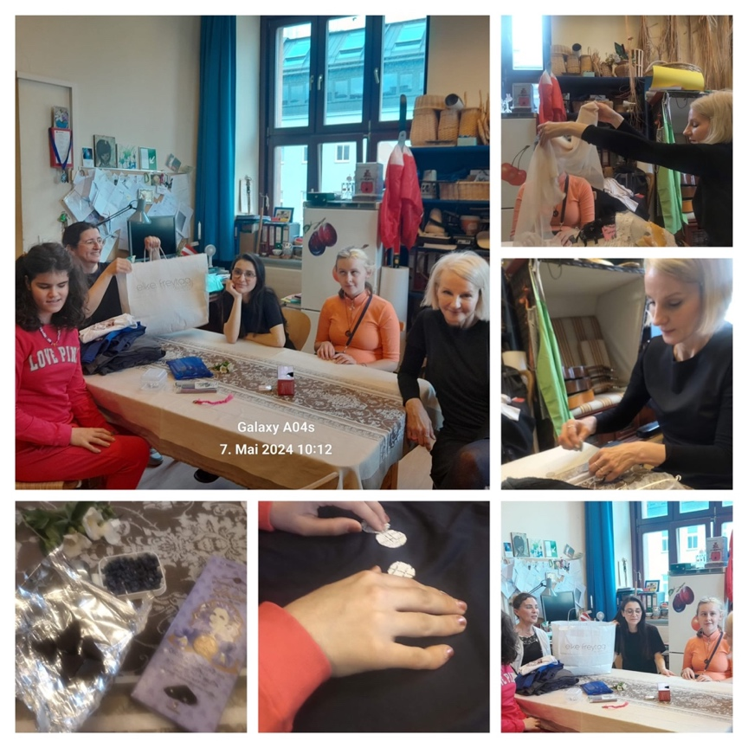
Fabric leftovers, Violette candy & chocolates with Jasmin flowers from the school garden for a good atmosphere

Image: fashion workshop with Austrian fashion designer Elke Freytag organised by Tatjana Crhistelbauer at the Vienna Bundesblindeninstitut BBI

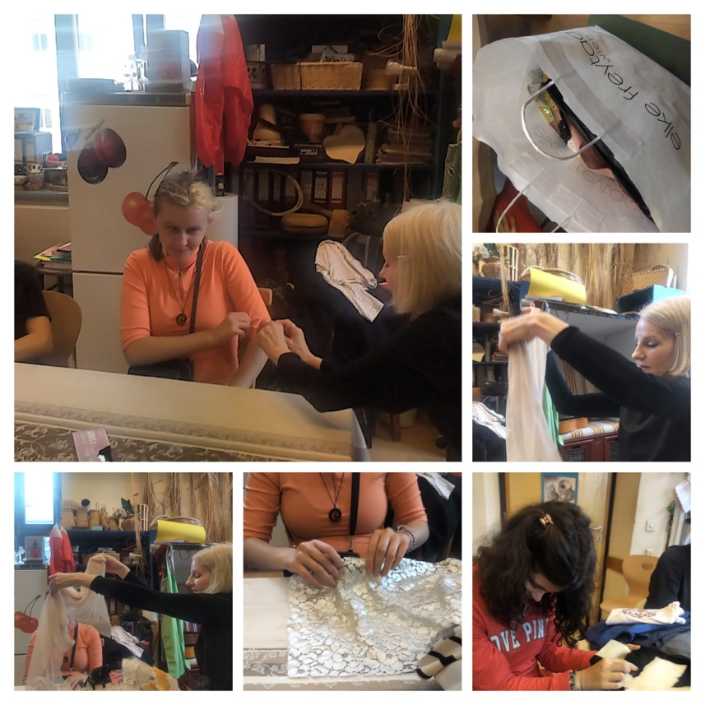

Source: EU Webpage: https://ec.europa.eu/commission/presscorner/detail/en/ip_23_3635
Weblink UNESCO article Webpage: https://courier.unesco.org/en/articles/ethical-fashion-rising-trend-or-empty-rhetoric
Weblink studio: https://www.hundertwasser.com/en/applied-art/663_a_apa95_sweet_sea_colony_on_the_salt_sea_voyage_-_egg_colony_of_zwolle_1732 Weblink Hundertwasser´s artwork 663 Zwollner Eirkolonie
Read more about : https://hundertwasser.com/angewandte-kunst/apa361_design_for_a_suit_and_essay_on_fashion_for_vogue_1954
Sources: Image, artwork, The Second Skin: https://www.hundertwasser.com/en/original-graphic/850_a_hwg96_the_second_skin_893
Read more about the Wor(l)ding method: https://www.tatjana-christelbauer.com/en/worlding
Read more about the Second Hand Fashion and it´s importance on the UNESCO webpage: https://sdgs.un.org/partnerships/empowering-african-fashion-sector-unesco-partnerships-incubator-opportunities-growth#:~:text=The%20second%2Dhand%20clothing%20market,even%20in%20oceans%20and%20rivers.
Source: Weblink EU: https://circulareconomy.europa.eu/platform/en/news-and-events/all-news/market-survey-second-hand-clothes
Weblink: UN https://uganda.un.org/en/271849-transforming-plastic-high-quality-sewing-threads
Elke Freytag webpage: https://www.elkefreytag.com/ueber-elke/

