Project ID: 2021-1-CZ01-KA220-SCH-000034484
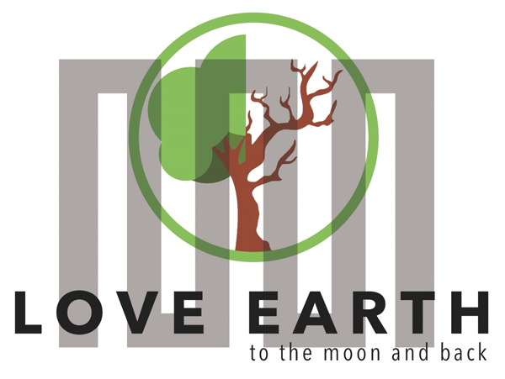

COURSE FOR ENVIRONMENTAL EDUCATION
e-Modules: Teaching Learning activities and their technology enhanced material set to develop

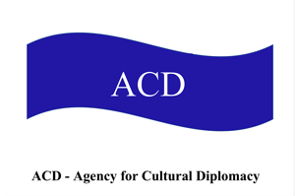

M6: Energy saving Nutrition, Responsible Consumption, Double Food Pyramid
Lesson bond for week-long workshops

COURSE AUTHOR:
©Tatjana Christelbauer MA (TC)
ACD Team Austria

DISCLAIMER Funded by the European Union. Views and opinions expressed are however those of the author(s) only and do not necessarily reflect those of the European Union or the European Education and Culture Executive Agency (EACEA). Neither the European Union nor EACEA can be held responsible for them.

COURSE SHARING LICENSE CC BY-NC-SA =

Canonical URL: https://creativecommons.org/licenses/by-nc-nd/4.0/

MODULE: 6

LESSONS Bond for week-long Workshops:
Energy saving Nutrition & responsible Consumption; Affordable, healthy, natural: Nettle ^Brennesssel; Double-Food Pyramid; LeMOON Delights

Subjects: Nutrition, Health & Wellbeing, Sustainable Development, Environmental Ethics, Dance Arts, Cultural Diplomacy, English, …

Content
- Introductory guide
  - Human Energy, Energy-saving Nutrition & Responsible Consumption.
  - Dance Arts: Energy-saving Nutrition, Responsible Consumption. Example, article
  - A Sustainable food System
- Responsible Consumption
  - Affordable natural products for healthy nutrition and responsible consumption:
Nettle ^ Brennesssel
  - Nettle tea
- Double Food-Pyramid
  - Double Food Pyramid: Food Choices, Cultural and Environmental Impact. Research and Practices in 3 Exercises
- Examples from ERASMUS+ project LeMOON activities

- Introduction to Energy-Saving Nutrition and Responsible Consumption
This lesson will introduce you to a human energy, energy-saving nutrition, and responsible consumption and to the concept of the double food pyramid, which helps us understand the balance between nutritious eating and environmental impact. Whether you can see the pyramid or need a description, this lesson is designed to be accessible and engaging for everyone. Explore how our food choices impact both our health and the environment, and how we can make more sustainable decisions. To be able to act in that way, it is useful to reflect on own behavioral patterns within the context as well as widen knowledge and gaining understanding about the importance of the energy-saving nutrition and responsible consumption.
Furthermore, some ideas about affordable energy-saving nutrition with nettle will widen the scope of the lesson with economic aspects as highly relevant, considering the hunger as one of the worldwide emerging issues.

In the last part of this lesson, examples from the ERASMUS+ project LeMOON activities and guide for engaging in and organizing Energy-saving nutrition and Responsible Consumption-related activities will widen the scope and increase the opportunity to experience nutrition form diverse perspectives.

  - Human energy
refers to the energy that our bodies obtain from food, which we use for daily activities and bodily functions. This energy is measured in calories or kilojoules.
Responsible consumption involves making mindful choices about the food we eat to ensure we are meeting our energy needs without overconsuming, which can lead to health issues and waste.

Engage in self-reflection, explain, and exchange experiences and views with your colleagues at school.
Extend your knowledge, with notes on Energy-Saving Nutrition.
Watch video in which is explained the science behind energy balance and how it affects you.
It provides practical tips – small steps that you can incorporate in your lifestyle to reach a healthy balance: http://www.eufic.org/page/en/page/ene....

  - Examples from Dance Arts
In dance arts education and professional practice, maintaining optimal energy levels through responsible consumption is crucial for performance and health. Dancers require balanced nutrition to support their high levels of physical activity.
Read from the first-hand experience in the interview with American Prima ballerina Misty Copland on the pressures, dancers are under to maintain a specific (sometimes unrealistic) body shape, and the consequences this can have:

„Dancing had always made me happy, and I wanted that back.
So, my priority became simply accepting my new self. I focused on what I wanted: to feel good,
to be confident in my skin again, to dance.

I really didn't try to stop bingeing. Instead, I started thinking about food not as solace but as the fuel that gave me the energy and strength I needed to dance—and to live. I paid attention to how my meals made me feel physically, started eating more vegetables and fish and gave up red meat and poultry. I still ate sweets occasionally because I love them—especially cupcakes and banana pudding—but now just one serving was plenty.
Within a few months,
I'd forgotten Krispy Kreme's number. (…)”

Read the full story:
https://www.energetiksblog.com.au/blog/2014/3/27/misty-copeland-on-body-issues-and-binge-eating

Discuss the issue raised in the story of Misty Copland.
What can we learn from her experience?
What was important for Misty Copland to make a “green shift” and improve her nutrition in a more responsible way?

Extend: Find more story, ask dance artist from your hometown about their practices and experiences with responsible nutrition and energy saving. Extend, ask professionals from some other field, compare, learn about variety of practices, learn diverse approaches, become more aware about and learn more about your own preferences and what is good for your energy, what makes you tired, WATCH, improve, …
Conclusion
Understanding human energy and practicing responsible consumption through energy-saving nutrition helps maintain a healthy balance of energy intake and expenditure. Making mindful food choices not only supports personal health but also promotes environmental sustainability by reducing waste and conserving resources. In fields like dance arts education, these practices are particularly important to ensure optimal performance and well-being.

References
Harvard T.H. Chan School of Public Health: "The Nutrition Source - Healthy Eating Plate & Healthy Eating Pyramid". https://nutritionsource.hsph.harvard.edu/healthy-eating-plate/
U.S. Department of Agriculture (USDA): "MyPlate Plan". https://www.myplate.gov/
National Institutes of Health (NIH): "Portion Distortion". https://www.nhlbi.nih.gov/health/educational/wecan/eat-right/distortion.htm
International Association for Dance Medicine & Science (IADMS): "Nutrition Resource Paper" https://iadms.org/media/3589/iadms-resource-paper-nutrition-resource-paper.pdf
World Food Program video on YouTube: Food waste, global hunger and you
https://www.youtube.com/watch?v=TVP3j7_W7og

1.3. A Sustainable Food System

What is a sustainable food system and how it relates with energy-saving nutrition?
Energy-saving nutrition focuses on choosing foods that provide the most health benefits with the least environmental impact. This means selecting ingredients that require less energy to produce, process, and transport. By making mindful choices, we can reduce our carbon footprint and contribute to a healthier planet.
Why it matters and how?
For example, buying fruits and vegetables that are in season and locally grown reduces transportation emissions and supports local farmers: buy apples in the fall or tomatoes in the summer. Using leftovers creatively, we can reduce waste. For instance, yesterday's roasted vegetables can become today's delicious vegetable soup.

ENGAGE: Watch/listen to the Videos on YouTube for more-in-depth details:
1. A sustainable food system for Europe
https://www.youtube.com/watch?v=M_o_xzSG8Qo&t=1s
UNESCO video: Culture and Food: Innovative Strategies for Sustainable Development: https://www.youtube.com/watch?v=QC-j4bQ5AEg

Watch the video in which the SAPEA presents the key messages from the 2020 evidence review report on how to transition to a sustainable food system. https://www.youtube.com/watch?v=M_o_xzSG8Qo

Read the Recommendations for Healthy Life provided by the World Health Organization (WHO) Europe: https://www.who.int/europe/news-room/fact-sheets/item/a-healthy-lifestyle---who-recommendations

- Responsible Consumption

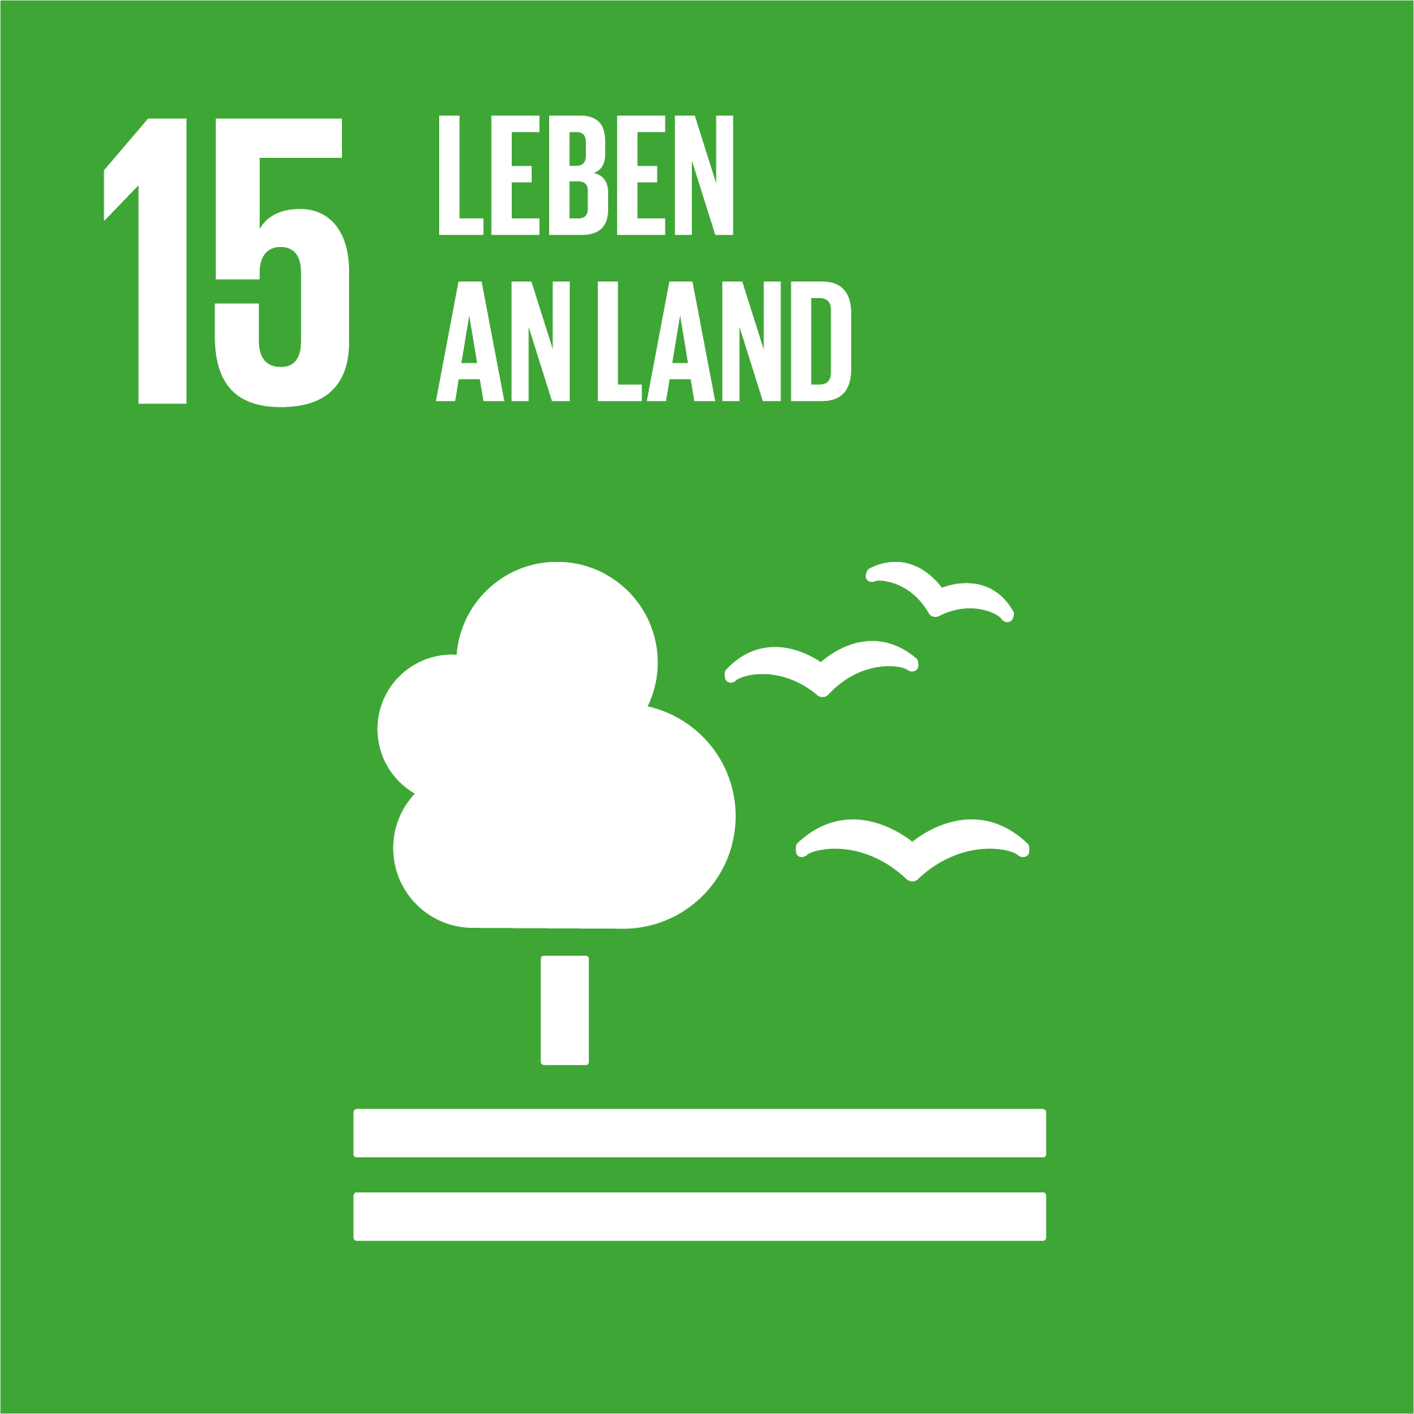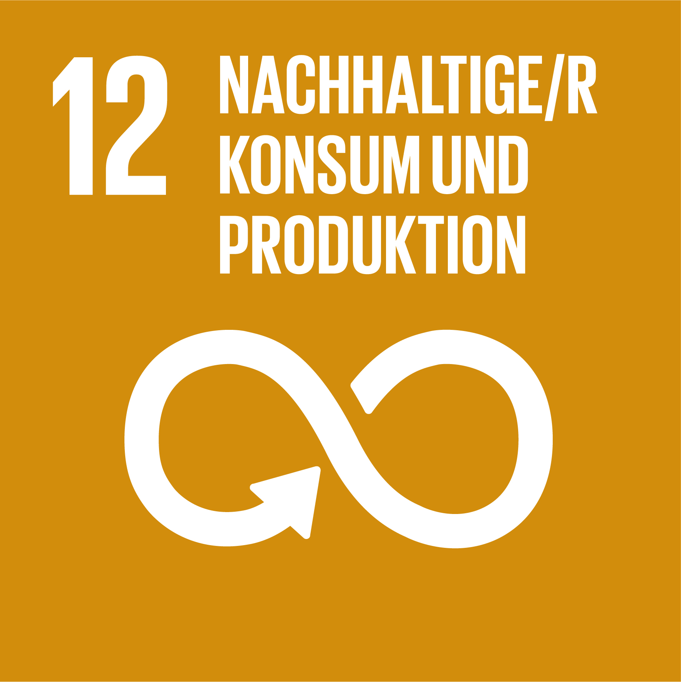
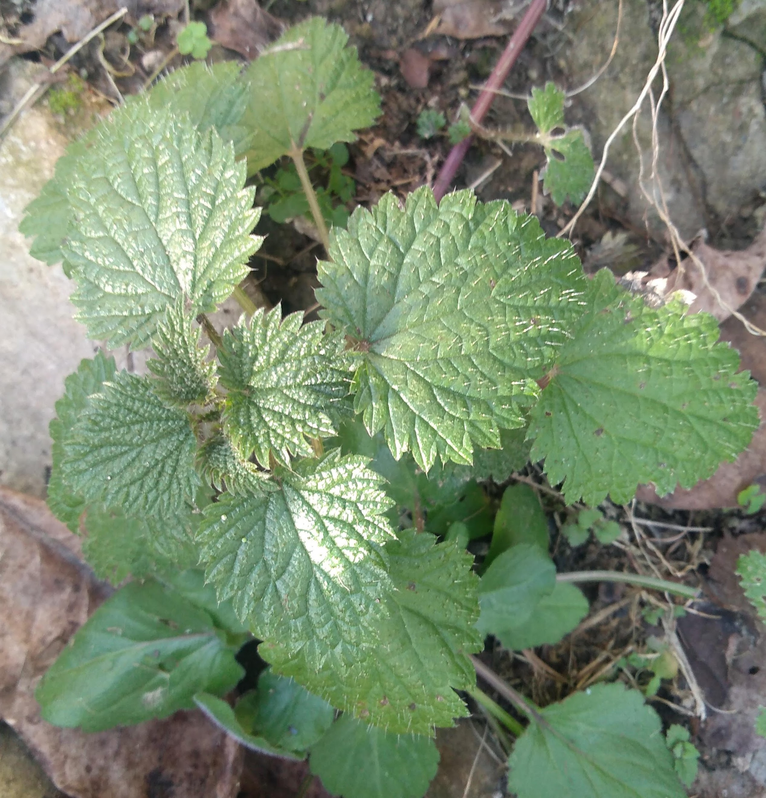
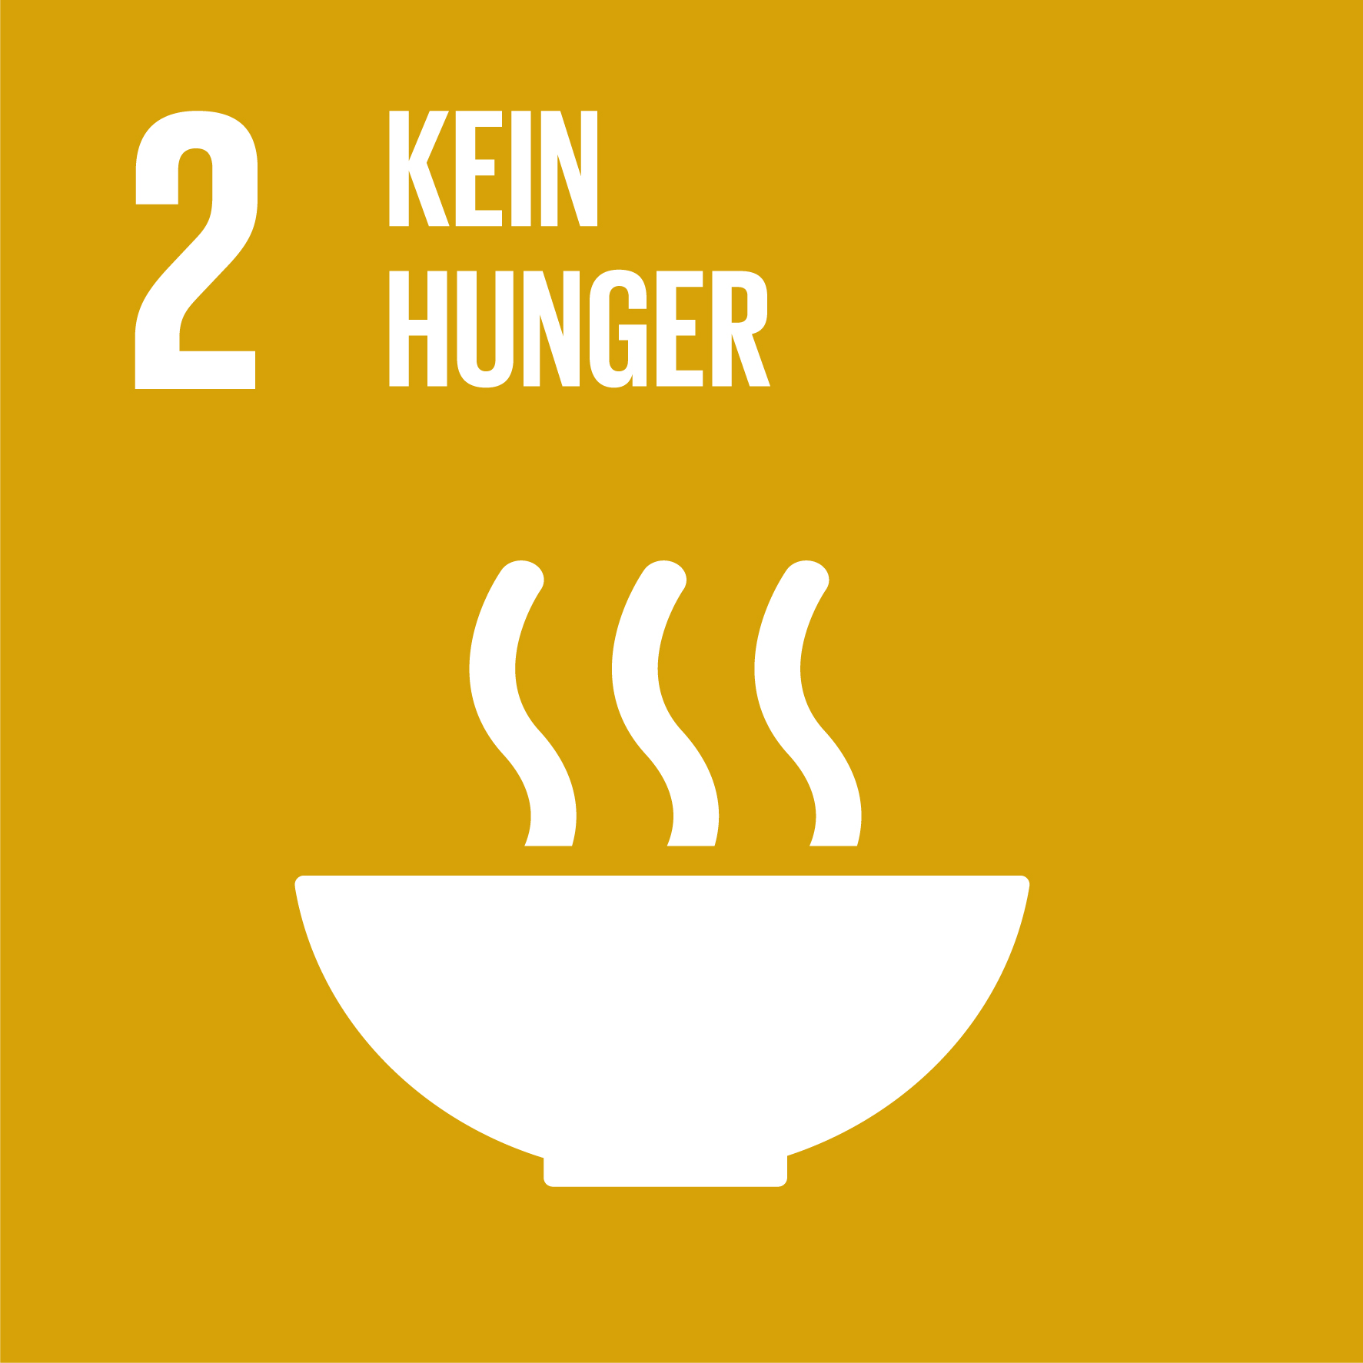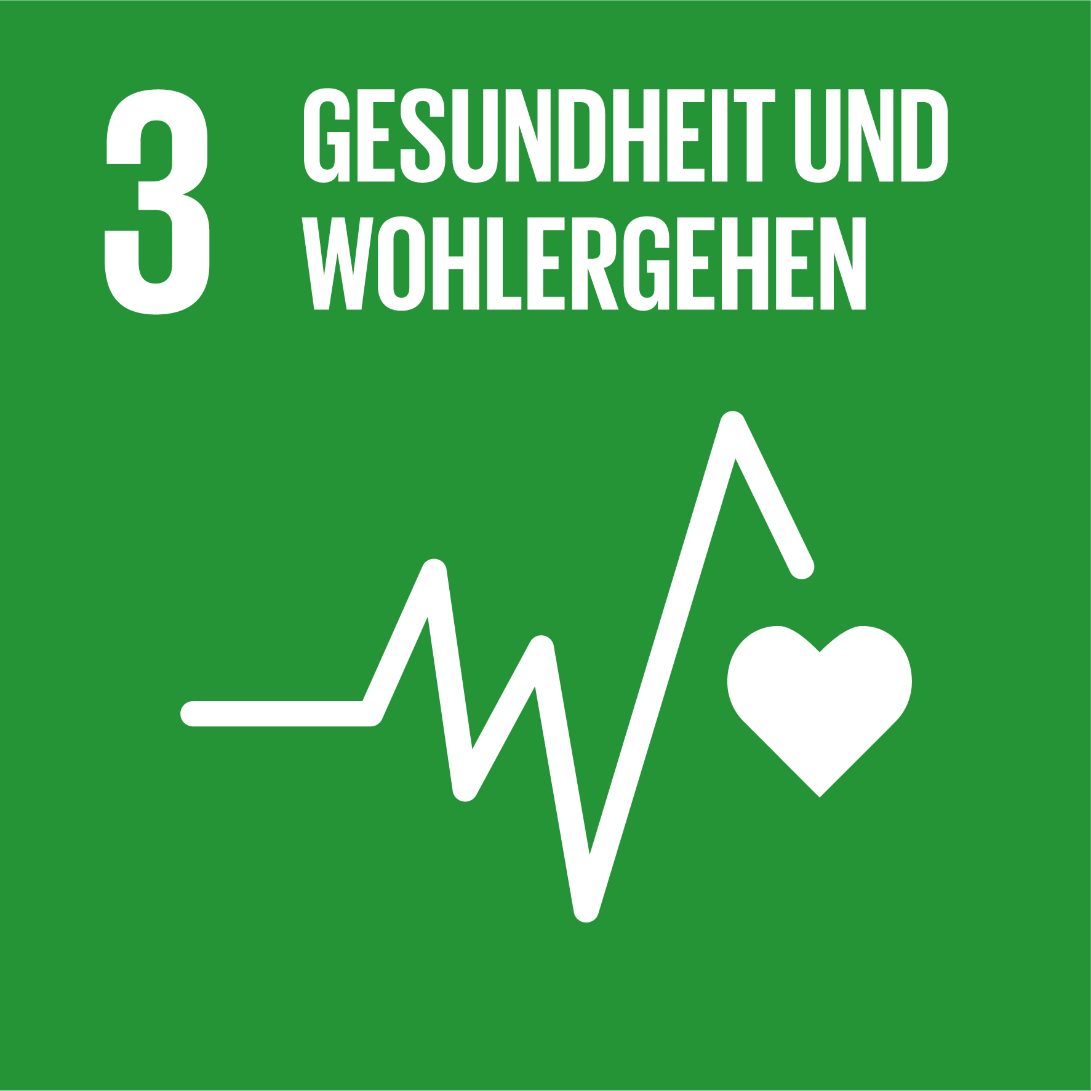

Images: UN SDGs – Brennesssel: affordable nutrition, good for health, natural product, supports healthy nutrition and responsible consumption

Did you know that the global WHI value for 2023 is 18.3, which is considered moderate, but not even a point below the WHI value for 2015 of 19.1? About 735 million people are denied the right to adequate food every day Did you know that the global GHI (Global Hunger Index) value for 2023 is 18.3? (Source: https://news.un.org/en/story/2023/07/1138612)
The right to food is a fundamental human right.
Did you now, that according to recent studies, about 133 kg of edible food end up in the thrash in every Austrian household per year. That corresponds to a value of 250 to 800 €!
In 2020, based on these facts, Austrian Museum of Natural History organized the special exhibition: “Best Before”. The exhibition looks at the reasons behind food waste. Farming, manufacturing, shops, homes, restaurants: the causes of this phenomenon are diverse – and disturbing.
Responsible consumption means being mindful of the resources used to produce the food we eat and making choices that are sustainable and ethical. This includes considering the environmental, social, and economic impacts of our food choices.

ENGAGE: Reflect on your food choices in terms of ethics and sustainability as explored by introductory guide and videos shared. Exchange your experiences with your fellow learners. Share examples and ideas for optimizing consumption in favor of people´s health, affordable healthy nutrition, and the environmental protection, including the aspect of culture and culinary as intangible cultural heritage.

  - Affordable natural products for healthy nutrition and responsible consumption:
Nettle ^ Brennesssel

How can some regional plant which grows “all around” be useful for optimizing nutrition and responsible consumption, while also preventing hunger with no or minimal costs?

Get inspired by environmental artist and activist Hundertwasser:
(...)"Do you know how easy it is to live without money? You just have to eat nettles. You can live off spinach made from nettles. Nettles grow everywhere. They are completely free."
Hundertwasser´s Nettle campaign: Brennesssel-Aktion

  - Nettle tea
Nettle tea is a nutrient-rich drink that can be a great alternative to sugary beverages. It is high in vitamins including iron, calcium, magnesium, and vitamins A, C, K, and B which are antioxidants that support immune function, and minerals, including iron, which is essential for red blood cell production, and calcium, important for bone health.
Have you ever eaten a dish made from nettles or drunk nettle tea?

ENGAGE, EXPLORE, PREPARE, TASTE: Read the blog article about the nutritional value of the Urtica dioica (nettle in Latin language) https://www.webmd.com/diet/health-benefits-nettle-leaf
Try preparing a tea or some other dish with nettle.
Add some honey or lemon into your nettle tea for a better taste if you want

- Double Food Pyramid

What is Double Food Pyramid?
The first pyramid was published in Sweden in 1974 with the simple code 4432, which defined the 4 main food groups translated into 4 daily servings, consisting of (4) Fruits/Vegetables, (4) Grains, (3) servings of Milk/Dairy, and servings of (2)Meats.
The double food pyramid is a visual tool that shows the relationship between healthy eating and environmental sustainability. By understanding and applying the double food pyramid, we can make choices that benefit both- our health and the planet.
It consists of two interconnected pyramids:
- Nutritional Pyramid which emphasizes foods that should be consumed more frequently for a balanced diet, like fruits, vegetables, whole grains, and lean proteins and
- Environmental Pyramid, which highlights the environmental impact of different foods, suggesting we consume foods with a lower environmental footprint more frequently, such as plant-based foods.

ENGAGE: Read the article on Double Food Pyramid Model developed by Barilla Center for Food and Nutrition to Raise Awareness about the Environmental and Nutritional Impact of Food: “Working toward Healthy and Sustainable Diets: The “Double Pyramid Model”, published by Frontiers in Nutrition 2015: doi: 10.3389/fnut.2015.00009, https://www.ncbi.nlm.nih.gov/pmc/articles/PMC4428432/

Look for more models and pyramids for #healthyNutrition and #responsibleConsumption in web, using the key terms. Explore more about in the following parts of this lesson bond.

  - Double Food Pyramid: Food Choices, Cultural and Environmental Impact. Research and Practices in 3 Exercises

Exercise 1: Double Food Pyramid with Products/Natural Levels and Environmental Impact

Objective: Create a double food pyramid, one focusing on food products you use and natural levels, and the other on the environmental impact of those products.

Pyramid 1: Products/Natural Levels
Base Level (Staples):
What are the staple foods that you eat every day (e.g., rice, bread, pasta)?
How do these staples provide you with essential nutrients like carbohydrates and fiber?

Second Level (Fruits and Vegetables):
Which fruits and vegetables do you consume regularly?
How do these fruits and vegetables contribute to your overall health (e.g., vitamins, minerals, antioxidants)?

Third Level (Proteins):
What are your main sources of protein (e.g., meat, fish, beans, nuts)?
Why is protein important for your body, and how do different sources provide various nutrients?

Fourth Level (Dairy and Alternatives):
Which dairy products or alternatives do you include in your diet (e.g., milk, cheese, yogurt, plant-based milk)? What role do these products play in maintaining bone health and providing other nutrients?

Top Level (Fats and Sweets):
What types of fats and sweets do you occasionally consume (e.g., oils, butter, sweets, snacks)?
How can you balance enjoying these foods while maintaining a healthy diet?

Pyramid 2: Environmental Impact
Base Level (Low Impact):
Which foods have the lowest environmental impact in terms of water use, land use, and carbon footprint? Why is it important to include low-impact foods in your diet?

Second Level (Moderate Impact):
Which foods have a moderate environmental impact, and what are their benefits and drawbacks?
How can you make informed choices about including these foods in your diet?

Third Level (High Impact):
What are some high-impact foods that you consume (e.g., beef, dairy products)?
How do these foods affect the environment, and what alternatives could you consider?

Fourth Level (Sustainable Practices):
Which foods are produced using sustainable practices (e.g., organic, locally grown)?
How can you support sustainable food production in your daily life?

Top Level (Reducing Waste):
What strategies can you use to reduce food waste in your household?
How does reducing food waste contribute to a lower environmental impact?

Exercise 2: Cultural Impact on Food Choices
Objective: Understanding the cultural impact on food choices and behavioral patterns and its impact on environment.

Why and how culture matters on food choices and behaviors and how it may impact environment?

Culture plays a significant role in shaping our food choices, influencing everything from the types of foods we consume to how we prepare and enjoy meals. These cultural practices can have a profound impact on the environment, as certain dietary habits are more sustainable than others. For example, diets rich in plant-based foods generally have a lower environmental footprint compared to those that rely heavily on meat. Understanding the relationship between culture, food choices, and environmental impact is crucial for promoting sustainable food practices and responsible consumption.
Food was first recognized by UNESCO as an intangible cultural heritage in 2010, featuring the Mediterranean diet, the French Gastronomic meal, the Mexican cuisine, and the Croatian gingerbread.
According to SDG Watch Austria, the industrialization of agriculture is largely responsible for the extinction of animal and plant species. Genetic engineering, patents on seeds and seed monopolies are a threat to the cultural heritage of biodiversity. (Source: https://www.unesco.at/en/culture/intangible-cultural-heritage/implementation-in-austria/translate-to-en-kulinarisches-erbe )

ENGAGE,: Make research and find examples from your national state on food culture in sustainable development.

EXPLORE, EXTEND, ADAPT EXPLAIN: Create a Wheelchart of Sustainable Food Culture, using the template The Wheel Chart of Sustainability, which was developed in Finland to help cultural organisations analyse and develop their own activities in accordance with the principles of sustainable development. This Wheel Chart divides the four different dimensions of sustainable development (ecological, economic, social and cultural) into eight different subject areas with three questions each. You can download and print it for free from the web in several different languages.
Source: https://cidoc.mini.icom.museum/blog/culture-creates-stability-the-wheel-chart-of-sustainability-leena-marsio-june-2020/

Here are some questions that can serve as the basis for each segment of the wheel, allowing students to explore how various aspects of food consumption intersect with sustainability, nutrition, and cultural impacts on the environment and could help guide the creation of a wheel chart for sustainable food, responsible consumption, healthy nutrition, and the cultural impact on the environment:

1. Sustainable Food Practices
What are the key principles of sustainable food production?
How does choosing local and seasonal foods contribute to environmental sustainability?
In what ways can reducing food waste lead to a more sustainable food system?

2. Responsible Consumption
What does it mean to practice responsible consumption in terms of food choices?
How can individuals reduce their carbon footprint through their dietary choices?
What role does portion control play in promoting responsible food consumption?

3. Healthy Nutrition
What are the main components of a balanced and healthy diet?
How do plant-based diets contribute to both personal health and environmental sustainability?
What cultural factors influence dietary preferences and how do these impact health?

4. Cultural Impact on the Environment
How do different cultures approach food consumption, and what are the environmental implications?
In what ways can traditional diets be more sustainable compared to modern, globalized diets?
How does the Double Food Pyramid illustrate the relationship between cultural food practices and environmental sustainability?

Exercise3: Creating a Double Food Pyramid and Observing Well-being, Budget, and Time
The task will help you apply what you have learned about the double food pyramid in a practical, real-world context. By tracking well-being, budget, and time, you will gain a deeper understanding of the interconnectedness of nutrition, environmental impact, financial considerations, and time management. This holistic approach to food and health can help you make informed, balanced, and sustainable choices in your daily life. In three

Task: Make a poster and create meals based on your double food pyramid at school and at home. Then, create a temporary diary for 1-3 weeks to WATCH how this tool impacts your well-being, time, and budget.
Guidance for your Double Food Pyramid-Poster, preparation of Meals and Food Diary creation:
The poster
should visually represent the nutritional aspects of the food items and their environmental and cultural impacts. Be creative, take photos of your food products, environment, and meals, add their places of origin (do some research about before).

Meal Planning and Preparation:
Using the double food pyramid, plan and prepare meals both at school (if possible) and at home.
Try to include a variety of foods from different levels of the pyramid.

Diary Keeping:
Keep a diary for 1-3 weeks. In your diary, record the following:
°Meals: Note what you eat based on the double food pyramid.
°Well-being: Reflect on how you feel physically and mentally after following this meal plan. Note any changes in your energy levels, mood, or overall health.
°Time: Track the amount of time you spend planning, preparing, and eating your meals.
°Budget: Keep a record of the cost of the food items you use and note any changes in your overall food budget.

At the end of the observation period, analyze your diary entries to see what patterns emerge. Conclude while reflecting on your experiences, consider the following questions:

How did your meal choices affect your well-being?
Were there any significant changes in the time you spent on food-related activities?
Did your food budget increase, decrease, or stay the same?

What You Can Learn by Observing Well-being, Budget, and Time:
By observing your well-being, you can learn how different foods and meal plans affect your physical and mental health. You may discover which foods give you more energy, improve your mood, or contribute to better overall health.
Tracking your budget helps you understand the financial impact of your food choices. You can learn how to plan nutritious and environmentally friendly meals that are also cost-effective. This skill is valuable for managing your finances and making sustainable food choices.
Observing the time spent on meal-related activities can help you identify ways to streamline your meal preparation and planning. You can learn to balance your time efficiently between school, home, and other activities while maintaining a healthy diet.

EXTEND your knowledge and experiences:
Engage in further activities and discussions
that will help us apply these concepts in practical and creative ways, such as by creating
a Recipe Challenge: Create a recipe using only local, seasonal ingredients. Think about how you can make it nutritious and environmentally friendly. Ask seniors in your family about their receipts, exchange with our fellow learners, make a collection of old receipts and add your creations. You can create a digital book with all the receipts, organize a school-culinary project, …

Ideas for Nutrition Optimization
Start a school garden to grow fresh vegetables and herbs, including nettle.
This provides hands-on learning about nutrition and sustainable agriculture.
Organize a garden club focused on gardening. Include raised beds for accessibility and tactile markers for plant identification. Look for a good model and create yours, …
Host workshops on meal planning and preparation to educate students about balanced diets and healthy cooking. Collaborate with local nutritionists or chefs to provide interactive sessions.
Create a mentoring program where students can mentor each other on healthy eating habits and share recipes. Pair interested students with mentors and provide resources on nutrition.
Introduce accessible apps that are compatible with screen readers and offer features like meal tracking, grocery lists, and nutritional information.
Develop accessible materials (Braille, audio) with and for visually impaired students about nutrition.
Ensure that all students can learn about and participate in healthy eating practices.
Partner with local farms to supply fresh, seasonal produce to the school cafeteria and support the local economy…

Conclusion
Optimizing nutrition at school is vital for maintaining energy, improving concentration, and supporting overall health. Encouraging responsible and innovative dietary habits will help students develop lifelong healthy eating patterns.
Add your notes:

- Examples from the workshop with BVI students at the Vienna BBI Institute
LeMOON-tastyArt for the Raindrop Ball reception during the ERASMUS+ project LeMOON multiplier event

Thematic Focus: Healthy nutrition, calculating calorie values, creative design
Tasks: creating raindrop cookies, LeMOON-bread, making nettle tea

- Raindrop-cookies ingredients, task for research
Research the nutritional values of the individual ingredients for the raindrop cookies:
- Thea (Austrian vegetable butter)
- ground almonds
- vegan white chocolate with cocoa respells
- vegetable/vegan butter cookies

LeMOON poofer-poopy-bread, Kaisersemmel- EarthLove
Ingridiens: mais puffer, lava salt form Iceland, vegetable butter, Imperial roll “Kaisersemmel”, fresh cheese, bird salad, blueberries

Description of ingridiens by the example of the Kaiser roll “Kaisersemmel”
The Kaiser roll (Emperor roll, German: Kaisersemmel), also called a Vienna roll (Wiener Kaisersemmel; as made by hand also: Handsemmel), or a hard roll, is a typically round bread roll, originally from Austria. It is made from white flour, yeast, malt, water and salt, with the top side usually divided in a symmetric pattern of five segments, separated by curved superficial cuts radiating from the centre outward or folded in a series of overlapping lobes resembling a crown. Kaiser rolls have existed in a recognizable form since at least 1760. They are thought to have been named to honor Emperor (Kaiser) Franz Joseph of Austria. There is also the theory that the name stems at least in part from a baker family called Kayzer in Opatów in Galicia which had been occupied by the Austrian monarchy. In the 18th century a law fixed retail prices of Semmeln (bread rolls) in the Habsburg monarchy. Allegedly, the name Kaisersemmel came into general use after the bakers' guild sent a delegation in 1789 to Emperor joseph II (b. 1741, r. 1765–1790) and convinced him to deregulate the price of bread rolls. (…)
Sources: https://info.bml.gv.at/themen/lebensmittel/trad-lebensmittel/speisen/kaisersemmel.html
https://en.wikipedia.org/wiki/Kaiser_roll#cite_note-3
Value: 1 Kaisersemmel (65 g):
621 kJ (148 kcal), Fett: 0,7 g, KH: 29,3 g
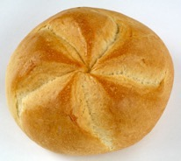

LeMOON-dishArt-creations made by students at the BBI Institute Vienna:
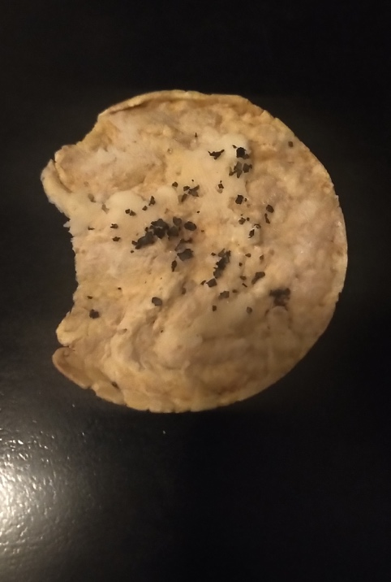
Le-MOON Maispuffer Moon with vegetable butter and lava salt from Iceland

Ingrediencies for Raindropcookies, LeMOON Kaiser roles, Nettle tea making, preparing, tasting
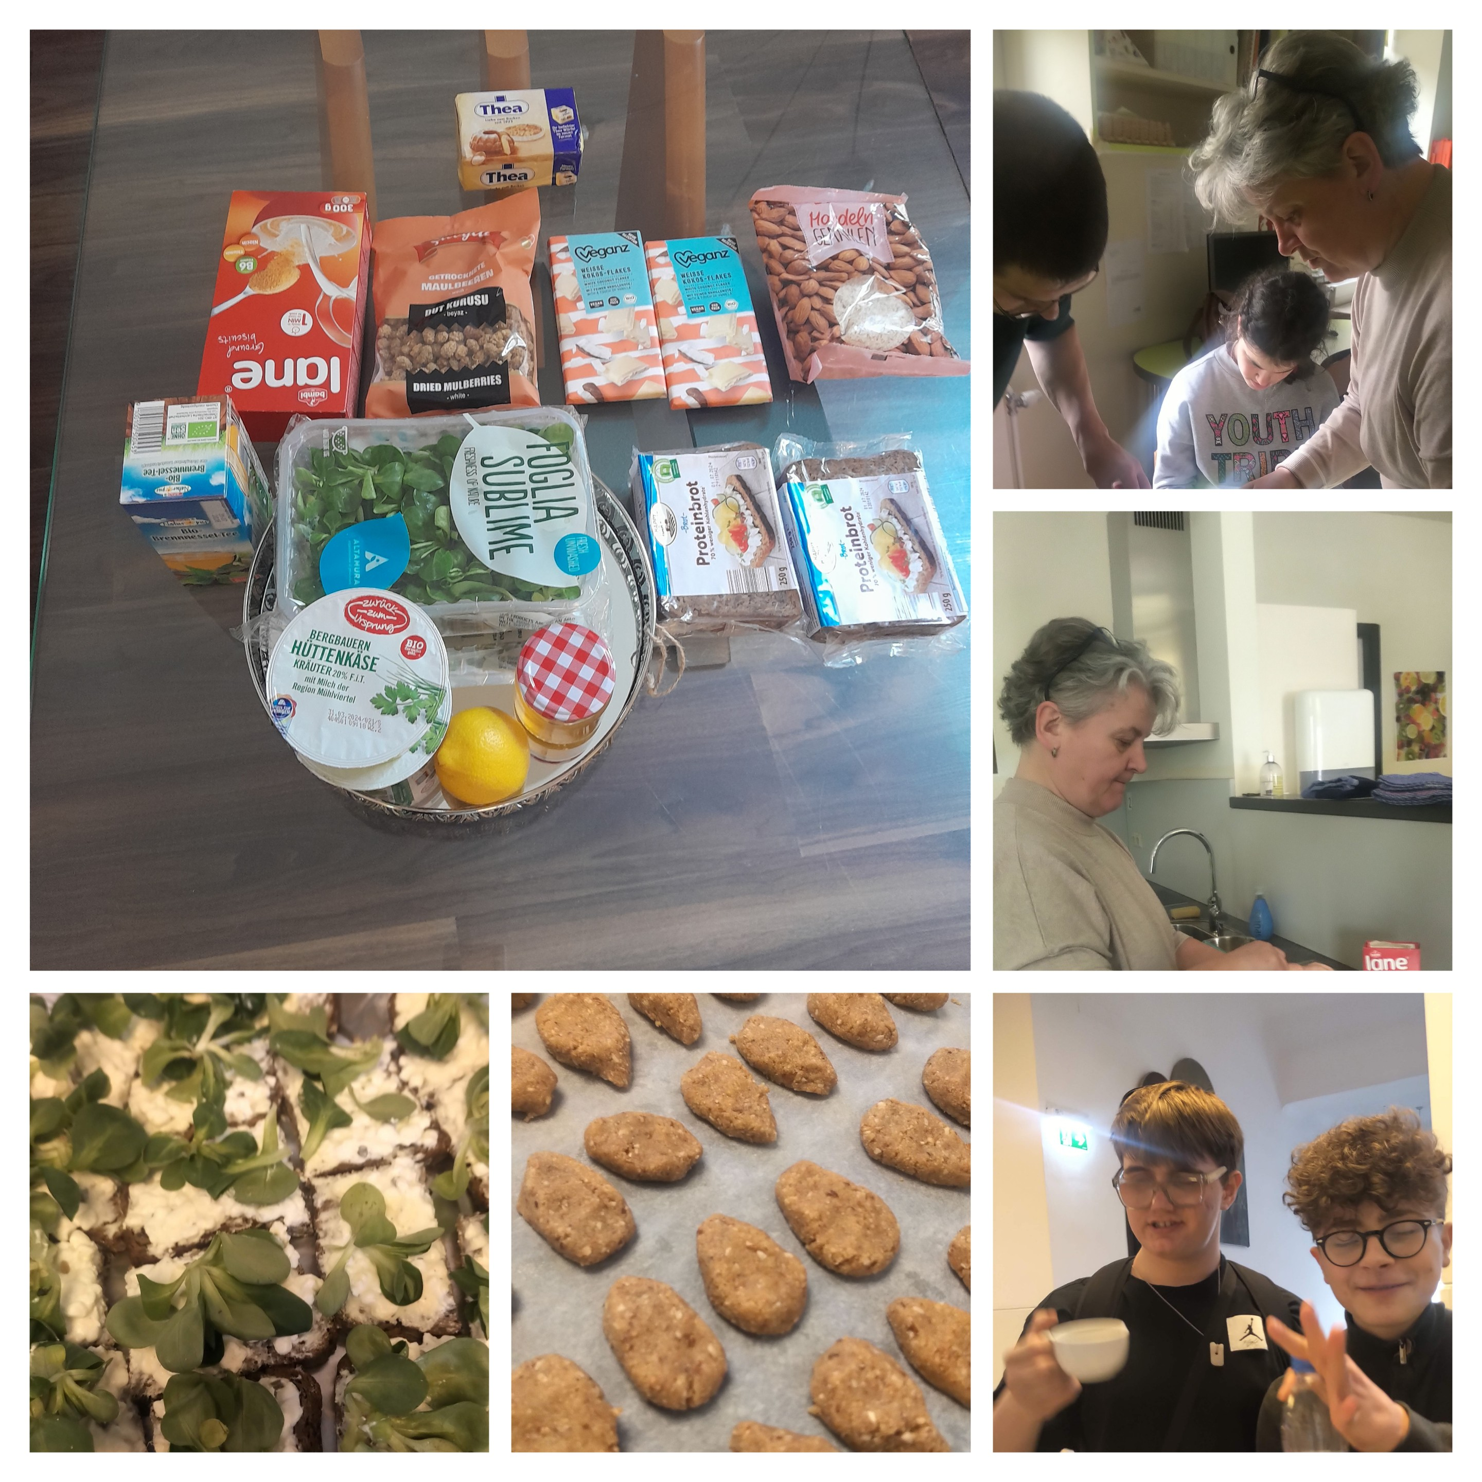

What matters by preparing such dishes for the event?
We have identified the culture and symbolic meaning of products, colors, tastes, energetic value, inclusive and barrier-free access to taste (think about allergies, culinary lifestyle, and culturally determined choices and restrictions. Additionally, design, serving, placing, descriptions, announcement, presentation - it all matters for the successful and tasty experience! Feel free to adapt these examples and activities to suit your classroom's needs and the resources available.

Carbon footprint: explained in the previous Modules1, info for your kind reminder: https://www.un.org/en/actnow/facts-and-figures
SAPEA is part of the European Commission's Scientific Advice Mechanism
Webpage, info: https://www.nhm-wien.ac.at/en/best_before
Read the full text from the Nettle-campaign (Brennessel-Aktion) by Hundertwasser With which he opposes artists' economic dependencies, which do not allow them to be independent and self-sufficient. Source: Hundertwasser Nettle Campaign: https://hundertwasser.com/texte/nettle-campaign https://hundertwasser.com/en/texts/brennessel-aktion
Source: Double Pyramid: healthy food for people, sustainable food for the planet. By United Nations System Standing Committee on Nutrition with Barilla Center for Food and Nutrition: https://www.unscn.org/web/archives_resources/files/Double_pyramide.pdf
Source: UNESCO: Culture and food: innovative strategies for sustainable development Conference : UNESCO. Executive Board, 206th, 2019: https://unesdoc.unesco.org/ark:/48223/pf0000367359 and: UNESCO: Traditional Mexican Cuisine—Authentic, Ancestral, Ongoing Community Culture, the Michoacan Paradigm. Fifth Intergovernmental Committee Meeting for the Safeguarding of the Intangible Cultural Heritage, Nairobi, Kenya (2010), pp. 15-19; UN Sustainable Gastronomy Day https://www.un.org/en/observances/sustainable-gastronomy-day

