Project ID: 2021-1-CZ01-KA220-SCH-000034484
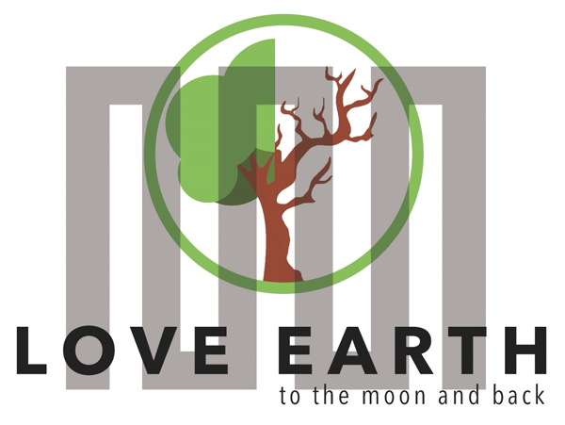

COURSE FOR ENVIRONMENTAL EDUCATION
e-Modules: Teaching Learning activities and their technology enhanced material set to develop

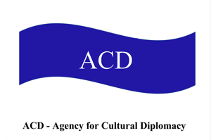

M6:
Policy Learning Guide
COURSE AUTHOR
©Tatjana Christelbauer MA (TC)
ACD Team Austria

DISCLAIMER
Funded by the European Union. Views and opinions expressed are however those
of the author(s) only and do not necessarily reflect those of the European Union or the European Education and Culture Executive Agency (EACEA). Neither the European Union nor EACEA can be held responsible for them.
COURSE SHARING LICENSE CC BY-NC-SA = 
Canonical URL: https://creativecommons.org/licenses/by-nc-nd/4.0/

MODULE: 6

LESSON: Policy Learning guide
SUBJECTS: Political Science, Ethics, English, …

Additional paper to the Lesson
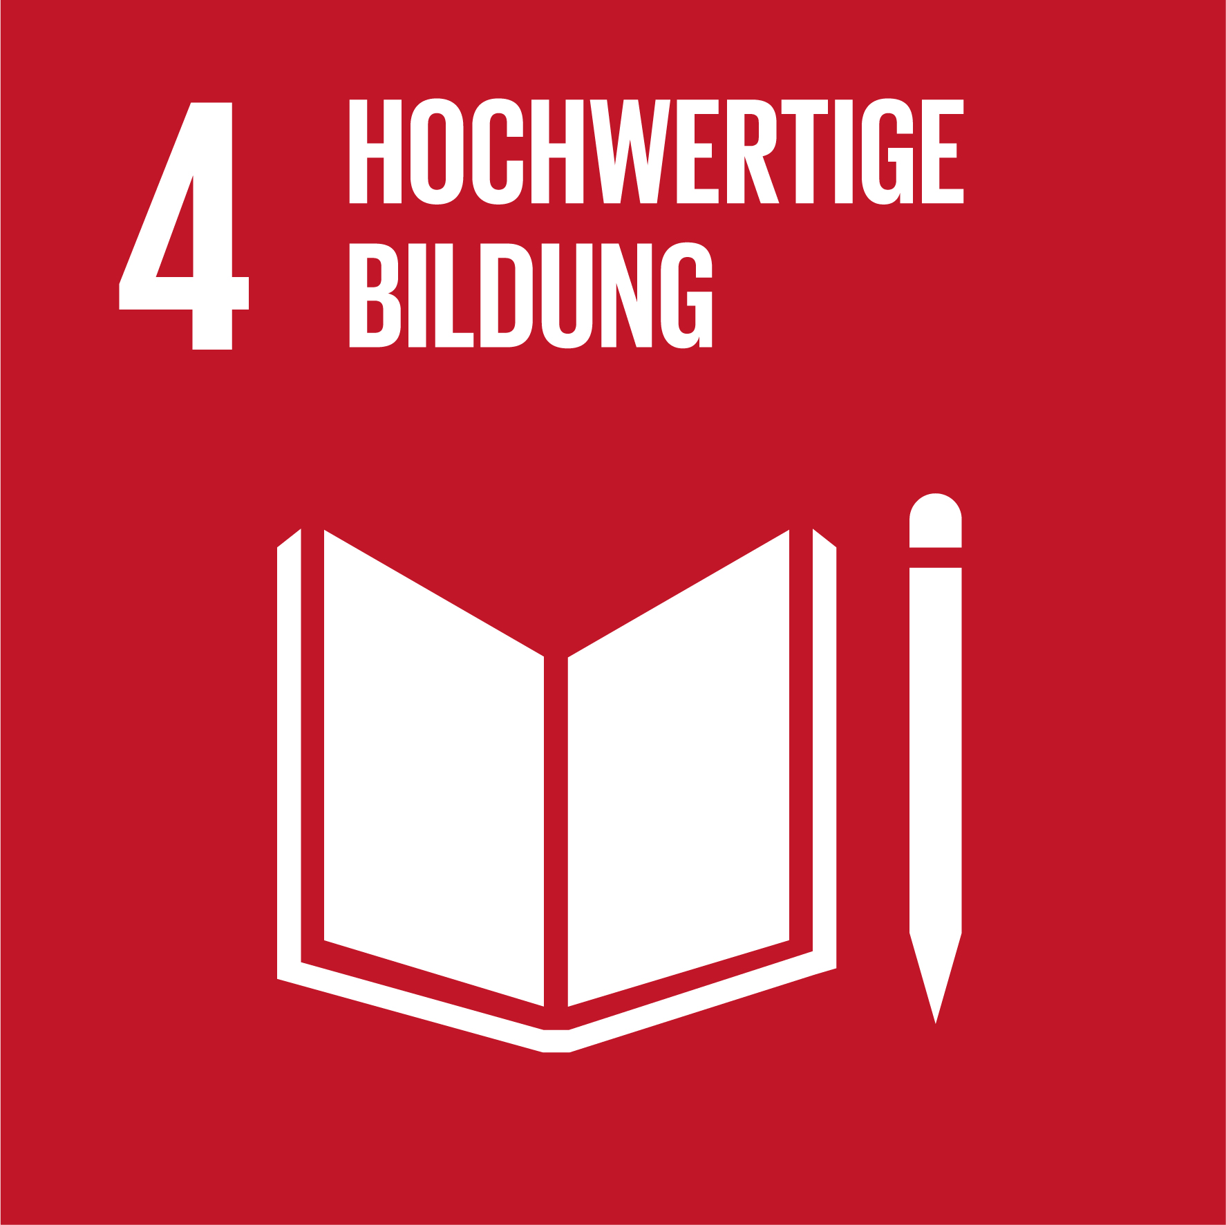
Human Rights, dignity & sustainability

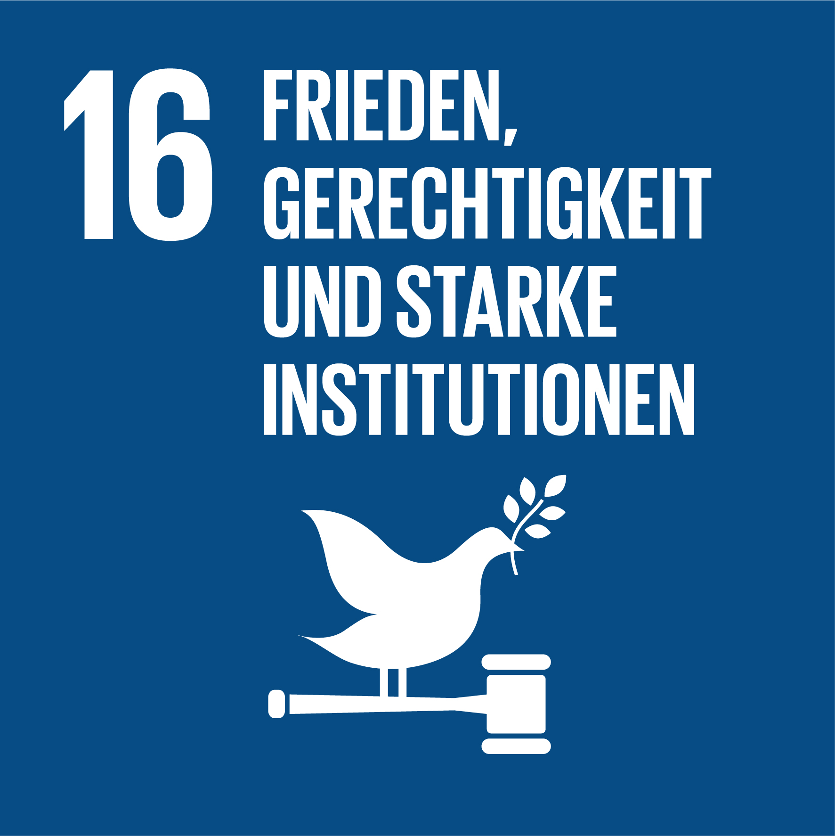
Understanding relational aspects of the UDHR and the UN SDGs
Art acts 4 Global Citizenship

Policy Learning Guide
To navigate the art_science_policy interface related to environmental governance towards ecological transition, we need specific skills and capacities. To set the stage, it's essential to understand the definitions and differences between treaties, policies, and agreements. This foundational knowledge is crucial for comprehending how our relationships with the environment are regulated and why these regulations matter.

Brief introductory
Policies are formal guidelines and rules set by governments or institutions to govern specific areas of public life, including environmental management, health, and education.
Treaties, on the other hand, are formal agreements between countries that are legally binding under international law.
Agreements are broader and can include non-binding accords or understandings between parties.
Understanding these distinctions is the first step in appreciating how people and the environment interact under these frameworks. This understanding is vital because well-crafted policies and agreements can significantly influence sustainable development and environmental justice, ensuring that resources are used responsibly and that all communities have fair access to a healthy environment.

Thematic-Focus-Related Policies briefly introduced in lessons by all 6 Modules:
To broaden our perspective, we will briefly introduce several thematic-focus-related policies that are crucial for further study:
- EU Inclusion Policy: Promoting inclusion and equality for all citizens.
- EU Youth Policy: Addressing the needs and potentials of young people in shaping a sustainable future.
- EU Language Policy: Promoting multilingualism and cultural exchange in the European Union./European Day of Languages EDL
- EU Health Policy: Ensuring public health standards and addressing environmental health issues.
- Gender Policy: Promoting gender equality in all aspects of sustainable development.
- The Green Deal: The EU’s strategy to become climate-neutral by 2050.
- WHO Documents and Reports: Including "Art & Health 2019," which explores the intersection of arts and health.
- UNESCO Declarations: Such as the 2005 and 2017 declarations that emphasize cultural diversity and environmental ethics in Sustainable Development .
- UN Declarations and Agenda 2030: Encompassing the Universal Declaration of Human Rights and the 17 SDGs, these documents highlight the interconnectedness of human dignity, environmental health, and the well-being of all species and ecosystems.
- AI Act: Regulating artificial intelligence to protect citizens' rights.
- European Union of Blind: Promoting inclusion and support for people with visual impairments.
- Youth 4 Health: Involving young people in health issues and policy.
- UNECE Youth Platform: Connecting and activating young people for sustainable development.
- Kyiv Protocol on Pollutant Release and Transfer Registers: Providing an ethical framework for environmental justice and supporting SDG 16 (Peace, Justice, and Strong Institutions).

Creative Tasks for Self-Study
To help you remember the list of documents and their relevance, here are some creative tasks:

Create a mindmap poster with key terms related to each document.
You can use the free MIRO platform for support: https://miro.com/mind-map/
Include elaborated relevant issues that matter at your school, local community, and personal life.
Identify the relational path between these issues and the documents, supporting further policy learning and monitoring activities.

Document Summary Postcards:
Write brief summaries for each document on individual postcards. Highlight the main objectives and relevant issues of each policy or agreement. Use these cards for quiz …

Environmental Justice Case Study: Select an environmental issue in your local community.
Research which policies or agreements apply to this issue.
Create a presentation or report detailing how these policies can help address the issue.

Policy Impact Journal:
Keep a journal documenting your observations of how specific policies impact your daily life and community. Reflect on the effectiveness of these policies and any areas for improvement.

Art Project 4 Policy learning and presentation:
Create proposal for an art project for the presentation of your objectives and relevant issues, contact local artists who are engaged in sustainable development topics, prepare invitation letters for inviting policy makers and representatives from the relevant governmental institutions and organizations to share your recommendations, and share your proposal with your teachers and schoolmates for its further development and the realization.

Next Steps: Classroom Presentation and Poster Creation
This self-study guide is the first step in preparing a brief introduction to one of the chosen policy papers, declarations, or action platforms. Each student will present their findings in the classroom. The next step involves composing a collaborative poster that collects all the presented documents and related key terms. This poster will also highlight a relevant issue discussed and agreed upon within the school or local community, connecting it to the particular policy paper/document/platform and the planned action.
By the end of this self-study guide and subsequent classroom activities, you will have a comprehensive understanding of the policies and agreements that shape our environmental interactions, the importance of sustainable development, and how each of us can play a part in fostering a more sustainable and just world. Let’s embark on this journey together, inspired by the visionary work of Hundertwasser and guided by the principles of environmental justice and sustainable development.
Relevant References, and Weblinks to introductory pages
- UN Agenda 2030: UN - Agenda 2030 and SDGs
- UNESCO Declarations: UNESCO 2005 Convention and UNESCO 2017 Declaration
- The Green Deal: European Commission - European Green Deal
- EU Language Policy/European Day of Languages (EDL): https://www.europarl.europa.eu/factsheets/en/sheet/142/language-policy
- EU Inclusion Policy: European Commission - Inclusion
- EU Youth Policy: European Youth Portal
- EU Health Policy: European Commission - Health
- Youth 4 Health: Youth for Health
- WHO Art & Health 2019: WHO - Art & Health
- AI Act: European Commission - AI Regulation
- European Union of Blind: European Blind Union
- European Skills Agenda and the European pact for Skills: https://ec.europa.eu/social/main.jsp?catId=1223
- UNECE Youth Dialogue Platform: https://unece.org/environment-policy/publications/engaging-young-people-implementation-esd-unece-region-good
- Kyiv Protocol on Pollutant Release and Transfer Registers: UNECE - Kyiv Protocol: https://unece.org/env/pp/protocol-on-prtrs-introduction
- Kyoto Protocol: UNFCCC - Kyoto Protocol to the United Nations framework on Climate change: https://unfccc.int/resource/docs/convkp/kpeng.pdf

Connect with the: UN Youth platform Science-Policy interface:
https://www.unmgcy.org/science-policy-interface
Sign the European Pact for Skills, and engage:
https://pact-for-skills.ec.europa.eu/index_en

Some of the listed policy documents and declarations, such as UN Agenda2030, UNESCO Declaration 2017, and The European Language Policy are included in further lessons and workshops with more details and tools for learning activities.

