Project ID: 2021-1-CZ01-KA220-SCH-000034484
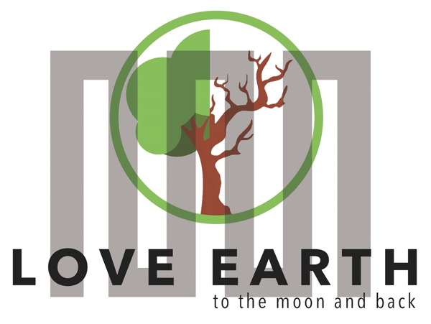

COURSE FOR ENVIRONMENTAL EDUCATION
e-Modules: Teaching Learning activities and their technology enhanced material set to develop

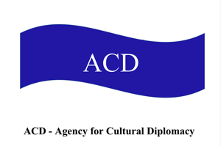
Thematic Units for Week-Long Workshop Sessions
M6: CD2030… Cultural Diplomacy, Cultural Democracy in Sustainable Development, Deliberative Democracy approach

COURSE AUTHOR
©Tatjana Christelbauer MA (TC)
ACD Team Austria in collaboration with prof.Alice Siu Phd ,Stanford University

DISCLAIMER
Funded by the European Union. Views and opinions expressed are however those
of the author(s) only and do not necessarily reflect those of the European Union or the European Education and Culture Executive Agency (EACEA). Neither the European Union nor EACEA can be held responsible for them.
COURSE SHARING LICENSE CC BY-NC-SA = 
Canonical URL: https://creativecommons.org/licenses/by-nc-nd/4.0/

Thematic Units for Week-Long Workshop Sessions:
Inquiry-Based Integrated Learning Workshop Series
on the Intersection of Arts, Science, and Policy

MODULE: 6

LESSON: Cultural Diplomacy, Cultural Democracy in Sustainable Development, Deliberative Democracy approach; thematic Focus to Global Citizenship, Human Rights;

SUBJECTS: Political science, policy learning
Cultural Diplomacy, Cultural Democracy,
Deliberative Democracy for Sustainable Development
CDC Model of the competences required for democratic culture and intercultural dialogue

Author: Tatjana Christelbauer MA, ACD/AT in collaboration with prof Alice siu Phd, Stanbford University, Deliberative Democracy Platform
Subjects: Political Science, Cultural Studies, Ethics, English, Cultural Diplomacy, + …
Introductory insights on the topic with guidance for engaging and development of practices in week-long projects

In this session, the three-fold attempt to political science and policy learning for engaging in sustainable development, is introduced through the lenses of theories and practices of Cultural Diplomacy for Cultural Democracy in Sustainable Development, while briefly spotlighting the concept of democracy as a political system of values through its implementation in practices,
with a deliberative approach which is grounded in the concept of Deliberative democracy (Stanford University, Deliberation Platform), perceived through the lens of Cultural Democracy (UNESCO),
in the practice of Cultural Diplomacy by civil society and youth
(ACD-Agency for Cultural Diplomacy CD2030… ).
Such an attempt is aimed to provide learners with guiding insights on ethical principles of Democracy, while spotlighting the importance of understanding diversity of views and practices as an essential aspect to be considered for understanding of challenges and opportunities connected with diverse culturally and politically shaped opinions of citizens and decision makers, and to empower youth with skills and competences for engagement and active participation in global conversations and decision-making processes.

Entry guide: Before starting with further details, explain your understanding of democracy, exchange your understanding with your fellow learners.

Guiding insights on the topic: Understanding Democracy through its relation to values promoted and protected
According to the United Nations, democracy is a system of government which "provides an environment that respects human rights and fundamental freedoms, and in which the freely expressed will of people is exercised." Supporting democracy worldwide is also a priority for the European Union. Democracy remains the only system of governance in which people can fully realize their human rights and is a determining factor for development and long-term stability.

- Cultural Diplomacy for Sustainable Development

Cultural Diplomacy for Sustainable Development is an approach to cultural diplomacy practices within the context and frame of the UN Sustainable Development Agenda 2030, for the purpose of awareness raising about the necessity for engaging in sustainable development as a matter of all people globally, of each one and of manyones together, for maintaining the current challenges and preventing further damages toward human world, species and the planet, while promoting science-evidence based informations, creating opportunities for engagement by educational projects and partnerships at the regional, national and global scale, for the mutual prosperity, for now & then …

Cultural Diplomacy can play a significant role in supporting sustainable development by promoting global citizenship, encouraging cross-cultural collaboration, and fostering inclusive and sustainable solutions to global challenges such as water management and environmental conservation. Youth and civil society organizations (CSOs) are pivotal in this process, leveraging cultural diplomacy to drive positive change and sustainable practices.

Some ideas about how Cultural Diplomacy in the practice of the civil society organisations (CSOs) and youth can support Sustainable Development:
°Building Awareness and Understanding: Cultural diplomacy initiatives can raise awareness about the importance of sustainable development and the need for responsible resource management.
By sharing stories, practices, and innovations from various cultures, young people and CSOs can highlight diverse approaches to sustainability.
°Encouraging Cross-Cultural Collaboration: Collaboration across cultures can lead to the development of innovative solutions to environmental challenges. Youth exchanges, international projects, and cultural events can bring together diverse perspectives and expertise to address issues such as water scarcity and pollution.
°Promoting Global Citizenship: Cultural diplomacy fosters a sense of global citizenship, encouraging individuals to think beyond their immediate environment and consider the impact of their actions on the global community. This mindset is crucial for promoting responsible consumption and environmental stewardship.
°Strengthening Partnerships: Cultural diplomacy can strengthen partnerships between communities, organizations, and governments, facilitating the sharing of resources, knowledge, and best practices. These partnerships are essential for achieving the United Nations Sustainable Development Goals (SDGs).
The CD2030…model has been developed by ACD-Agency for Cultural Diplomacy association president Tatjana Christelbauer in 2020, with the aim to provide a framework followed by evident examples from established platforms and initiatives, educational & art projects for Cultural Diplomacy for Sustainable Development in the practice of civil society and youth. Weblink to more details: https://www.acdvienna.org/cd/

- Cultural Democracy
The term Cultural Democracy was coined during the Eurocult conference in Helsinki organized by UNESCO in 1972, as a response to the aspiration of the ministers to agree on a shared cultural strategy, by embracing diverse artistic expressions and including a variety of cultures and arts into funds for the protection of the World Cultural Heritage, and beyond, for more just and democratic cultural policies, which will enable access to arts & culture for the wider population, diverse styles, and expressions, without pointing out one "elite" or mainstream art & cultural style.
Why, and how it matters?

Here are 3 components for understanding the concept and meaning of cultural democracy:

- Cultural democracy places great value upon cultural diversity. It proposes that measures should be taken to preserve and promote cultural activities from the full array of traditions present in any community, not from just one of those traditions. In a sense, this is a kind of "democracy of taste" a belief that mutual respect is a prerequisite to survival in a multicultural world. According to a report provided by the EU, citizens who participate in cultural activities are much more likely to engage in civic and democratic life.

However, in a democratic society which has adopted human rights as its primary value foundation, valuing cultural diversity will have certain limits as there is a potential tension between valuing human rights and valuing cultural diversity. These limits are set by the need to promote, respect, and protect the human rights and freedoms of other people. Hence, it is assumed here that cultural diversity always ought to be valued unless it undermines the human rights and freedoms of others.

Engage: exchange your experiences, engage in discussion on the topic of cultural diversity and human rights. Concepts to Emphasize: Concepts to Emphasize: Equal dignity, universal and inalienable human rights, fundamental freedoms; Cultural diversity as an asset, right to be different, intercultural dialogue.
Here are five guiding questions for students to research and discuss human rights and cultural diversity in their school environment, focusing on signs and symbols that represent these concepts. These questions will guide students towards a deeper understanding of how symbols and signs shape their school environment and provide a framework for meaningful discussions on human rights and cultural diversity:

What symbols or signs are prominently displayed in our school that reflect cultural diversity?
  - Encourage students to identify and analyze visual representations such as flags, figures, posters, artwork, or cultural artifacts that celebrate diversity.
How do these symbols contribute to a sense of inclusivity and respect for cultural differences among students and staff?
  - Guide students to explore the impact of these symbols on fostering a welcoming and inclusive school environment.
Are there any symbols or signs that might unintentionally exclude or marginalize certain cultural groups?
  - Prompt students to critically examine whether any symbols or signs in the school environment may inadvertently convey biases or exclusions.
How can we initiate a dialogue about the meanings and interpretations of these symbols among students and staff?
  - Encourage students to propose methods for engaging their peers and teachers in constructive discussions about the cultural significance of symbols.
What actions can we take to ensure that our school environment continues to uphold human rights principles while celebrating cultural diversity?
  - Challenge students to brainstorm practical steps or initiatives that promote inclusivity, respect for human rights, and cultural understanding within the school community.

Extend: Find some suitable case from media on tensions between valuing human rights and valuing cultural diversity. Deliberate your opinion in a discussion with colleagues.

2. A second component of the idea of cultural democracy is participation. Cultural democracy proposes a cultural life in which everyone is free to participate. According to the CDC-Model , the benefits of participating in cultural activities include: increased likelihood to vote, to volunteer and to participate in community activities, projects and organisations; the development of positive social attitudes associated with civic and democratic values and identities, such as feelings of community belonging, tolerance, trust and empathy for people from different backgrounds; the development of personal and social skills and competencies that are essential for functioning democracies as they enable individuals to be more effective citizens - like self-expression, the ability to listen to others, to understand different perspectives and to facilitate conflict resolution.
Personal interests in participating in cultural activities can be supported through education and encouraged by facilities made available, but such experiences can vary, depending on diverse factors, such as political system in which education is provided, economic power, social status, etc.

Engage: Reflect on your cultural practices and how your practices are encouraged and supported or not. What an impact may have your cultural practices on your likelihood to vote, to volunteer and to participate in community activities, projects and organisations; on the development of positive social attitudes associated with civic and democratic values and identities, such as feelings of community belonging, tolerance, trust and empathy for people from different backgrounds; the development of personal and social skills and competencies that are essential for functioning democracies as they enable individuals to be more effective citizens - like self-expression, the ability to listen to others, to understand different perspectives and to facilitate conflict resolution. Exchange your experiences with your colleagues and fellow learners.

Extend: Summarize your findings, propose solutions for the improvement of conditions if needed.
Connect&Act: reach out to youth clubs and organizations in your local community, engage in cultural practices which may have positive impact on development of the democratic values, intercultural understanding, and support development of the personal and social skills and competencies that enable individuals to be more effective citizens.

3. A third component of the idea of cultural democracy is that cultural life itself should be subject to democratic control.
To do so, we need to participate in determining the directions that cultural development takes, and we should all be able to have a say in the public cultural issues that concern us. That means that we need specific skills and competences, which enable us to engage in a meaningful way.
Culture, in this sense, is an all-encompassing idea: it contains the arts, politics, the built environment, and the entire array of voluntary activities that are part of human life.
According to the CDC Model, there are 20 competences that need to be targeted by educators in order to empower learners to act as competent and effective democratic citizens. These competences are subdivided into values, attitudes, skills, and knowledge and critical understanding. The 20 competences are summarised diagrammatically in Figure 1.
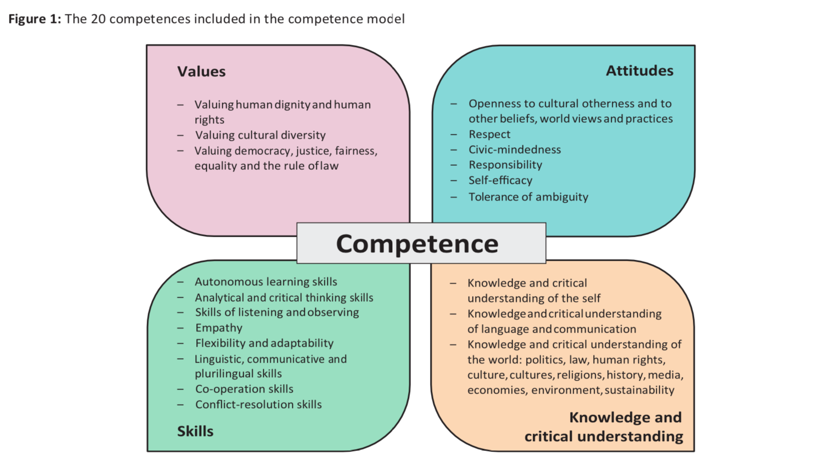

Engage: Reflect on your cultural practices through the prism of the listed competences, divided into values, attitudes, skills, knowledge & critical understanding. How does it apply on your self-perception? What cultural practices would you find as relevant, for development of competences as listed in the figure above?
Extend: Read the full document (footnote 5, p. 5) to gain deeper understanding of the competence model. Evaluate how cultural practices contribute to the development of (students') competencies as democratic citizens with strong intercultural, diversity, and communication skills.
Make cluster with relevant cultural practices and connect them with 4 categories. Create further cultural practices for development of competences above. Set a goal, evaluate your practices, WATCH its effects on your competences, make a diary for the impact evaluation.

Here is a brief guide for impact evaluation of cultural practices on students' competence development:

Set a Goal: Define the specific outcomes you aim to achieve through cultural practices, such as intercultural competence, diversity awareness, and effective communication skills among students.
Design Evaluation Criteria: Develop clear and measurable criteria to assess the desired competencies. This could include criteria like awareness of cultural diversity, ability to engage in constructive dialogue across cultures, and proficiency in communicating effectively with diverse groups.
Choose Evaluation Methods: Select appropriate methods to gather data and evaluate impact. This might involve surveys, interviews, focus groups, or observation of student interactions during cultural activities and discussions.
Implement Data Collection: Conduct evaluations during and after the implementation of cultural practices. Collect both qualitative data (e.g., insights from interviews and focus groups) and quantitative data (e.g., survey results on perceived competence levels).
Analyze and Interpret Results: Analyze the data collected to assess the impact of cultural practices on students' competence development. Identify strengths, weaknesses, and areas for improvement. Use the findings to inform future cultural programs and educational strategies.

- What makes democracy ´deliberative´?

deliberation: slow and careful movement or thought

The term ´deliberative´ emphasizes the use of logic and reason as opposed to power-struggle. Deliberation is an approach to decision-making in which citizens consider relevant facts from multiple points of view, converse with one another to think critically about options before them and enlarge their perspectives, opinions, and understandings

Deliberative democracy is a form of democracy in practice by sharing diverse perspectives and making informed decisions through dialogue and debate. Its roots traces back to ancient Greece, where the concept of citizens gathering in assemblies to discuss and make decisions on public matters was practiced in city-states like Athens.
It aims to enhance and inform existing democratic practices through active involvement of citizens in decision-making in different policy areas, and it has evolved over time.

Here are some key insights about the concept:
Informed Decision-Making: Deliberative democracy emphasizes the importance of making decisions based on well-informed deliberation rather than mere voting.
It encourages citizens to engage in rational discourse, exchange ideas, and weigh different perspectives before reaching a conclusion.
Inclusivity: Deliberative democracy strives to include diverse voices and viewpoints in the decision-making process. It values the participation of all citizens, regardless of their background, identity, or socio-economic status, to ensure that decisions reflect the interests and concerns of the entire community.
Public Reasoning: Central to deliberative democracy is the idea of public reasoning, where citizens engage in reasoned debate using evidence, logic, and ethical considerations. This process fosters mutual understanding and consensus-building, leading to more robust and legitimate outcomes.
Dialogue and Debate: Deliberative democracy encourages open dialogue and constructive debate among citizens, policymakers, and stakeholders. Through respectful discourse and active listening, participants can explore complex issues, challenge assumptions, and find common ground.
Accountability and Transparency: Deliberative democracy promotes accountability and transparency in decision-making processes. It encourages policymakers to justify their decisions based on public deliberation and to be transparent about the factors influencing their choices.
Empowerment: By providing opportunities for citizens to engage meaningfully in political deliberation, deliberative democracy empowers individuals to take ownership of the democratic process. It cultivates civic skills, critical thinking, and civic virtues essential for active citizenship.

Overall, deliberative democracy offers a vision of democracy that goes beyond mere voting and emphasizes the value of informed, inclusive, and deliberative decision-making in shaping a just and equitable society. Committed to “actively enable and encourage DEMOCRATIC PARTICIPATION at national, regional and local levels through free and fair elections, the Committee of Ministers to member States on Deliberative Democracy adopted in 2023 the Recommendation CM/Rec(2023)6 , which has become the first international standard in this field. The Recommendation contributes to the Reykjavik Principles of Democracy, in which member States have declared:

“ (…) We see democratic security as key for member States to address current and future challenges together and to secure peace and prosperity in Europe. We consider that the Council of Europe, with its seat in Strasbourg, symbol of peace and reconciliation, is uniquely placed to bring together, on an equal footing, all countries of Europe to protect democratic security in Europe and to counter the undermining of human rights, democracy and the rule of law.2

In the 20th century, scholars like Jürgen Habermas played a crucial role in shaping the concept of deliberative democracy. James S. Fishkin, a political scientist and professor at Stanford University, further developed the concept of deliberative democracy with his work on deliberative polling.
Deliberative polling involves structured discussions among participants facilitated by trained moderators. These discussions may take place in small groups or plenary sessions and are guided by specific prompts and questions designed to encourage thoughtful deliberation. It begins by selecting a random sample of participants from the population. This ensures a diverse and representative group of citizens, reflecting different demographics, perspectives, and backgrounds.
Participants are encouraged to engage in interactive deliberation, where they listen to different perspectives, ask questions, challenge assumptions, and express their own views.
Facilitators ensure that discussions remain respectful, inclusive, and focused on the issue at hand.
Throughout the deliberative process, participants have the opportunity to refine their opinions and preferences based on the information presented and the insights gained from dialogue with others.
Deliberative polling often includes mechanisms for collecting feedback from participants, such as surveys or structured feedback sessions. This feedback allows organizers to assess the effectiveness of the deliberative process and identify areas for improvement.
At the conclusion of the deliberative process, participants may be asked to develop policy recommendations or proposals based on their deliberations. These recommendations can provide valuable insights for policymakers and contribute to more informed and democratic decision-making.
The goal is to elicit informed opinions from participants and gauge public preferences on complex policy issues. Deliberative polling is a method used to engage citizens in informed dialogue and debate on public policy issues.
Prof. Fishkin's deliberative polling® method has been used in various countries around the world to inform public policy decisions and enhance democratic practices. It emphasizes the importance of informed citizen deliberation and aims to bridge the gap between public opinion and policymaking by ensuring that the voices of ordinary citizens are heard in the political process.

AI-well acts: Truth, Trust & Hope 2030: Virtual sessions with Stanford University Deliberation Platofrm

At Stanford University, deliberative democracy is practiced through platforms like the Deliberative Democracy Forum, where students come together to discuss pressing issues facing society today. These discussions help shape public opinion, influence policy decisions, and contribute to positive social change.
The deliberative Polling method has been explored with blind and visually impaired students from Vienna Institute for Blind BBI, and with ca 80 high school students from 6 partner countries, participants in the ERASMUS+ project LeMOON bei virtual sessions with Prof. Alice Siu, Stanford University, on the topic of AI-ethics and use of assistive technologies, which were created and organized by Tatjana Christelbauer (ACD Vienna/AT). Following the EU-Ethical Guide for AI use, teachers and students, have reflected on their experiences and have summarized their findings and policy recommendations under the title “AI-well acts: Truth, Trust & Hope2030 …” in poster formats, which they have presented during the virtual meeting on the occasion of the annual celebration of the European Day of Languages 2023.

Engage: As young adults, your voices matter. By participating in deliberative democracy, you have the opportunity to influence the direction of your community, your country, and even the world.
Your opinions and ideas can help address global challenges, promote social justice, and build a more sustainable future for all.
Connect with the platform, explore how deliberative polling works, prepare topic for discussion, and try. https://deliberation.stanford.edu/what-deliberative-pollingr

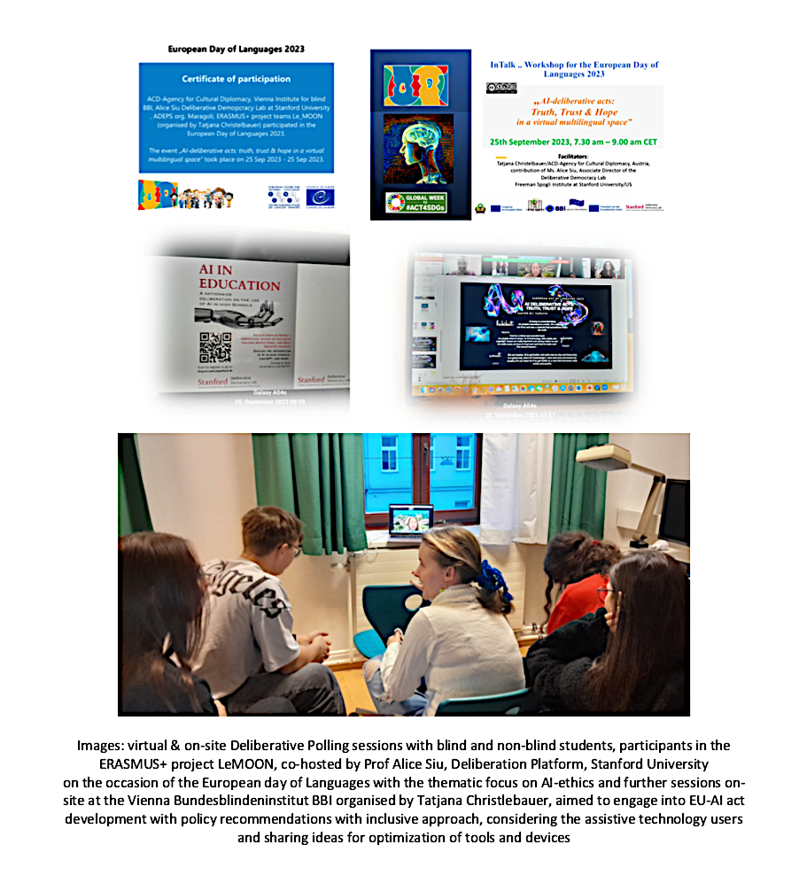

Weblink info to the European Day of Languages 2023 Deliberative Polling session:
https://www.acdvienna.org/w-%C3%B6-eu/le-moon-erasmus/edl-23/

- artImpact2030 … Example from ACD-association CD2030…practices: The Gemstone-message

Cultural Democracy2030... as coined in the practice of the ACD-Agency for Cultural Diplomacy team, describes a diversity-inclusive approach to a variety of expressions deriving from arts and cultural practices, grounded within the UN Agenda2030 as one common frame of values.
Aiming to actively contribute to the current transitions of cultures and lifestyles toward sustainable development, the ACD team initiates art-based educational projects and collaborative platforms, calling upon professionals from arts and culture, politics and diplomacy, economy, and finance to engage in debates, exchange their experiences and views on current challenges they are facing,
share their recommendations for the improvement of conditions and contribute to more just, democratic financial aids for professionals engaged in art education, performance, promotion, business, design, ..

Deliberative approach to arts and culture, particularly to artistic freedom is encourage within the frame of values grounded in the UN Agenda 2030 and the Universal Human Rights Declaration.
Examples from practices are included to illustrate how ACD team promotes cultural democracy through cultural diplomacy practice framed within the UN Agenda2030 and the Universal Human Rights Declaration. Media poster “Gemstone-Message” for the UNESCO annual celebration of the World Day for Cultural Diversity for Dialogue and Development, while thinking Cultural Diversity, Cultural Democracy & Cultural Diplomacy 2030… with Sustainable Development approach, and underlining the artistic freedom, in the Gemstone-Message & The Statement of the conference team in contribution to 75th Anniversary of the Human Rights declaration in 2023: HR75

The “Gemstone Message” is inspired by photo image captured during the ERASMUS+project
"The Rhythm of Nature_Environmental Education in Dance Arts“ workshop in Warsaw, Poland
The Rhythm of Objects, led by Pawel Michno. Dancers have received diverse gemstones- each a piece of some mineral crystal with the task to explore the variety of symbolic meanings of each small gemstone by guided imagination, which was followed by individual and contact improvisation. Diverse colors, shapes, patterns, and associative images were enacted by touching the gemstone. Moving while holding the small piece in the hand, associating with the object by creating the bodily movement, creating a story, connecting with partners, exploring diverse forms of expression, and finding in sync were experienced by rhythmically engaged ones, within a group. It was a challenging experience to connect diverse patterns, movement vocabularies, interests, and embodied cultures,
but we finally could compose the story in which every gemstone found its meaningful place.
The online conference in contribution to the HR75th Anniversary was aimed to bring together professionals from arts and policy, on the topic of Dance arts in & 4 Human rights.

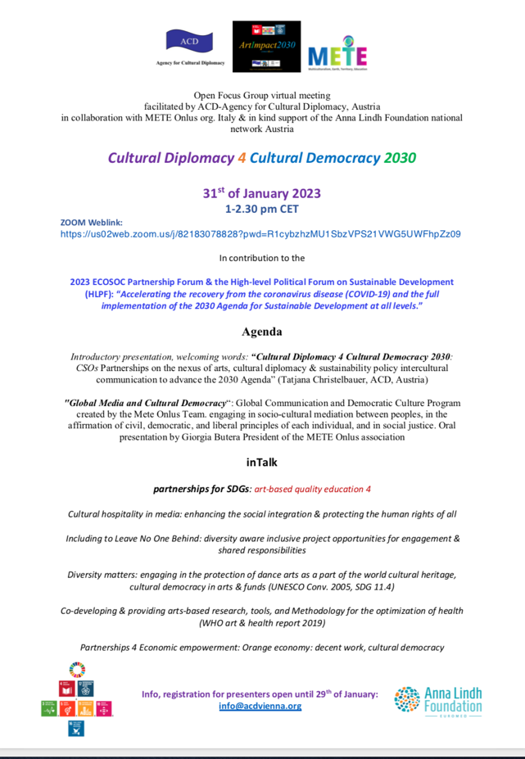
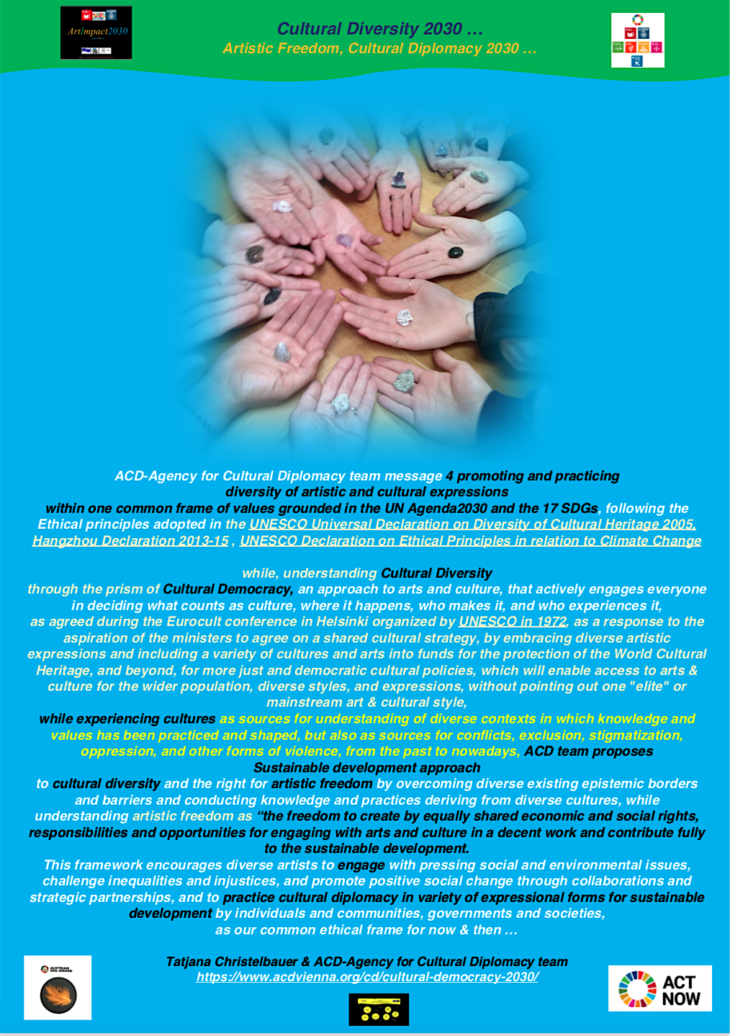
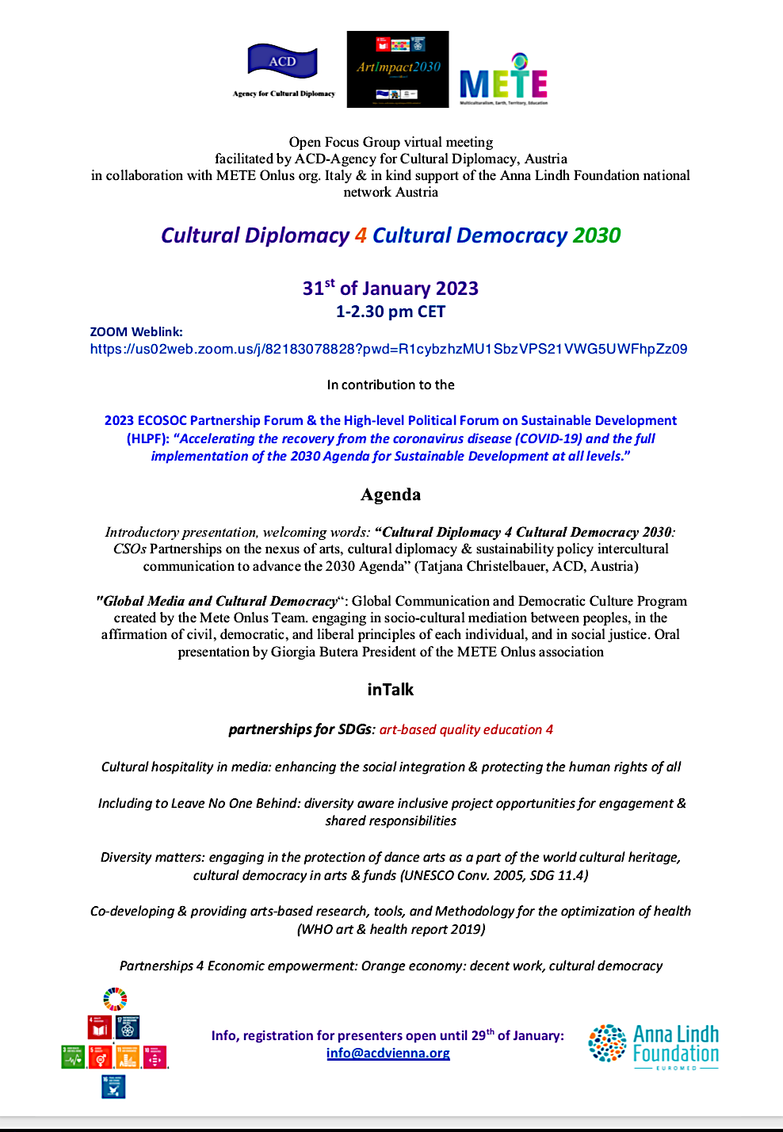

References:
Culture and democracy, the evidence How citizens’ participation in cultural activities enhances civic engagement, democracy and social cohesion: lessons from international research. This report analyses the concrete link between democracy and culture. It maps out how citizens who participate in cultural activities are much more likely to engage in civic and democratic life. Publication office of the European Union. Pdf download: https://op.europa.eu/en/publication-detail/-/publication/07370fba-110d-11ee-b12e-01aa75ed71a1/language-en
Reflections on the Politics of Culture (Essay is adapted from "Cultural Policy and Cultural Democracy," Chapter 11 of Crossroads (Talmage, CA: DNA Press, 1990, pp. 107-109): http://www.wwcd.org/cd2.html

Video. UNESCO futures of Education: https://www.youtube.com/watch?v=7865y7hbehY
Connect with ACD open focus group Let´s brick 4 UNESCO Futures of Education: https://www.acdvienna.org/futures-of-education/

Source webpage European Parlament: https://www.europarl.europa.eu/factsheets/en/sheet/166/promoting-democracy-and-observing-elections
Engage in more detailed reading following the guiding insights and examples form practices in the lesson on the topic of Cultural diplomacy with brief introductory “CD2030 ...” in the Module 6
Read more about the relational aspects between the Universal Human Rights Declaration and the UN Agenda 2030 in the lesson “Human Rights & Sustainable Development” , MODULE 1. Note form Auth.
Source: EU webpage source: Reference Framework of Competences for Democratic Culture – Volume 1 Model. P.2 Weblink: https://rm.coe.int/a-model-of-the-competences-required-for-democratic-culture-and-intercu/16809940c3
Source: A model of the competences required for democratic culture and intercultural dialogue. Weblink to download: https://rm.coe.int/a-model-of-the-competences-required-for-democratic-culture-and-intercu/16809940c3
Source: Culture and democracy, the evidence How citizens’ participation in cultural activities enhances civic engagement, democracy and social cohesion: lessons from international research. Publication office of the European Union. P.5. Pdf download: https://op.europa.eu/en/publication-detail/-/publication/07370fba-110d-11ee-b12e-01aa75ed71a1/language-en
Source: Council of Europe (2016), Competences for democratic culture: living together as equals in culturally diverse democratic societies, Council of Europe Publishing, Strasbourg, www.coe.int/en/web/education/competences-for-democratic-culture.
Source: Reykjavik Declaration, p.9: https://rm.coe.int/4th-summit-of-heads-of-state-and-government-of-the-council-of-europe/1680ab40c1
Webpage: Stanford University, Deliberative Democracy Platform: https://deliberation.stanford.edu/what-deliberative-pollingr
Webpage Stanford University profile Prof. Siu: https://deliberation.stanford.edu/people/alice-siu
Webpage event info: https://www.acdvienna.org/sdgs/hr75-dance-arts-in-4-human-rights-un-sdgs/

