Project ID: 2021-1-CZ01-KA220-SCH-000034484
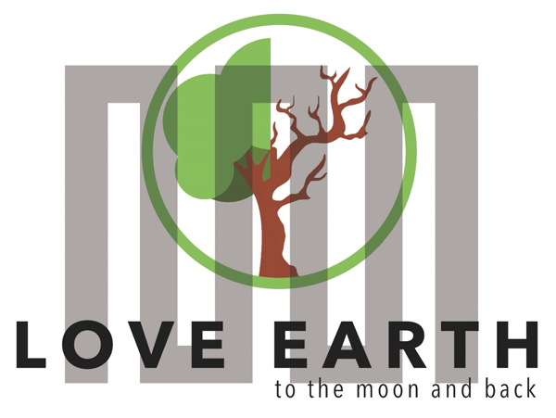

COURSE FOR ENVIRONMENTAL EDUCATION
e-Modules: Teaching Learning activities and their technology enhanced material set to develop



M4: art4health lesson: Blue Moon acts
COURSE AUTHOR
©Tatjana Christelbauer MA (TC)
ACD Team Austria

DISCLAIMER
Funded by the European Union. Views and opinions expressed are however those of the author(s) only and do not necessarily reflect those of the European Union or the European Education and Culture Executive Agency (EACEA). Neither the European Union nor EACEA can be held responsible for them.
COURSE SHARING LICENSE CC BY-NC-SA = 
Canonical URL: https://creativecommons.org/licenses/by-nc-nd/4.0/

MODULE: 4
LESSON: arts4health. The Blue Moon acts
SUBJECTS: Psychology, Arts, English, …

The Flucht ins All & The BLUE MOON act

Insights and questions for self-reflection on emotional and mental state space in the context of safety and self-protection against threatening circumstances,
guided with artworks of Hundertwasser

Aims: Guide for self-reflective “navigation in mental space”, awareness about own life conditions, relational aspects and methods used for maintaining challenges, regenerative approach to ethical reasoning, coding and recognizing signs in symbolic interaction

Methods: Guided moral imagination with sustainable approach to moral decision making, metaphoric interpretation, “The Grammar of Seeing”, analytic thinking, storytelling

- Introductory
The “BlueMoon-effect” 4 #sustainableme: regenerative mindful practices
Inspired by Hundertwasser´s artworks

The "BlueMoon-exercise" draws inspiration from Hundertwasser's artworks
"The Blue Moon" and "Escape to Outer Space “, as a tool for responsive thinking about "escaping." Hundertwasser comments on the artwork by stating, “(...) pictures of dreams have nothing at all to do with quality. So many painters have tried time and again to eternalize a seemingly fantastic parallel world under the influence of drugs and alcohol. Nothing has ever resulted from it. Unless one has this world inside oneself.
But then one needs neither drugs nor alcohol.”
The "BlueMoon-exercise" is aimed to support moral decision-making during emergencies like wars and natural disasters, as well as by emotionally driven needs to escape unpleasant or threatening situations. Furthermore, the exercise may help preventing self-damaging practices and the self-deception by using stimulative substances which are life-threatening and instead, provide guidance for practicing a regenerative escape, and creation of a safe, real- or imaginative space for a self-reflective analysis about underlying reasons for the need to escape.
Inspired by the artworks of Hundertwasser and his comment to the composition of artworks “The Blue Moon” and the “Escape in Universe”, the “BlueMoon-exercise” has been created as a responsive thinking tool to the topic of “escaping” as a two-fold method, which may help by a moral decision making in emergency such as by wars and natural disasters, but also can by emotionally-led need to “escape” some unpleasant or even threatening situation or life event.

- The BlueMoon Effect:
This effective residual presence of the BlueMoon as a ´mindmarker´ can be explored by practicing self-guided imagination, to focus attention on the present moment and imagine consequences, aiding in ethical reasoning and self-protection while identifying potential or real dangers and noticing details related to causes of the emerging need to escape, for real safety, and wellbeing. The imaginative attempt of the “BlueMoon”, may be enacted by one´s need for “escaping” from some event, cause, person, … and help find and create a real or imaginative safe place, be it in a real emergency such as by natural disasters and wars, or by some emotionally led or socially led event.
  - Engage in self-reflection:
Ethical Reasoning: What is the meaning of “escape”? What situations or emotions make you feel the need to escape? How do you usually respond to these situations, and what are the outcomes? Can you identify a healthier way to address these feelings and circumstances?
Reflect on your experiences with dreams and “parallel world”, and how it all matters. Exchange your experiences with your colleagues, write a story about safe space inspired by Hundertwasser´s artwork and his comment, draw your moon, imagine consequences when escaping some matters, re-imagine, dream, awake, dream again …
  - Artwork interpretation
Explore, Experience, Explain: See the artworks of Hundertwasser 1966 and view following aspects: the titles of the works, the serial numeric value of the artworks, the year when each was finished, view in detail, describe the artworks to a blind person, make notes on different positions of the motives, find 5-10 differences in artworks:
650 A
DER BLAUE MOND - ATLANTIS - FLUCHT INS ALL
The Blue Moon - Atlantis - Escape to Outer Space
LA LUNE BLEUE
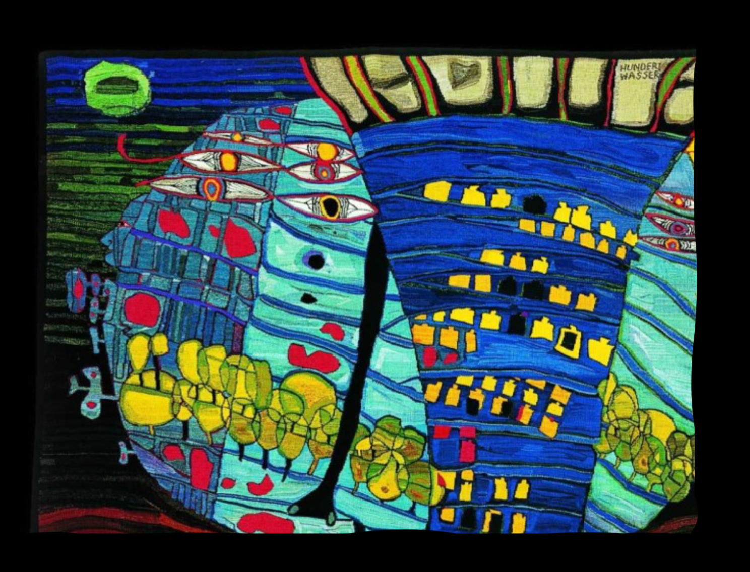
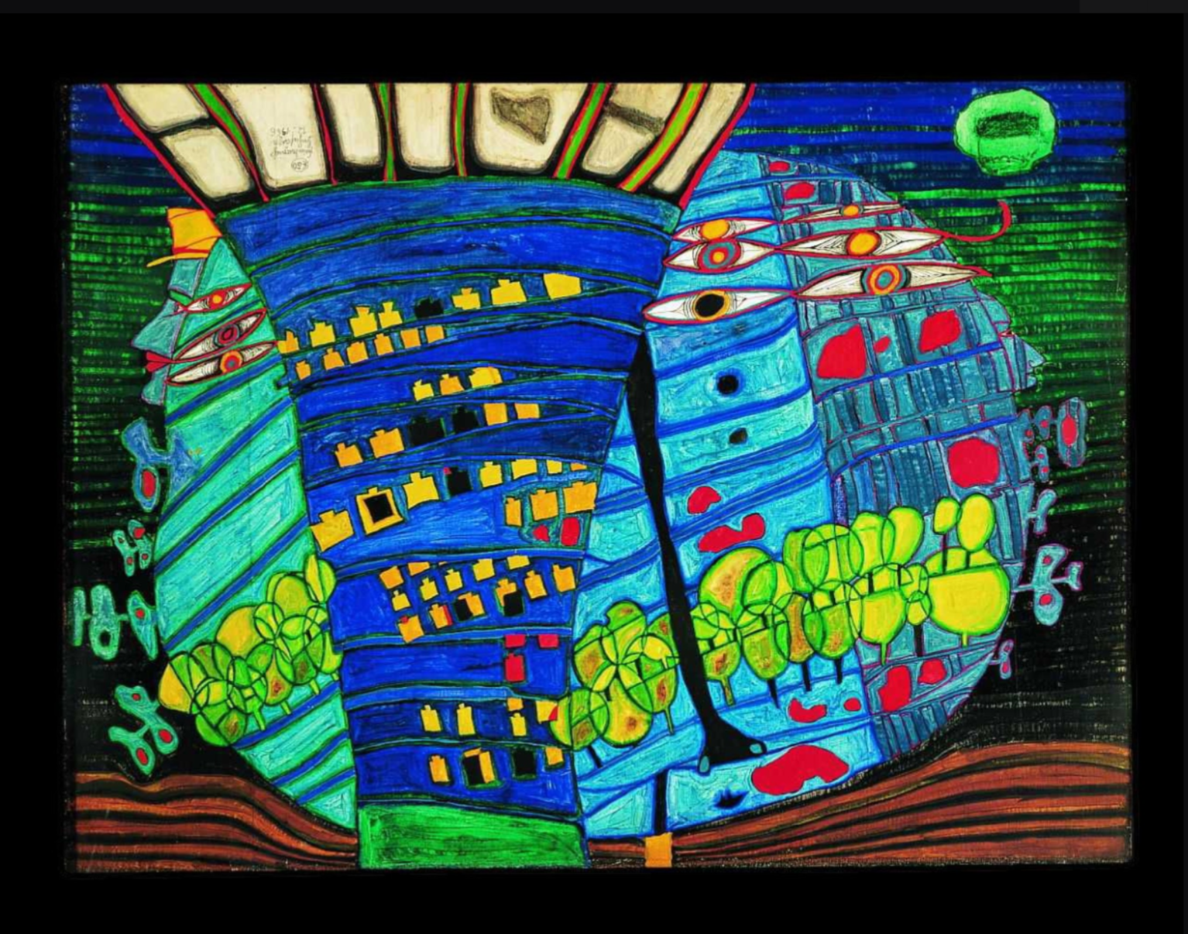

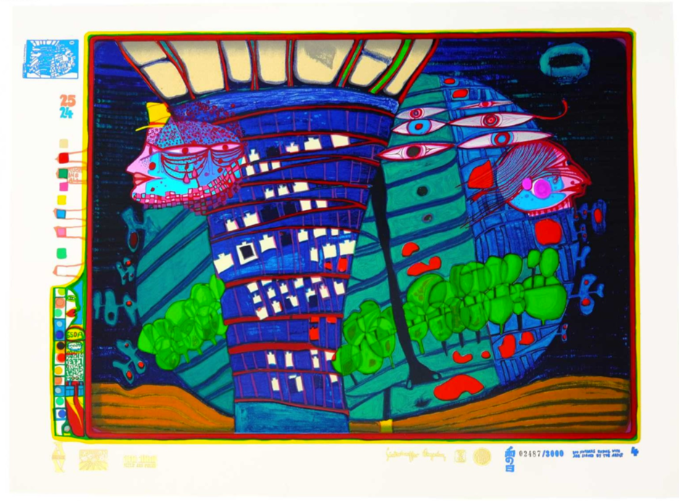

© 2024 Die Hundertwasser gemeinnützige Privatstiftung Wien

Read more about the artwork of Hundertwasser:
https://hundertwasser.com/malerei/650_der_blaue_mond_-_atlantis_-_flucht_ins_all_575

Self-reflection:
What symbols and figures in Hundertwasser’s artworks resonate with you, and why?
How do the titles "Escape into Universe" and "The Blue Moon" influence your understanding of the artworks?
How can you create a personal escape space inspired by these artworks?

- Exercise for Guided Imagination and Ethical Reasoning
Thought Experiment with the Three Pillars of Sustainability
Objective: Evaluate the impacts of escape behaviors through the lenses of social, economic, and ecological sustainability.

Guiding Questions for Social Impact:
How do your escape behaviors affect your relationships with family and friends?
Can escaping be a form of seeking support or isolating oneself? If, explain how, and why?
What else can help in providing a healthier form of escape or support?

Guiding Questions for Economic Impact:
What are the financial costs of destructive escape behaviors (e.g., substance abuse)?
How might choosing regenerative activities (like hobbies or exercise) impact your financial stability in the long term?
Can investing in personal growth and well-being lead to better economic opportunities?
Provide examples.

Guiding Questions for Ecological Impact:
How do certain escape behaviors (like excessive consumption or travel) impact the environment?
What are some eco-friendly ways to escape or recharge? (e.g., spending time in nature, engaging in conservation activities)
How does connecting with nature help in reducing stress and promoting regeneration?

Activity:
Create a personal action plan for a regenerative escape. Include at least one activity each for social, economic, and ecological impact. For instance, plan a nature walk (ecological), budget for a hobby that brings joy (economic), and schedule a meet-up with friends or family (social).
Share your plan with a partner or in a small group. Discuss how these activities can help in creating a sustainable and regenerative approach to managing stress and escaping.

Phase 2: Creating Your Own Escape Space
Imagine Your Space: Now, take elements from both artworks to create your own escape space. Picture a place where you feel completely safe and at peace. It could be a garden under the stars, a mystical forest, or a floating island in the universe. Combine the vibrant, life-filled patterns of "Escape into Universe" with the serene, magical light of "The Blue Moon."
Build the Scene: Add details to your space. Maybe there are colorful, spiraling paths leading to hidden clearings, or a gentle blue light that illuminates everything softly. Include symbols that have personal meaning for you—trees, stars, or abstract shapes that represent your thoughts and dreams.
Feel the Space: Walk through your escape space. Feel the textures under your feet, breathe in the scents, and listen to the sounds. Let this place become vivid in your mind. It is a space you can return to whenever you need a moment of peace and regeneration.
Affirmation and Reflection: Create a short affirmation or mantra that captures the essence of this space. It could be something like, "In my universe, I find peace and strength," or "Under the blue moon, I am renewed." Repeat this affirmation to yourself and feel its power anchoring you in this safe, imaginative space.
Reflect again, repeat and mark important findings
How can the concepts of the "BlueMoon-exercise" help you make better decisions in stressful situations? What are the social, economic, and ecological impacts of your escape behaviors? How can you ensure that your methods of escape contribute positively to your well-being and the environment? Keep practicing your self-reflection on the topic, create your real safe places

Conclusion:
Remember that this escape space is always within you, inspired by the art and your own imagination. You can return here whenever you need to recharge and reflect, using the guiding light of the blue moon and the vibrant life of the universe to find balance and renewal.

Conclude by yourself:

Regarding the perception of art, Hundertwasser spoke about enacting of "individual films" that arise from associations guided by viewing the works of art. As he expressed in his 1957 text “The Grammar of Seeing,” when viewing works of art the “grammar of seeing” should be expanded from its set of rules, the imagination should be stimulated, and associative images should be evoked in the viewer. And no two pictures are the same..." Applying on Hundertwasser´s idea and situating the notion of the “individual film” in the process of creation of the exercise, I “expand the set of rules” aiming to stimulate ethical imagination and enact associative images by the viewer, while taking this one particle out of the whole picture and situating it within a new context, but keeping the ethical link to the origin by the exercise overall aim, which is grounded in the social and environmental ecology, as also promoted by Hundertwasser. Note from Auth. Read more about Hundertwasser´s Pintorarium: https://hundertwasser.com/en/texts/das_pintorarium
Regenerative thinking practice is guided by imagining, self-reflecting, analyzing and re-imagining life-threatening causes and conditions, understanding making affirmative
Source: from: Hundertwasser 1928-2000, Catalogue Raisonné, Vol. 2, Taschen, Cologne, 2002, p. 520. Weblink to artwork of Hundertwasser and his comment: https://hundertwasser.com/malerei/650_der_blaue_mond_-_atlantis_-_flucht_ins_all_575

