Project ID: 2021-1-CZ01-KA220-SCH-000034484
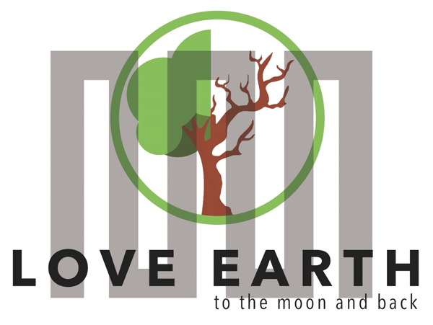

COURSE FOR ENVIRONMENTAL EDUCATION
e-Modules: Teaching Learning activities and their technology enhanced material set to develop
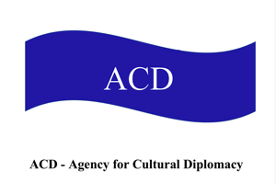

Thematic Units for Week-Long Workshop Sessions:
Inquiry-Based Integrated Learning Workshop Series
on the Intersection of Arts, Science, and Policy"

M1: LOVE in sustainable development #stayinlove

COURSE AUTHOR:
©Tatjana Christelbauer MA (TC)
ACD Team, Austria

DISCLAIMER
Funded by the European Union. Views and opinions expressed are however those of the author(s) only and do not necessarily reflect those of the European Union or the European Education and Culture Executive Agency (EACEA). Neither the European Union nor EACEA can be held responsible for them.
COURSE SHARING LICENSE CC BY-NC-SA =
Canonical URL: https://creativecommons.org/licenses/by-nc-nd/4.0/

MODULE: 1
LESSON: Languages of Love in sustainable development
SUBJECTS: Psychology, English, Fine Arts, Environmental Ethics, …

Exercise: Languages of Love in Sustainable Development

Objective
The exercise aims to highlight the importance of communication in relational cultures. Guiding insights are applied on Triangular Theory of Love by Robert Sternberg and its application to environmental love and sustainable development, inspired by Austrian reform pedagogue for early child education M. Margarete Schörl’s humanistic education principles grounded in the idea of fellowship love (charity), a kind of devotion to fellow (human.) With examples form environmental art created by Austrian environmental artist and activist Friedensreich Hundertwasser, guiding insights are extended with the focus on environmental love and its varieties in a multilingual setting.
For brother understanding of how (love) relationships are regulated and protected, tasks for project activities and policy dialogues are provided. European Policy papers are briefly introduced.

Supported competences and skills: attentive communication skills as green skills

1: Understanding the Triangular Theory of Love
Instructions for teachers:

Start by providing the survey to your students, collect, and evaluate their responses to the topic, for the entry. Instructions for the evaluation are attached in the separate document together with the L-Survey

Introduction to Triangular Theory of Love:
Read the paper attached and Explain Robert Sternberg's Triangular Theory of Love which consists of three components:
Intimacy: Feelings of closeness, connectedness, and bondedness.
Passion: The drives that lead to romance, physical attraction, and sexual consummation.
Commitment: The decision to remain with another and plan for the future.

1.2. Application to Environmental Love:
Intimacy with Nature: Developing a deep connection and understanding of the natural environment.
Passion for Sustainability: Feeling passionate about protecting and preserving the environment.
Commitment to Sustainable Practices: Making a conscious decision to engage in and advocate for sustainable practices.

1.3. #stayinlove: inspired by Margarete Schörl’s Humanistic Education
Discussion on “Mitmenschlichkeit” (from German: humanity, “mit” points out “with”, therefore the focus on the “fellowship”) and "Stay in Love" Motto:
Mitmenschlichkeit: The importance of human compassion and love in education.
#stayinlove: Schörl’s idea “bleibe in Liebe” as a guiding principle to promote ethical relational cultures that are peaceful and constructive.

Exercise1
Part 1: Survey on Love and Relationships
Instructions:
Provide the survey to your students for engaging in the topic and in doc format for digital use, collect messages in audio formats, use other forms by your choice. Evaluate their responses by targeting priorities from

Survey Questions:
How do you define love? Share a thought, a quote, a poem, experience ,…
Can you describe a time when love motivated you to act sustainably or ethically?
How important is love in creating a peaceful and supportive social environment?
In what ways can love help resolve conflicts without causing harm?
How do you think practicing love to our next and compassion in daily life can contribute to sustainable development?
Have you experienced disappointment and/or violence in a love relationship?
If so, how have you went through that experience? Have you asked some friend, family member or some consultant for support? How was your health and wellbeing affected by such experience? How long it took you to come out of that experience and recover emotionally? What consequences/if any have you taken from that experience in your further relationships? S
hare more about by your interest …

Instructor's Guide: Evaluating Student Responses and Preparing the Lesson
To effectively prepare the lesson based on students' responses to the survey on love, the teacher should focus on the following three key points:

Understanding Definitions and Perceptions of Love:
Focus Point: Identify common themes in how students define love in their personal relationships.
Instruction: Pay attention to the variety of definitions and perceptions students have about love. Look for patterns in their descriptions, such as emotional closeness, support, care, or shared values. This will help in tailoring the lesson to address the students' inherent understanding and broaden their perspectives.
Application: Use these insights to introduce different aspects of love, including Sternberg's Triangular Theory, and show how these definitions can relate to both personal relationships and broader societal contexts, including environmental love.

Motivation and Ethical Actions:
Focus Point: Analyze examples where love motivated students to act sustainably or ethically.
Instruction: Highlight instances where students' actions driven by love have led to sustainable or ethical outcomes. These examples can serve as powerful illustrations of the practical impact of love on behavior and decision-making.
Application: Use these real-life examples to connect the concept of environmental love with students' experiences, emphasizing the role of love in fostering sustainable development. Encourage students to share their stories and reflect on how love can be a motivating factor in ethical actions.

Conflict Resolution and Compassion:
Focus Point: Examine how students view the role of love in creating a peaceful environment and resolving conflicts without harm.
Instruction: Look for insights into how students believe love contributes to peace and conflict resolution. Understanding their views can help in designing activities that build on their existing knowledge and skills.
Application: Use these insights to design activities that emphasize compassionate communication and conflict resolution. This can include role-playing scenarios, group discussions, and other interactive exercises that reinforce the importance of love and empathy in maintaining peaceful relationships and solving conflicts.

Step-by-Step Preparation
By focusing on these points, the teacher can create a lesson that is relevant, engaging, and directly connected to the students' experiences and interests. This approach will not only make the topic of love more relatable but also highlight its importance in promoting sustainable development and ethical relationships.

Review Survey Responses:
Categorize responses to identify common themes and unique perspectives.
Note any recurring ideas or significant outliers that could enrich class discussions.

Develop Lesson Content:
Incorporate students' definitions and perceptions of love into the introduction of the Triangular Theory of Love. Use real-life examples provided by students to illustrate how love can lead to sustainable and ethical actions.

Design Interactive Activities:
Plan activities that build on students' experiences with love as a conflict resolution tool, such as role-playing or group discussions. Include exercises that emphasize compassionate and attentive communication, tying these skills to the broader theme of sustainability and ethical behavior.

2. CLIL-based Exercise: Languages of Love
Explanation: This exercise focuses on the importance of communication in relational cultures and how attentive communication skills can be considered green skills that contribute to sustainability. Students will explore kind, friendly, and attentive terms and phrases, as well as understand the impact of negative communication such as cyberbullying and judgment.

Instructions for teachers for the entry lesson activities:
Language and Content Integration:
Discuss quotes about love from various cultural and linguistic backgrounds. Translate collected quotes including all language resources spoken by your students by all exercises, make a collection of language resources before starting this activity.
Interpret quotes while situating them in daily life and connecting them with student´s experiences and ideas about their meaning.
Translate collected Key Terms
^ include all language resources spoken by your students:
Love: Liebe (German), …
Sustainability: Nachhaltigkeit (German), …
Compassion: Mitgefühl (German), …
add more key terms by your choice

Extended activities by 2-hours+Workshops:
°Collecting Terms and Phrases for attentive communication:
Divide students into multilingual groups and provide each group with a set of terms and phrases that are kind, friendly, and attentive. Examples may include following terms: Kindness: Kind (English) Nett (German), …; Friendliness: Friendly (English), Amical (French), Freundlich (German), …; Attentiveness: Attentive (English), Aufmerksam (German), …;

°Collect terms and phrases that represent threatening (violent) communication such as:
Cyberbullyin, Prejudice, (English), Vorurteil (German), Hate speech (English), Hassrede (German) …
Situate collected terms and associate them with a case or existing campaign, such as # event

Discussion and Presentation:
  - Ask each group to discuss the positive and negative terms and phrases. How do these affect relationships and communication within a community?
  - Each group will present their findings and suggest ways to promote positive communication while reducing negative interactions.

3. Workshop: Promoting Positive Communication: WATCH & #stayinlove

In this workshop, guiding insights are provided for engaging in research about and exploring how communication culture is regulated at the European level through Policy papers, at the national state level, and in schools. Furthermore, with insights provided for research and discussions about how communication in social media is experienced and regulated, learners will engage in extended research and analysis about how regulations regarding hate speech, cyberbullying, and other forms of violence are enforced, comparing and analyzing their effectiveness.
Finally, the call for further engagement and proposed activities, such as engaging in WATCH-initiatives, reporting cases and sharing evidence -based policy recommendations for the improvement of regulations with relevant authorities, including governmental entities and social media providers. Additionally, guidelines are provided for connecting with the EU Youth campaign to support its impact by promoting it within schools and via social media, by organizing related activities in local communities and at schools to further endorse positive communication.

Engage: Policy papers and regulations: How is communicational culture regulated and in what forms?

Engage in research about Policy papers and regulations connected with communicational cultures and rules at the EU -level, at your national State level and at school.
Read about the youth campaign led by the Council of Europe Youth Department “No Hate Speech Movement “ seeking to mobilise young people to combat hate speech and promote human rights online. Launched in 2013, it was rolled out at the national and local levels through national campaigns in 45 countries. The movement will remain active beyond 2017 through the work of various national campaigns, online activists and partners.
Weblink: https://www.coe.int/en/web/no-hate-campaign

Explore, explain: How is your national state engaged in such campaigns?
Research about and connect with related initiatives. Get inspired by the Austrian State Chancellery to engage, if not yet:
https://www.bundeskanzleramt.gv.at/agenda/jugend/lebensqualitaet-und-miteinander/no-hate-speech.html#:~:text=Hassrede%20bezeichnet%20%C3%84u%C3%9Ferungen%2C%20die%20zu,Opfer%20k%C3%B6nnen%20Beratung%20suchen.

How is communicational culture regulated in your school?
How is communicational culture regulated in social media?

°Engage in research, compare and engage individually and/or within a small group together with students at your school with a critical eye, if regulations related to hate speech, cyberbullying and similar forms of violence in media are respected. Collect and connect your findings, situate them and present.

Here is a guidance for your research:
1st phase
Conduct Comprehensive Research:
Begin by gathering information on regulations pertaining to hate speech, cyberbullying, and other forms of violence in social media platforms. Read the European and your national Policy regulations. Use reputable sources such as government websites, academic articles, and reports from reputable organizations.
Compare and Analyze:
Compare the regulations across different social media platforms and regions. Analyze how effectively these regulations are enforced and whether they adequately address issues of hate speech and cyberbullying. Consider factors such as reporting mechanisms, moderation policies, and transparency in enforcement.
Engage Critically and Collaboratively:
Engage in discussions individually or within small groups with fellow students at your school. Approach the topic with a critical eye, questioning assumptions and biases. Share insights, perspectives, and findings to deepen understanding and foster collaborative learning.

2nd phase: Present your findings
Presentation Guidance:
Summarize Research Findings:
Start by summarizing your research findings, highlighting key regulations and their enforcement mechanisms. Provide an overview of the current landscape of communicational culture regulation in social media.
Identify Gaps and Challenges:
Identify any gaps or challenges in the existing regulations, particularly concerning the prevention of hate speech, cyberbullying, and similar forms of violence. Discuss limitations in enforcement, loopholes in policies, or emerging issues that may not be adequately addressed.
Propose Recommendations for Improvement:
Based on your research and analysis, propose recommendations for improving communicational culture regulation in social media. Consider practical solutions such as enhancing reporting systems, implementing stricter moderation policies, or increasing transparency in content moderation decisions. Support your recommendations with evidence and examples from your research.
Propose improvement, share your recommendations for the policy improvement with responsible governmental entities, social media provider and further relevant entities, connect with the EU Youth campaign and support its impact by sharing the info and presenting the campaign in your school and via social media; organize supporting activity at your school and local community; WATCH media and look for cases which may not be in accordance with the EU regulations, report, avoid participating in compromising dialogues on social media, #stayinlove by your response while being aware of details shared, the context and backdrop connected, approve the information if it is a “fake news” and check the provider, understand the purpose of the information and read comments if available to get bigger picture, report and share when detecting fake, fraud, hate speech or whatever matters for you.

4. It hurts to wait with love if love is somewhere else HWG46: jealousy, Yellow Houses
"When you mix architecture with love, you get box houses-of-cards with yellow hot-water-bottle windows. In every window a blue tear. The red tower is located at Vienna's West Train Station. Near it is where she lived. Plattensteiner, my astrologer, said I should paint a lot when I am unhappily in love, especially then. Later I would not get around to it." (from: Hundertwasser 1928-2000, Catalogue Raisonné, Vol. 2, Taschen, Cologne, 2002, p. 507)

Engage, explore, explain: What role plays jealousy in love relationships? Engage in discussions, learn from experience of Hundertwasser, find your form for expression, describe motives as for the blind person. Whit what feeling would you associate the yellow color? What nuance would be the best suitable? How many nuances of yellow are on the artwork and on what motives?

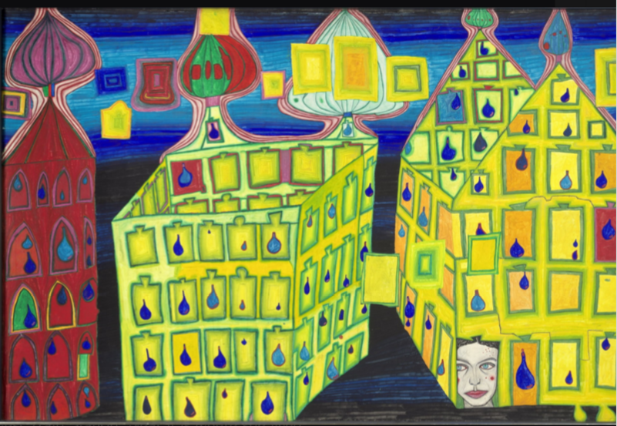

© 2024 The Hundertwasser non-profit foundation
630
GELBE HÄUSER - MIT DER LIEBE WARTEN TUT WEH, WENN DIE LIEBE WOANDERS IST - EIFERSUCHT
YELLOW HOUSES - IT HURTS TO WAIT WITH LOVE IF LOVE IS SOMEWHERE ELSE
MAISONS JAUNES – JALOUSIE
Hundertwasser, Venice 1966
Source:
https://www.hundertwasser-kalender.de/poster-and-art-prints/Mini-Art-Prints-with-Passe-partout/YELLOW-HOUSES, https://www.hundertwasser.com/en/paintings/630_gelbe_haeuser_-_mit_der_liebe_warten_tut_weh_wenn_die_liebe_woanders_ist_-_eifersucht_559

Weblink to info page: https://www.acdvienna.org/futures-of-education/intalk-sessions-unesco-futures-of-education/
Hundertwasser webpage to artworks: https://www.hundertwasser-kalender.de/poster-and-art-prints/Mini-Art-Prints-with-Passe-partout/YELLOW-HOUSES, https://www.hundertwasser.com/en/paintings/630_gelbe_haeuser_-_mit_der_liebe_warten_tut_weh_wenn_die_liebe_woanders_ist_-_eifersucht_559
Source: https://commission.europa.eu/strategy-and-policy/priorities-2019-2024/new-push-european-democracy/equality-and-inclusion_en , EU policy Youth in External Action: https://ec.europa.eu/commission/presscorner/detail/en/ip_22_5884 , Ending gender-based violence: https://commission.europa.eu/strategy-and-policy/policies/justice-and-fundamental-rights/gender-equality/gender-based-violence/ending-gender-based-violence_en#:~:text=The%20Commission%20proposed%20new%20legislation,against%20women%20and%20domestic%20violence. , EU gender equality strategy: https://commission.europa.eu/strategy-and-policy/policies/justice-and-fundamental-rights/gender-equality/gender-equality-strategy_en
Download paper, 3 pages introduction to Triangular Model of Love. Weblink: https://www.hofstra.edu/pdf/community/slzctr/stdcsl/stdcsl_triangular.pdf
Poster action #stayinlovewebpage info: https://www.acdvienna.org/aktuell/cd-2030-unesco-mondiacult-2022/heartbell2030-stayinlove-poster-action/

