Project ID: 2021-1-CZ01-KA220-SCH-000034484
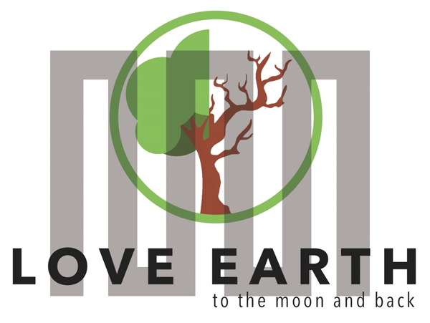

COURSE FOR ENVIRONMENTAL EDUCATION
e-Modules: Teaching Learning activities and their technology enhanced material set to develop

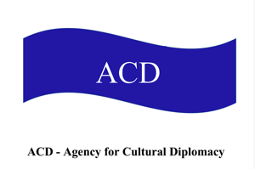

M1: Humans & Nature: Love EARTH to do MOON and back …
Lesson bond for week-long workshops in two parts
COURSE AUTHOR
©Tatjana Christelbauer MA (TC)
ACD Team Austria

DISCLAIMER
Funded by the European Union. Views and opinions expressed are however those
of the author(s) only and do not necessarily reflect those of the European Union or the European Education and Culture Executive Agency (EACEA). Neither the European Union nor EACEA can be held responsible for them.
COURSE SHARING LICENSE CC BY-NC-SA =
Canonical URL: https://creativecommons.org/licenses/by-nc-nd/4.0/

MODULE: 1

LESSON: Love EARTH to the MOON and back

SUBJECTS: love relationships, relational aspect sin space

Author: Tatjana Christelbauer MA, ACD/AT

Competences & Skills promoted: green skills in communication, creative thinking, collaboration, presentation, interdisciplinary thinking on the nexus of art-science-policy

Subjects: Language & Communication, Psychology, Space Education, Global Citizenship, Environmental Education, English, Ethics, policy, fine arts, cultural diplomacy, …
AI Wombo Art #loveearthcreated by project LeMOON student participant
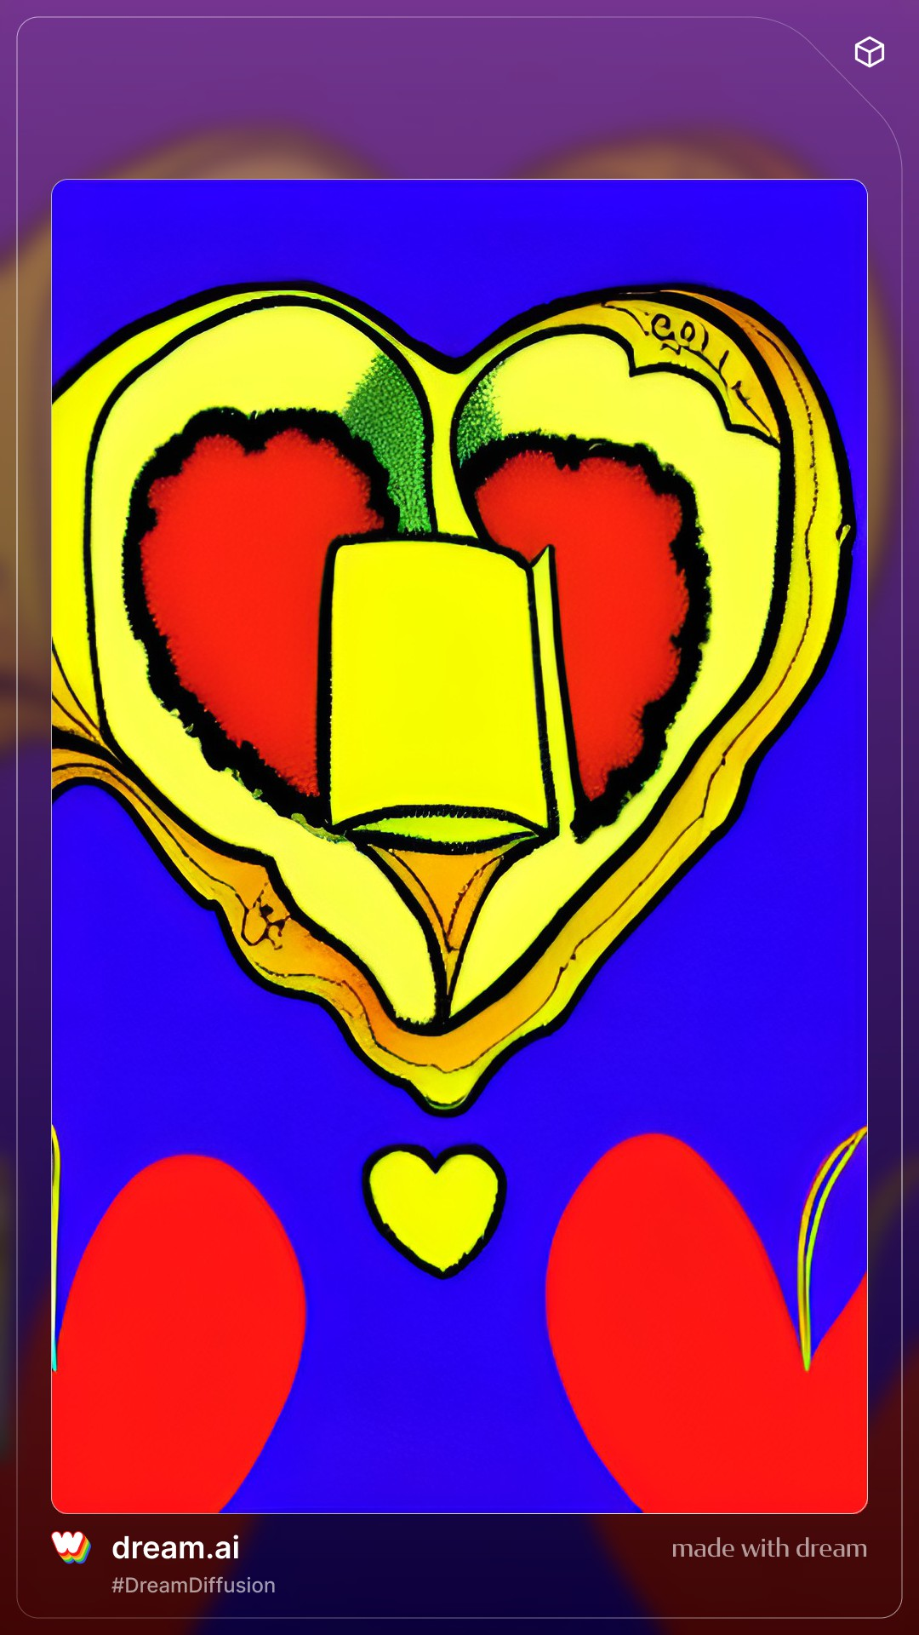

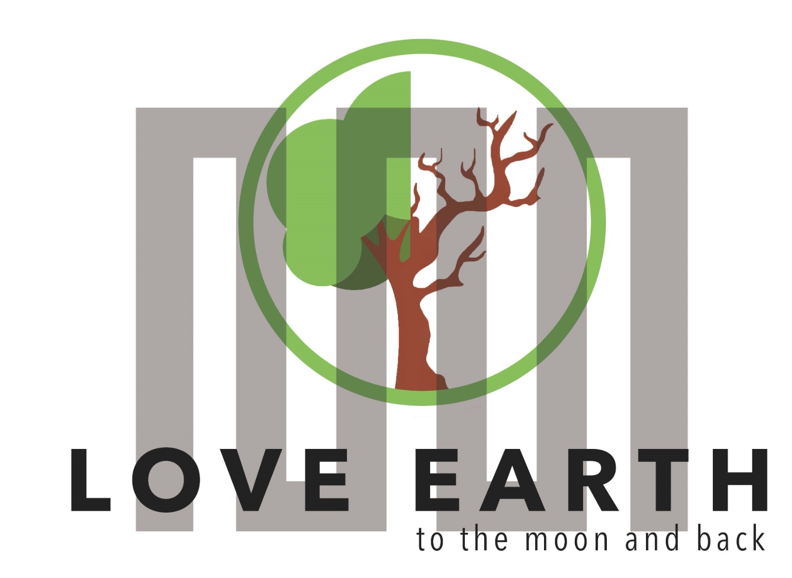
Love EARTH to the MOON and back
(The title of the ERASMUS+ project)

  - Etymology of Love to the Moon and back

“Love to the Moon and back …” what does it mean?

The phrase “Love … to the Moon and back” may have been boosted by space exploration and the moon landing in the 1960s, as an official NASA document, for instance, used the phrase to the moon and back when describing a program in 1969. The saying spread in the 1990–2000s, as evidenced by its use in popular culture. In 1992, the band Spectrum released a song titled “(I Love You) To the Moon and Back.” The composer John Adams had a chorus of children repeat “I love you to the moon and back,” in a piece he wrote in response to the 9/11 terrorist attack.

Engage:
How is your experience and understanding of the phrase? Are you using phrases in your daily life?
If you would use the phrase, for whom will it be best suitable to say so?
How is the phrase translated in another languages?
And, why it matters to analyze the origin of words and phrases we use?

Explore, Experience:
Make research, ask your colleagues about their experiences …
Collect responses, create a mindmap #lovetothemoonandback, make poster and create postcards with drawings and collected ideas from discussion; Create Earth and Moon from available natural material, use some material for connecting the notes about “Love to the Moon and back ..” Translate in another languages. Create a dictionary with key terms. Take a photo of your mindmap, poster with postcards and key terms with the phrase “Love ---- (insert whom or what) to the Moon and back” and share the photo image on some relevant social media channel, compose a short text related to the phrase and it´s meaning in human relations.

  - Love on distance: fun calculation
Thinking in length, how long it takes to spread love from Earth to the Moon and back?
´Earth and the Moon are an average of 384,400 kilometers (238,855 miles) apart,
but when we see them in pictures online or in print, the distance and size may not be to scale.
To get a sense of the distance between the Moon and Earth, consider this: When astronauts traveled to the Moon and back in the ’60s and ’70s, it took three days in each direction, and their craft reached speeds of nearly 40,000 km/h (25,000 mph)!
At freeway speeds, it would take more than five months to drive that same distance.
How long would it take by bike?

    - Love on distance
How is distance relationship affected and supported by social media?
What is the difference in quality between social media relationships and relationships with people you have met personally? What quality criteria matters for you when connecting via social media?

Reflect on your relationships, exchange your views with colleagues.
Add more questions, widen the scope of the topic by your interests and needs.
Look for media and scientific data and analytics related to the topic to support your research, engage in further research activities related to love and relationships on distance.
Get more guidance by the next lesson part with insights about relational aspects Earth-Space.

- Space and Its Relational Aspects with Earth
“The universe is everything. It includes all of space, and all the matter and energy that space contains. It even includes time itself and, of course, it includes you.
Earth and the Moon are part of the universe,
as are the other planets and their many dozens of moons.”

The relationship between Earth and space is essential for understanding how our planet is situated into the broader universe. NASA’s research emphasizes that Earth is intricately connected to space through phenomena such as the Earth’s magnetic field, which protects us from solar radiation, and the orbiting satellites that provide critical data on weather, climate, and environmental changes.
This connection helps us monitor natural disasters, manage resources like water, and understand the impact of human activities on the environment. Exploring space also inspires artistic expression and ethical considerations about our place in the cosmos and our responsibilities as global citizens.
As we explore space, ethical considerations about our impact on these distant worlds become increasingly important, highlighting the need for responsible exploration and the recognition of how distant celestial bodies can significantly affect our daily lives, including weather and climate.

Engage: watch/listen to the Video: NASA’s Story on Earth Observation on YouTube
https://www.youtube.com/watch?v=8DQeFmWUyd8
and the Hauston Museum of natural Sciences video on YouTube. Earth and the Moon: A Unique Relationship https://www.youtube.com/watch?v=prfp9Ta3_VE

Guiding Questions:
How does the Moon influence Earth’s natural systems?
Explain the role of the Moon in creating tides, stabilizing Earth’s rotation, and affecting the length of days.
Videos: NASA´s Moon Fact Sheet: https://nssdc.gsfc.nasa.gov/planetary/factsheet/moonfact.html
National Geographic´s Moon Page: https://www.nationalgeographic.com/science/article/moon-exploration
How can space relations inspire for the Global citizenship?
The Earth-Moon relationship can be seen as a metaphor for how individuals and communities influence each other. Just as the Moon’s gravity affects tides on Earth, our actions can create ripples that impact others. Despite the distance, the Moon’s constant presence and influence on Earth remind us of the importance of maintaining connections and understanding the far-reaching effects of our actions. This metaphor emphasizes the interconnectedness of global citizenship, where caring for local and personal challenges is part of a larger context of global responsibility.

- Sustainable Love … #planetarylove
Love connects us to the world around us, and this connection is especially profound when we think about our relationship with nature. Imagine a kind of love that goes beyond romantic feelings and personal attachments—a love that binds us to the Earth itself.
This love roots in the sensation of being deeply connected to nature, breathing with it, and feeling its pulse in every moment.

This form of love means caring for the environment as we would for our closest friends or family.
It’s about respecting the trees that give us oxygen, the rivers that provide water, and the animals that share our planet. It involves seeing ourselves as part of a larger web of life, where every action we take can either harm or heal our natural world.
When we truly love nature, we commit to not causing harm, violence, or damage.
We understand that our well-being is intertwined with the health of the Earth. Just as we wouldn't hurt someone we love, we strive to protect and nurture our environment. This love encourages us to be mindful of our actions—reducing waste, conserving resources, and advocating for sustainable practices.
This deep connection inspires us to live gently and tread lightly, ensuring that future generations can experience the same wonders we do. Loving nature is about fostering a relationship built on respect and care. It’s a love that calls us to cherish its gifts and preserving its beauty. By embracing this love, we become part of a global effort to create a more sustainable and compassionate world, where humans and nature thrive together.

  - Understanding "Love" in the Context of Environmental Awareness
Love is often thought of in the context of personal relationships, but its principles extend far beyond human interactions. When we think about love in terms of environmental awareness, it encompasses a deep respect and care for the natural world and our social environment. This form of love does not seek to possess or exploit but to nurture and protect, much like how nature provides for us selflessly. At its core, love is about creating and sustaining positive, respectful, and attentive relationships. This applies not only to how we treat other people but also to how we interact with the environment around us. True love, in this context, means recognizing the interconnectedness of all life and acting in ways that promote the well-being of the planet and its inhabitants.

Just as love in human relationships involves respect, loving the environment means understanding and respecting the intricate balance of ecosystems. This involves minimizing harm and avoiding activities that disrupt or destroy natural habitats.
Love for the environment manifests through sustainable living practices, such as reducing waste, recycling, conserving energy, and using resources wisely. These actions show a commitment to preserving the earth for future generations.
In a social context, love means fostering a sense of community and belonging. It involves supporting and uplifting others, creating inclusive spaces where everyone feels valued and respected.
Love also translates to social responsibility, where individuals and communities work together to address social and environmental issues. This can include volunteering, advocating for policy changes, and educating others about the importance of environmental stewardship.
Love That Does Not Grasp or Hurt
The concept of love that does not grasp or hurt is vital when considering our relationship with the environment. This form of love is non-possessive and non-destructive; it seeks to uplift and sustain rather than dominate and deplete.

- Non-Grasping Love: In human relationships, non-grasping love is characterized by freedom and trust. Similarly, in our relationship with nature, this means not exploiting natural resources for immediate gain but using them responsibly and sustainably. It’s about finding a balance between our needs and the health of the planet.
- Non-Hurting Love: Just as we avoid causing harm to those we love, we must strive not to harm the environment. This involves reducing pollution, protecting endangered species, and addressing climate change. By making mindful choices, we can prevent damage to the earth and ensure it remains a vibrant, life-sustaining home for all creatures.

Engage in discussion, exchange experiences and opinions on the topic of love relations and relationships. Create #LOVEproject at school, include all responses from students, extend activities with art project, organize exhibition, make poster with statements shared by students, collect emerging phone numbers and advisory offices for emerging case, encourage students to share their experiences and interests, create your #loveletters to …

Nature’s Generosity
Nature demonstrates love through its abundance and generosity. It provides us with clean air, fresh water, food, and countless other resources. Nature's gifts are given freely and without expectation of return, serving as a model for how we might approach our relationship with the environment.
While nature gives generously, it is crucial for us to give back. This reciprocal relationship can be expressed through conservation efforts, reforestation projects, and other initiatives that restore and protect natural habitats.
Developing a sense of appreciation and gratitude for nature’s gifts can inspire us to act with greater care and responsibility. When we recognize the beauty and value of the natural world, we are more likely to engage in behaviors that preserve and enhance it.

Conclusion
Understanding love in the context of environmental awareness involves extending the principles of care, respect, and non-harm to our natural and social environments. By fostering a loving relationship with the earth, we can create a sustainable, healthy world where both people and nature can thrive. Just as nature provides for us with generosity and balance, we too can learn to give back and nurture our planet with love and respect. By embracing a love that protects, respects, and nurtures, we can help build a future where humanity lives in harmony with nature, ensuring the well-being of all living things.

References
For further reading and exploration, consider these resources:
- Environmental Protection Agency (EPA): Provides guidelines and resources on sustainable practices and environmental stewardship. EPA
- World Wildlife Fund (WWF): Focuses on conservation efforts and how individuals can contribute to protecting the planet. WWF
- United Nations Environment Programme (UNEP): Offers global perspectives on environmental issues and solutions. UNEP

Summarize your findings and present them while organizing art & science presentation at school or at some other suitable place.

3.2. Example from practice
Love Letters to Earth: HeartBell2030 … #stayinlove
Workshop for the European Day of Languages and UNESCO MONDIACULT World Conference 2022
#stayinlove
Hashtag-phrase inspired by the Austrian reform pedagogue for early childhood Margarete Schörl´s, trust in the ability of all humans to act responsibly, practice fellowship love to our next, with the note “bleibe in Liebe“ (from German into English: stay in love) and therefore act carefully, by leaving and causing NO damage toward and within the human world and nature
is a precondition for life together in peace.

Sources: https://www.socialnet.de/lexikon/Schoerl-Margarete
https://www.acdvienna.org/futures-of-education/m-sch%C3%B6rl-envisioning-space/

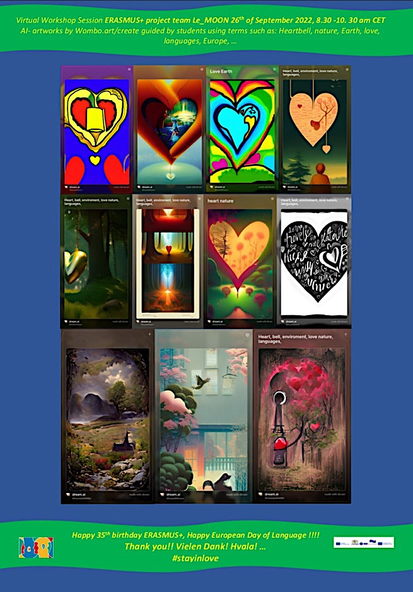

Read more about the workshop, get inspired for engaging in celebration of the European Day of Languages with some topic that matters for you, connect the festivities, frame your project within relevant initiatives, such as the ERASMUS+ project team LeMOON have done by connecting with the UN Global Week act4SDGs and the UNESCO MONDIACULT World Conference 2022:
https://www.acdvienna.org/aktuell/cd-2030-unesco-mondiacult-2022/heartbell2030-stayinlove-poster-action/

  - Love Letter
Hundertwasser

Read the excerpt from “I Love Schiele”
“I love Schiele, Picasso and Klee and their ilk, and Giotto, the old masters and the like.
But in-between and besides them there is a yawning emptiness. The simple is still broad.
I often dream like Schiele, my father, about flowers that are red, and birds and flying fish and gardens in velvet and emerald green and human beings who walk, weeping, in red-yellow and ocean-blue.
Yet I am barred from paradise. “

From the diaries 1950/1951.

Read the text laud, close your eyes, imagine the colors, and plants, birds, and fishes …
Interpret the Love letter, read the whole text, find out, what is it all about and how saying something in French differs from the same in German … Try, is it like that from your experience? If so, in what language can something be “better said”, or “sound more nicely” even when the content is not really nice one.
Find examples, explore more:
https://hundertwasser.com/en/texts/ich_liebe_schiele

II part:
More Exercises on the topic of Love in relational cultures

Exercise: Languages of Love in Sustainable Development

Objective
The exercise aims to highlight the importance of communication in relational cultures. Guiding insights are applied on Triangular Theory of Love by Robert Sternberg and its application to environmental love and sustainable development, inspired by Austrian reform pedagogue for early child education M. Margarete Schörl’s humanistic education principles grounded in the idea of fellowship love (charity), a kind of devotion to fellow (human.) With examples form environmental art created by Austrian environmental artist and activist Friedensreich Hundertwasser, guiding insights are extended with the focus on environmental love and its varieties in a multilingual setting.
For brother understanding of how (love) relationships are regulated and protected, tasks for project activities and policy dialogues are provided. European Policy papers are briefly introduced.

Supported competences and skills: attentive communication skills as green skills

1: Understanding the Triangular Theory of Love
Instructions for teachers:

Start by providing the survey to your students, collect, and evaluate their responses to the topic, for the entry. Instructions for the evaluation are attached in the separate document together with the L-Survey

Introduction to Triangular Theory of Love:
Read the paper attached and Explain Robert Sternberg's Triangular Theory of Love which consists of three components:
Intimacy: Feelings of closeness, connectedness, and bondedness.
Passion: The drives that lead to romance, physical attraction, and sexual consummation.
Commitment: The decision to remain with another and plan for the future.

Application to Environmental Love:
Intimacy with Nature: Developing a deep connection and understanding of the natural environment.
Passion for Sustainability: Feeling passionate about protecting and preserving the environment.
Commitment to Sustainable Practices: Making a conscious decision to engage in and advocate for sustainable practices.

2. Inspired by Margarete Schörl’s Humanistic Education #stayinlove:
Discussion on “Mitmenschlichkeit” (from German: humanity, “mit” points out “with”, therefore the focus on the “fellowship”) and "Stay in Love" Motto:
Mitmenschlichkeit: The importance of human compassion and love in education.
#stayinlove: Schörl’s idea “bleibe in Liebe” as a guiding principle to promote ethical relational cultures that are peaceful and constructive.

Part 1: Survey on Love and Relationships
Instructions:
Provide the survey to your students for engaging in the topic and in doc format for digital use, collect messages in audio formats, use other forms by your choice. Evaluate their responses by targeting priorities from

Survey Questions:
How do you define love? Share a thought, a quote, a poem, experience ,…
Can you describe a time when love motivated you to act sustainably or ethically?
How important is love in creating a peaceful and supportive social environment?
In what ways can love help resolve conflicts without causing harm?
How do you think practicing love to our next and compassion in daily life can contribute to sustainable development?
Have you experienced disappointment and/or violence in a love relationship?
If so, how have you went through that experience? Have you asked some friend, family member or some consultant for support? How was your health and wellbeing affected by such experience? How long it took you to come out of that experience and recover emotionally? What consequences/if any have you taken from that experience in your further relationships? S
hare more about by your interest …

Instructor's Guide: Evaluating Student Responses and Preparing the Lesson
To effectively prepare the lesson based on students' responses to the survey on love, the teacher should focus on the following three key points:

Understanding Definitions and Perceptions of Love:
Focus Point: Identify common themes in how students define love in their personal relationships.
Instruction: Pay attention to the variety of definitions and perceptions students have about love. Look for patterns in their descriptions, such as emotional closeness, support, care, or shared values. This will help in tailoring the lesson to address the students' inherent understanding and broaden their perspectives.
Application: Use these insights to introduce different aspects of love, including Sternberg's Triangular Theory, and show how these definitions can relate to both personal relationships and broader societal contexts, including environmental love.

Motivation and Ethical Actions:
Focus Point: Analyze examples where love motivated students to act sustainably or ethically.
Instruction: Highlight instances where students' actions driven by love have led to sustainable or ethical outcomes. These examples can serve as powerful illustrations of the practical impact of love on behavior and decision-making.
Application: Use these real-life examples to connect the concept of environmental love with students' experiences, emphasizing the role of love in fostering sustainable development. Encourage students to share their stories and reflect on how love can be a motivating factor in ethical actions.
Conflict Resolution and Compassion:
Focus Point: Examine how students view the role of love in creating a peaceful environment and resolving conflicts without harm.
Instruction: Look for insights into how students believe love contributes to peace and conflict resolution. Understanding their views can help in designing activities that build on their existing knowledge and skills.
Application: Use these insights to design activities that emphasize compassionate communication and conflict resolution. This can include role-playing scenarios, group discussions, and other interactive exercises that reinforce the importance of love and empathy in maintaining peaceful relationships and solving conflicts.

Step-by-Step Preparation
By focusing on these points, the teacher can create a lesson that is relevant, engaging, and directly connected to the students' experiences and interests. This approach will not only make the topic of love more relatable but also highlight its importance in promoting sustainable development and ethical relationships.

Review Survey Responses:
Categorize responses to identify common themes and unique perspectives.
Note any recurring ideas or significant outliers that could enrich class discussions.

Develop Lesson Content:
Incorporate students' definitions and perceptions of love into the introduction of the Triangular Theory of Love. Use real-life examples provided by students to illustrate how love can lead to sustainable and ethical actions.

Design Interactive Activities:
Plan activities that build on students' experiences with love as a conflict resolution tool, such as role-playing or group discussions. Include exercises that emphasize compassionate and attentive communication, tying these skills to the broader theme of sustainability and ethical behavior.

3. CLIL-based Exercise: Languages of Love
Explanation: This exercise focuses on the importance of communication in relational cultures and how attentive communication skills can be considered green skills that contribute to sustainability. Students will explore kind, friendly, and attentive terms and phrases, as well as understand the impact of negative communication such as cyberbullying and judgment.

Instructions for teachers for the entry lesson activities:
Language and Content Integration:
Discuss quotes about love from various cultural and linguistic backgrounds. Translate collected quotes including all language resources spoken by your students by all exercises, make a collection of language resources before starting this activity.
Interpret quotes while situating them in daily life and connecting them with student´s experiences and ideas about their meaning.
Translate collected Key Terms
^ include all language resources spoken by your students:
  - Love: Liebe (German), …
  - Sustainability: Nachhaltigkeit (German), …
  - Compassion: Mitgefühl (German), …
  - add more key terms by your choice

Extended activities by 2-hours+Workshops:
°Collecting Terms and Phrases for attentive communication:
Divide students into multilingual groups and provide each group with a set of terms and phrases that are kind, friendly, and attentive. Examples may include following terms: Kindness: Kind (English) Nett (German), …; Friendliness: Friendly (English), Amical (French), Freundlich (German), …; Attentiveness: Attentive (English), Aufmerksam (German), …;
°Collect terms and phrases that represent threatening (violent) communication such as:
Cyberbullyin, Prejudice, (English), Vorurteil (German), Hate speech (English), Hassrede (German) …
Situate collected terms and associate them with a case or existing campaign, such as # event

Discussion and Presentation:
  - Ask each group to discuss the positive and negative terms and phrases. How do these affect relationships and communication within a community?
  - Each group will present their findings and suggest ways to promote positive communication while reducing negative interactions.

4. Workshop: Promoting Positive Communication: WATCH & #stayinlove

In this workshop, guiding insights are provided for engaging in research about and exploring how communication culture is regulated at the European level through Policy papers, at the national state level, and in schools. Furthermore, with insights provided for research and discussions about how communication in social media is experienced and regulated, learners will engage in extended research and analysis about how regulations regarding hate speech, cyberbullying, and other forms of violence are enforced, comparing and analyzing their effectiveness.
Finally, the call for further engagement and proposed activities, such as engaging in WATCH-initiatives, reporting cases and sharing evidence -based policy recommendations for the improvement of regulations with relevant authorities, including governmental entities and social media providers. Additionally, guidelines are provided for connecting with the EU Youth campaign to support its impact by promoting it within schools and via social media, by organizing related activities in local communities and at schools to further endorse positive communication.

Engage: Policy papers and regulations: How is communicational culture regulated and in what forms?
Engage in research about Policy papers and regulations connected with communicational cultures and rules at the EU -level, at your national State level and at school.
Read about the youth campaign led by the Council of Europe Youth Department “No Hate Speech Movement “ seeking to mobilise young people to combat hate speech and promote human rights online. Launched in 2013, it was rolled out at the national and local levels through national campaigns in 45 countries. The movement will remain active beyond 2017 through the work of various national campaigns, online activists and partners.
Weblink: https://www.coe.int/en/web/no-hate-campaign

Explore, explain: How is your national state engaged in such campaigns?
Research about and connect with related initiatives. Get inspired by the Austrian State Chancellery to engage, if not yet:
https://www.bundeskanzleramt.gv.at/agenda/jugend/lebensqualitaet-und-miteinander/no-hate-speech.html#:~:text=Hassrede%20bezeichnet%20%C3%84u%C3%9Ferungen%2C%20die%20zu,Opfer%20k%C3%B6nnen%20Beratung%20suchen.

How is communicational culture regulated in your school?
How is communicational culture regulated in social media?
°Engage in research, compare and engage individually and/or within a small group together with students at your school with a critical eye, if regulations related to hate speech, cyberbullying and similar forms of violence in media are respected. Collect and connect your findings, situate them and present.

Guidance for your research:
1st phase
Conduct Comprehensive Research:
Begin by gathering information on regulations pertaining to hate speech, cyberbullying, and other forms of violence in social media platforms. Read the European and your national Policy regulations. Use reputable sources such as government websites, academic articles, and reports from reputable organizations.
Compare and Analyze:
Compare the regulations across different social media platforms and regions. Analyze how effectively these regulations are enforced and whether they adequately address issues of hate speech and cyberbullying. Consider factors such as reporting mechanisms, moderation policies, and transparency in enforcement.
Engage Critically and Collaboratively:
Engage in discussions individually or within small groups with fellow students at your school. Approach the topic with a critical eye, questioning assumptions and biases. Share insights, perspectives, and findings to deepen understanding and foster collaborative learning.

2nd phase: Present your findings
Presentation Guidance:
Start by summarizing your research findings, highlighting key regulations and their enforcement mechanisms; Provide an overview of the current landscape of communicational culture regulation in social media; Identify any gaps or challenges in the existing regulations, particularly concerning the prevention of hate speech, cyberbullying, and similar forms of violence; Discuss limitations in enforcement, loopholes in policies, or emerging issues that may not be adequately addressed.
Based on your research and analysis, propose recommendations for improving communicational culture regulation in social media; Consider practical solutions such as enhancing reporting systems, implementing stricter moderation policies, or increasing transparency in content moderation decisions. Support your recommendations with evidence and examples from your research.

Propose improvement, share your recommendations for the policy improvement with responsible governmental entities, social media provider and further relevant entities, connect with the EU Youth campaign and support its impact by sharing the info and presenting the campaign in your school and via social media; organize supporting activity at your school and local community; WATCH media and look for cases which may not be in accordance with the EU regulations, report, avoid participating in compromising dialogues on social media, #stayinlove by your response while being aware of details shared, the context and backdrop connected, approve the information if it is a “fake news” and check the provider, understand the purpose of the information and read comments if available to get bigger picture, report and share when detecting fake, fraud, hate speech or whatever matters for you.

5. It hurts to wait with love if love is somewhere else HWG46: jealousy, Yellow Houses
"When you mix architecture with love, you get box houses-of-cards with yellow hot-water-bottle windows. In every window a blue tear. The red tower is located at Vienna's West Train Station. Near it is where she lived. Plattensteiner, my astrologer, said I should paint a lot when I am unhappily in love, especially then. Later I would not get around to it."

(from: Hundertwasser 1928-2000, Catalogue Raisonné, Vol. 2, Taschen, Cologne, 2002, p. 507)

Engage, explore, explain: What role plays jealousy in love relationships? Engage in discussions, learn from experience of Hundertwasser, find your form for expression, describe motives as for the blind person. With what feeling would you associate the yellow color? What nuance would be the best suitable? How many nuances of yellow are on the artwork and on what motives?

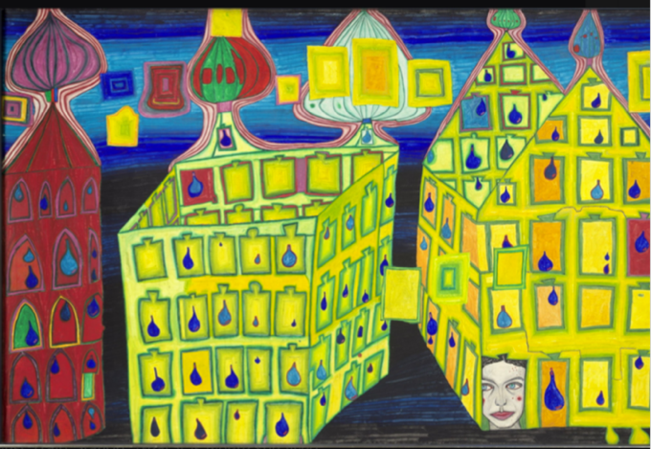
630
GELBE HÄUSER - MIT DER LIEBE WARTEN TUT WEH, WENN DIE LIEBE WOANDERS IST - EIFERSUCHT
YELLOW HOUSES - IT HURTS TO WAIT WITH LOVE IF LOVE IS SOMEWHERE ELSE
MAISONS JAUNES – JALOUSIE

https://www.hundertwasser-kalender.de/poster-and-art-prints/Mini-Art-Prints-with-Passe-partout/YELLOW-HOUSES
https://www.hundertwasser.com/en/paintings/630_gelbe_haeuser_-_mit_der_liebe_warten_tut_weh_wenn_die_liebe_woanders_ist_-_eifersucht_559
#stayinlove

Excerpt from the NASA lesson: https://www.jpl.nasa.gov/edu/teach/activity/modeling-the-earth-moon-system/
Source: NASA https://science.nasa.gov/exoplanets/what-is-the-universe/
Weblink to info page: https://www.acdvienna.org/futures-of-education/intalk-sessions-unesco-futures-of-education/
Hundertwasser webpage to artworks: https://www.hundertwasser-kalender.de/poster-and-art-prints/Mini-Art-Prints-with-Passe-partout/YELLOW-HOUSES, https://www.hundertwasser.com/en/paintings/630_gelbe_haeuser_-_mit_der_liebe_warten_tut_weh_wenn_die_liebe_woanders_ist_-_eifersucht_559
Source: https://commission.europa.eu/strategy-and-policy/priorities-2019-2024/new-push-european-democracy/equality-and-inclusion_en , EU policy Youth in External Action: https://ec.europa.eu/commission/presscorner/detail/en/ip_22_5884 , Ending gender-based violence: https://commission.europa.eu/strategy-and-policy/policies/justice-and-fundamental-rights/gender-equality/gender-based-violence/ending-gender-based-violence_en#:~:text=The%20Commission%20proposed%20new%20legislation,against%20women%20and%20domestic%20violence. , EU gender equality strategy: https://commission.europa.eu/strategy-and-policy/policies/justice-and-fundamental-rights/gender-equality/gender-equality-strategy_en
Download paper, 3 pages introduction to Triangular Model of Love. Weblink: https://www.hofstra.edu/pdf/community/slzctr/stdcsl/stdcsl_triangular.pdf
Poster action #stayinlovewebpage info: https://www.acdvienna.org/aktuell/cd-2030-unesco-mondiacult-2022/heartbell2030-stayinlove-poster-action/

