Project ID: 2021-1-CZ01-KA220-SCH-000034484
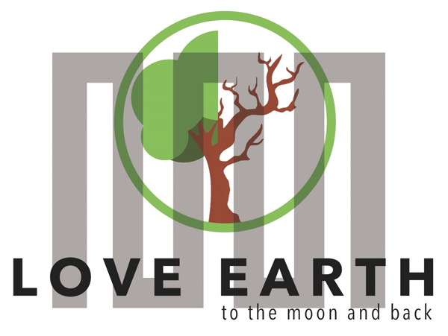

COURSE FOR ENVIRONMENTAL EDUCATION
e-Modules: Teaching Learning activities and their technology enhanced material set to develop


COURSE AUTHOR
©Tatjana Christelbauer MA (TC),
contributor: Dr. Geraldine Fitoussi-Hoffmann
ACD Team Austria:

DISCLAIMER
Funded by the European Union. Views and opinions expressed are however those of the author(s) only and do not necessarily reflect those of the European Union or the European Education and Culture Executive Agency (EACEA). Neither the European Union nor EACEA can be held responsible for them.
COURSE SHARING LICENSE CC BY-NC-SA = 
Canonical URL: https://creativecommons.org/licenses/by-nc-nd/4.0/

MODULE: 1
STEAM LESSON bound: Environmental Ethics in Space education

STEAM lesson on the intersection of arts_science_policy
Author: Tatjana Christelbauer MA, ACD/AT : Relational aspects, Space Policy, Art meditation
Contributor: Areal Sea workshop Dr. Geraldine Fitoussi-Hoffmann, ACD-Agency for Cultural Diplomacy Space Academy member; KariFilm media
Subjects: Environmental Education, Physics, Social Sciences, Space Education, Policy Learning, Environmental Ethics, Mental Health, Fine Arts, English, …
Learning & Social Competences & Skills promoted: green skills such as sustainable communication practices and awareness building, ethical reasoning, inquiry-based learning, working with media, analytic thinking, critical thinking, presentation techniques (storytelling, …)
Resources used: European Space Agency ESA, U.S. National Aeronautics and Space Administration agency NASA, European Union Space Policy, materials & media created by authors of this lesson
Table of Content
1. Relational Tides: Water, Space, Earth, Physics, and Space Education
1.1. Introduction to the Topic
1.2. Facts from Current Statistics and Science Related to Water Resources
1.3. Greenhouse Gas in Space and its impact on Earth's Climate
1.4. Observing Earth from Space: media for introductory guide, inquiry discussion
2. Space Policy: Regulation of Performance in Space
2.1. Brief introduction, Austrian Space Policy
2.2. Introduction to EU Space Policy
2.3. Ethics of Using Satellites for Observing Water on Earth
3. Space in Careers, International Relations
3.1. Job profile: astronaut
3.2. Daily life in Space
3.3. Workshop: Areal Sea - Impact Awareness & Human Activities:
- Ethical considerations of space exploration
4. Excurse: Once with a “Blue Moon under the Earth”: Art mediation exercise inspired by Hundertwasser´s artwork “The Blue Moon under the Earth”
^ Unify, summarize, affiliate
Environmental Ethics in Space Education
  - Relational ties Space-Earth: ´Understanding the Earth system and the complex interactions that shape our planet is paramount for addressing environmental challenges, mitigating climate change, preparing for natural disasters, managing resources sustainably and conserving biodiversity.´ ESA
Explore more, watch/listen to video of NASA on YouTube: Learning Space With NASA – Studying Earth From Space: https://www.youtube.com/watch?v=P2gAMsmZHp4
Explore Steamy relationships between Earth and Space through the lens of the Water vapor, the Earth´s most abundant greenhouse gas, and is also a key part of Earth’s water cycle: the path that all water follows as it moves around Earth’s atmosphere, land, and ocean as liquid water, solid ice, and gaseous water vapor. It’s responsible for about half of Earth’s greenhouse effect — the process that occurs when gases in Earth’s atmosphere trap the Sun’s heat. Greenhouse gases keep our planet livable. Without them, Earth’s surface temperature would be about 59 degrees Fahrenheit (33 degrees Celsius) colder. (…) Visit the NASA webpage and read the whole text: https://science.nasa.gov/earth/climate-change/steamy-relationships-how-atmospheric-water-vapor-amplifies-earths-greenhouse-effect/
  - Facts from current statistics and science related to water resource: Water

How it matters in the current sustainable development and what effects have the climate change on our water resource on Earth?

Excerpt from the United Nations webpage:
´Water and climate change are inextricably linked. Climate change affects the world’s water in complex ways. From unpredictable rainfall patterns to shrinking ice sheets, rising sea levels, floods and droughts – most impacts of climate change come down to water (UN Water).
Climate change is exacerbating both water scarcity and water-related hazards (such as floods and droughts), as rising temperatures disrupt precipitation patterns and the entire water cycle (UNICEF).´
According to United Nations statistics, about two billion people worldwide don't have access to safe drinking water today (SDG Report 2022), and roughly half of the world's population is experiencing severe water scarcity for at least part of the year (IPCC). These numbers areexpected to increase, exacerbated by climate change and population growth (WMO)
Only 0.5 per cent of water on Earth is useable and available freshwater – and climate change is dangerously affecting that supply. Over the past twenty years, terrestrial water storage – including soil moisture, snow and ice – has dropped at a rate of 1 cm per year, with major ramifications for water security (WMO).´
Insights from the European Space Agency:
Less than 3% is freshwater on Earth. Then the vast majority of this is locked up in icecaps and glaciers, leaving less than 1% available for drinking and other domestic needs, agriculture and industrial processes, and more. When abundant, water allows economies to grow, but in times of scarcity, it can cause life-threatening crises. It has never been more important to manage water supplies effectively to make good use of every drop – and satellites orbiting the planet
can play an important role in this process. Thanks to satellites, we are better placed than ever before to understand and measure the processes driving the water cycle and the impact that climate change and human activity are having.
They also allow us to measure and monitor, for example, the changing shape of lakes, reservoirs, and rivers so that mitigation strategies can be put in place.

  - Greenhouse gas in space and its impacts on Earth´s climate
Water vapor is Earth's most abundant greenhouse gas. It's responsible for about half of Earth's greenhouse effect — the process that occurs when gases in Earth's atmosphere trap the Sun's heat. Greenhouse gases keep our planet livable. Water vapor is also a key part of Earth’s water cycle: the path that all water follows as it moves around Earth’s atmosphere, land, and ocean as liquid water, solid ice, and gaseous water vapor. (NASA)

Engage in further readings, navigate to NASA webpage, find more details about how atmospheric water vapor amplifies Earth’s greenhouse effect
https://science.nasa.gov/earth/climate-change/steamy-relationships-how-atmospheric-water-vapor-amplifies-earths-greenhouse-effect/

Explain your findings about impacts of the atmospheric water vapor on Earth´s greenhouse effect on climate, and how it matters for us in daily life. Find articles in media about how people manage extreme weather conditions and what are the main challenges connected with climate change and space.
Extend: Navigate to the lesson provided by ESA “Parallel experiment at school and in the space”,
notice details and aspects related to sustainable use of resources, relational aspects and modes among cosmonauts and students.
„During his mission on the International Space Station, ESA astronaut Paolo Nespoli attempted to grow plants in a miniature greenhouse. At the same time, European schoolchildren and the Mars500 crew ran the same educational experiment to compare results. (…)“
https://www.esa.int/Science_Exploration/Human_and_Robotic_Exploration/Education/Greenhouse_in_space

How is the EARTH observed from space?

Navigate to Webpage of ESA, find EARTH WATCH from Space- video: https://www.esa.int/Applications/Observing_the_Earth/Watch_online_Earth_from_Space_special_edition6
Extend your experience with observation: Notice the WATCH-method and make further research about the current number of satellites surrounding the Earth, think about how observation of the Earth may also impact human health and privacy. Find out if and how it matters by researching in web. Use trustful media and news portals to get quality information.

- Space Policy: How is the performance in space regulated?
There is no claim for sovereignty in space; no nation can “own” space, the Moon or any other body. Weapons of mass destruction are forbidden in orbit and beyond, and the Moon, the planets, and other celestial bodies can only be used for peaceful purposes. United Nations Committee on the Peaceful Uses of Outer Space (UNCOPUOS).
Why is important to regulate performance in space and how it matters?

Engage in research, look for historical documents and cases, compare them with current cases, present your findings, explain your opinion, exchange opinions with your colleagues. Engage in further reading, learn about national regulations and the EU space policy.

  - From Austria to the space
In 2001, Austria established a National Point of Contact for Space Law (NPOC Austria) in reference to the European Centre for Space Law (ECSL). The NPOC Austria's objective is to promote space law in Austria and to support students. It serves as the first contact point for people interested in space law. Austria has its own national law regulating space activities enacted the Austrian Outer Space Act in 2011 which was complemented by the Outer Space Regulation in 2015. In 2007, the European Space Policy has for the first time created a common political framework for space activities in Europe.

  - EU Space Policy
Engage: Follow the weblink to the EU page with insights to EU Space Policy: https://www.consilium.europa.eu/en/policies/eu-space-programme/
Make notes about the aims and purpose of the EU Space Policy and research about implemented activities in your country of residence.
Explore how learning about satellite technology and its applications can lead to more informed decisions about resource management and environmental conservation
Situate: Look for a case study related to water-related challenges in your local community or find some international report about current environmental disaster connected with water.
Discuss how the use of satellites can enhance our understanding of the Earth's water cycle and contribute to global water management efforts.
Guiding questions designed to help you research and discuss the ethics of using satellites for observing water on Earth and investing in expensive space technologies.
Additionally, a relevant link to illustrate the importance of this topic for humans on Earth and the value of learning about it is included.

  - Ethics of Using Satellites for Observing Water on Earth and Ethical Considerations

Engage in research: What are the primary purposes of using satellites? How many satellites are surrounding the Earth?
How do satellites help in monitoring, and managing water resources?
What ethical issues arise from the use of satellites to observe water resources on Earth? How do satellites contribute to water conservation and management, and what are the potential privacy concerns related to satellite observations? How can we balance the need for space exploration with the need to address urgent problems on Earth?
How do investments in space technologies benefit scientific research and technological advancement? What are the opportunity costs of investing in space technologies compared to other areas such as healthcare and education?
How do international collaborations in space technology investments influence global relations?
How might advancements in space technologies contribute to solving global challenges such as climate change and resource management? What are the long-term ethical implications of humanity's increasing presence in space?

Use the weblink to find guidance for your further study and research on how satellites are used to monitor and manage water resources on Earth, illustrating their importance for human life &the environment: NASA Earth Science Division: How Satellites Help Understand Earth's Water Cycle
Extend further: Learn more about the Mission of the European Space Agency ESA and NASA, discover lessons and programs for engaging Create project related to Space education and sustainable development.
Reach out, connect & act: https://www.un.org/en/actnow/ten-actions-world-working-together
Space4Youth UNOOSA: https://www.unoosa.org/oosa/de/ourwork/space4youth/index.html
Space Generation advisory Council: https://spacegeneration.org/united-nations/space-and-youth-2030

- Space in careers, international relations

  - Job profile: astronaut
Learn more about this job profile, listen to Women astronauts by NASA on YouTube videos:
https://www.youtube.com/watch?v=FR8gWTSk1jI and: https://www.youtube.com/watch?v=GP66C_7icxg

For more fun discoveries, read about water use by astronauts, and learn about
Water Recovery System following the weblink:
https://www.nasa.gov/missions/station/iss-research/nasa-achieves-water-recovery-milestone-on-international-space-station/#:~:text=ECLSS%20is%20a%20combination%20of,from%20crew%20breath%20and%20sweat.

Who was the first astronaut in the world?
Engage in research: connect historical facts, find responses from astronauts about their experiences, learn about the mission, its purpose, outcomes and effects on humanity, nature and space

  - Daily life in space:
How are human relations performed in the space?
Engage in research, here are some guiding questions for research related to relational culture and wellbeing:
Investigate the dietary requirements of astronauts during space missions.
What types of food are included in their diet, and how are these foods selected to meet their nutritional needs? Explain how the lack of gravity affects food consumption and digestion in space.
Explore the hygiene practices that astronauts must follow while aboard the International Space Station (ISS). How do astronauts manage personal hygiene, such as bathing and dental care?
How do astronauts adapt their exercise routines and physical activities in the microgravity environment of space to counteract muscle atrophy and bone density loss, and what role does nutrition play in supporting their physical health and performance during space missions? What leisure activities are available to astronauts during their downtime in space, and how do these activities contribute to their mental health and well-being during extended missions?
Explore the challenges astronauts face in maintaining intimate relationships while in space, considering factors such as physical separation, communication barriers, and the unique stressors of space missions. Provide a case study or interview with an astronaut discussing their experiences and strategies for navigating relationships in space. Research more, learn from “unusual” examples, get inspired by new discoveries!
“I’ve been asked many times what’s the hardest thing about space flight and I say it’s learning the language. When I became Deputy Chief at the Astronaut Office it became very obvious to me that as we were moving into long duration missions, we needed to develop our communication skills and our what we call ‘soft skills’... (…)”

Dr. Peggy Whitson, Astronaut and former Commander of the International Space Station, Chief of the Astronaut Office, and Chairperson of the Astronaut Selection Board
Final note: Add some more quotes from astronauts by your choice, finalize the lesson with a summary of insights you found most useful and relevant for your study.
Mixed guide and media for further discoveries and engagement
Visit space museums and exhibitions, look for movies, music, dances inspired by space, discover how space is integrated in arts; Follow social media pages of ESA, NASA, and related pages from connected scientific institution; Engage in projects and initiatives related to ethics in space and share your knowledge and practices with students from another country, follow open calls for participation and action by the United Nations and the European Youth portals; Become an ´green ´astronaut, advocate, contribute to more green sustainable performance in space, it is a Collaboration without Borders, watch the YouTube shorts: https://www.youtube.com/shorts/xz_N4xhcOvI
Watch videos for further guide:
Teacher resources: Astronaut Journaling
National Air and Space Museum
https://www.youtube.com/watch?v=BRAGY5VQePE
Our Planet, Our Home
Earth Day Perspective by NASA:
https://www.youtube.com/watch?v=8DQeFmWUyd8
European Space Agency
ESA’s Euclid space mission
https://www.youtube.com/watch?v=wtiN1xXSspk
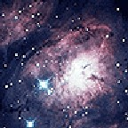
Kosmos
By Ben Pirard, CC BY-SA 3.0, https://commons.wikimedia.org/w/index.php?curid=1835505

  - Engage in the Workshop: Areal Sea: Impact-Awareness of & dilemmas related to human activities in space, through space images
Contribution created by Dr. Geraldine Fitoussi-Hoffmann
Navigate for guidance to the topic by the PREZI presentation following the weblink: https://prezi.com/view/4Tq0ri5qjpJSvYQVqDgy/
The Aral Sea seen by satellite. Left in 2006, right in 2009:
Images Credits GeoVille Information Systems
Introductory: A human-induced natural disaster: the water that fed the lake was diverted for cotton cultivation.
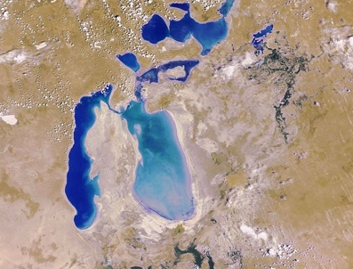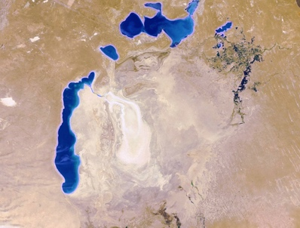
The size of the lake has been considerably reduced.
The consequences: disappearance of fish and birds, loss of economic activity for fishermen and inhabitants, displacement of the population, health problems linked to the polluted desert.
Engage:
°Observe the two images and see the changes
-°Reflect on the choices made. Understand the impacts. What do we understand from these images?
We understand that water resources are not inexhaustible, and we reflect on the economic benefits of cotton crops / disastrous ecological, human, and economic consequences.
°Describe images by using AI tools for help, provide assistance for screen readers
°To go further, look for examples using satellite images: Space Images Search: www.esa.int
of changes in the size of forests and large cities and think about the economic, ecological, and human caused consequences.
^Include ethical considerations into consideration and discussion:
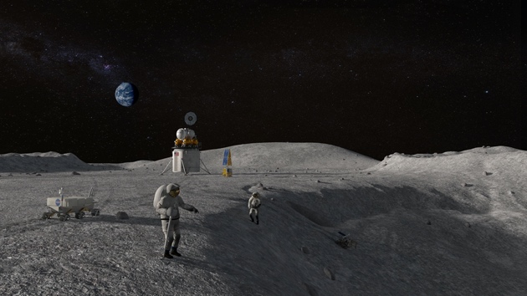

Image source: NASA
Is it ethically correct to go to the Moon to get water?
Is it ethically correct to send people into space?
to build a lunar base as a training ground for going to Mars?

Engage: Reflect on this question considering following aspects:
1.space techniques are a source of technological innovations
that have an impact on sustainable ecological practices;
2.the costs for developing and using space techniques are high
3.There are maybe other priorities for the large investment
Connected with climate change on Earth!

What can be done and how to make the best cost-efficient solution?
Explore in ethical dilemma by a role play. Create and propose innovative solutions
Debate the ethical implications of investing large sums of money into space technologies while there are ongoing crises on Earth that require immediate attention. Explain: Exchange your opinion with colleagues, search in media and web for cases related to the topic. Navigate to the NASA lesson on Sea-Level rise for further guidance: https://www.jpl.nasa.gov/edu/teach/activity/the-science-of-earths-rising-seas/

- Excurse: Once with a “Blue Moon under the Earth”
Art mediation exercise inspired by Hundertwasser´s artwork:
355
BLUE MOON SOUS TERRE
BLAUER MOND UNTER DER ERDE
Blue Moon Under the Earth

Painted at Altaussee, April 1958
https://www.hundertwasser.com/malerei/355_blue_moon_sous_terre__293

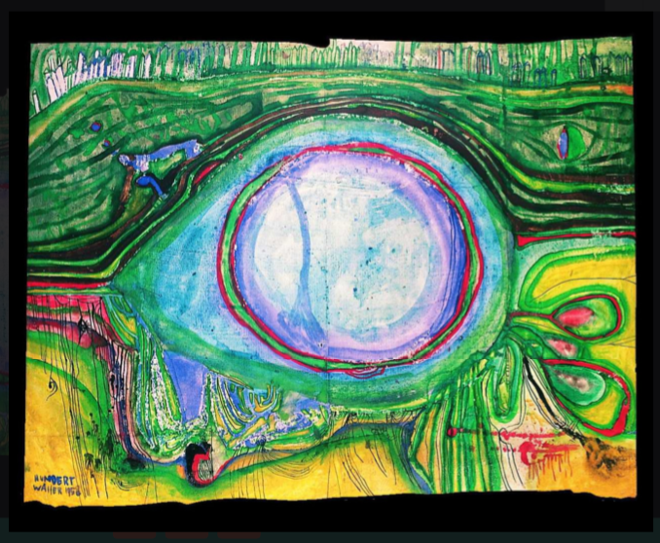
© 2024 Die Hundertwasser gemeinnützige Privatstiftung Wien
Introductory guide
What is Blue Moon?
From the perspective of the space science and semantic, to the meaning of the phrase,
the “Blue Moon”, translated in German as der “Blaue Mond”, is a rare lunar event that only occurs on average every two and a half years in a season with four full moons. A blue moon is not blue in color. In fact, a blue moon does not look any different than a regular, monthly full moon.
It´s rare appearance has been applied in the phrase "Once in a blue moon …", meaning, something happening rare. ^ (Source: NASA: https://spaceplace.nasa.gov/full-moons/en/
The practice of designating the second full moon in a month as "blue" originated with amateur astronomer James Hugh Pruett in 1946. The 1937 Maine Farmers' Almanac article was misinterpreted by James Hugh Pruett in a 1946 Sky and Telescope article, leading to the calendrical definition of “blue moon” that is now most commonly used, i.e. the second full moon in a calendar month. (Source: https://skyandtelescope.org/observing/what-is-a-blue-moon/ )

Engage: Situating Hundertwasser´s artwork “The Blue Moon under the Earth” in this lesson which focus is given on relational aspects and environmental ethics in space, the exercise is aimed to extend the previous science-policy approach with semantic meaning and symbolic relational aspects.
Guided imagination with multilingual approach enables multiple entries to interpretation and thus to understanding of the artwork through diverse lenses. Such experiences are supporting creative thinking and transdisciplinary learning, with multisensorial experience.

Art mediation exercise: ©Semantic embodiment method
°Read the title of the Hundertwasser´s artwork in all three languages, interpret it´s meaning,
by your free imagination, by each language separately.
^Notice difference by your interpretation (if any). Use this experience by some other opportunity, to widen your awareness about how pronouncing or reading in diverse languages may have different impact on your associative images and memory, interpretation, and also punctuation-meaning what matters the most.
°Explore and play with words and titles. Let your imagination move, navigate the space flight across linguistic space and make a postcard and / or diary, with notes about experiences from your journey.

°Imagine a story related to the title of the artwork.
°Describe the artwork as for the blind person.
°Get inspired for further interpretations while noticing the composition of details related to colors, shapes, figures, motives.
°Create a story, make your drawing, imagine the blue moon under the Earth. Try interpreting the title metaphorically, such as by saying “Once in a blue moon…”: how would you interpret the Blue Moon under the Earth?

This exercise may inspire for playful imagination and for creative journey across spaces, be it imaginative or real, engage, explore, explain and extend your experiences by presenting your created artwork to the topic of the Blue Moon, a story- maybe a fiction or a role play? … Whatever comes, creative experience is aimed to widen perspectives and support cross-disciplinary thinking and learning.

You can try creating with AI online tools such as
Dream by Wombo art: https://dream.ai/card/37216455-df04-4e79-b252-455a2761cb98
and using the Braille art for widening experience with AI and assistive technologies:
https://www.pathstoliteracy.org/just-fun-braille-designs/

Extend further: Try observing the Blue Moon by opportunity, visit observatory, learn about the use of a telescope, get informed when it will appear. Look by NASA or ESA, here is the weblink to webpage with further resources for educators on Moon phases:
https://nasaeclips.arc.nasa.gov/video/ourworld/our-world-moon-phases

Related lessons: Module 2 “Cyclical nature”, Lesson parts on Dreams, Daydreaming, Module 4 “Environmental impact on Human Health”, Hundertwasser “The Blue Moon, Escape in the Outer Space”

^ Unify, summarize, affiliate
your experiences form this lesson bond within a project or by presentation to some of most impressive learning experiences you could gain.

Here are sone ideas for guidance:
Constructing a space shuttle from available resources at school, reflecting on insights from this lesson bond in a role play;
Art project inspired with environmental ethics in space;
Visit of a space station, observatories, space museum, digital experience through new media technologies such as virtual reality;
Drafting policy recommendations, engaging in environmental ethics and protection of space;
More by your choice …

Source webpage ESA: https://www.esa.int/Applications/Observing_the_Earth/10_ways_Earth_is_interconnected
Webpage, source: https://www.un.org/en/climatechange/science/climate-issues/water#:~:text=About%20two%20billion%20people%20worldwide,and%20population%20growth%20(WMO).
Source: https://www.esa.int/Applications/Observing_the_Earth/Satellites_key_to_addressing_water_scarcity
The Outerspace Treaty Weblink: https://www.spacefoundation.org/space_brief/international-space-law/ ; https://www.unoosa.org/oosa/en/ourwork/spacelaw/treaties/introouterspacetreaty.html
In 2012, Austrian Red Bull skydiver Felix Baumgartner took a helium balloon into the stratosphere and skydived back to earth. The Austrian jumped from the balloon effectively while in space, where the normal rules of sky diving do not apply. What do you think, which rules would apply to such action? Read more about, watch the video: https://edition.cnn.com/2022/10/14/sport/felix-baumgartner-red-bull-sky-dive-spt-intl/index.html
Source, Webpage: https://austria-in-space.at/en/space-law/nationalspacelaw.php#:~:text=Austria%20has%20its%20own%20national,Outer%20Space%20Regulation%20in%202015.
Semantic embodiment method was developed in this multilingual form by Tatjana Christelbauer in 2004-6, established in the practice of the Wor(l)ding method which was awarded with Innovation certificate by Austrian center for language competence ÖSZ Graz in 2014 https://www.tatjana-christelbauer.com/en/worlding , and additionally extended with scientific essay written by Dr. Michael Kimmel based on further practices developed by Tatjana Christelbauer in 2023 during the ERASMUS+ project “The Rhythm of Nature”: https://www.tatjana-christelbauer.com/en/letsrain/environmentaleducation/dancearts

