Project ID: 2021-1-CZ01-KA220-SCH-000034484
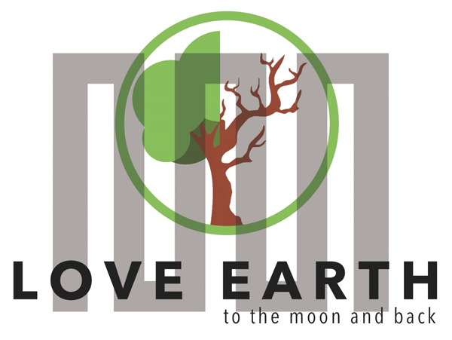

COURSE FOR ENVIRONMENTAL EDUCATION
e-Modules: Teaching Learning activities and their technology enhanced material set to develop


COURSE AUTHOR
M1 STEAM lesson: Creative Science with Two Moons
©Tatjana Christelbauer MA (TC)
ACD Team Austria

DISCLAIMER
Funded by the European Union. Views and opinions expressed are however those of the author(s) only and do not necessarily reflect those of the European Union or the European Education and Culture Executive Agency (EACEA). Neither the European Union nor EACEA can be held responsible for them.
COURSE SHARING LICENSE CC BY-NC-SA = 
Canonical URL: https://creativecommons.org/licenses/by-nc-nd/4.0/

MODULE: 1

LESSON: Creative Science with Two Moons

Didactics of applied arts and science
Guiding lesson for teachers with a source from Martin Wagenschein,

Subjects: physics, biology, social sciences, music, fine arts, pedagogy, …

Author: Tatjana Christelbauer MA, ACD/AT
Keyterms: #physics #wellbeing #arta4health #martinwagenschein #beethoven #creativelearning #waldorfpedagogy

- Introductory Guide
What is the teaching and learning of natural science using an inquiry-based approach?
Inquiry-based science adopts an investigative approach to teaching and learning where students are provided with opportunities to investigate a problem, search for possible solutions, make observations, ask questions, test out ideas, and think creatively and use their intuition.
In this lesson, we are exploring the relevance to creative learning of physics and the relationship between humans, nature, and wellbeing, by an example from didactic work of the visionary German physicist and educator, Martin Wagenschein (1896-1988) who believed that learning should be grounded in concrete experience and observation of the natural world.

In his essay "Two Moons," Wagenschein explores the idea that our understanding of nature is shaped by our own experiences and perceptions. He argues that we cannot fully understand the natural world without first experiencing it, and that our own subjective experiences play a key role in shaping our perceptions and understanding of nature. This concept of experiential learning and the importance of subjective experience in shaping our understanding of the natural world has important implications for the study of physics and the relationship between humans, nature, and wellbeing. By engaging with nature through creative and experiential learning activities, students can gain a deeper understanding of the laws and principles that govern the natural world and develop a greater appreciation for the beauty and complexity of the natural world. This, in turn, can have a positive impact on their wellbeing, helping them to develop a greater sense of connection to the natural world and to see themselves as part of a larger ecosystem.

This concept of experiential learning and the importance of subjective experience in shaping our understanding of the natural world has important implications for the study of physics and the relationship between humans, nature, and wellbeing. By engaging with nature through creative and experiential learning activities, students can gain a deeper understanding of the laws and principles that govern the natural world and develop a greater appreciation for the beauty and complexity of the natural world. This, in turn, can have a positive impact on their wellbeing, helping them to develop a greater sense of connection to the natural world and to see themselves as part of a larger ecosystem.

  - Tasks for engaging for teachers:
Read Martin Wagenschein's "Two Moons"
https://www.natureinstitute.org/article/martin-wagenschein/two-moons
and the essay: Save the Phenomena
The Primacy of Unmediated Experience, to extend
https://www.natureinstitute.org/article/martin-wagenschein/save-the-phenomena-the-primacy-of-unmediated-experience

° Reflect on your teaching practice and get inspired for some novel interdisciplinary trials, by including and connecting physics with arts, health, and wellbeing.
° Make notes about your experiences with students while following the guidance and proposed tasks. Create more such lessons and connect with a colleague who teaches arts, psychology, if you are teaching physics and v.v.
° Explore more by the exercise based on Martin Wagenschein's "Two Moons" and the Moonlight Sonata composed by the Ludwig van Beethoven

This exercise allows students to explore the relationship between nature, music, and dance,
and to think about how our own experiences and perceptions shape our understanding of the natural world. By engaging with the Moonlight Sonata and the concept of "Two Moons," students can gain a deeper appreciation for the power of art to shape our relationship with nature and the world around us.

- Task for teachers & students:
Step one: start by discussing the concept of nature's influence on human feelings and wellbeing, and how this has been explored in art and literature. Introduce Martin Wagenschein's essay "Two Moons" and the idea that our understanding of nature is shaped by our own experiences and perceptions.

Explore:
°Play a recording of the Moonlight Sonata by Beethoven and ask students to listen and pay attention to how the music makes them feel. Encourage them to close their eyes and imagine a scene in nature that the music might be associated with.
°Listen the story of a visually impaired student how shares her impressions while playing the Moonlight Sonata (double-click on the black box):


°Exchange impressions with your students, ask them to create their sound-or video Moon-story
°Ask students to research in web and select a series of images of the moon, both in its natural state and in various stages of eclipse or illumination. Ask them to choose one image that they feel best represents the mood and feeling of the music.
°Using the chosen image as inspiration, have students create a dance piece that reflects the mood and feeling of the Moonlight Sonata. Encourage them to explore movement and gesture that evokes the natural world, and to think about how their own experiences and perceptions shape their movement choices.
°After students have had time to create and practice their dance pieces, have them perform for the class. Encourage them to share their thoughts and feelings about the connection between nature, music, and dance, and how this exercise helped them to explore these connections in a new way.
°Search for more composed music pieces, poems, songs, inspired by moon
°Extend your journey on the path of Martin Wagenschein with “Dialogues with nature” on Spotify by your interests on the webpage of the Nature Institute: https://www.natureinstitute.org/podcast/in-dialogue-with-nature or on Spotify: https://open.spotify.com/show/3pShAySeBcrFFMxSBhBXEE

