Project ID: 2021-1-CZ01-KA220-SCH-000034484
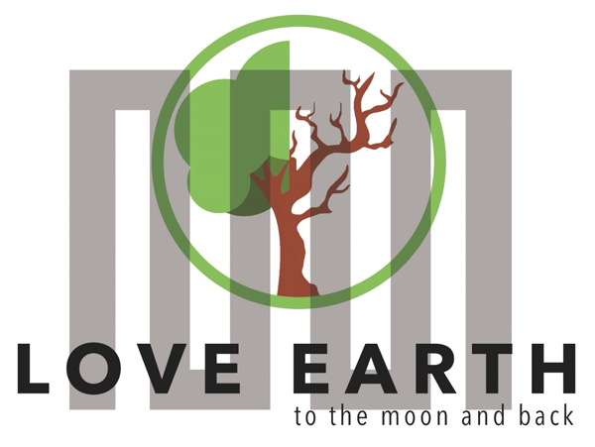

COURSE FOR ENVIRONMENTAL EDUCATION
e-Modules: Teaching Learning activities and their technology enhanced material set to develop

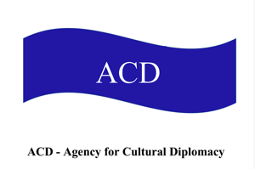

M1: WATCH- initiatives

COURSE AUTHOR
©Tatjana Christelbauer MA (TC)
ACD Team Austria

DISCLAIMER
Funded by the European Union. Views and opinions expressed are however those
of the author(s) only and do not necessarily reflect those of the European Union or the European Education and Culture Executive Agency (EACEA). Neither the European Union nor EACEA can be held responsible for them.
COURSE SHARING LICENSE CC BY-NC-SA =
Canonical URL: https://creativecommons.org/licenses/by-nc-nd/4.0/

MODULE: 1 Humans & Nature

LESSON: Sustainable Development Monitoring methods:
The significance of WATCH

Guiding insights for week-long workshops

Subjects: Geography, Biology, Social Science, English, Ethics, Policy Learning

Sustainable development monitoring methods
- The Significance of "Watching"
"Watching" as a method goes beyond passive observation; it embodies active engagement, such as monitoring, holding the system accountable for its actions, and advocating for improvements in judicial policy and practice.
When we "watch" engaged, we are attuned to the complexities of our environment, recognizing the interconnectedness of people, nature, and all living beings. This mindful approach allows us to perceive the subtle nuances of our interactions and to respond with empathy, compassion, and ethical reasoning.

  - SDG-Watch and Monitoring Success:
The Sustainable Development Goals (SDGs) provide a framework for global action to address pressing social, economic, and environmental challenges. SDG-Watch initiatives play a crucial role in monitoring progress towards achieving these goals at the local, national, and international levels. By tracking indicators and collecting data on key issues such as poverty, education, health, and environmental sustainability, SDG-Watch programs enable policymakers, organizations, and communities to assess their efforts, identify gaps, and take corrective action as needed.

  - Psychological Perspective on "Watching" Engaged:
From a psychological standpoint, "watching" engaged involves heightened awareness and cognitive empathy—the ability to understand and share the feelings of others.
This empathetic awareness extends not only to human experiences but also to the well-being of other species and the planet as a whole.
By cultivating empathy and ethical reasoning, individuals can develop a deeper connection to their surroundings and act as stewards of the environment, advocating for justice, equity, and sustainability.
Learning to "Watch" Engaged in Daily Life, students can learn to "watch" engaged in their daily lives by practicing mindfulness, empathy, and critical thinking.
This involves:
- Observing and reflecting on their own actions and their impact on others and the environment.
- Seeking out diverse perspectives and understanding the interconnectedness of social, environmental, and economic issues.
- Taking action to address challenges and promote positive change, whether through advocacy, community engagement, or personal lifestyle choices.

By integrating the principles of "watching" engaged into their daily lives, students can become active participants in building a more just, sustainable, and compassionate world.
In summary, "watching" engaged involves active awareness, empathy, and ethical reasoning. SDG-Watch initiatives play a vital role in monitoring progress towards global goals, while a psychological perspective highlights the importance of empathy and mindfulness in fostering positive change.

Some relevant references related to "watch" initiatives and the principles of engagement,
as explained:
SDG Watch Europe: a broad, cross-sectoral civil society alliance based in Brussels. Its goal is to hold the EU and national governments to account for the implementation of the 2030 Agenda for Sustainable Development (SDGs). https://sdgwatch.at/en/who-we-are/sdg-watch-europe/

SDG Watch Austria: SDG Watch Austria is a broad, cross-sectorial network of more than 220 civil society and non-profit organizations working in alliance with the private and academic sector. Together, we work for an ambitious implementation of the 2030 Agenda and its 17 Sustainable Development Goals (SDGs) in Austria
https://sdgwatch.at/en/who-we-are/sdg-watch-austria/

UNESCO's Education for Sustainable Development (ESD):
https://en.unesco.org/themes/education-sustainable-development
UNESCO's ESD initiative promotes the integration of sustainability principles into education systems worldwide. It emphasizes the importance of fostering active citizenship, critical thinking, and ethical reasoning to address global challenges.

United Nations Environment Programme (UNEP): https://www.unep.org/
UNEP works to promote environmental sustainability and address pressing environmental issues. Its initiatives include monitoring programs, such as the Global Environment Outlook
(GEO), which assesses the state of the environment and tracks progress toward environmental goals.

UNICEF's Child Rights Monitoring and Reporting:
https://www.unicef.org/protection/child-rights-monitoring-and-reporting
UNICEF supports child rights monitoring and reporting efforts worldwide, empowering children and youth to advocate for their rights and participate in decision-making processes that affect their lives.

World Health Organization (WHO) Mental Health Action Plan:
https://www.who.int/publications/i/item/9789241501105
WHO's Mental Health Action Plan emphasizes the importance of promoting mental well-
being and addressing mental health issues through comprehensive, community-based
approaches. It underscores the role of social support, resilience-building, and community
engagement in mental health promotion.

- Introduction to Wildlife Observation and Conservation:
Welcome, students and teachers, to the exciting world of wildlife observation and conservation! In today's guide, we'll explore the "watch" strategy as a powerful tool for protecting threatened species and ecosystems. Whether it's bird-watching, fish-watching, whale-watching, or any other form of wildlife observation, the act of "watching" enables us to connect with nature, learn about its inhabitants, and advocate for their protection.
The Power of Observation: Wildlife observation, or "watching," involves observing animals in their natural habitats, whether it's in forests, wetlands, oceans, or urban areas. By observing wildlife, we can learn about their behaviors, habitats, and interactions with their environment. This knowledge is essential for understanding the needs of species and developing effective conservation strategies.
The "Watch" Strategy: The "watch" strategy goes beyond mere observation; it involves actively monitoring and protecting wildlife and their habitats. Whether it's through citizen science programs, wildlife monitoring initiatives, or ecotourism activities like bird-watching tours or whale-watching excursions, the "watch" strategy empowers individuals and communities to become stewards of the natural world.
Impact on Conservation: Wildlife "watching" plays a crucial role in conservation efforts by raising awareness about the importance of biodiversity, identifying key threats to species and ecosystems, and advocating for policy changes to protect them. By engaging in wildlife observation and monitoring, we can contribute valuable data to scientific research and conservation projects, helping to safeguard the future of our planet's wildlife.

  - Task for Students and Teachers:
Research "Watch" Initiatives: Research existing "watch" initiatives in your local community and worldwide, focusing on bird-watch, fish-watch, whale-watch, or other wildlife observation programs. What are their objectives, and how do they contribute to wildlife conservation?
Sign Petition for Action: Choose a "watch" initiative that resonates with you and sign a petition or support campaign in favor of its conservation goals. Encourage your colleagues to join you in taking action for wildlife protection.
Create Your "Watch" Action: As a school community, develop your own "watch" action plan, whether it's establishing a bird-watching club, organizing a beach clean-up to protect marine life, or creating a wildlife habitat on school grounds. Define an ethical code of conduct for your "watch" activities, emphasizing respect for nature and each other.

Here are some relevant WATCH initiatives and references:
Bird-Watching Initiatives:
BirdLife International: BirdLife International is a global partnership of conservation organizations that promotes bird-watching and bird conservation worldwide. Their website offers resources, bird guides, and information on bird-watching events: https://www.birdlife.org/

Fish-Watching and Marine Conservation:
Reef Check Foundation: Reef Check Foundation is an international nonprofit organization dedicated to coral reef conservation. Their volunteer-based programs include fish-watching surveys and marine habitat monitoring: https://www.reefcheck.org/
The Ocean Foundation: The Ocean Foundation supports various marine conservation initiatives, including citizen science projects focused on fish-watching and ocean health monitoring: https://oceanfdn.org/
Whale-Watching and Marine Mammal Conservation:
Whale and Dolphin Conservation (WDC): WDC is a leading global organization dedicated to the conservation of whales and dolphins. They offer resources for whale-watching enthusiasts and advocate for the protection of marine mammals: https://us.whales.org/
Marine Mammal Monitoring Programs: Many coastal regions and marine protected areas have volunteer-based marine mammal monitoring programs that involve whale-watching tours and data collection efforts. Check with local environmental organizations or government agencies for opportunities to get involved.

Citizen Science Initiatives:
iNaturalist: iNaturalist is a citizen science platform where users can record and share observations of plants, animals, and fungi. It provides valuable data for scientific research and conservation efforts: https://www.inaturalist.org/
eBird: eBird is a global birding platform developed by the Cornell Lab of Ornithology and the National Audubon Society. Bird-watchers can submit their bird sightings and contribute to bird population monitoring and research: https://ebird.org/
Blind-Bird watching initiative
Colombia is home to more than 1,900 different bird species. Bird watchers love to travel to this biodiverse hotspot to take in the beauty of nature. A pioneering initiative in Latin America, wants to give the visually-impaired greater access to this natural treasure. CGTN's Michelle Begue reports. Watch CGTN LIVE on your computer, tablet or mobile: https://www.youtube.com/watch?v=mO3cJ2v1QL4

Community-Based Conservation Projects:
Local Environmental NGOs and Community Groups: Many local environmental organizations and community groups organize "watch" initiatives focused on wildlife observation, habitat restoration, and conservation advocacy. Check with organizations in your area for opportunities to participate and contribute to conservation efforts.
These initiatives provide valuable opportunities for individuals and communities to engage in wildlife observation and conservation activities, contributing to the protection of biodiversity and the sustainable management of natural resources.

