Project ID: 2021-1-CZ01-KA220-SCH-000034484

COURSE FOR ENVIRONMENTAL EDUCATION
e-Modules: Teaching Learning activities and their technology enhanced material set to develop

DISCLAIMER
Funded by the European Union. Views and opinions expressed are however those of the author(s) only and do not necessarily reflect those of the European Union or the European Education and Culture Executive Agency (EACEA). Neither the European Union nor EACEA can be held responsible for them.

COURSE AUTHORS
Justyna Pająk-Jaroszewska, Martyna Florkowska-Kardasz

COURSE SHARING LICENSE
You are free to:
- Share — copy and redistribute the material in any medium or format for any purpose, even commercially.
- Adapt — remix, transform, and build upon the material for any purpose, even commercially.

MODULE 2 | CYCLICAL NATURE
PART 2 | Grouping the natural resources on Earth
Lesson 2 | Pros and cons of the use of natural resources.

SUMMARY

1. COURSE TIME, TARGET AND TOPIC 3

2. COURSE OBJECTIVES 3
Competences promoted in this lesson: 3
Lesson objectives: 3

3. LEARNING – TEACHING PROCESSES 3

4. EVALUATION 3

5. DOCUMENTS 5
ENGAGE 5
EXPLORE 7
EXPLAIN 8
EXTEND 10
EVALUATE 11

1. COURSE TIME, TARGET AND TOPIC
- Age of target students: 15+
- Teaching time: 2 hours
- Disciplines: English, art, ICT, biology, social studies, geography
- Title: Pros and cons of the use of natural resources.

2. COURSE OBJECTIVES

Competences promoted in this lesson:
- Communication in foreign languages competence
- Digital competence
- Learning to learn competence
- Social and citizenship-related competencies
- Initiative and entrepreneurship competencies
- Cultural awareness and expression competences

Lesson objectives:
- The students can define and give examples of natural resources (revision of Lesson 1)
- The students are aware of pros and cons of the use of particular natural resources.
- The students reflect on their own actions and choices regarding natural resources

3. LEARNING – TEACHING PROCESSES
There are 4 activities in this lesson:
- ENGAGE: Explanation of the concept of natural resources
- EXPLORE: A discussion on significance of natural resources
- EXPLAIN: Exploring pros and cons of various natural resources considering environmental, social, and economic aspects
- EXTEND: Preparation of visual presentations or posters highlighting the advantages and disadvantages of a chosen natural resource

4. EVALUATION
Students to reflect on what they have learned and how it might influence their own actions and choices regarding natural resources.

5. DOCUMENTS

ENGAGE

Natural resources

- The lesson begins with some thought-provoking images related to natural resources. Students are supposed to explain the concept of ‘natural resources’ and name the natural resources they can see in the pictures. In this way we gauge prior knowledge and let the students warm up.
Expected answers:
natural resources: ‘sources of energy, wealth etc which occur naturally and are not made by man, eg coal, oil, forests etc ‘
(source: https://dictionary.cambridge.org )
In the pictures they can see: forests, minerals, petroleum/oil, geothermal energy

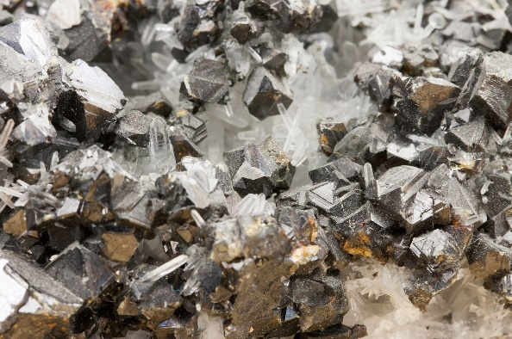
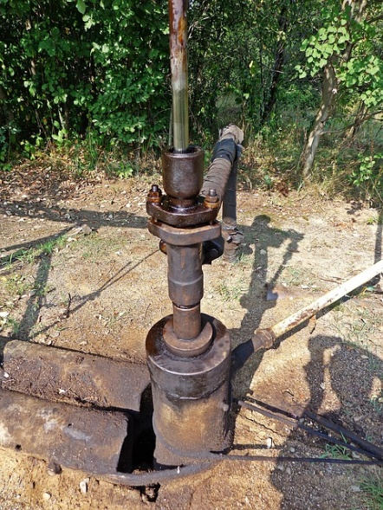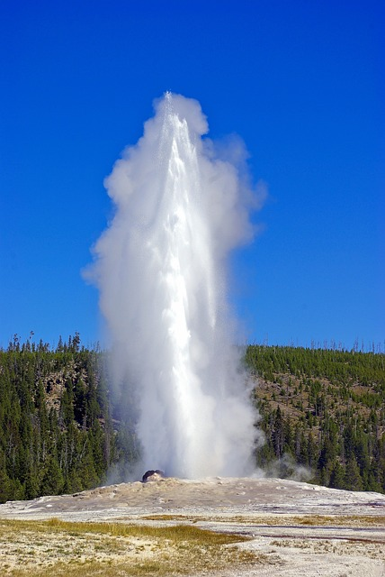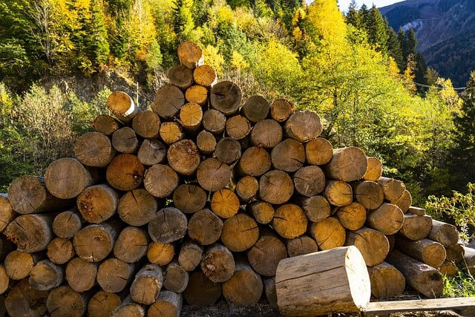

Source: https://pixabay.com/pl
- Next, they give some more examples of natural resources (the ones they remember from Lesson 1)

Suggested answers:
Freshwater and marine resources, wildlife, renewable energy sources (wind/wind power, water, sun/sunlight/solar energy, hot springs/geothermal energy) natural gas, coal, soil, etc.
Source: https://www.britannica.com/science/natural-resource

EXPLORE
Significance of natural resources
The teacher stimulates discussion on significance of natural resources. The students give their own examples of the use of various natural resources. All the students are meant to be engaged in a short class discussion.

EXPLAIN

Pros and cons of different natural resources

- The class is divided into small groups. Each group is assigned a specific natural resource (e.g. water, forests, minerals, renewable energy). The teacher chooses a few of them.
- The groups explore the pros and cons associated with their assigned resource considering environmental, social, and economic aspects.
- The groups present their findings on https://padlet.com

Useful links:
https://sciencing.com/the-disadvantages-of-using-renewable-natural-resources-13662778.html
https://sciencing.com/advantages-disadvantages-natural-environments-8577629.html
https://enlightio.com/why-are-natural-resources-important

Possible answers:
Water:
Pros: Essential for drinking, agriculture, and industrial processes; supports aquatic ecosystems; renewable through the water cycle.
Cons: Overuse and pollution can lead to water scarcity and environmental degradation; uneven distribution can cause conflicts.
Forests:
Pros: Provide timber, fuelwood, and non-timber forest products; habitat for wildlife; carbon sequestration; recreational value.
Cons: Deforestation can lead to loss of biodiversity, soil erosion, and carbon emissions; illegal logging threatens ecosystems.
Minerals:
Pros: Used in various industries, infrastructure, and technologies; contribute to economic development and job creation.
Cons: Extraction can lead to habitat destruction, pollution, and land degradation; mining can have social and human rights impacts.
Petroleum and Natural Gas:
Pros: Provide energy for transportation, heating, and electricity generation; support industries and economic growth.
Cons: Non-renewable resource; greenhouse gas emissions contribute to climate change; oil spills can cause ecological damage.
Soil/Agricultural Land:
Pros: Essential for food production; supports livelihoods and rural economies; biodiversity conservation.
Cons: Soil degradation through intensive farming practices; deforestation for agriculture; water pollution from agrochemicals.
Renewable Energy Sources:
Pros: Reduce reliance on fossil fuels; mitigate climate change; promote energy independence; renewable and sustainable.
Cons: Initial high costs of infrastructure; intermittency of some sources (e.g., solar and wind); land and habitat impact for large-scale projects.
Freshwater and Marine Resources:
Pros: Provide food, transportation, and recreational opportunities; support marine ecosystems and biodiversity.
Cons: Overuse and pollution can lead to water scarcity and habitat destruction; unsustainable fishing practices can deplete fish stocks.
Minerals:
Pros: Used in various industries and technologies; contribute to economic growth and development.
Cons: Mining can have significant environmental impacts; extraction can disrupt ecosystems and communities; resource depletion.

NOTE:
It's important to note that the pros and cons can vary depending on factors such as local context, extraction methods, management practices, and technological advancements. Sustainable and responsible use of natural resources is crucial to mitigate negative impacts and ensure their long-term availability.

EXTEND

Making a poster/presentation

  - Students prepare (individual) visual presentations or posters highlighting the advantages and disadvantages of a chosen natural resource ( the one that has not been discussed in class yet) and present them to the class at a later date.

  - The audience may ask questions, there may be a class discussion to compare and contrast the different resources, their pros and cons, and the potential trade-offs involved in resource use.

EVALUATE

- The students to reflect on what they have learned and how it might influence their own actions and choices regarding natural resources.

- The teacher and their students summarize the main points of the lessons, emphasizing the need for responsible resource management and sustainable practices.

