Project ID: 2021-1-CZ01-KA220-SCH-000034484
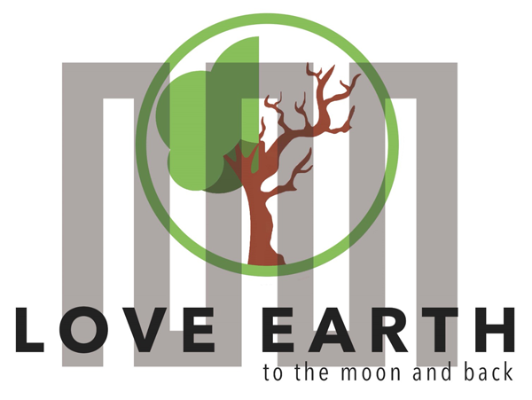

COURSE FOR ENVIRONMENTAL EDUCATION
e-Modules: Teaching Learning activities and their technology enhanced material set to develop

DISCLAIMER
Funded by the European Union. Views and opinions expressed are however those of the author(s) only and do not necessarily reflect those of the European Union or the European Education and Culture Executive Agency (EACEA). Neither the European Union nor EACEA can be held responsible for them.

COURSE AUTHORS
Lubomír Hájek, Petra Garay

COURSE SHARING LICENSE
You are free to:
- Share — copy and redistribute the material in any medium or format for any purpose, even commercially.
- Adapt — remix, transform, and build upon the material for any purpose, even commercially.

MODULE 1 | HUMAN AND NATURE
PART 3 | The positive and negative effects of nature on human being ; The natural and artificial environment
Lesson 1 | The positive and negative effects of nature on human being - Atmosphere

SUMMARY

1. COURSE TIME, TARGET AND TOPIC 3

2. COURSE OBJECTIVES 3
Competences promoted in this lesson: 3
Lesson objectives: 3

3. LEARNING – TEACHING PROCESSES 3

4. EVALUATION 3

5. DOCUMENTS 4
ENGAGE 4
EXPLORE 5
EXPLAIN 5
EXTEND 6
EVALUATE 7

1. COURSE TIME, TARGET AND TOPIC
- Age of target students: 15+
- Teaching time: 2 hours
- Disciplines: Biology, Human sciences, Chemistry
- Title: The positive and negative effects of nature on human being, part 2 - Atmosphere

2. COURSE OBJECTIVES

Competences promoted in this lesson:
- Communication in foreign languages competency
- CLIL
- Digital competency
- Learning to learn competency.
- Initiative and entrepreneurship competencies
- Social and citizenship- related competence
- Cultural awareness

Lesson objectives:
- The students deepen their knowledge regarding the varieties of fertilizers.
- The students deepen their knowledge about the importance of the trees.
- They apply the knowledge for practical activities.

3. LEARNING – TEACHING PROCESSES
There are 4 activities in this lesson:
Atmosphere:
- ENGAGE: Why are trees important?
- EXPLAIN: discuss topics - deforestation, magic of one single tree, how trees can heal
- EXPLORE: monoculture, polyculture, FSC
- EXTEND: Tasks for students – the right way of cutting a tree, communication of the trees

4. EVALUATION
Lithosphere- advantages and disadvantages of chemical

DOCUMENTS

ENGAGE
Area of focus: Trees providing oxygen
Q: Discuss in groups and state the reasons why trees are important.
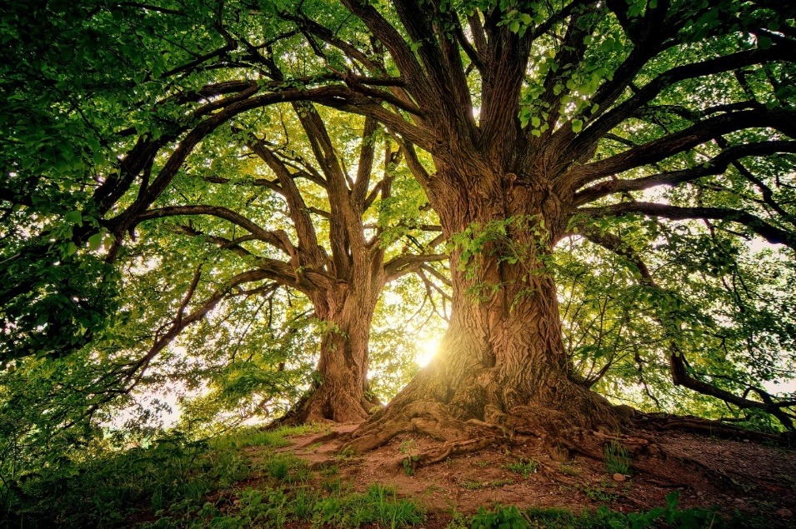
Possible answers: Caption: Tree in nature © source: pixabay.com
Functions of trees
- Regulate climate.
- Filter the water
- Clean the air.
- Source materials

Picture source © pixabay.com

Q: Study and discuss the following topics - deforestation, magic of one single tree, how trees can heal,

Deforestation
Not only forests are disappearing, but trees also disappear from everywhere, and for many reasons.
Even from places such as agricultural lands, savanna, forest, cities.

An example is a rainforest – rainforests are disappearing because of many reasons.
- economic corruption (Brazil economy is built on trade with wood)
- palm oil farms
- climate change (fire forest, extreme heat)
- black market (rare animal and plant species)
- growing population
Picture source © pixabay.com

How the deforestation looks like:
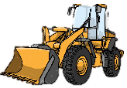
explored part of rainforest

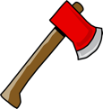
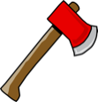

Illustration creators © Lubomír Hájek, Petra Garay CC BY 4.0

The magic of one single tree:
- cooling effect of 1 healthy tree=10 room sized A/C units operating for 20hours a day
- surface and air temp. May be 20°-45° cooler than areas without tree shade.
- one tree can produce up to 150kg oxygen a year – enough for one person for entire year.
- up to 30% of precipitation is absorbed by the root system – reducing storm water runoff and flooding potential to urban properties.
- 1 mature tree can store up to 378,5 litters of water during storms events, the soil dryness during hot months.

SO, TREES BASICALLY SAVE YOU MONEY!!!

How trees heal:
- HELP REDUCE SKIN CANCER (shade from trees reduces the UV rate which is the primary cause of skin cancer) (decreases sunburn in just 50 % shade)
- TREES AND BUSHES CAN REDUCE STRESSFUL NOISES BY 50 % AND ALSO PROVIDE SAFETY FOR ANIMALS IN A BUSY CITY
- KEEPING THE AIR CLEAN – childhood asthma rates are lower in urban areas with higher density of trees

EXPLAIN
: Discuss what is monoculture and polyculture. Right after that, fill in this table.
Task for students:

POSITIVES NEGATIVES

MONOCULTURE

POLYCULTURE

Q: Discuss the significance of this logo:
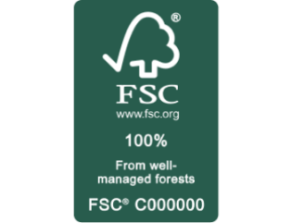

Picture source ©: Pixabay.com
FSC
You can find this logo on almost every product. It is a company that focus on sustainable wood source. They don´t cut trees across the board, but individual trees that are suitable for processing. This type of cutting trees does not disturb the ecosystem of the forest.

EXTEND
Q: Watch the video and find out how trees communicate with each other
https://www.youtube.com/watch?v=7kHZ0a_6TxY

Other ways how trees communicate:
- using pheromones to warn each other.
- chemical signals

The strongest will survive – some plants take this more like a competition rather than cooperation.
For example:
- Orchids – hacking the system.
- Black walnut tree – producing toxic chemicals into the system.
- Black locust tree – the leaves that fall from the tree, release the poison into the ground below.

EVALUATE
Caption: Money grow © Source: pixabay.com
Q: What are the benefits of urban trees?

Possible answers:
Urban tree benefits
- air cooling, filters of urban pollutants
- habitats for animals (increasing urban biodiversity)
- regulating water flow and improving quality of the water
- one tree can absorb up to 150kg of CO2 per year (climate change)
- providing food, wood can be used for heating or cooking.
- spending time near trees improves physical and mental health (decreasing stress and blood pressure)
- trees planted around buildings can reduce air conditioning needs by 30% and save energy used for heating by 20-50%

Sources:
- https://www.treekeeperswc.org/tree-benefits-information

