Unit 2: MicroCredential implementation and EU Data Model

Within the process of implementation of MicroCredentials (MC), one of the critical issues is their recognition for further study or employment by government authorities, HE institutions and employers. Quality of learning content and assessment is a determining factor. Without recognition, MCs cannot be integrated into national and international learning ecosystems.
In the past, short-term courses and other small learning programmes were less regulated in terms of essential standards for quality and descriptive data. The EU works on setting up a compulsory and comprehensive data model for documentation of features as well as criteria for international recognition of MicroCredentials.
In this unit, we will address some aspects of quality assurance related to MCs. Further on, the prevalent and binding EU Model for Digital Credentials (including MicroCredentials) will be introduced. The last section focuses on the preparation for issuing a digital MC based on the EU data model, including the description of transparent assessment.
Eventually, teachers and faculty members in HE should be able to design and implement MicroCredential programmes based on learning objectives and outcomes, pedagogical considerations, delivery modalities, transparent assessment and adequate learning resources.

How to implement the idea of MicroCredentials in teaching

2.1.1. Quality Aspects for Development and Implementation
MicroCredentials could gain importance over the last decade as a tool to make (higher) education more flexible, accessible and inclusive. With respect to this fast development, issuers and authorities must be aware of quality as a key for sustained usability and value for learners. MCs are subject to internal and external quality assurance by the system producing them (European Commission 2022, p 29): education or training institutions, or labour market stakeholders like authorities, companies, or associations like chambers of commerce. It is essential that quality assurance (QA) focuses on the needs of learners. The features of MC (see Unit 1.2.) offer some new challenges for QA.
For the DigiProf Project, we assume that the course providers are (system-) accredited HE institutions. Accordingly, quality of provision for MicroCredentials lies with them.
A first aspect of quality is linked to the qualification setting of the EU Bologna Process:
It should be achievable to align the content of the respective MCs to the European Qualification Framework (EQF), when creating and maintaining new learning units, which respond to educational or societal needs.
Slides ‘EQF 1 and 2’
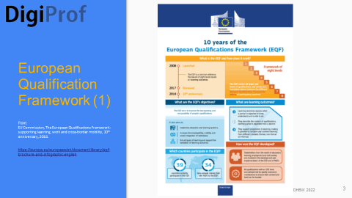
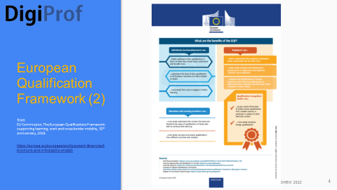
Fig.2.1. European Qualification Framework

With regard to the process of MicroCredential development, a second aspect of quality seems to be strongly related:
Apart from providing transparent information about policies, the involvement of learners in all steps of development, implementation and evaluation of MicroCredentials is required (e.g. EU MicroBol Project 2022). If MCs are explicitly included in new developments or re-design of procedures in HE-institutions, teachers will play an important role as they are the ‘active element’ of unbundling content and shaping new learning units like MCs. Accordingly, feedback from peers and other stakeholders should be collected and included in the development of MicroCredentials.
In the end, relevance for learners as well as for the labour market can be guaranteed if MicroCredentials are designed as ‘distinct, targeted learning achievements, and learning opportunities leading to them are updated as necessary, to meet identified learning needs.’ (European Commission 2021, p 3)
Teachers should be aware that only a learner-centered approach leads towards a sought-for and valued MicroCredential which is worthwhile the effort of designing and issuing it.
A third aspect of quality of MicroCredentials relates to transparency:
In order to make MCs understandable, measurable and comparable (European Commission 2022, p 30), teachers are the key persons providing for substantial information on content, learning outcomes, assessment, workload and level of the learning offer. The ECT-System (ECTS) as well as the EQF provide for guidelines regarding workload and level. The EU Model for Digital Credential Data (EDCI) supports a standardised and very comprehensive declaration of all elements needed for transparency. It will be explained in Unit 2.2.3.
Eventually, for the sake of transparency, teachers could suggest key words or tags for registration of the MC in a database for learning opportunities within their HE institutions, or even on a pertinent external platform, depending on the status of the MicroCredential (e.g. in terms of openness).
Other issues of quality like access and availability, stackability, portability and recognition are not within direct access of the teacher. The involved institution ought to address these aspects, and also provide for information and guidance on their offer of MicroCredentials.

2.1.2. Content-related Design Approach
This chapter intends to recall the factual content-related process, which is needed to follow the idea of learner-centered teaching. The usefulness of a MicroCredential is closely related to the careful extraction of feasible subject areas for constituting a small learning unit.
Teachers should keep in mind that by carrying out a MicroCredential, the (more or less experienced) learner enters a journey which, apart from leading to obtaining a certificate in the end, ideally provides for a positive experience along the learning pathway. The MicroCredential should be designed to encourage, support and reward learning in a relevant competence area focusing on an enclosed topic.
PDF ‘Content-related Design Approach to MC_DHBW_Oct2022_rev.pdf’
Graphics/Slides are prepared accordingly ‘How to develop a MC_Slides_Short Guide_DHBW_17.03.2023
https://drive.google.com/drive/folders/1NjSUlQMU7FFp2iGo8ODTuk0r3RrbH9Jx
PDFs ‘ANNEX I, II, III_How to develop a MC_UCG_Oct2022.pdf’

2.1.3. Resources used in Unit 2.1.
Council of the European Union (2022). Proposal for a Council Recommendation on a European approach to micro-credentials for lifelong learning and employability’ https://data.consilium.europa.eu/doc/document/ST-9237-2022-INIT/en/pdf

European Commission (2017). Directorate-General for Education, Youth, Sport and Culture, ECTS users' guide 2015, Publications Office. https://data.europa.eu/doi/10.2766/87192
European Commission (2018). Infographic: The European Qualifications Framework (EQF): supporting learning, work and cross-border mobility, 10th anniversary. https://europa.eu/europass/system/files/2020-05/EQF%20infographic-EN.pdf

European Commission (2020). Europass Digital Credentials Infrastructure (EDCI). Presentation.
https://ec.europa.eu/futurium/en/system/files/ged/edci_presentation.pdf

European Commission (2021). A European Approach to Micro-Credentials. Brochure. https://education.ec.europa.eu/sites/default/files/2022-01/micro-credentials%20brochure%20updated.pdf
EU MicroBol Project (2022). Micro-credentials linked to the Bologna Key-Commitments, Common Framework for Micro-credentials in the EHEA. https://microcredentials.eu/wp-content/uploads/sites/20/2022/03/Micro-credentials_Framework_final-1.pdf

2.1.4. Examples for Unit 2.1.
1. Analytical framework: how should we think about the role of MicroCredentials in higher education? Three Scenarios: Orr, D., Pupinis, M., & Kirdulytė, G. (2020). Towards a European approach to micro-credentials: A study of practices and commonalities in offering micro-credentials in European higher education. Publications Office of the European Union. https://doi. org/10, 2766, 7338. p 46-49
https://ec.europa.eu/education/sites/default/files/document-library-docs/towardseuropean-approach-micro-credentials-analytical-report.pdf

2. MicroCredentials in European higher education institutions: OECD (2021). Micro-credential innovations in higher education: Who, What and Why?. OECD Education Policy Perspectives, No. 39. p 8-15. https://doi.org/10.1787/f14ef041-en
3. Alignment of Micro-Credentialing and Outcomes-Based Education: Modern Campus & UPCEA (2023). Shifting Paradigms: Understanding Institutional Perspectives on Microcredentialing. p 16-17. https://moderncampus.com/pdfs/shifting-paradigms-understanding-institutional-perspectives-on-microcredentialing.pdf

4. Challenges in MicroCredential Development: Illustrative Cases. Fischer, T., Oppl, S., & Stabauer, M. (2022). Micro-Credential Development: Tools, Methods and Concepts Supporting the European Approach. p 9-11.
https://scholar.google.com/scholar_url?url=https://www.researchgate.net/profile/Thomas-Fischer-28/publication/356568140_Micro-Credential_Development_Tools_Methods_and_Concepts_Supporting_the_European_Approach/links/61a11c843068c54fa51f4a48/Micro-Credential-Development-Tools-Methods-and-Concepts-Supporting-the-European-Approach.pdf&hl=de&sa=T&oi=gsb-gga&ct=res&cd=0&d=6628720968170107388&ei=-jPuY4qwFZWwmgGXtIe4Aw&scisig=AAGBfm0uremz8H-i-MXmmRrJDFIJwwpipw

5. ‘Designing and Assessing Micro-credential Offerings’: Tooley, M., & Hood, J. (2021). Harnessing Micro-Credentials for Teacher Growth: A National Review of Early Best Practices. New America. p 15-22.
https://files.eric.ed.gov/fulltext/ED612409.pdf

6. ‘Reprint of Council of Chief State School Officers’ “Design, Assessment, and Implementation Principles for Educator Micro-credentials: Tooley, M., & Hood, J. (2021). Harnessing Micro-Credentials for Teacher Growth: A National Review of Early Best Practices. New America. Appendix B. p 52-54. https://files.eric.ed.gov/fulltext/ED612409.pdf
7. SURF edubadges in Netherlands: Issuing digital certificates to students.
https://www.surf.nl/en/edubadges-issuing-digital-certificates-to-students

8. SUNY The State University of New York: Gain New Skills, Knowledge, and Experience with Microcredentials at SUNY. https://www.suny.edu/microcredentials/

please also have a look at examples of Unit 1.2.
add on: past case studies as predecessors of MicroCredentials
9. Case Study No. 2 ‘Addressing the needs of learners and addressing the needs of the nation: a module in UNISA’s BA in Court Interpreting’: Wallmach, K. in: Welch, T., Reed, Y. (ed.) (2004), Designing and Delivering Distance Education: Quality Criteria and Case Studies from South Africa. NADEOSA. p 80-86. https://www.saide.org.za/documents/Nadeosa_Quality_Critiera.pdf
10. Case Study No. 13 ‘The quality assurance process for undergraduate courses in the Department of Linguistics at UNISA’: Sanderson, P. . in: Welch, T., Reed, Y. (ed.) (2004) Designing and Delivering Distance Education: Quality Criteria and Case Studies from South Africa. NADEOSA. p 202-210. https://www.saide.org.za/documents/Nadeosa_Quality_Critiera.pdf

2.1.5. Further reading for Unit 2.1.

European Commission (2018). The European Qualifications Framework (EQF): supporting learning, work and cross-border mobility, 10th anniversary.
https://europa.eu/europass/system/files/2020-05/EQF%20Brochure-EN.pdf

EU Project MicroBol (2021). Micro-credentials linked to the Bologna KeyCommitments
https://microcredentials.eu/wp-content/uploads/sites/20/2021/07/MICROBOL-Recommendations-1.pdf
Fischer, T., Oppl, S., & Stabauer, M. (2022). Micro-Credential Development: Tools, Methods and Concepts Supporting the European Approach. Conference Paper.
https://www.researchgate.net/publication/356568140_Micro-Credential_Development_Tools_Methods_and_Concepts_Supporting_the_European_Approach
NUFFIC (2022). The Rise and Recognition of Micro-credentials: Stacking Modules and the Future of the Qualification.
https://www.nuffic.nl/sites/default/files/2022-03/The%20rise%20and%20recognition%20of%20micro-credentials.pdf
OECD (2021). Quality and value of micro-credentials in higher education: Preparing for the future. OECD Education Policy Perspectives, No. 40. https://doi.org/10.1787/9c4ad26d-en.

Orr, D., Pupinis, M., & Kirdulytė, G. (2020). Towards a European approach to micro-credentials: A study of practices and commonalities in offering micro-credentials in European higher education. Publications Office of the European Union. https://ec.europa.eu/education/sites/default/files/document-library-docs/towardseuropean-approach-micro-credentials-analytical-report.pdf
Robson, J. (2022). Micro-credentials: Reshaping adult education and training. The OECD Forum Network. Blog Post. https://www.oecd-forum.org/posts/micro-credentials-the-new-frontier-of-adult-education-and-training

2.1.6. Self-reflective Questions Unit 2.1.
Please see extra file - “self reflective questions”!

  - European Digital Credential Environment for MicroCredentials

2.2.1. EU System for Issuing and Receiving Digital Credentials (EDCI)

The European Digital Credentials Infrastructure (EDCI) offers standards and services for HE institutions with regard to Digital MicroCredentials across the European Union.
Some major aims are:
- reduce the work and cost of issuing secure credentials,
- eliminate administrative work involved in verifying credentials,
- get the automatic support of EU recognition instruments and best practices on data privacy
as well as
- increase efficiency in processing recruitment applications,
- automatically detect fake or tampered credentials,
- increase transparency of credentials.
The integration of IT tools from the EU Commission (for issuing, storage, verification, viewing and transfer) into HE-institutions’ software systems is enabled and in ongoing further development. One of the scenarios is to enable cross-border MC-portability by using the European Blockchain Services Infrastructure (EBSI), which is mapped and designed within the European Blockchain Partnership (EBP).

For the training purpose in DigiProf, solely the ‘service’ section (yellow) of the EDCI is relevant:
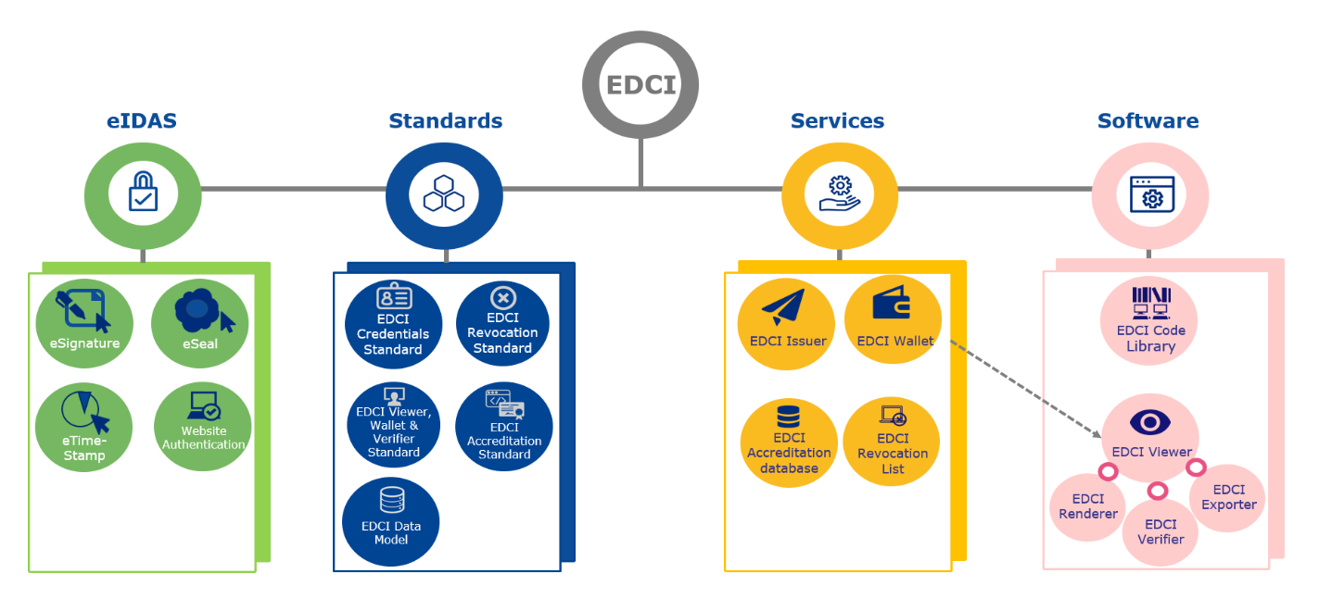

Fig.2.2. EDCI for issuing and receiving Digital Credentials
https://europa.eu/europass/en/interoperability-european-digital-credentials-learning

Based on the systematic EDCI background, teachers or professors are able to design and issue a credential manually by filling in the data in the template of the EUROPASS Credential Builder complying with the latest European data model. This process is subject of the next section.

2.2.2. EUROPASS

The EDCI aims at two main sections of stakeholders:
- the learners who, after achievement, receive a MicroCredential and
- the issuers of MicroCredentials.
A third important target group are the recognising institutions or employers, who are not in the focus of this training material.
Particularly for the learners, the EUROPASS is designed as a multilingual tool for learning and working in Europe. After registration, it offers the learner to create, maintain and extend his or her personal profile. The system includes a CV-creator as well as a cover letter functionality. Furthermore, a directory for personal skills and interests as well as a test of digital skills is available.
Video: https://audiovisual.ec.europa.eu/en/video/I-192547?&lg=EN

The EUROPASS is linked with National Qualifications Frameworks (NQF) and provides for opportunity guidance as well as for course- and job-recommendations.

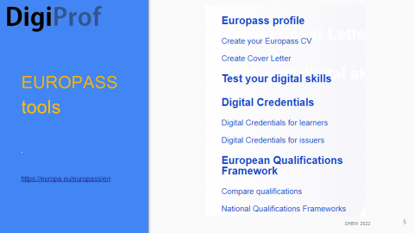
Fig.2.3. Europass tools

For learners, the most important feature of EUROPASS relating to MicroCredentials is included in the section of opportunity guidance with focus on ‘Learn in Europe’.

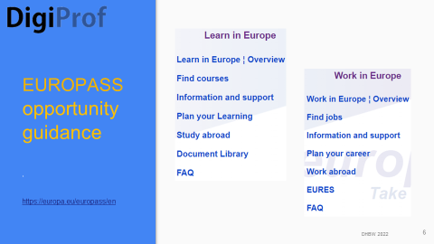
Fig.2.4. Europass opportunity guidance

The Document Library contains all documents and files for learning and working in one safe and free online space. Europass CVs, Cover Letters, Digital credentials, awards, certificates, diplomas and any other relevant documents can be uploaded here.
This is where digital MicroCredentials as a certificate can be stored for further use, in a portable and stackable format. A built-in digital wallet enables learners to add and administer their certificates, as well as to hand out the address to an issuing institution for direct deposit of digital documents. Learners can also upload certificates themselves.
For issuers, the EUROPASS provides for a tool not only for supporting the students in keeping track of all their learning achievements, but also for issuing documents:
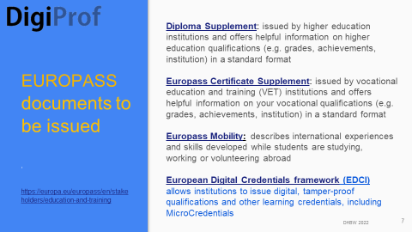
Fig.2.5. Europass documents

An HE institution who owns a qualified electronic seal and aims for issuing MicroCredentials can use the EUROPASS Online Credential Builder. It sets up a digital template for data and credential quality descriptors. The first step is to build reusable institution-adapted templates for MicroCredentials. For issuing purpose, these can be completed with the student data and grades if applicable. Obviously, the issuer can also upload prepared MicroCredential-files and directly move on to digitally sealing them.
This Credential Builder operates with a model of Digital Credentials developed by the EU Project ECCOE, which will be introduced in Unit 2.2.3.
PDF ECCOE How does an EDCI MicroCredential look like.pdf
One of the ECCOE ‘How to …’ guidelines describes the process of issuing a MC and is available in multiple languages:
PDF ECCOE_How_to_issue_digitally_signed_credentials.pdf
For various information about the EUROPASS system, the Audiovisual Service of the EUROPASS website can be consulted.
It is very likely that HE institutions use their own software capabilities to establish a process for issuing MicroCredentials, which then could be transferred to the EDCI ecosystem. Provision is made by the EU for developing own applications. In order to facilitate automatic transfer of data for Micro-Credentialing, the Virtual Learning Environment (VLE) of the HE institution needs to provide for certain pre-conditions, apart from Moodle or another Learning Management System (LMS), to make this process work.

2.2.3. ECCOE Digital Credential (Data) Model

The EU Erasmus+ ECCOE project developed a data model for interoperability of learning opportunities, qualifications and credentials in Europe. Based on the ESCO system and the MicroHE metadata standard, it is used by the European Commission for implementation of the EDCI, as described in the previous sections.
The ECCOE Data Model not only comprises the central elements of a MicroCredential, but also makes available a set of analytic options, e.g.
- indicator how well the student was graded compared to other students,
- histogram of results achieved by all students of this MC,
- description of a single score (or score range) within a histogram of results.
Furthermore, it adds depth to the central elements, e.g. by adding sub-specifications,
as well expands the data set, for example regarding
- awarding process and opportunity,
- entitlement and it’s specification,
- persons involved,
- issuing organisation or agent,
- accreditation and verification,
- media representation.

For the essential subject of transparent assessment, which is a focal point in DigiProf,
it can be seen from the details of the model, how transparency is mapped (apply filter ‘Assessment Specification’ and ‘Assessment’).
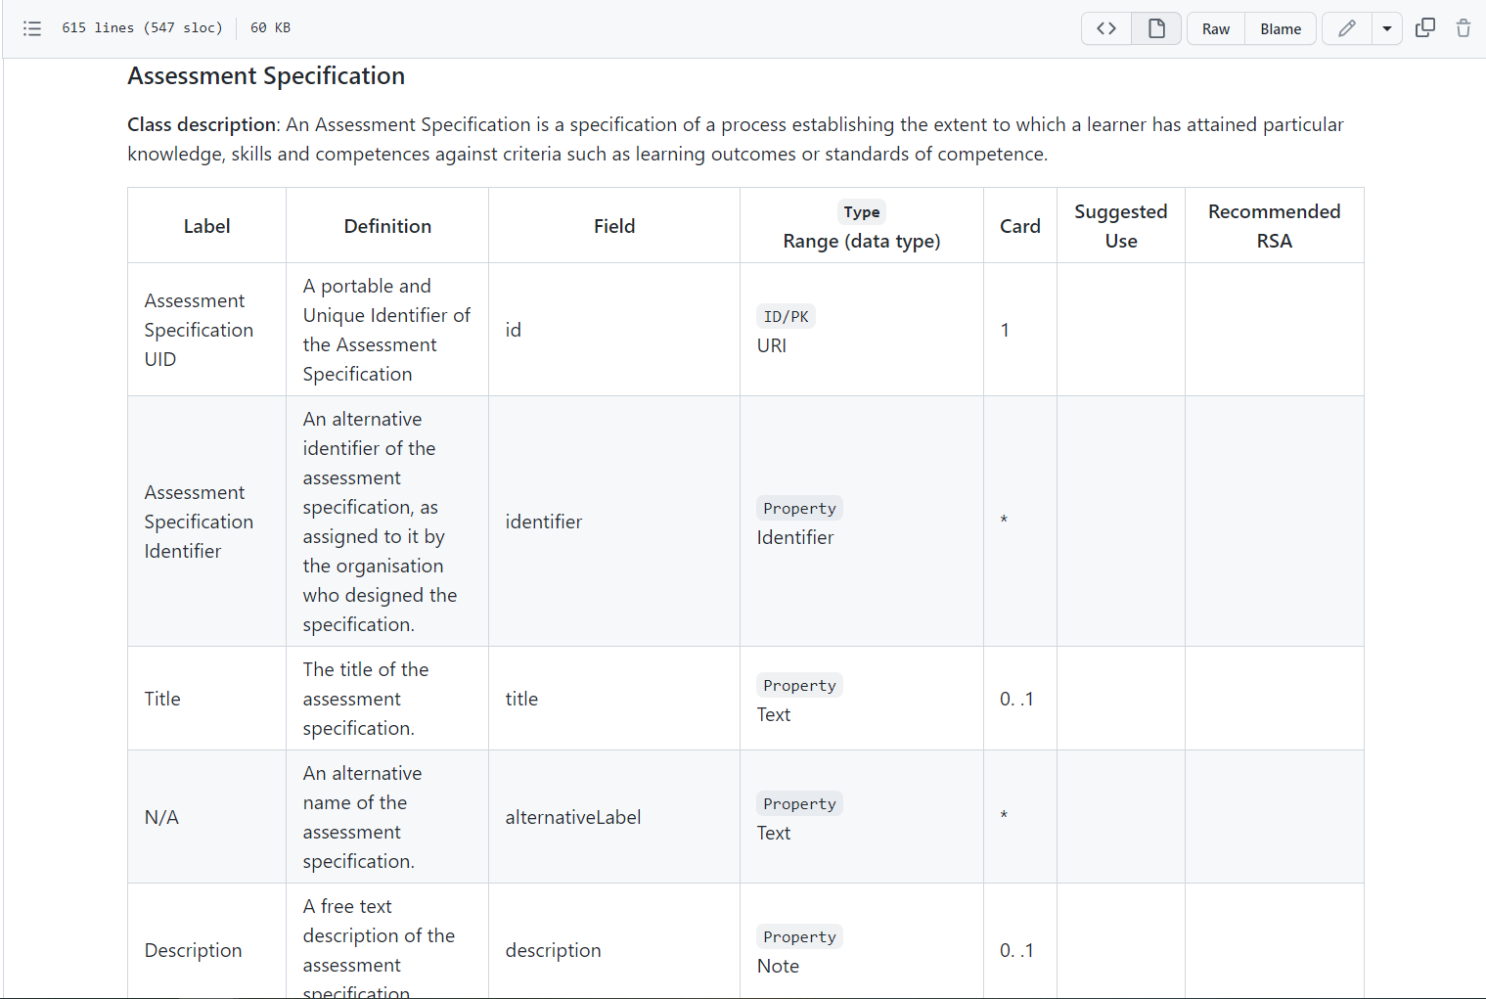
Fig.2.6. Assessment Process Specification in the ECCOE Digital Credential (Data) Model
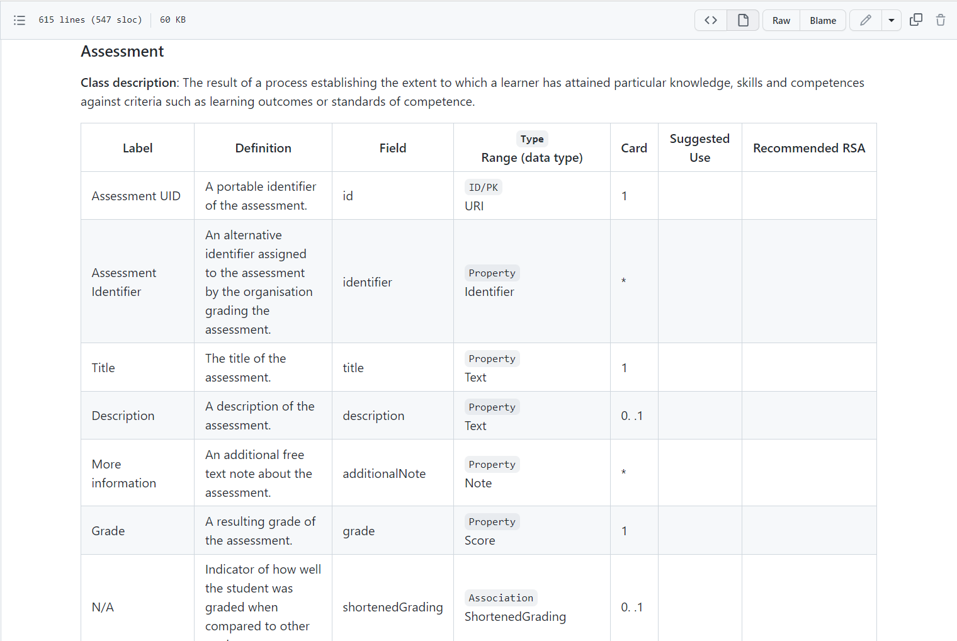
Fig.2.7. Assessment Result Specification in the ECCOE Digital Credential (Data) Model

With its data model, ECCOE built on the EDCI foundations and devised a credential template that is customised to the needs and requirements of the HE sector to support better credential portability between HE institutions (HEI). The project consortium designed an ubiquitous flexible solution to serve the needs of the key stakeholders of MicroCredentials (learners, HEI and employers).
An important outcome of the ECCOE project is the Learning Opportunity description template, which enables HE institutions to feed a database with courses, modules or MOOCs, represented according to a standard scheme. From this data set, the MicroCredential certificate descriptors can be created.
Apart from the type of assessment (formative/accumulative, summative/after conclusion of a defined period)), the teacher has to classify the assessment objects (knowledge, skills, autonomy/responsibility) and then select the type of assessment:
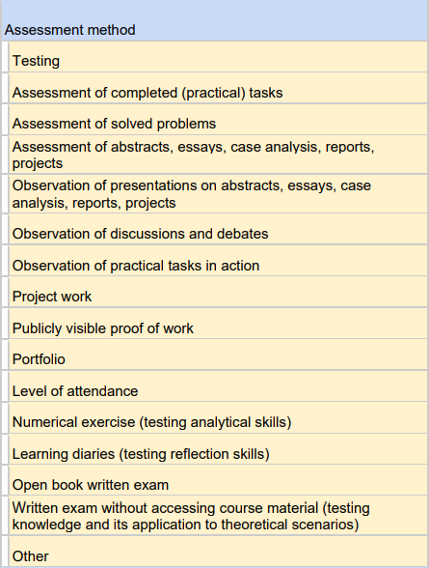
Fig.2.8. Data values for Assessment Method in ECCOE Digital Credential (Data) Model
Procedures like authentication of learners, the place of assessment (online/ on site), the deployment of plagiarism identification tools, and other identifiers are subject to record as well as the kind of examiner (or the type of the software) and the format of assessment:
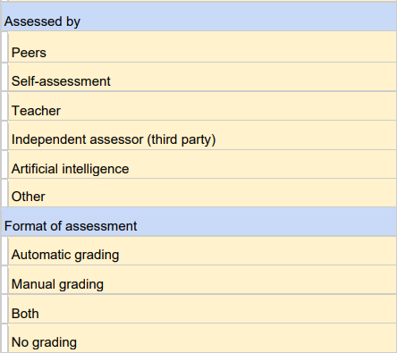
Fig.2.9. Data values for Assessment Provision and Format in ECCOE Digital Credential (Data) Model

The grading, of course, is another essential element of the MicroCredential description, related to transparent assessment.
The Learning Opportunity Description Template provides for a valuable background for the development of a new MicroCredential, establishing the base for Unit 2.3. .
Please have a look at ANNEX III:
PDF ANNEX III ECCOE Micro Credential Module Description.pdf
For practical use, the ECCOE project developed a guideline ‘How to create a micro-credential module description’ which is available in multiple languages.

PDF ECCOE_How_to_create_a_module_description.pdf

2.2.4. Resources used in Unit 2.2.
ECCOE project outputs (2022). https://eccoe.eu/outputs/
Lukošienė, M., Volungevičienė, A., Daukšienė, E. (2022), Quality criteria for credential description, Public report.
https://eccoe.eu/wp-content/uploads/sites/28/2022/09/ECCOE_O1_Quality-criteria-for-credential-description_Public-Report.pdf

2.2.5. Examples for Unit 2.2.

1. ECCOE How does a EDCI MicroCredential look like.pdf
https://eccoe.eu/wp-content/uploads/sites/28/2022/09/ECCOE-microcredential-issued-by-POLIMI.pdf
2. Success story Micro-credentials, A PhD student applies for specific courses in a foreign country, EBSI (2023). https://ec.europa.eu/digital-building-blocks/wikis/display/EBSI/Micro-credentials
3. Register and create your own EUROPASS-example!
https://europa.eu/europass/eportfolio/screen/profile-wizard?lang=en

2.2.6. Further reading for Unit 2.2.

Arnold, D., Antonaci, A., Blaschke, L. M., Casanova, G., Giannatelli, A., Lukošienė, M., ... & Cuevas, B. S. (2020). The ECCOE Approach to Quality Reviewing Online Descriptions of Learning Opportunities. In EDEN Conference Proceedings (No. 1, pp. 66-75). https://doi.org/10.38069/edenconf-2020-rw0008
ECCOE Output 5: How to guides in ENG, FR, ES, IT, GER, NL, LIT (2022).
https://eccoe.eu/outputs/io5/
For more information on EUROPASS Digital Credentials please watch the
detailed video tutorial on how to build an issue Europass Digital Credentials (2020): https://audiovisual.ec.europa.eu/en/video/I-199527?lg=EN&sublg=en
2.2.7. Self-reflective Questions Unit 2.1.
Please see extra file - “self reflective questions”!

2.3. Assessment within an EU MicroCredential

2.3.1. Importance of assessment transparency for MicroCredentials

As, defined earlier, an assessment is the result of a process determining the extent to which a learner has attained particular knowledge, skills and competence.
In teaching practise, assessments disclose a level of achievement and can be linked to a specific grading scheme that rates the learner’s performance in the assessment.
This function is supported by the ECCOE Digital Credential (Data) Model.
But how does this model assist the necessity of transparency?
The DigiProf Project is based on the mission to demonstrate the importance, function and implementation of transparent assessment being crucial to shaping and issuing a MicroCredential. Several logical implementations are stated by the MicroBol MicroCredentials Framework (EU MicroBol Project, 2022):
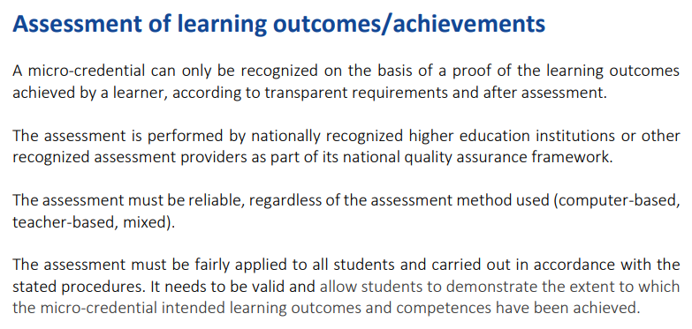
It can be assumed that these properties of assessment within MicroCredentials should help rebuting one of the main concerns for all stakeholders: the adequate and certified quality. We have shed some light on this issue in Unit 2.1., and now come back to it.
The ECCOE team explored how an issuer can prove MicroCredential quality and suggested (ECCOE, 2022):
- provide rich, meaningful data
- list learning outcomes
- reference to multilingual skills and competence frameworks
- describe assessment in detail
- use ECCOE template as guide
Transparent requirements and a reliable assessment are the keys for satisfying the needs of the main stakeholders (learners, HE institutions, employers). If the HE educator provides a comprehensive description of assessment, the quality of the developed MicroCredential can be proved.

2.3.2. Representation of Transparent Assessment in the ECCOE Digital Credential (Data) Model

In this unit, we will follow the advice of the ECCOE team and show how to describe assessment features within the ECCOE template.
Please have a look at the exemplary description of assessment features for a selected Learning Opportunity.
Slides_TM Unit 2.3.Transparent Assessment ECCOE_DHBW.pptx
Looking at the detailed process of setting up a quality assured Digital Credential, it becomes clear, how much work has been done and still is ahead - if we want to include those small learning units, which have long been part of HE provision, into our learning ecosystems as MicroCredentials.
For sure, the rapid developments regarding Virtual Learning Environments (VLE) in Higher Education will make implementation of MCs easier and help to ensure quality delivery, integration and recognition whilst avoiding learning fragmentation.

2.3.2. Resources used in Unit 2.3.
ECCOE Credential Metadata Open Consultation (2022). How the ECCOE credential properties look in credential building template and on the credential preview.
https://eccoe.eu/wp-content/uploads/sites/28/2022/03/O4-OPC-Visual_context.pdf
EU MicroBol Project (2022), Micro-credentials linked to the Bologna Key-Commitments, Common Framework for Micro-credentials in the EHEA.
https://microcredentials.eu/wp-content/uploads/sites/20/2022/03/Micro-credentials_Framework_final-1.pdf

2.3.3. Examples for Unit 2.3.
Please have a look at Unit 3

2.3.4. Further reading for Unit 2.3.

Iniesto, F., Ferguson, R., Weller, M., Farrow, R., & Pitt, R. (2022). Introducing A Reflective Framework for the Assessment and Recognition of Microcredentials. The Open/Technology in Education, Society, and Scholarship Association Journal, 2(2), 1–24.
https://doi.org/10.18357/otessaj.2022.2.2.37 https://journal.otessa.org/index.php/oj/article/view/37/27
Trepulė, E., Volungevičienė, A., Teresevičienė, M., Daukšienė, E., Greenspon, R., Tamoliūnė, G., ... & Vaitonytė, G. (2021). Guidelines for Open and Online Learning Assessment and Recognition with Reference to the National and European Qualification Framework Micro-Credentials as a Proposal. https://portalcris.vdu.lt/server/api/core/bitstreams/7b469aed-bea3-42a9-8c80-942c98d05b5b/content
Trepulé, E., VOLUNGEVIČIENĖ, A., TERESEVIČIENĖ, M., Greenspon, R., & Costa, N. (2021). How to Increase the Value of Digital Badges for Assessment and Recognition in Higher Education. A University Case. Informatics in Education, 20(1), 131-152.
https://scholar.google.com/scholar_url?url=https://www.infedu.vu.lt/journal/INFEDU/article/677/file/pdf&hl=de&sa=T&oi=gsb-gga&ct=res&cd=0&d=10833328969201517631&ei=MhnuY9HYMJWwmgGXtIe4Aw&scisig=AAGBfm0JG4ZKyX-polin38wJ3viBt296pQ

2.3.5. Self-reflective Questions Unit 2.1.
Please see extra file - “self reflective questions”!

CONGRATULATIONS !!
You worked your way through DigiProf Training on MicroCredentials
Unit 2

