Unit 1: What is a MicroCredential?

The basement of understanding the idea of a MicroCredential (MC) is to know about it’s elements, features, scope of practical application and it’s limits. With this unit, we want to set the scene for planning of and making informed decisions regarding future-proof transparent digital assessments within the micro-credentialisation ecosystem.
One of the roles of educators is preparing adequate learning offers with useful description and transparent assessment-methods. This aspect of teaching gains more and more importance considering the differentiation within the educational system, no matter if face to face or in a Virtual Learning Environment (VLE).
Many new formats evolved over the past years, and we will start with this topic before we shed light on the key features of MC and, in Unit 2, on their development for implementation, e.g. as part of a regular curriculum.
  - Background and Definition of MC
1.1.1. OER, MOOCs, MCs in EU and globally
Concepts of MicroCredentials are certainly nothing new. Short-term courses and small learning units including certificates have been offered by different providers for years. Most of them did focus on outreach and continuing professional development (CPD) for the training of skilled professionals and workers. Several professions require continuous training and upskilling for quality and safety reasons (e.g. in medical careers). Compared to Macro-Credentials, such as full degree or qualification programmes, MicroCredentials can be a tool to downsize and shorten longer learning programmes for greater flexibility, agility and diversity.
In the European Union, ideas of digital teaching and learning evolved from the concept of Open Educational Resources (OER) and also from the implementation of Massive Open Online Courses (MOOC), both focusing on the huge potential of segmented digital learning opportunities in terms of non-stationary participation of learners.
Over the past few years, the idea of making use of these Micro-learning Units for attaining credentials has been elaborated. 2018 was already a year of MOOC-based degrees (e.g. displayed at platforms like Class Central https://www.classcentral.com/ ). However, the variation within credentials and between them was not satisfying the needs and ideas of learners, universities and the labour market.
Consequently, the European MOOC Consortium (EMC) developed a Common Micro Credential Framework (CMF), providing for a consistent standard to support life-long learning. This Bologna-compatible concept is integrated with the European Qualification Framework (EQF), valid for Higher Education (HE) as well as for professional and vocational training (VET). The shift of focus to learning outcomes supports a reasonable match between the needs of the labour market (for knowledge, skills and competences) and education and training provisions. With this broad approach, the CMF facilitates validation of MicroCredentials in non-formal and informal learning. It also fosters the transfer and use of qualifications across different national education and training systems to build competences according to the European Skills Agenda .
In other parts of the world, much more activities could be observed, possibly due to the fact that education is a highly important topic, not only societally, but also economically. The US and Australia are at the front end of the market. Many new developments were and still are piloted, accompanied and evaluated by academic studies.
Several EU-Projects discussed the use and the features of MicroCredentials. The Final report of ‘A European Approach to Micro-Credentials’ (2020) summarises the results:
https://education.ec.europa.eu/sites/default/files/document-library-docs/european-approach-micro-credentials-higher-education-consultation-group-output-final-report.pdf .
Transparency and quality became crucial aspects with regard to the aim of EU-wide recognition of MCs.
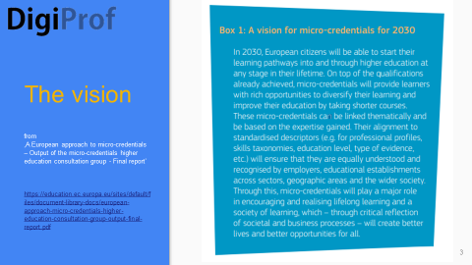
Fig.1.1. MC Vision

Meanwhile, since mid of 2022, we arrived at a state where the EU commission has confirmed the concept of Micro-Credentialisation with its adaption of the ‘Proposal for a Council Recommendation on a European approach to MicroCredentials for lifelong learning and employability’
https://data.consilium.europa.eu/doc/document/ST-9237-2022-INIT/en/pdf .
The EU expects HE institutions to adopt this ‘Proposal’ and come up with a concept for implementation until the end of 2023 (§21, page 26). The scope includes MicroCredentials, as well as policies that can support their effective design, issuance and use. In particular, the EU framework for Micro-Credentialing aims for harmonising the wide variation of certificates offered in HE (and in other education areas), which currently leads to various challenges, e.g. regarding recognition.

1.1.2. Definition, Categories of MicroCredentials (MC), Stakeholders, Usability
How can the nebulous construct of a MicroCredential be narrowed down?
A shared and transparent definition of MicroCredentials is key to enable and accelerate the development and implementation of MicroCredentials. It will allow for MCs performing as a trusted skills currency.
In the first section a) of §5 of the 2022 EU Council Recommendation, it is stated that a ‘Micro-credential’ means the record of the learning outcomes that a learner has acquired following a small volume of learning. These learning outcomes will have been assessed against transparent and clearly defined criteria.’
This definition follows the idea of the EMC in 2020 and many other consulting bodies who contributed a considerable amount of research, discussion and joint negotiation.

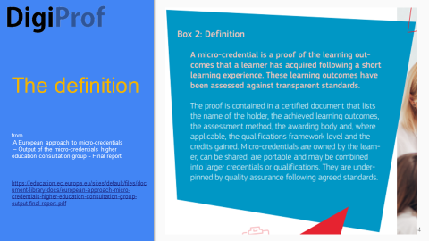
Fig.1.2. MC definition and specification of the MC certificate 2020

It has to be noted, that “Research in the area of alternative credentials usually covers two main aspects: learning activities that lead to a credential, and the credential itself. The term ‘MicroCredential’ is often used to describe both aspects. For example, both a short learning course and a certification are called a MicroCredential” (Orr et al. 2020, p 38).
Basically, MicroCredentials can be both, credit-bearing and non-credit bearing, which provides learners with the flexibility to choose learning pathways according to their preferences and situation. Brown et al (2020) depicted the context in a chart.

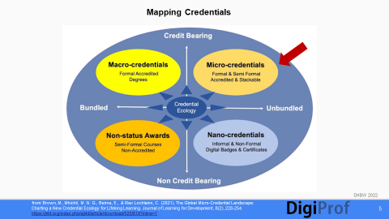
Fig.1.3. Mapping MCs

For the project DigiProf is located in HE, we assume that credit-bearing MCs are the standard. They mirror the level of complexity and autonomy required in a typical learning unit of a formal qualification. This entails the alignment of the assessment to a formal academic qualification level. In the end, these MCs are likely to be recognised by universities, institutions and the world of work and thus linked to learners’ CPD and employability.
Who are the stakeholders of Micro-Credentialisation?
MicroCredentials do not emerge and endure in isolation, but form part of a larger ecosystem. It is essential to apprehend the interconnectedness of the various components at the touch points of education system, human society and world of work. We need to keep in mind this comprehensive ecosystem before embarking on any Micro-Credentialing initiative.
Several ideas of the elements and functionalities of such ecosystem occurred over the last years. One of the most expansive can be found in Australia, where the MCs are narrowly coupled with the education business (the ‘product’ is the MC):
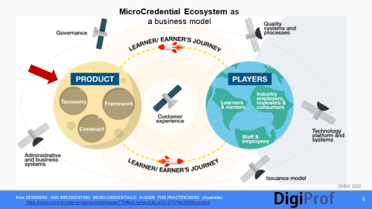
Fig.1.4. MC Ecosystem example Australia
The role of employers is multiple, as shown here:
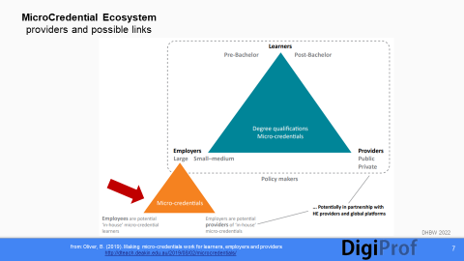
Fig.1.5. MC Ecosystem: providers and possible links
The EU has a more diversified perspective regarding the needs which can be satisfied. In the first section a) of §5 of the EU Council Recommendation, we can find a hint towards the beneficiaries of MCs and their necessities: ‘Learning experiences leading to microcredentials are designed to provide the learner with specific knowledge, skills and competences that respond to societal, personal, cultural or labour market needs.’
At the core of the ecosystem, the learners (partly being earners) can be located, as well as the MC-issuing organisations, e.g. HE institutions, with their teachers and staff. Furthermore, there are the employers and the governments, the quality agencies, IT providers, etc. .
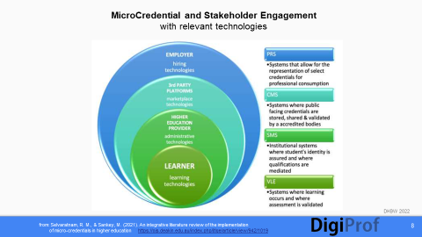
Fig.1.6. MCs and their Stakeholders
The institutional preparedness of the issuing organisation is an essential prerequisite to get and keep the ecosystem running. And, of course, policymakers and governmental authorities have to set the stage beforehand.
How can MCs be used?
Acquisition of small units of learning, skills or competencies, which have a distinct value in the world of work, for personal (professional) needs or for societal and cultural purposes can be seen as an important contribution to initial and continuous education.
The value of the achievement is dependent on the verification by a recognised and trusted issuing authority (e.g. educational institution or industry body). The possibility of issuing a digital artefact, as an alternative to a traditional formal transcript, enhances the usability of a personalised MicroCredential in various national and international settings.
The specific features of a MC provide for a very flexible scope of application, be it for building expertise in a single subject, or for composing a whole unit of life-long learning, possibly even for attaining a degree.
1.1.3. The Role of Transparent Assessment
Considering the aim of creating standards for MicroCredentials, it needs to be realised that, apart from formal criteria and requirements, the focus is on the content:
What should the learner know and be able to after the accomplishment of the MC? This is not trivial, even if the MC would cover a simple introduction in basic health and safety rules of the university.
Like in more comprehensive learning units, the learning outcomes of MicroCredentials are in the center of attention within the process of curriculum development and instructional design. Interlinked with this aspect is their recognition for further study or employment by government authorities, higher education institutions and employers. This is one of the most critical issues related to MCs. Without recognition they cannot be integrated into national and international learning ecosystems.
Recognition of certificates needs assessment. It is obvious that the level of grading related to the achievements has to be delineated when designing a MC.
For setting up a MicroCredential it is essential to indicate the link between learning outcomes, assessment and grading. The concept of Constructive Alignment (see e.g. Biggs, J., Tang, C., & Kennedy, G. 2022) provides for a suitable foundation.
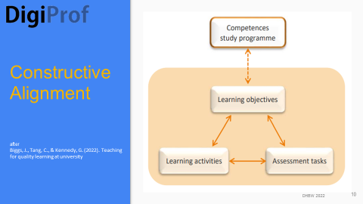
Fig.1.7. Concept of Constructive Alignment

The adequacy of the assessment method as well as the scope, the degree of complexity and the overall difficulty of the assessment tasks need explicit disclosure. This is a fundamental task of educators being experts in their subjects.
Two preceding training units in the DigiProf project are dedicated to digital assessment methods as well as to support and involvement of students, based on evidence generated by learning analytics. Their purpose is to give guidelines for creating transparent digital assessment, which is an essential element of Micro-Credentialing.

1.1.4. Resources used in Unit 1.1.
Biggs, J., Tang, C., & Kennedy, G. (2022). Teaching for quality learning at university.
OER-available: Biggs, J., Tang C. (2011).Teaching for quality learning at university, 9 fourth edition, 95 ff.
Brown, M., Mhichil, M. N. G., Beirne, E., & Mac Lochlainn, C. (2021a). The Global Micro-Credential Landscape: Charting a New Credential Ecology for Lifelong Learning. Journal of Learning for Development, 8(2), 228-254.
https://jl4d.org/index.php/ejl4d/article/view/525/617
Council of the European Union (2022). Proposal for a Council Recommendation on a European approach to micro-credentials for lifelong learning and employability’ https://data.consilium.europa.eu/doc/document/ST-9237-2022-INIT/en/pdf
European Commission (2020). A European Approach to Micro-Credentials, Final Report.
https://education.ec.europa.eu/sites/default/files/document-library-docs/european-approach-micro-credentials-higher-education-consultation-group-output-final-report.pdf
Oliver, B. (2019). Making micro-credentials work for learners, employers and providers. http://hdl.voced.edu.au/10707/515939. Retrieved from dteach. deakin. edu. au/microcredentials.

Orr, D., Kirdulytė, G., & Pupinis, M. (2020). Towards a European approach to micro credentials: A study of practices and commonalities in offering micro credentials in European higher education : analytical report. Publications Office of the European Union. https://data.europa.eu/doi/10.2766/7338

1.1.5. Examples for Unit 1.1.

1. Find a Micro Credential at SUNY (USA): https://www.suny.edu/microcredentials/microlist/
2. List of Micro-Credentials of University of Maine (USA):
https://www.maine.edu/student-success/micro-credentials/list-of-micro-credentials/
3. Find a Microcredential at The Open University (UK):
ttps://www.open.ac.uk/courses/microcredentials
4. Professional Practice Credentials at Deakin University (AUS):
https://credentials.deakin.edu.au/credentials/
5. MicroCredentials at Dublin City University (IRL):
https://www.dcu.ie/connected/micro-credentials
6. Explore MicroCredentials of University College Dublin (IRL):
https://www.ucd.ie/microcredentials/explorecourses/

7. Micro Courses and Micro-Credentials of University of Toronto (CAN):
https://learn.utoronto.ca/programs-courses/unique/micro-courses-and-micro-credentials?gclid=Cj0KCQjwpeaYBhDXARIsAEzItbF5vnB-oQnAPvZevYHloTcsEepFvxGoEv8OoYpDYd_8bEZ8HC8wGV8aAjbgEALw_wcB#search-courses

1.1.6. Further reading for Unit 1.1.
EMC European MOOC Consortium (2019). EMC Common Microcredential Framework.
https://emc.eadtu.eu/images/EMC_Common_Microcredential_Framework_.pdf
see also: Future Learn (2019). The Common MicroCredential Framework (CMF). https://www.futurelearn.com/info/the-common-microcredential-framework
Kohler, M., Gamrat, C., Raish, V., & Gross, E. (2021). Microlearning and micro-credentials in higher education. In Microlearning in the digital age (pp. 109-128).

Mac Lochlainn C., Nic Giolla Mhichil, M., Wessels, O., Kiiskilä, S., Pirkkalainen, H., and Palvalin, M. (2022), ECIU University Micro-Credentials: A vision for European learners, values, and priorities.
https://assets-global.website-files.com/551e54eb6a58b73c12c54a18/62ab225477535859cb10972f_Paper%203%20ECIU_corrections.pdf

Selvaratnam, R. M., & Sankey, M. D. (2021). An integrative literature review of the implementation of micro-credentials in higher education: Implications for practice in Australasia. Journal of Teaching and Learning for Graduate Employability, 12(1), 1-17.
https://ojs.deakin.edu.au/index.php/jtlge/article/view/942/1019
University of Toronto (2021). Report of the Provost’sAdvisory Group On Lifelong Learning Opportunities (2021).
https://www.provost.utoronto.ca/wp-content/uploads/sites/155/2021/06/Lifelong-Learning-Report_FINAL.pdf
1.1.7. Self-reflective Questions Unit 1.1.
Please see extra file!

  - Key features of MicroCredentials (MC)
1.2.1. Aims and Envisaged Advantages

In general, MCs can fulfill various objectives in the field of competence development as they offer a stencil for configuring learning content according to a certified standard. From HE perspective, interest in MicroCredentials has been growing, inspired by demand from adult learners for short and flexible forms of learning. Meanwhile, data from Learning Analytics (LA) contribute to adaption to learners’ needs, no matter if they are regular or ‘external’ students, fostering the aim of accommodating diversity and inclusion.
The perspective of industry and employers indicates the demand for verified skills-based credentials to satisfy the needs of the continuously transforming world of work. As digitalisation and a shift in awareness of transversal skills challenge the education ecosystem, learning with MicroCredentials is a suitable solution.
MicroCredentials aim for providing flexible learning path solutions for different purposes enabling recognition and identification with national and EU-wide qualification frameworks. In the end, they have to be compatible with the emerging digital credentialing ecosystem.
The advantage of MicroCredentials for stakeholders like learners, HE-institutions and employers are obvious, particularly if compared with a more traditional credential, e.g.:
for learners (mainly)
- responsiveness to evolving technology, changing methods and techniques
- ability for learners to demonstrate granular competences
- short duration enables flexible and fast professional development (CPD),
- fostering equity by being more accessible and affordable, e.g. for external students,
- distinctive just in time value by offering specialised topics,
- inclusive through adaption of content for a personalised learning experience (e.g. by using LA-data,
- digital availability provides for mobility (on demand, anywhere, anytime),
- transparent learning outcomes and assessment methods ensure relevance and validity of content,
- recognition is enabled due to standardised certificates
- stackable credit bearing MCs provide a track for a degree
for HE-institutions (mainly)
- HE institutions can outreach and offer topical learning experiences to non-regular students from different backgrounds and generations
- shared responsibility for developing competences in society by involvement of HE,
- possibility to test (digital) learning units, reflect and innovate for HE institutions,
- MC format offers business-opportunities for HE institutions,
- investing in and developing new MCs is an opportunity to innovate and grow,
for employers (mainly)
- access to broad talent pool for employers and provision for rapid and focused upskilling of workforce,
- tailored professional learning for CPD increases employee retention
- opportunities for HE-employer collaboration
- promotion of life-long and life-wide learning with impact on employability

It is not intended to line up all advantages, however, educators and learners will find out what can be expected from a MC and where are its limits.
In HE, we can assume that student-learners choose MCs to complete a set of units for a course, or that ‘external’ learners want to add new content to enhance their professional development.
Several EU countries analysed the potential of the EU commission’s recommendation regarding MicroCredentials and see different aspects of the integration in their Education Systems. Here is an exemplary SWOT chart from a German Educational Institution (BIBB):
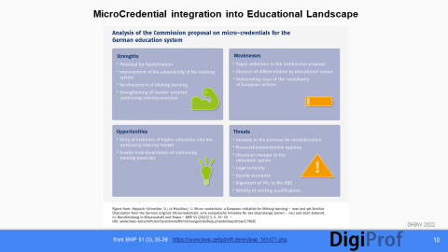
Fig.1.8. MC Integration into Educational Landscape

The ECIU (European Consortium of Innovative Universities) welcomes the change based on the EU commission’s recommendation as a chance to translate visions into practise, e.g. https://www.eciu.eu/news/eciu-university-supports-micro-credentials-council-recommendation and: Brown et al (2021b).

1.2.2. Possible Barriers and Critical Perspective

MicroCredentials in HE are still at the early stage of development. Concomitant research is required to evaluate their effectiveness and acceptance.
As the educational ecosystem is in a state of dynamic changes, various barriers might appear and challenge the implication of MicroCredentials, e.g.:
- The belief of some learners that MCs hold less value than more traditional certifications is still prevalent. Stakeholders might need support to understand that a MC in fact offers training on current and evolving skills, as well as knowledge aligned with existing and future needs. Thus, credentialing organizations need to create awareness for the validity of their MCs. They can learn from regular feedback by stakeholders to inform the development, quality standards and communication around their MC.
- HR professionals and HE admittance offices might be hesitant to recognizing MCs in the hiring or admission process if there is no evidence of topicality and no transparent assessment. Certainly, for recognition by HE institutions and employers likewise, it is important that the quality of a MC is guaranteed and the learning outcomes are displayed in a standard providing for comparability. The reputation and institutional accreditation of the issuer might play a role as well.
Apart from manifold barriers in the user- or issuer area of the MC ecosystem, there are some more general critical aspects compiled by parts of the science community and discussed within policy-maker circles. MicroCredentials are being critically appraised for various reasons:
- For one thing, it is stated that the hype for Micro-Credentialing reflects the exiguity to unbundle higher education curricula and degree programs for increased efficiency and profitability (Ralston 2021).
- On the other hand, authors see some risk observing a resurgent movement among industry and higher education leaders to reframe the HE curriculum towards vocational training (Ralston 2021). This view labels MCs as a result of neoliberal learning postulates. The purpose-free and self-directed character of learning in HE is seen in danger.
- Supporters of a critical approach also may see MCs as a tool for boosting the potential of human capital theory to manipulate HE curricula to align with ostensive world of work market requirements (Wheelan 2021). Unlike a degree program, MCs typically lack a general education approach, prioritising instead the transfer of applied knowledge and skills for serving workforce needs.
- Since industry-specific competencies are in many aspects subject to expiry, employees must constantly return to life-long learning providers to update their skill sets - and possibly muster a considerable financial contribution (Ralston 2021).
However, in spite of partial criticism, some authors see opportunities to improve the effects of the ‘MC-craze’ by reintroducing a ‘distinctly human element’ (Pollard 2022).
Accordingly, the ideas for a regulated and beneficial future Micro-Credentialing can be summarised in three activity strands:
- embed MicroCredentials into the regular curriculum,
- align them with the mission of the HE institution,
- foster and maintain a critical and reflective pedagogy.
These three aspects mirror exactly the intention of this training material for DigiProf with regard to MicroCredentials.
    - Properties and Elements of a MC (building blocks)

a) properties
In the first section a) of §5 of the EU Council Recommendation, we can find criteria for the properties of MCs: ‘Microcredentials are owned by the learner, can be shared and are portable. They may be stand-alone or combined into larger credentials. They are underpinned by quality assurance following agreed standards in the relevant sector or area of activity’.
With this in mind, you are invited to have a look at the slides below.
8 Slides ‘Properties of MC’ (extra document)
b) elements
The EU Council Recommendation also gives details on the constituting elements of a MicroCredential in Annex 1, stating: ‘The use of the European standard elements to describe micro-credentials does not, in itself, imply official validation or recognition, but is a key enabler for it’. This is a remit and mission for issuers, quality assurance agencies and recognition departments of various stakeholders.
The following slides will give an overview.
5 Slides ‘Elements of MC’ (extra document)
With background described here, the partners in EU are invited and challenged to transform the recommendations of the EU Commission into something more tangible.
The 2023 European Year of Skills is an opportunity to take on this task.
Every transformation needs exploration and discussion, particular with regard to MicroCredentials:

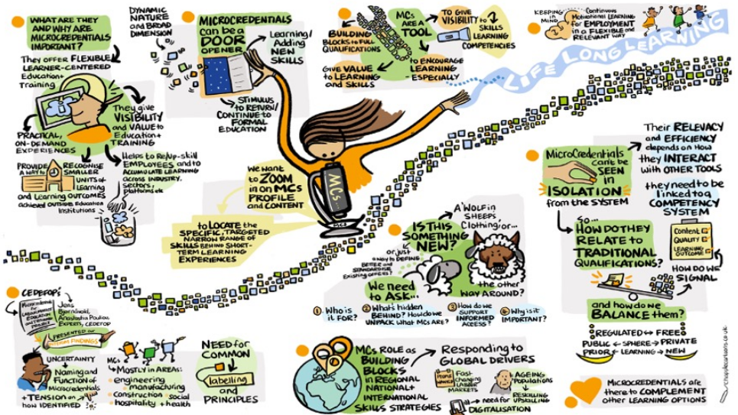
Fig.1.9. Reasons and Impact of MCs ( Graphic: CEDEFOP ACVT/DGVT meeting 2022 )
https://www.cedefop.europa.eu/en/news/microcredentials-new-opportunity-lifelong-learning

As shown in the picture, expectations and speculations are manifold in times of shortage of skilled employees. However, political, institutional and operational settings provide for the substrate fostering the development of MCs, and each implementation of a MC will bring new insights helping to channel the debate towards a reasonable design of these small and flexible learning units.

1.2.4. Resources used in Unit 1.2.
ad 1.2.1. (MCs overview)
ECIU (2021). ECIU University supports Micro-Credentials Council Recommendation. https://www.eciu.eu/news/eciu-university-supports-micro-credentials-council-recommendation
Tamoliune, G., Greenspon, R., Tereseviciene, M., Volungeviciene, A., Trepule, E., & Dauksiene, E. (2023, January). Exploring the potential of micro-credentials: A systematic literature review. In Frontiers in Education (Vol. 7, p. 1037). Frontiers.
https://www.frontiersin.org/articles/10.3389/feduc.2022.1006811/full

ad 1.2.1. (Delineation & Benefits of MC)
Brown, M., Mhichil, M. N. G., Beirne, E., & Mac Lochlainn, C. (2021a). The Global Micro-Credential Landscape: Charting a New Credential Ecology for Lifelong Learning. Journal of Learning for Development, 8(2), 228-254.
https://jl4d.org/index.php/ejl4d/article/download/525/618?inline=1

Brown, M., Mhichil, M. N. G., Beirne, E., & Mac Lochlainn, C., Pirkkalainen, H., Wessels, O. (2021b). Supporting the micro-credentials movement, ECIU White Paper on Micro-credentials, ECIU University 2021, DOI: 10.5281/zenodo.4438507.
https://assets-global.website-files.com/551e54eb6a58b73c12c54a18/6043a9dd006226486010050e_ECIU_Sheet-update_3032021.pdf

Hippach-Schneider, U., Le Mouillour I. (2022). Micro-credentials: a European initiative for lifelong learning – new and yet familiar, Berufsbildung in Wissenschaft und Praxis –BWP (Vocational Training in Research and Practice), 51(3), 35-39.
https://www.bwp-zeitschrift.de/en/bwp_161471.php
ad 1.2.2. (barriers/critique)
Banks, D., Waters, P.: Does Microcredentialing work?
https://www.gtlaw.com.au/knowledge/does-microcredentialing-work

Pollard, V., Vincent, A. Micro-credentials: A Postdigital Counternarrative. Postdigit Sci Educ 4, 843–859 (2022). https://doi.org/10.1007/s42438-022-00311-6
https://link.springer.com/article/10.1007/s42438-022-00311-6
McGreal, R., Olcott, D. A strategic reset: micro-credentials for higher education leaders. Smart Learn. Environ.9, 9 (2022). https://doi.org/10.1186/s40561-022-00190-1
Ralston, S.J. Higher Education’s Microcredentialing Craze: a Postdigital-Deweyan Critique. Postdigit Sci Educ 3, 83–101 (2021). https://doi.org/10.1007/s42438-020-00121-8 https://link.springer.com/content/pdf/10.1007/s42438-020-00121-8.pdf?pdf=button%20sticky
Wheelahan, L., & Moodie, G. (2021). Analysing micro-credentials in higher education: a Bernsteinian analysis. Journal of Curriculum Studies, 53(2), 212-228. https://www.tandfonline.com/doi/pdf/10.1080/00220272.2021.1887358

ad 1.2.3. (Properties & Data Model)
European Commission (2020). EDCI Data Model. Slides. https://ec.europa.eu/futurium/en/system/files/ged/edci_presentation.pdf
and https://github.com/european-commission-empl/European-Learning-Model
Proposal for a Council Recommendation on a European approach to micro-credentials for lifelong learning and employability - Adoption’, May 2022
https://data.consilium.europa.eu/doc/document/ST-9237-2022-INIT/en/pdf
1.2.5. Examples for Unit 1.2.

1. CorShip: MicroCredential Template for Entrepreneurship and Co-Innovation https://www.corship.eu/microcredential/
and a related research paper on the use of MCs for Entrepreneurship teaching:
Friedl, Christian (2021). Stimulating intrapreneurial intentions with digital business training I n the VET sector: The potential of massive open online courses," International Journal for Business Education: Vol. 162: No. 1, Article 3. https://ir.library.illinoisstate.edu/ijbe/vol162/iss1/3

2. Certifying Your Future: MicroCredential on Higher Education 4.0:
https://www.futurelearn.com/courses/higher-education-certifying-your-future

3. Knowledge Graphs: MicroCredential on improving www search results https://open.hpi.de/courses/knowledgegraphs2020 (self paced, elder version)
https://open.hpi.de/courses/knowledgegraphs2023 (from Oct 23, newest version)
4. Data-informed Decision-Making in a Pandemic: MicroCredential on how leadership decisions can be supported with data
https://ki-campus.org/courses/data-driven-decisions?locale=en
5. AI Explorables for Schools: MicroCredential about implementation of short, interactive online games in STEM teaching
https://ki-campus.org/courses/ai-explorables-schools?locale=en

6. Mercedes Benz Drive Program: 17 weeks program for upskilling employees towards technician status
https://www.uti.edu/programs/automotive/specialized-training/mercedes-benz-drive

7. MicroCredential Principles and Framework of e campus Ontario.
https://www.ecampusontario.ca/wp-content/uploads/2020/11/Micro-credentials-en1.pdf

1.2.6. Further reading for Unit 1.2.

All Digital (2022). Position on the proposed Council Recommendation on a European Approach to Micro-Credentials for Lifelong Learning and Employability.
https://all-digital.org/all-digitals-position-on-the-proposed-council-recommendation-on-eu-approach-to-micro-credentials/

Desmarchelier, R., Cary, L.J. (2022). Toward just and equitable micro-credentials: an Australian perspective. Int J Educ Technol High Educ, 25. https://educationaltechnologyjournal.springeropen.com/articles/10.1186/s41239-022-00332-y?fbclid=IwAR3EDZQz4XxsUjd5YhivS3h906sTlpZ2K8ehPFoAwdwhdY9bjow2u-OWjrw#citeas / https://doi.org/10.1186/s41239-022-00332-y

ETF Policy Brief (2022). Micro-Credentials are taking off: How important are they for making Lifelong Learning a reality?
https://www.etf.europa.eu/sites/default/files/2022-05/Micro-credentials%20%281%29-combined_1%20copy_0.pdf
EURASHE (2021). Micro-credentials in Professional Higher Education. EURASHE statement within the European Open Public Consultation. Position Paper.
https://www.eurashe.eu/resource-library/

Gauthier, T. (2020). The value of microcredentials: The employer's perspective. The Journal of Competency‐Based Education, 5(2), e01209.
https://onlinelibrary.wiley.com/doi/10.1002/cbe2.1209
LLLP Lifelong Learning Platform (2022). LLLP Reaction to Individual Learning Accounts and Microcredentials - a first step to learning entitlements?
https://lllplatform.eu/news/lllp-reaction-to-individual-learning-accounts-and-microcredentials-a-first-step-to-learning-entitlements/
Maina, M.F., Guàrdia Ortiz, L., Mancini, F. et al. A micro-credentialing methodology for improved recognition of HE employability skills. Int J Educ Technol High Educ 19, 10 (2022). https://doi.org/10.1186/s41239-021-00315-5
Teresevičienė, M., Trepulė, E., Daukšienė, E., Tamoliūnė, G., & Costa, N. (2020). Are universities ready to recognize open online learning? . International education studies. Ontario: Canadian Center of Science and Education, 2020, Vol. 13, iss. 2. https://files.eric.ed.gov/fulltext/EJ1241954.pdf
West, R. E., & Cheng, Z. (2023). How Open Microcredentials/Badges Support Learning in
Micro-, Meso-, Macro-levels. Digital Credential Evolution, 69 Handbook of Open, Distance and Digital Education, 1197. https://www.researchgate.net/profile/Frank-Xiao-4/publication/366849526_Handbook_of_Open_Distance_and_Digital_Education/links/63b550f803aad5368e648836/Handbook-of-Open-Distance-and-Digital-Education.pdf#page=1188

1.2.7. Self-reflective Questions Unit 1.2.
Please see extra file!

CONGRATULATIONS !!
You worked your way through DigiProf Training on MicroCredentials
Unit 1

