3.1. How to foster student engagement?
As already mentioned before, it is important to design learning activities that generate evidence and foster learners’ metacognition and self-regulated learning (SRL) skills (see 1.1) and also to analyse and interpret the available evidence to support SRL and learners’ engagement (see 2.1 and 2.2).

In this section, we will describe how to promote student engagement and how to engage students in VLEs. Then, we will provide an overview of Moodle-based strategies that support course design and help engage students on the basis of LA, after having analysed learners’ evidence. Finally, we will explain how to engage students in reflecting and self-assessing their learning process.

3.1.1. Students' engagement in VLEs
Engagement is defined by Bond and Bedenlier (2019:2) as “the energy and effort that students employ within their learning community, observable via any number of behavioural, cognitive or affective indicators across a continuum. It is shaped by a range of structural and internal influences, including the complex interplay of relationships, learning activities and the learning environment .”

Cognitive engagement | Affective engagement | Behavioural engagement
Deep learning strategies, self-regulation and understanding (e.g. critical thinking, operational reasoning, self-regulation, preference for challenging tasks). | Positive reactions to the learning environment, peers and teachers, as well as their sense of belonging and interest (e.g. enthusiasm, sense of belonging, satisfaction, curiosity). | Participation, persistence and positive conduct (e.g. Attendance, Homework completion, Participation/involvement, Interaction, Study habits/accessing course material).
Table 1. Dimensions of student engagement (Adapted from Bond et al., 2020)

In line with this definition, Bond and Bedenlier (2019) propose a “student engagement framework” that conceptualises how educational technology, in addition to having an impact on students’ social engagement, also influences short-term and long-term academic outcomes (see Fig. 1). The former refers to discipline-specific knowledge and higher-order thinking skills, motivation, sense of belonging and well-being, improved relationships through peer learning and collaboration, etc. The latter relates to lifelong learning, personal development and greater involvement in the wider educational community.

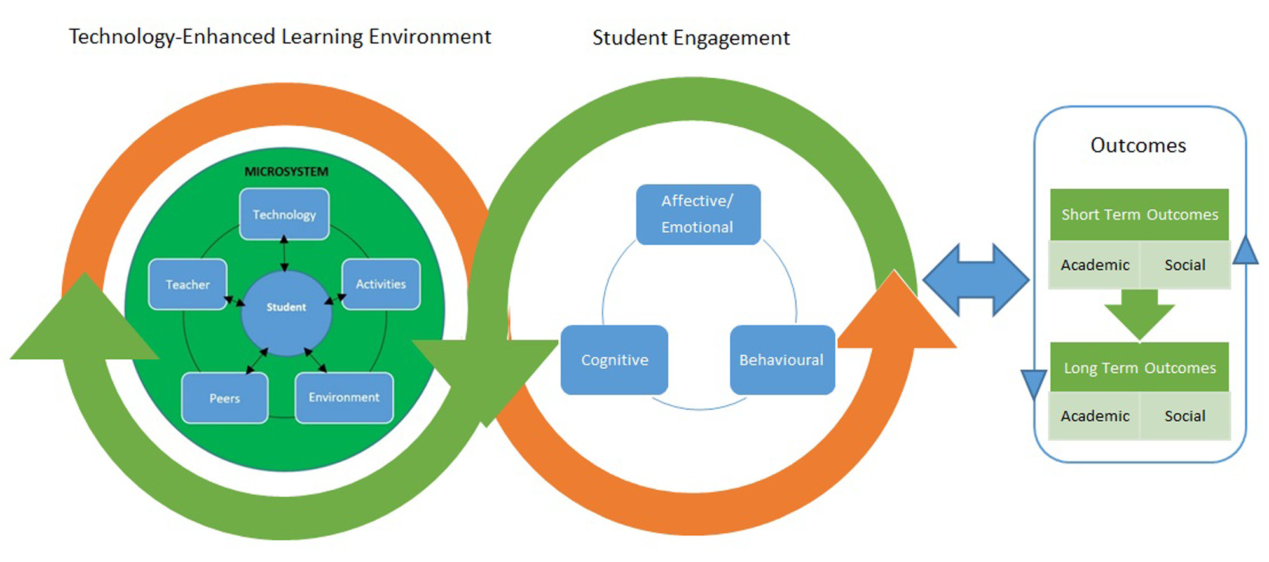Figure 1. Student engagement framework Bond and Bedenlier (2019, p.8)

The close interplay between technology-enhanced learning, engagement and outcomes require teachers to periodically reflect on their ability and confidence in the use of technology, their role as facilitators and the impact of their practices in student achievement.

Do you want to know more? The following document will show you visually the student engagement framework, a list of indicators of student engagement, learner engagement data, possible ways to measure engagement and techniques and examples to promote engagement. Click here

The role of teachers, therefore, is crucial in fostering learners’ engagement. To achieve this goal, they shall be able to:

- Promote active learning (Prince, 2004) and a sense of belonging to a community of learners.
- Put learners at the centre and make them responsible for their learning.
- Focus both on what and how learners learn.
- Challenge learners to foster learners' metacognition, and develop their critical skills but also their SRL skills.
- Pursue meaningful learning connecting to real-world issues.
- Require learner commitment to oneself and to others.
- Promote reflection for learner self-awareness of what and how they learn (see 1.1).

As the table below shows, instructors have to acquire different roles depending on the context and the type of learners and they have to adapt the learning process accordingly.

Learner role | Teacher role | Process
Newcomer | Social negotiator | Instructor provides activities that are interactive and that help learners get to know one another. Instructor expresses expectations for engagement in the course, provides orientation to the course, and keeps learners on track. Examples: icebreakers, individual introductions, discussions concerning community issues such as Netiquette rules in a virtual lounge.
Cooperator | Structural engineer | Instructor forms dyads of learners and provides activities that require critical thinking, reflection, and sharing of ideas. Examples: Peer reviews, activity critiques.
Collaborator | Facilitator | Instructor provides activities that require small groups to collaborate, solve problems, reflect on experiences. Examples: content discussions, role-playing, debates, jigsaws.
Initiator / partner | Community member / challenger | Activities are learner-designed or learner-led. Discussions begin to go not only where the instructor intends but also where the learners direct them to go. Examples: Group presentations and projects, learner-facilitated discussions.
Table 2. Adapted from: Conrad, R. M., & Donaldson, J. A. (2011). Engaging the online learner: Activities and resources for creative instruction (Vol. 38). John Wiley & Sons. (p.9)

In a VLE, it is important to engage students in content creation through learning by teaching activities, peer-based activities and collaborative learning in a hyflex environment.

This can be done through:
(1) Moodle or other VLEs combined with a synchronous tool (Zoom or MS Teams for instance). While a VLE requires an ongoing engagement at any time according to students’ availability, instead a videoconference tool represents a one-time engagement at a specific time. The combination of the two has to occur synergically. For instance, during a one-time session in Zoom, the teacher explains the basic theoretical notions related to the class and explains the activity that students have to carry out. During this session, students express their doubts and ask questions. After the synchronous session, students are required to deliver their activity in the forum and to answer each other’s contributions suggesting ways to improve it.
(2) Learner autonomy-supportive teachers. This means that thanks to their teachers, students feel responsible for their own learning, suggest further learning materials uploaded in the VLE, suggest possible changes in the syllabus and “criticise” constructively the didactic content proposing improvements. This also implies that students are able to search for learning content outside of the VLE and share it with peers and teachers to nurture the discussion.
(3) Collaboration among peers. There are tools that work successfully when combined with a VLE and that allow teamwork. Among them, there are wikis and Google docs but also text-annotation tools such as Amanote and Hypothesis. Amanote allows students to annotate a wide range of course materials through slides, videos and text to boost their productivity. Hypothesis allows students to annotate the web and to engage them with social annotation. Students can select texts, reply and share annotations and collaborate privately with peers. Similarly, there are video tools for social engagement such as Annoto, VideoAnt, and Edpuzzle, which turn passive video consumption into an active, social and collaborative experience and allow you to add annotations, comments and images to videos. Annoto allows students to share their ideas and write comments while watching a video, turning their learning experience into a social one. VideoAnt has very similar features and was created by the University of Minnesota, Edpuzzle is specifically designed for schools and makes lessons interactive allowing students and teachers to add notes, images and questions during the video lesson.

In addition, here below there is a list of tools that can be used to engage students in online education, meaningful learning and gamification.

- Quizziz. It is designed for assessment, instruction and practice and it allows the creation of quiz games that students can play in class and/or at home.
- Kahoot. It is a multifaceted service that can be used in schools, at work, at home and in academic contexts, it allows you to create quiz games students can play alone or in teams.
- Plickers. It is designed for formative assessment and it works through cards for multiple choice quizzes. Students can play alone or in teams.
- ClassCraft. It contributes to students’ motivation, behaviour improvement and teamwork because it turns every class into a role-play, like a videogame.
- Genia.ly. It creates eye-catching presentations, visually attractive infographics and conceptual maps to foster students’ engagement and metacognitive skills.
- Match The Memory. It creates flashcard memory games for free using videos, pictures, events and links.

(4) Peer-based learning (learning by teaching). When learners are trained on how to use the aforementioned tools and then share their artefacts with the group, they become co-creators, they teach each other and the teachers themselves learn from them. Learning becomes a bi-directional process.

To explore these topics further click here

3.1.2. VLE-based tools supporting course design and engagement
As already explained in section 1, when designing an online course, it is important to foresee the strategies that would help teachers collect evidence on how students interact with learning resources and activities. Evidence-based data help teachers improve their day-to-day teaching practice by showing what resources are not accessed by students, what activities are less engaging, and what topics or concepts remain unclear and require more discussions or hands-on practices. In addition, evidence can show teachers that some students do not interact with course content at all, and it might be a signal that students might be at risk of drop-out. Therefore, it is important to get in touch with them and discuss the situation.
In this section, we suggest tools useful to evaluate student commitment and motivation with the aim of readjusting activities and hence improving their engagement. At the same time, the proposed tools allow students to increase their level of metacognition regarding their learning and their engagement.
Some of the tools are:
- Discussion forum
- Group choice
- Choice
- Feedback
- Badges
Discussion forum
The Forum activity allows students and teachers to exchange ideas by posting comments as part of a 'thread' (fig. 2). Files such as images and media may be included in forum posts. The teacher can choose to grade and/or rate forum posts and it is also possible to give students permission to rate each other's posts.
The number of contributions to a forum is a way to rate the level of participation and engagement of students. Once learning analytics show little evidence of engagement, s/he can take corrective actions by designing a more engaging activity, by grading forum assignments and by setting up peer feedback activities.

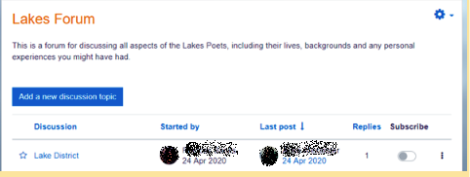
Figure 2. An example of a Discussion forum in Moodle

Group choice
This tool allows students to create a group for a task, join an existing group or change the group, depending on the instructor's decision. It provides an opportunity to check and assess whether students are sufficiently engaged to join a group and to engage in the group activity accordingly. Any answer shows a certain level of student engagement. However, the lecturer should draw on his/her knowledge of group dynamics and learning behaviour to learn more about the group's choice or replacement decisions. A group choice tool may also be used by a teacher to help students plan their own learning by allowing them to not only create groups themselves but also to choose the date of the assignment presentation (fig. 3). It is important that if the tutor observes passive engagement of certain students, he/she should take note of this and contact the students by e-mail or by posting a general message on the discussion forum.
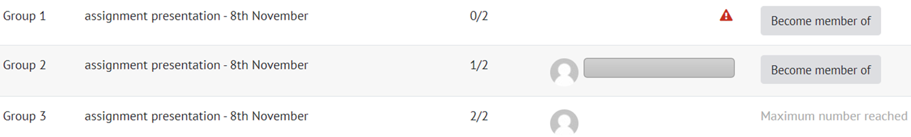
Figure 3. An example of a group choice activity in Moodle

Choice
The choice tool allows the teacher to ask a single question and offer multiple possible answers. It tool allows the teacher to create an activity in which the students themselves can choose how to develop a particular topic. For example, students can choose if they want to analyse and discuss climate change issues from an economic or legal perspective. The results can be published after the students have answered, after a certain date, or not be published at all. Moreover, the results can be published with student identification or anonymously. Giving learners the choice to decide what they want to learn increases their level of engagement. In this way, lecturers respond to their learning needs and interests. When using this tool, any response indicates the level of engagement and may serve as a starting point for a deeper discussion.

Feedback
The feedback tool allows teachers to create and conduct surveys and can be used for course or teacher evaluations. Thanks to this tool, it is possible to redesign a task or an activity that did not work well. The feedback tool can be used throughout the semester as well as at the end of the course. Throughout the course, feedback can be collected to investigate if students understand the key concepts presented in class, what resources they find most useful and what additional resources they would find relevant. Instead, the final feedback is related to the internal course quality assessment, where students are asked to share their insights and opinions on several questions related to the course content. Even though all surveys are planned at the beginning of the semester, some questions might be edited, added or removed, according to learning progress, issues or questions that appear when working with different groups of students each semester (fig. 4).

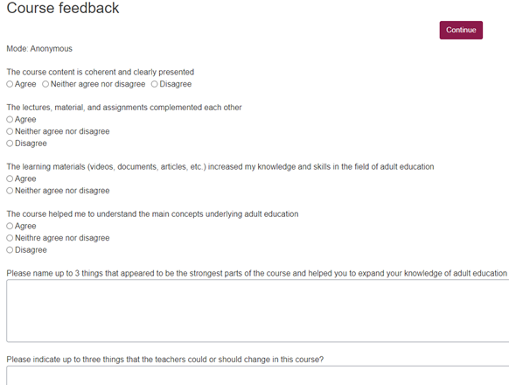
Figure 4. An example of course feedback (Trepule & Tamoliune, personal communication, 2022, MA study course “Concepts of adult education”, Vytautas Magnus University)

Badges
A VLE like Moodle allows teachers to assign badges, which are a good way of celebrating achievement and showing progress. Badges may be awarded based on a variety of chosen criteria and may be displayed on a user's profile or published in a badge public collection. Badges are connected with the process of gamification of learning and can be a powerful engaging factor.

3.1.3. Engage students in reflecting and self-assessing their learning process
At the beginning of the course, establish what learners already know, understand, and can do. This will make it easier to plan learning and teaching that responds to learners’ needs and expectations. Then, ensure that learning outcomes are aligned with the learning content, activities and assessment strategies and that the tasks to be carried out are explained beforehand (see 1.2.). In addition, not only do teachers have to take into account the quality of the learning materials but also the quantity. In other words, it is important not to exceed the number of learning materials. In the case of a blended course, align in-class and out-of-class activities and show them in a tutorial. Propose interesting learning resources and show students Bloom’s taxonomy (fig. 5) at the beginning of the course to improve their critical skills.

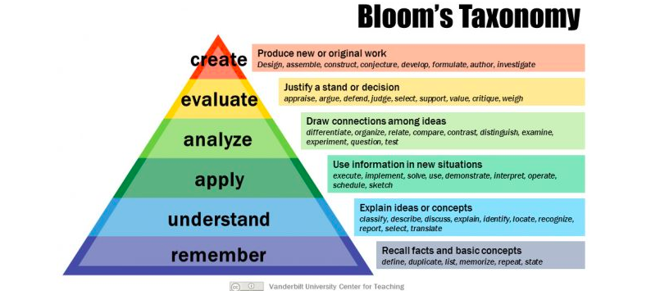

Figure 5. Bloom’s Taxonomy revised to show students how to improve critical thinking skills and achieve higher-order learning (Anderson et al., 2001). Image source: Armstrong, P. (2010). Bloom’s Taxonomy. Vanderbilt University Center for Teaching. Retrieved [14-12-22] from https://cft.vanderbilt.edu/guides-sub-pages/blooms-taxonomy/.

Bloom’s taxonomy (1959) is a hierarchy of learning objectives and embraces three facets of learning: thinking (mental skills), feeling (emotional skills) and doing (practical skills). Bloom’s work suggests that students need to be cognitively challenged through remembering-type questions, thought-provoking questions and questions that allow them to make connections.
In the revised version (Anderson et al., 2001), for each level of the taxonomy, there are action verbs that help teachers put together a lesson plan and inform students about how to develop their critical skills. For more information about these verbs, please click here.

During the course, provide students with opportunities for self-reflection and reflection in a group, offer continuous feedback and help them develop collaboration in groups. Design not only a summative assessment, but also formative assessment strategies that would help students identify their learning strengths, and weaknesses and help you as a teacher recognise where students are struggling. Examples of a formative assessment may include prompt quizzes, concept mapping, 1-sentence summary, in-class discussion, teamwork, etc. Another important aspect is that students need to feel the teacher’s presence and s/he has to provide frequent feedback to their assignments.

At the end of the course, make sure that you recollect feedback from your students and that they are allowed the possibility to reflect on their own learning (e-portfolio tool, feedback survey, interviews with students).

A proper design of assessment criteria also plays a very important role in fostering students’ engagement (sharing assessment instruments, for example). However, these training materials do not revolve around this aspect. If you want to know more about assessment, please check this course. https://teacamp.vdu.lt/course/view.php?id=89

The following best practices will shed more light on the aforementioned issues.

BEST PRACTICE EXAMPLE 1
Title: The English online course via MSTeams Mamet-Michalkiewicz, M. (2020). Conversation in English course. Based on personal experience. University: University of Silesia, Master Study Program
Section of the framework: B - Metacognitive strategies to measure students’ academic success (e.g. Discussions are organised to identify successful learning factors; learning activities facilitate students’ perception of their role, self-concept and academic success)
What competencies and learning outcomes of the DigicompEdu Framework are we addressing?

COMPETENCIES | LEARNING OUTCOMES
Self-regulated learning  Actively engaging learners  Analysing evidence | - (Monitor performance). To use digital technologies (e.g. ePortfolios, learners’ blogs) to allow learners to record and showcase their work.  - To use digital technologies to visualise and explain new concepts in a motivating and engaging way, e.g. by employing animations or videos.  - To design and implement learning activities which generate data on learner activity and performance.

Key issues: This best practice is based on an English language course focused on conversation. The course is an online course taught via MS Teams. The teacher has designed various learning activities that help collect evidence about learners' academic success. Group work, individual work, pair work and discussion helped engaging learners. The teacher showed students introductory presentations and provided reflections and continuous feedback during the course. At the beginning of the course, students were given a rubric for speaking assessment criteria to affect students’ cognition.
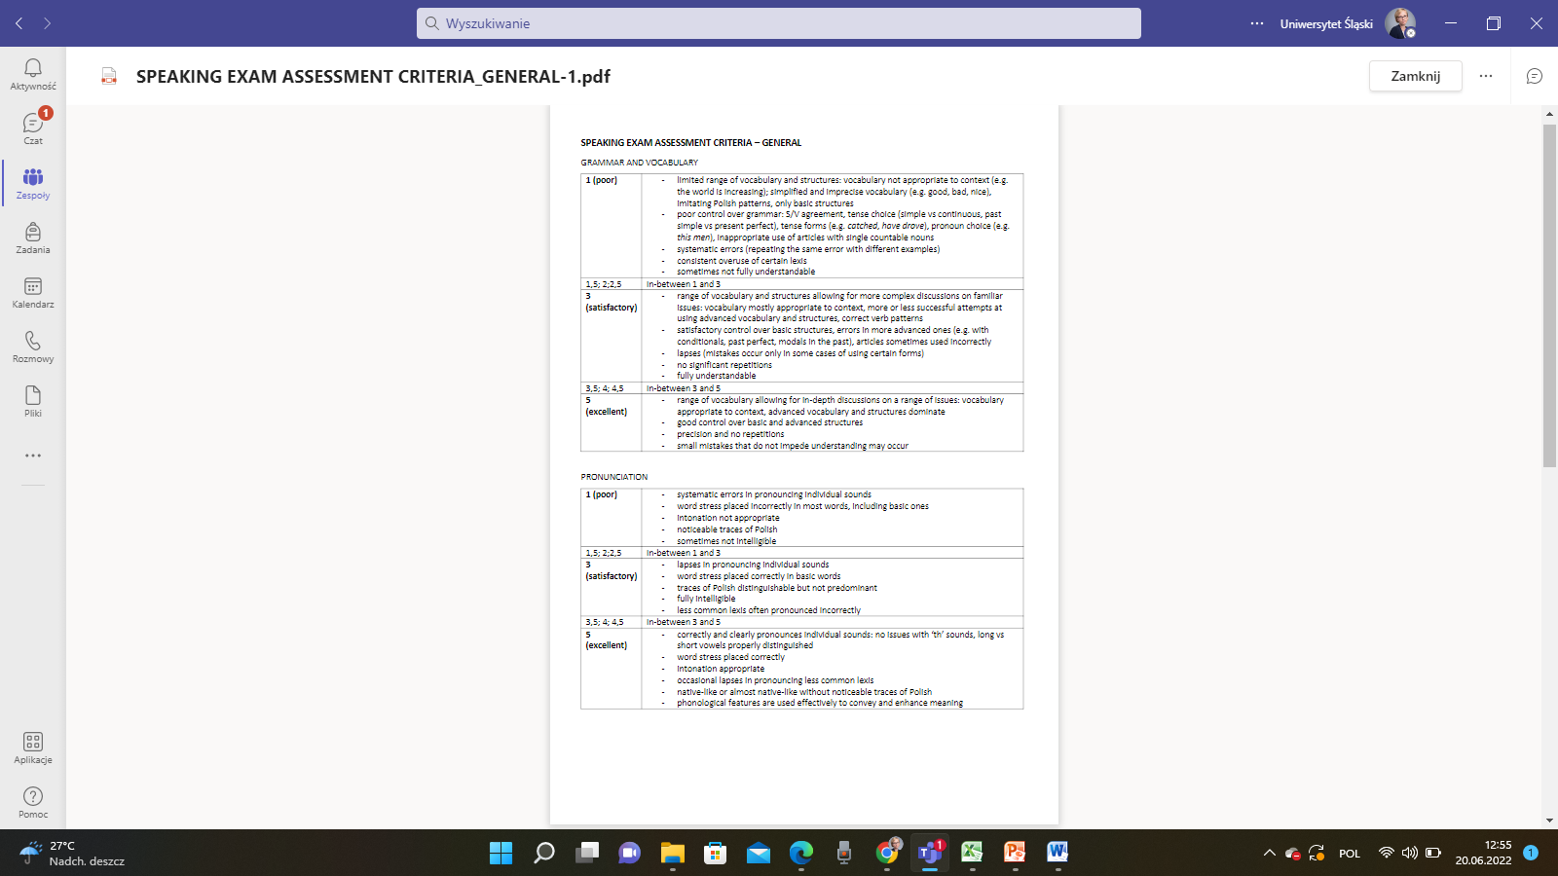
Figure 1. Speaking assessment criteria. MS Team image from Master Study Program, University of Silesia.

To learn about students as learners, the teacher asked the students to watch a short film on introducing themselves and then to record a short film individually:
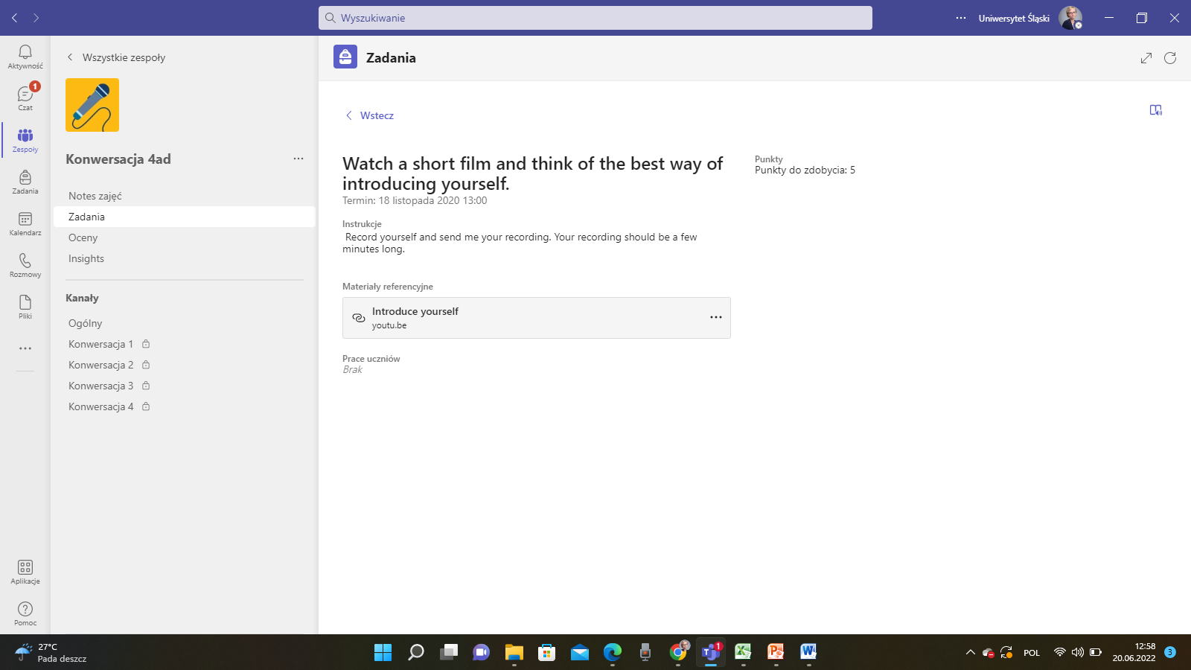
Figure 2. Watch a short film and think of the best way of introducing yourself. MS Team image from Master Study Program, University of Silesia.

In order to get to know one another, the following assignment was to prepare a presentation on the student’s hobbies, interests, talents, passions, likes and dislikes.
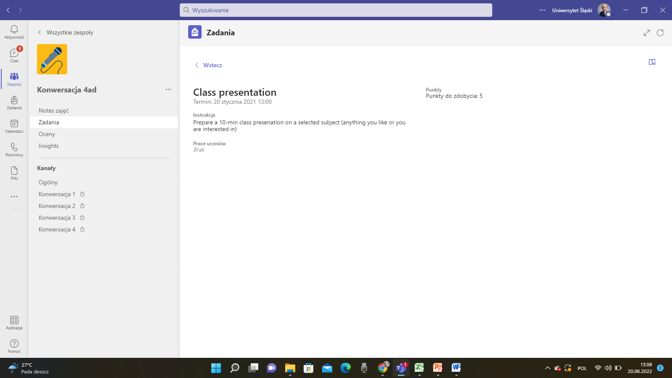
Figure 3. Description of a task and a sample presentation. MS Team image from Master Study Program, University of Silesia.

Figure 4. Description of a task and a sample presentation. MS Team image from Master Study Program, University of Silesia.
Introductory slides, students’ presentations, general conversations within the group and small group conversations were also very useful for teachers to take into consideration the issues that affect students’ learning. Students are thus actively engaged in peer learning activities.
Relevance for teachers: Students received continuous feedback and evaluation. The first evaluation took place after the first two meetings in order to verify whether students' expectations were fulfilled; afterwards, the teacher conducted a mid-term evaluation and, at the end of the project, there was the final evaluation. After the implementation of the project, the teacher did a self-evaluation on the basis of a student satisfaction questionnaire. To evaluate the course, the teacher adopted the Delphi evaluation method.
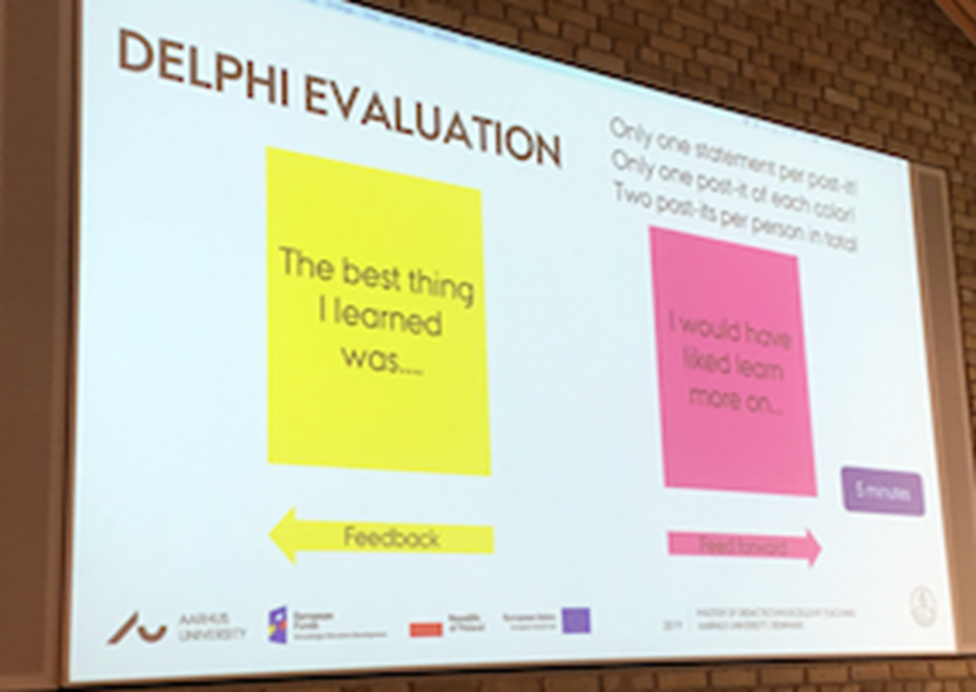
Figure 5. Delphi evaluation method. Image based on personal experience submitted by University of Silesia.
Active communication between students and teachers and students themselves is crucial in facilitating the language learning process. Discussion forums, breakout rooms, Padlet, Menti, and group work results allow teachers to follow the progress of students. During this course, the most useful MS Teams tools to create metacognitive learning strategies for students were discussion forums. Students and teachers participated in discussions and the forum allowed the teacher to check the level of participation of students. Last but not least, using MS Teams allowed for communication with students and was a good way to continue the conversations that started in class. MS Teams favoured group online interactions as it resembles popular social networks that are so common among students.

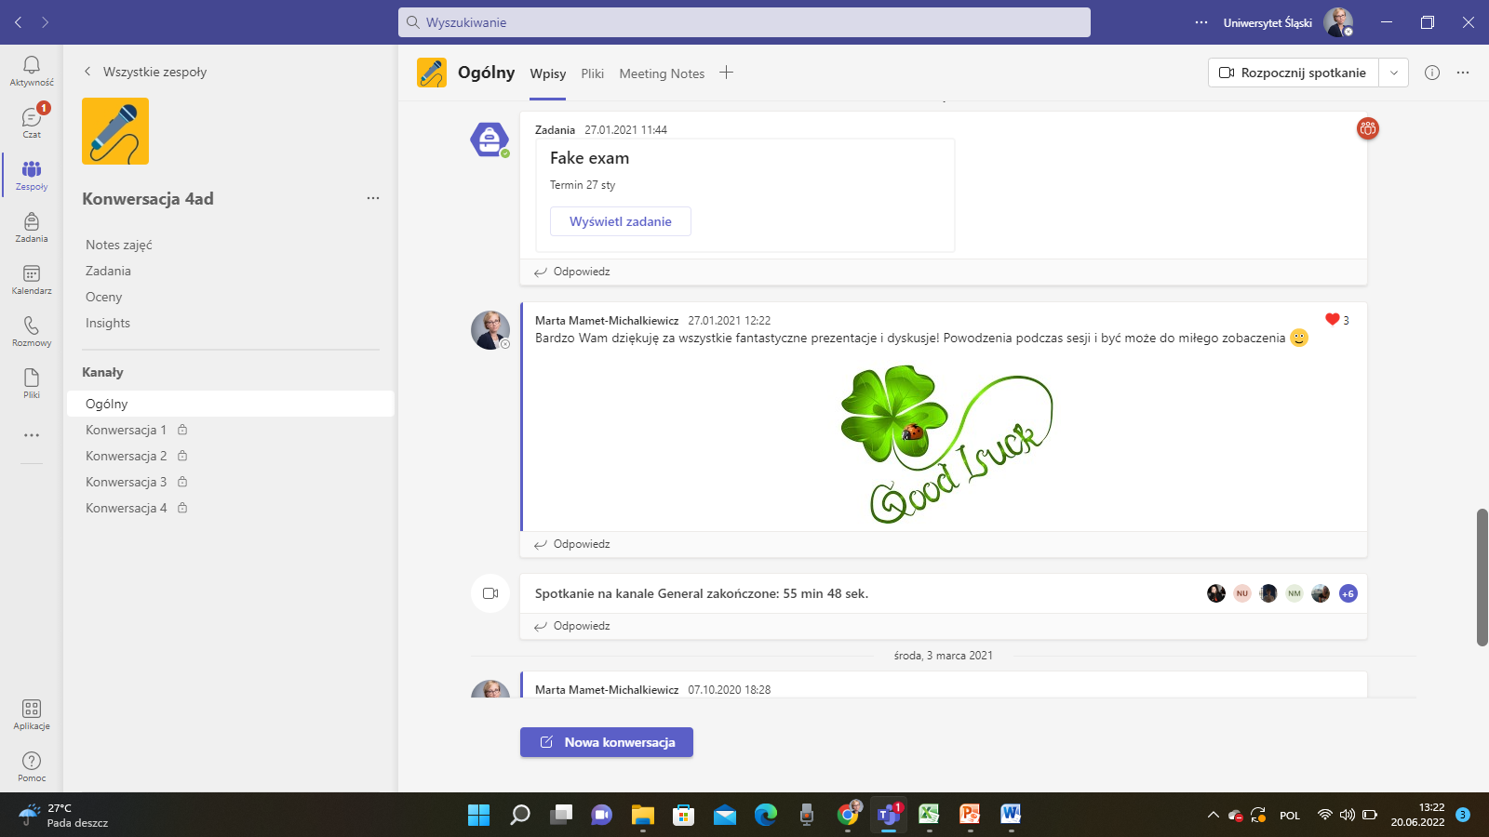
Figure 6. Chats between the students and the teacher on MS Teams group account. MS Team image from Master Study Program, University of Silesia.

BEST PRACTICE EXAMPLE 2

Title: The blended course in Translation Studies. Mamet-Michalkiewicz, M. (2020). Translation as a cultural phenomenon. Based on personal experience. University: University of Silesia, Master Study Program
Section of the framework: A - Metacognitive strategies to measure awareness of teaching and learning (e.g. Teachers plan activities for students to provide feedback on learning resources and learning design solutions; teachers adapt learning design to offer differentiation of tasks, individualisation and adaptation of learning)
What competencies and learning outcomes of the DigicompEdu Framework are we addressing?

COMPETENCIES | LEARNING OUTCOMES
Assessment strategies  Self-regulated learning  Feedback and Planning | - To use digital technologies to enhance summative assessment in tests, e.g. through computer-based tests, implementing audio or video (e.g. in language learning), using simulations or subject-specific digital technologies as test environments.  SELF-REFLECTION  - To use digital technologies to enable learners to reflect on and self-assess their learning process.  - To use digital technology to grade and give feedback on electronically submitted assignments.

Key issues: This best practice is about a course on contemporary translation studies. During the course, students had to write essays and translate literary texts from English into Polish and from Polish into English. This course addressed problems of theory and practice of translation in light of major methodological approaches to literary and cultural studies.
The objectives of the course were: (1) to make students aware of the interdependence between one’s capability of perceiving phenomena/entities in one’s own language and in metanarratives of one’s own culture and the ability to perceive phenomena/entities in another language and in metanarratives of another culture (2) to enhance their understanding of the mechanisms responsible for the functioning of texts.
The course was taught in a hybrid mode, its teachers adapted the learning design to offer differentiated tasks in class and out of class, and gave their students individual tutorials on their translations which resulted in an individualised and personalised learning process.
The tutorial was used to combine and align in-class activities and out-of-class activities to make students continuously develop their projects. The specific in-class and out-of-class activities are listed in the figure below:
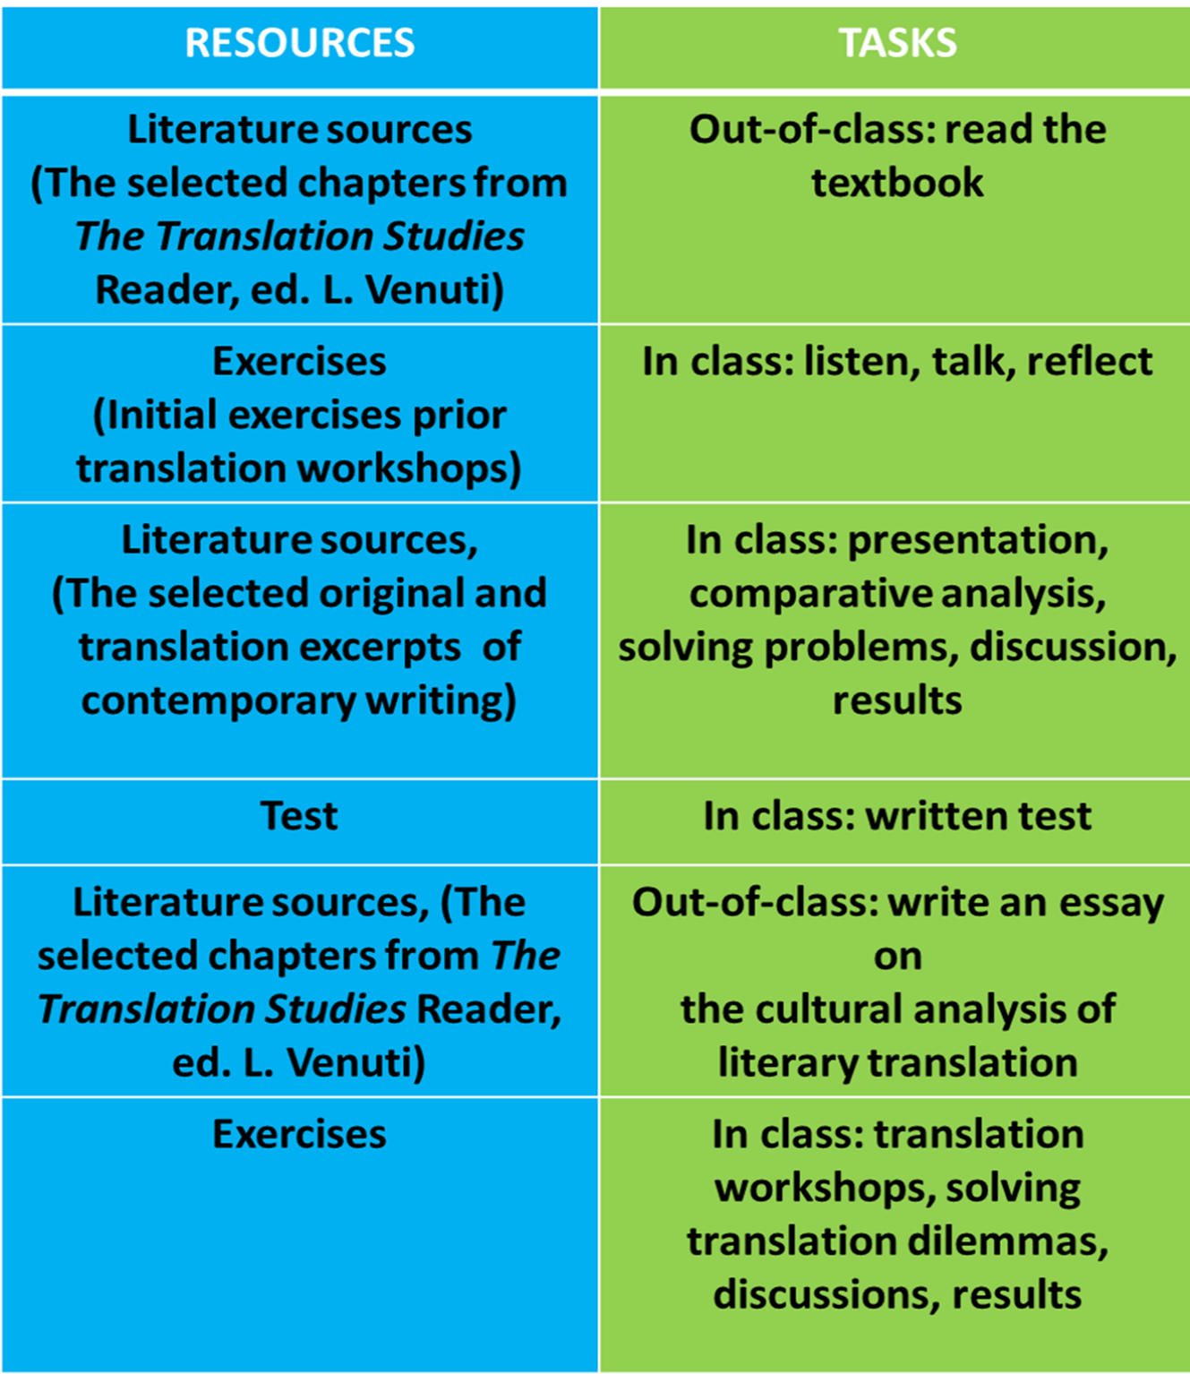
Figure 1. The tutorial focused on solving translation dilemmas by using in-class and out-of-class activities. Image based on personal experience submitted by University of Silesia.

The tutorial focused on combining analogic and online learning material. Its main objective was to make the students aware that there are no right or wrong answers in translation studies and that the space between the source text and the target text is the space of interpretation and reflection. The space of „between” was discussed with the students the most often.
Figure 2. Discussion: Initial interview activity with students involved in the tutorial. Image based on personal experience submitted by University of Silesia.

During the tutorial, several learning activities were included. Teachers conducted an early general evaluation of their students’ knowledge on translation studies gained during the first cycle of studies. Mentimeter was the tool adopted to show the students’ knowledge of the subject. On the basis of the outcome of the students’ responses, an individually crafted course was designed for students. The learning tools included: translation workshops, essay evaluation (with questions), student or teacher reflection (in writing), one minute paper, translation debates and online tests and surveys.
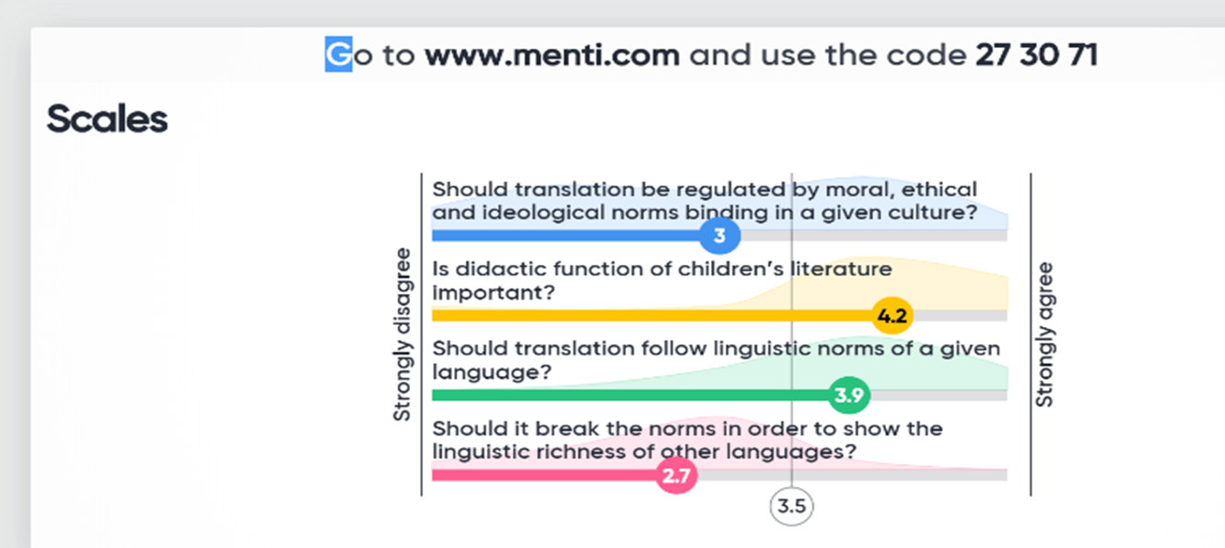
Figure 3. Results from an online assessment of student learning with an online test through Mentimeter. Image based on personal experience submitted by University of Silesia.

After the initial four meetings, students gave the first presentation of their research in translation studies. During meeting 6, students submitted the first essay on the theory of literary translation, during the forthcoming meetings they submitted excerpts of their literary translation activities (meetings 8,10,12) that were discussed in detail during meetings 9,11, and 13 (written feedback, feedback dialogue). The last two meetings were designed for preparing and discussing the final essay or literary translation (according to a student’s choice) as a final product of the course.
Each meeting was devoted to a different aspect of translation studies which resulted in broadening the students’ abilities in translating and critically evaluating existing translations.

Relevance for teachers:
- Students’ learning outcomes were assessed continuously (after each meeting).
- Their essays, literary translations, presentations and class participation were assessed.
- Students’ learning outcomes were assessed by means of a quality and translation writing rubric submitted to students in the first meeting.
- During each tutorial, students were given written and oral feedback on each submitted essay, translation and presentation.
- During each tutorial feedback/feedforward was delivered to a student by means of the feedback dialogue method.
Bloom's Taxonomy was also used during the course to show students how to improve critical thinking skills and achieve higher-order learning and also for the purposes of individualization and adaptation of learning.

References
Anderson, L.W. and Krathwohl, D. R., et al (Eds.) (2001). A Taxonomy for Learning, Teaching, and Assessing: A Revision of Bloom’s Taxonomy of Educational Objectives. Allyn & Bacon. Boston, MA (Pearson Education Group).

Armstrong, P. (2010). Bloom’s Taxonomy. Vanderbilt University Center for Teaching. Retrieved [14-12-22] from https://cft.vanderbilt.edu/guides-sub-pages/blooms-taxonomy/.

Bloom, B.S. (1956) Taxonomy of Educational Objectives, Handbook: The Cognitive Domain. David McKay, New York.

Bond, M., & Bedenlier, S. (2019). Facilitating student engagement through educational technology: Towards a conceptual framework. Journal of Interactive Media in Education, (1), 1–14. https://doi.org/10.5334/jime.528

Bond, M., Buntins, K., Bedenlier, S., Zawacki-Richter, O., & Kerres, M. (2020). Mapping research in student engagement and educational technology in higher education: a systematic evidence map. Int J Educ Technol High Educ 17, 2. https://doi.org/10.1186/s41239-019-0176-8

Conrad, R. M., & Donaldson, J. A. (2011). Engaging the online learner: Activities and resources for creative instruction (Vol. 38). John Wiley & Sons.

Fan, S.; Chen, L.; Nair, M.; Garg, S.; Yeom, S.; Kregor, G.; Yang, Y.;Wang, Y. (2021). Revealing Impact Factors on Student Engagement: Learning Analytics Adoption in Online and Blended Courses in Higher Education. Educ. Sci. 2021, 11, 608. https://doi.org/10.3390/educsci11100608

Prince, M. (2004). Does Active Learning Work? A Review of the Research. Journal of engineering education, 93(3), 223-231. https://doi.org/10.1002/j.2168-9830.2004.tb00809.x

