Unit 1.1. How to design metacognitive teaching and learning strategies?
Do you know how your students learn? Do students know how they learn? By helping students understand the learning strategies and methods that help them learn better, you can promote their engagement, performance and success. Metacognitive learning opportunities can help students take ownership of their learning. In addition, metacognitive knowledge fosters learners’ forethought and self-reflection, which are crucial for self-regulated learning.
The teacher is responsible for designing metacognitive strategies that would foster learners’ SRL, by going through the design (forethought), teaching and learning (monitoring) and re-design (self-reflection) phases in the courses s/he holds. Research confirms that metacognitive activities in online higher education generated from learning analytics enhance teachers’ reflection in a more systematic way. As a consequence, better decision-making on how to improve learning design is possible. At the same time, metacognitive learning strategies help teachers measure student awareness of their roles as learners and the teaching and learning process.
This unit will illustrate the metacognitive learning strategies that you should use to foster student engagement and to create activities that generate evidence and inform the instructional design of your courses.
1.1.1. Metacognitive strategies to empower learners to plan, monitor and reflect on their own learning
Metacognition consists of two complementary processes, which are (1) knowledge of cognition, and (2) the regulation of cognition. The knowledge of cognition refers to learners’ awareness of themselves as learners, i.e., understanding the way they learn, the factors that influence their performance or the different learning strategies adopted according to the situation. Regulation of cognition refers to the learners' ability to set goals, plan and monitor learning and self-assess learning outcomes. It also refers to the learning strategies to choose and the decisions and changes to make. It is important for you to engage learners in active collaboration and discussion from the very first classes and this could be achieved by designing engaging learning activities.
How to create these learning activities and what digital tools can support them?
You can promote metacognitive strategies that foster learners’ awareness about their own learning by:
- inviting students to contribute to the course plan development by asking them to introduce themselves and share their prior knowledge or experience in a given topic,
- encouraging learners to reflect on and share what are their learning strategies and what learning methods they like the most,
- indicating what they will learn in this course,
- inviting learners to share their learning expectations or needs.
- encouraging learners to create a study plan with the learning goals set and learning strategies described;
- allowing students to contribute to the learning by choosing what topics they would like to explore more, what tasks to complete and when;
- helping learners determine individually what they already know and what they need to learn to complete an assignment;
- fostering self-reflection and self-assessment on how they succeeded and if they achieved their personal learning goals;
- encouraging learners to review and evaluate their learning process and learning strategies that they applied.
Strategy example 1. Fostering self-reflection about the learning
There are Moodle-based or external tools that can support the above-mentioned activities. For example, a Padlet tool may be embedded, allowing the creation of a shared ‘wall’ where all students can share their learning experiences (fig. 1).
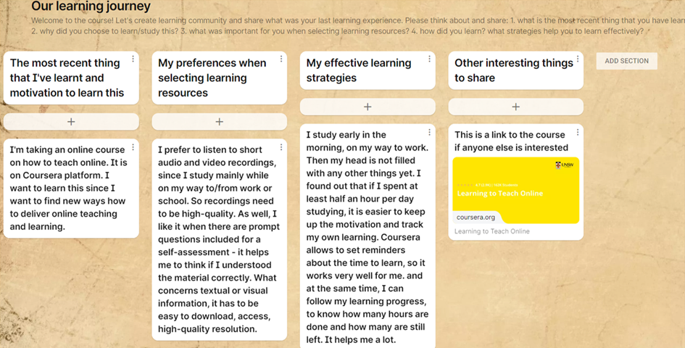
Figure 1. An example of a Padlet tool to foster learners’ metacognition and collect data on learning experiences (activity created for this training material, Tamoliune, 2022)
Such activities may raise students’ self-reflection on how they learn and what is important for them to learn. These data can inspire teachers on how to deliver teaching and learning to support learners’ performance, engagement and SRL. In addition, according to the data collected, you can review the pre-designed course content, decide if it covers learners’ expectations and if other topics should be added or not. In such a way, you will show your students that you expect them to participate actively. Make sure that you analyse the needs and expectations expressed by your students during the course and provide feedback on whether or not they can be met.
Strategy example 2. Deconstructing and “thinking aloud” the learning process
You can help students plan and think of their learning by modelling your own thinking process. For example, when introducing an assignment, deconstruct the process of the assignment development by giving step-by-step instructions on how to complete the task. You can use the Moodle Assignment tool to provide the details by deconstructing the process in the description section (fig 2.).
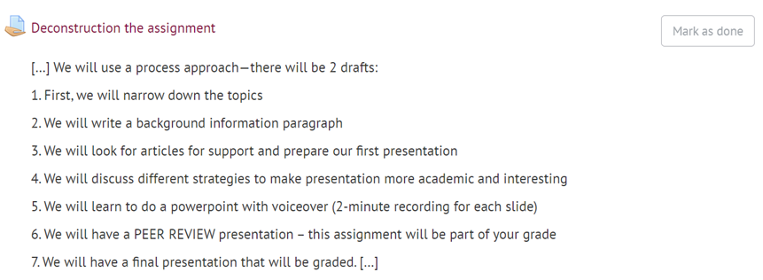
Figure 2. Example of a ‘deconstructed’ task description leading students to understand the steps involved in the assignment development (adapted from Volungeviciene et al., 2021, p.140)
Strategy example 3. Promoting learners’ critical thinking and reflection
When designing a course, bear in mind that learning activities should inspire critical thinking, personal interest and original understanding. These activities have to trigger learners’ awareness of how they learn and, at the same time, inform you on how learners progress with the course.
For example, when you want to promote critical thinking and reflection among students, it is good to ask them an open and challenging question. You might use a Moodle discussion forum to stimulate students with different questions, allowing them to reflect and share their knowledge on a given topic. In such a way, students have the possibility to self-assess their knowledge and learning process (fig. 3), and to observe if they are as actively involved in learning and discussions as their peers are. Discussion questions could also be pre-designed in a way that students could answer them while being in-class or at any given time stated by the teacher.
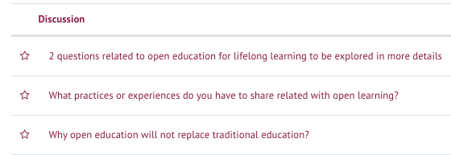
Figure 3. An example of pre-set questions on Moodle Forum (Trepule & Tamoliune, MA study course “Concepts of adult education”, Vytautas Magnus University)
Of course, VLE-based tools, like Feedback, Quiz, Wikis, also can be used when designing metacognitive learning activities. Moreover, these tools collect traces of learners’ performance. More on how to set up Moodle-based tools and how different tools may be used to collect and generate data is introduced in subunit 1.3.
1.1.2. Metacognitive strategies to foster learners’ metacognitive thinking about a learning design
An important factor related to teaching design is the consistency of learning activities. In other words, you have to make sure that all the tasks match with the learning outcomes. Moreover, the overall structure of the course should be easy to follow. Learners should be able to identify the learning pathway and understand how each topic, learning resource, activity and assignment contribute to their successful learning.
Strategy example 4. Creating concept maps to reflect on the course concepts
Let’s provide an example of activity. In the first task, for example, you can ask students to look for three definitions of “open education” and to describe them according to their characteristics. In the second task, they should work in groups to develop a concept map in which the definitions and characteristics are grouped (fig.4). To do this, students can choose any tool among the following: Moodle Mindmap, Mindmup, Mindmeister, Genially.

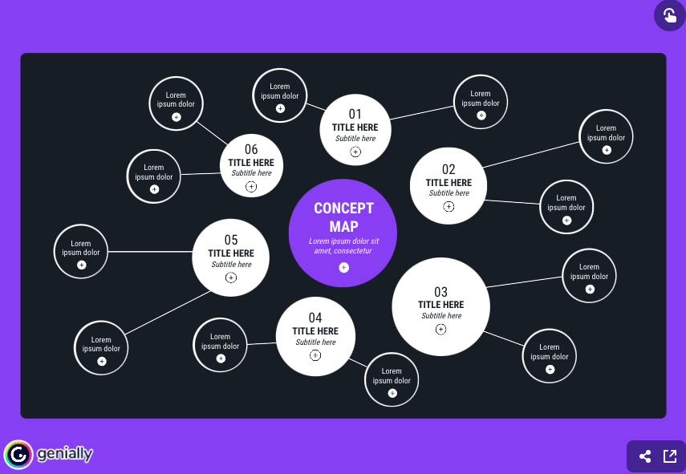
Figure 4. A “Genially” Template for a circular concept map (image source: https://genial.ly/template/circular-concept-map/)

When students complete these assignments, they develop conscious task performance. And at the same time, you develop metacognition by:
· adding VLE-based learning outcomes in the course
· creating assignments and linking them with learning outcomes, as indicated in the course/assignment or study guide description (more in unit 1.2.)
· setting up and using clear evaluation criteria for each assignment, which can be checked in a study guide
· providing feedback on the grade issued and marking which learning outcomes have been achieved or not.
Strategy example 5. Identifying learning content that requires more explanation
Another metacognitive learning strategy is to encourage learners to ask questions during the class so that the teacher can give on-time responses. To do this, you can use any tool that allows you to co-create documents, e.g., Google Jamboard (fig. 5).
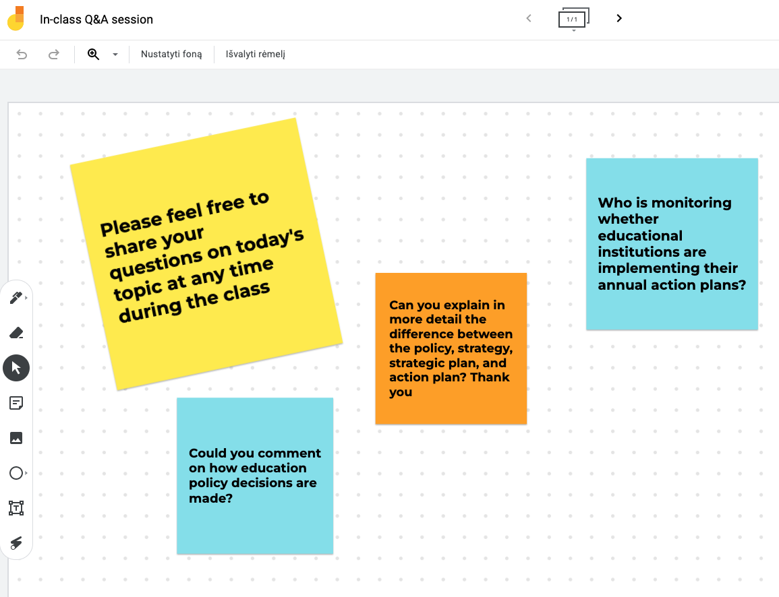
Figure 5. Q&A activity during a synchronous class using Google Jamboard tool (activity created for this training material, Tamoliune, 2022)
Strategy example 6. Self-assessing one’s learning and course content
In order to help students self-assess and monitor their knowledge, you can invite them to provide feedback on a given topic, course unit, learning method, learning resources, on the usefulness of teachers’ feedback, on the clarity of assessment criteria, etc. At the same time, you can ask students to reflect on their own work during the course and on their engagement and participation in synchronous classes. Moodle-based Feedback instrument, for example, allows you to collect learners’ feedback (fig. 6) and, at the same time, generates data on how many answers have been provided.
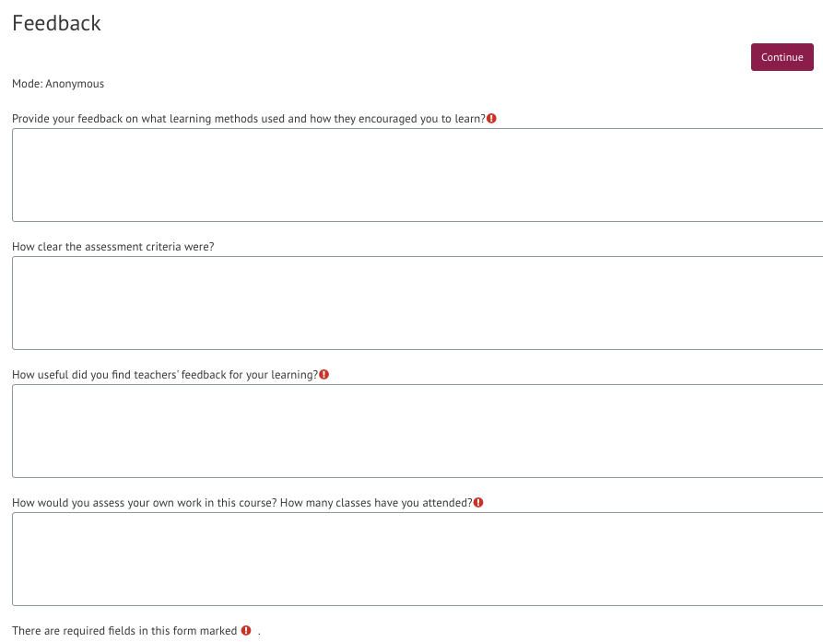
Figure 6. An example of Moodle-based feedback activity on learning design (Trepule & Tamoliune, MA study course “Concepts of adult education”, Vytautas Magnus University)
Feedback activities should be designed when needed or at least at the end of the course. For example, you can ask learners how they can apply the new knowledge in their practice or what resources they find most successful. These questions foster learners’ metacognition and awareness of how they perceive the topic or the course. You can understand better what their learning preferences are.
Strategy example 7. Inviting learners to co-create learning resources
You can foster social presence and emphasise the importance of a learning community by inviting students to share learning resources that they find useful for learning in a given course. To do this, you can use Moodle glossary, wikis, or some other external tool.
You will find more ideas on learning tools that can support learners’ engagement and metacognition in other units of this training material. Moreover, unit 2.2 will provide you with some recommendations on how to make data-informed teaching and learning interventions, while unit 3 will introduce teaching and learning strategies that may help you support and engage students in learning.

Best practice example
Title: A research study on an online study course of English (Volungeviciene et al., 2021)
University: Vytautas Magnus University (VMU), Lithuania
Section of the framework: B - Metacognitive strategies to measure students’ academic success
What competencies and learning outcomes of the DigicompEdu Framework are we addressing?

COMPETENCIES | LEARNING OUTCOMES
Self-regulated learning  Actively engaging learners  Analysing evidence | - (Monitor performance). To use digital technologies (e.g. ePortfolios, learners’ blogs) to allow learners to record and showcase their work.  - To use digital technologies to visualise and explain new concepts in a motivating and engaging way, e.g. by employing animations or videos.  - To design and implement learning activities which generate data on learner activity and performance.

Key issues: This best practice description introduces the metacognitive learning activities that are designed and delivered in an online English language course in Moodle (and in the virtual conference room). Here the teacher has designed various learning activities that would help collect evidence on learners' academic success and learning design.
Tasks like group work, individual work, pair work, discussions, and analysis, allow teachers to engage learners better. Similarly, introductory presentations, reflections, and feedback given to and from peers affect students’ cognition. Here are some strategies used in the course:
Two-slide PowerPoint
Since the course is taken by students from different study fields and study programs, the teacher aims to learn more about students as learners. Therefore, the teacher asks to create a two-slide PowerPoint of introduction and posts it on Moodle at the very beginning when the course starts.
- The first slide was divided into two parts. The first half focused on serious information – students’ names, education, and work. The second side of the slide reveals a student as a person – hobbies, interests, talents, passions, etc.
- The second half of the slide was for students to share their likes and dislikes. Thanks to this strategy, the teacher aimed to foster their reflection on their own learning preferences.
- Students were encouraged to present and discuss how they felt about their role as a student, a brother/sister, an English learner, or a professional in the job position he/she had at that moment.
In this task, students are required to introduce themselves to the classmates and the teacher. Students post their introductions on a discussion forum where everybody from the group can participate (fig. 1).
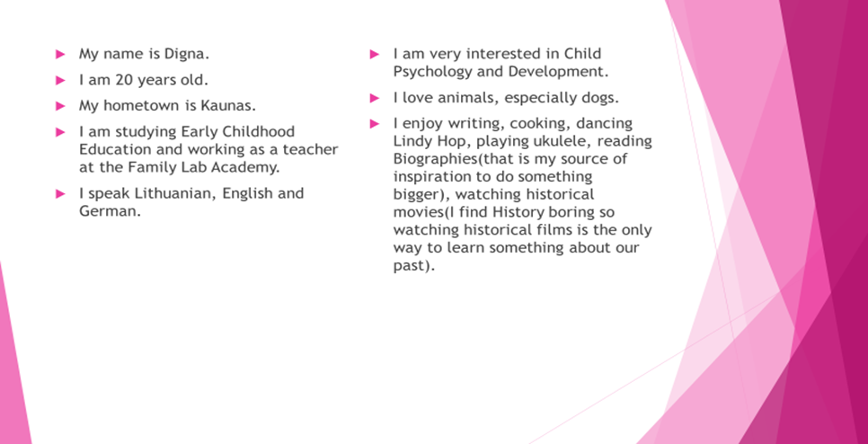
Figure 1 . Example of student presentation from the English language course (Volungeviciene et al., 2021, p. 138).
The slides’ purpose is to know more about students, their strengths, weaknesses and interests. Introductory slides and students’ presentations are useful for teachers to know more about learners’ context (family, work, passions, professional interests). Thanks to this information, teachers can encourage students to find out topics for future assignments according to their interests. By making these decisions, the teacher fosters learners' self-regulated learning, allowing them to plan their own learning or reflect on what topics they want to explore in their assignments.
Peer learning activities
Another learning design strategy that the teacher applies in the course is peer learning activities. By asking students to review peers’ presentations according to a set of criteria, the teacher raises awareness of their cognitive knowledge and skills (fig. 2). Students need to think critically, reflect on their own presentation, compare the results, and, when needed, make decisions on how to improve their own learning.
Please review the presentation. Write comments and suggestions. Please do not comment on grammar. Your goal is to help your friends make a better presentation:
The problem is clear.
I understand the seriousness of the problem.
The problem is relevant to Lithuania. It is clear to me.
I understand the 2 reasons/effects presented in the next two slides.
Each reason or effect is not only clear but is documented and has relevant information.
Each reason has information that was new to me. There are no ideas that are so well known that everyone knows without reading this information.
The solution is clear. There is only ONE solution and not 10 little steps on how to achieve something.
The solution is based on a real example and it is clear what that example is.
The person has documentation. Each slide has visible in-text citations, and the pictures are documented.
The reference slide is nicely organized. It is organised alphabetically by the author's last name or the title of the article if there is no author.
This presentation was interesting because…
My other recommendations:
Figure 2 . An example of peer-assessment criteria (Volungeviciene et al., 2021, p. 144).
Throughout the study period, the teacher assesses students through a variety of assessment and self-assessment tools, like discussion forums, where students are encouraged to reflect and give feedback to peers on their performance and assignments.
Self-reflection on the learning process
At the end of the semester, learners have to reflect on their learning process. This can be done through a follow-up of an introductory activity by means of slides. Students are invited to reflect on their learning experience, think about if and how they would study differently in the future and evaluate their own learning. Teachers encourage students to rate the usefulness of learning content, what they found the most and least useful, and, finally, what learning strategies or experiences can be applied in their future studies. By using metacognitive learning strategies, the teacher engages learners in a continuous reflection on their learning practices. Such reflections help students think about their role in the learning process and in the learning community.
A list of reflective questions is also introduced after students have delivered the first-class project presentation (fig. 3). Through this task, the teacher invites students to reflect on the assignment's process and assess the value of the assignment.
Reflections after each assignment reinforce students’ metacognition and, at the same time, allows teachers to receive feedback on their learning design.
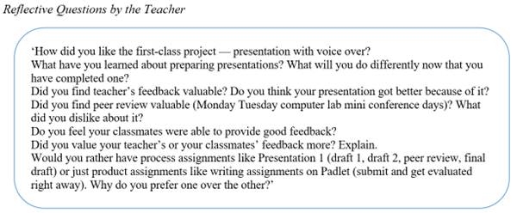
Figure 3. Reflective questions introduced to students after the assignment (Volungeviciene et al., 2021, p. 142).
Quizzes and a gradebook
Finally, weekly quizzes and a gradebook are used to support metacognitive learning strategies and self-regulated learning. Quizzes are created using the Moodle Quiz tool every week and the time is set for completing each quiz. It allows students to learn consequently, plan their learning, check if they use enough effort to achieve intended learning outcomes and be aware of their own learning progress. The gradebook allows students to follow their achievements and regulate their learning accordingly.

Relevance for teachers:
The improvement of learning design is based on frequent reflections on assignments and follow-up activities. Teachers change the syllabus every semester and adapt it during the semester considering students’ needs, personalities and study programme peculiarities. The teacher’s aim is to push students outside of their comfort zone by encouraging them to share their opinion, critically assess peers’ learning and use argumentation. Diverse Moodle tools are used each semester and, at the same time, the teacher explores new possibilities about the learning design each semester. Discussion forums, Padlet, and group work results allow teachers to follow the progress of students. One of the most useful Moodle tool during this course was Padlet, where all students and teachers participated in the discussions. All these tools together allow teachers to follow students’ learning progress.

References
Volungeviciene, A., Tereseviciene, M., & Trepule, E. (2021). Learning Analytics: a Metacognitive Tool to Engage Students. Research study. Sciendo. https://doi.org/10.2478/9788366675643

