Project ID: 2021-1-CZ01-KA220-SCH-000034484

COURSE FOR ENVIRONMENTAL EDUCATION
e-Modules: Teaching Learning activities and their technology enhanced material set to develop

DISCLAIMER
Funded by the European Union. Views and opinions expressed are however those of the author(s) only and do not necessarily reflect those of the European Union or the European Education and Culture Executive Agency (EACEA). Neither the European Union nor EACEA can be held responsible for them.

COURSE AUTHORS
Céline CORNEILLE, Paul FERNANDEZ, Frédéric GUILLERAY,
Marine ROBINI and Ervan ROUSSEL.

COURSE SHARING LICENSE
You are free to:
- Share — copy and redistribute the material in any medium or format for any purpose, even commercially.
- Adapt — remix, transform, and build upon the material for any purpose, even commercially.

MODULE 3 | NATURE AND CLIMATE CHANGE
PART 3 | Greenhouse effect
Lesson 1 | What is greenhouse effect?

SUMMARY

1. COURSE TIME, TARGET AND TOPIC 3

2. COURSE OBJECTIVES 3
Competences promoted in this lesson: 3
Lesson objectives: 3

3. LEARNING – TEACHING PROCESSES 3

4. EVALUATION 3

5. DOCUMENTS 4
ENGAGE 4
EXPLORE 6
EXPLAIN 7
EXTEND 10
EVALUATE 11

1. COURSE TIME, TARGET AND TOPIC
- Age of target students: 15+
- Teaching time: 2 hours
- Disciplines: Biology
- Title: What is greenhouse effect?

2. COURSE OBJECTIVES

Competences promoted in this lesson:
- Communication in foreign languages competency
- Digital competency
- Learning to learn competency
- Social and citizenship-related competencies

Lesson objectives:
- Students explain the earth’s atmosphere and greenhouse effect.
- Students make inferences about greenhouse effect.

3. LEARNING – TEACHING PROCESSES
There are 4 activities in this lesson:
- ENGAGE: Life is allowed thanks to greenhouse effect (discussion)
- EXPLORE: Any heated body emits infrared radiation (read and make a diagram)
- EXPLAIN: Describe the greenhouse effect (presentation or stop motion)
- EXTEND: Modeling the greenhouse effect (modelling)

4. EVALUATION
The evaluation is described in the last part of document.

5. DOCUMENTS

ENGAGE
Life is allowed thanks to greenhouse effect

This moment is useful:
- to capture students' interest and introduce the concept of the greenhouse effect
- and to think about its importance for the development of life on Earth.

For there to be a significant greenhouse effect there has to be a lot of greenhouse gas in the atmosphere. Not just a large percentage, but a large amount of gas AND the pressure of the atmosphere must be also quite important.

Table of the theoretical temperature of the planets (T_{t}) and their actual temperature (T_{sur}).
 | Mercury | Venus | Earth | Mars
Theoretical temperature (T_{t}) | 165 | -40 | -15 | -64
Average surface temperature (T_{sur}) | 165 | 465 | 15 | -59
Composition of atmosphere in gases

Q1. Complete the table with the composition of atmosphere in gases for each planet.

Q2. Determinate the planet with a greenhouse effect and the consequences of this greenhouse effet.
Answer :
- There is no greenhouse effect on Mercury (no atmosphere) and the theoretical temperature is close to the actual temperature.
- On Venus, there is a huge greenhouse effect (because there is a lot of CO₂ and a huge pressure of the atmosphere) leading to an actual temperature of 462 °C instead of -41°C without any greenhouse effect.
- On Earth, there is a greenhouse effect (because there is CO₂ and a pressure of the atmosphere) leading to an actual temperature of 15°C instead of -18°C without any greenhouse effect.
- On Mars, there is almost no greenhouse effect (because there is CO₂ but there is almost no pressure) leading to an actual temperature of -58°C instead of -64°C without any greenhouse effect.

Ask to the students if the greenhouse effect is a positive or negative phenomenon for Earth.
Answer : it is a positive phenomenon for the life on Earth because without the greenhouse effect, the temperature on Earth would be around -15°C.

So what could be the problem today ?
Answer : the greenhouse effect is to strong and it warms the Earth too much…

EXPLORE
Any heated body emits infrared radiation

Instructions:
- Distribute the document below to students.
- Ask them to read it carefully and highlight key points.
- As a group, discuss the main ideas presented in the text.
- Then distribute a blank sheet of paper to each group and ask them to create a diagram based on the text.
- Each group then presents its work.

DOCUMENT: any heated body emits infrared radiation
The Earth, like all objects with a temperature above absolute zero (-273.15 degrees Celsius), emits thermal radiation.
When the Sun illuminates the Earth, the Earth's surface absorbs this energy. In return, the Earth re-emits this absorbed energy in a different form, mainly as infrared radiation.
This process follows from Planck's Law, which describes how heated objects emit electromagnetic radiation. The Earth, heated by solar energy, reaches temperatures that cause it to emit mainly in the infrared spectrum.
The infrared radiation emitted by the Earth is crucial for maintaining the planet's overall temperature. Without this re-emission mechanism, the Earth would rapidly lose its heat and become inhospitable.

EXPLAIN
Describe the greenhouse effect

Instructions
- Using the resources at your disposal, create a presentation showing what happens to the sun's rays as they reach the Earth.
- You must identify precisely which arrow corresponds to the greenhouse effect in the presentation.
- If you have time: make a stop motion instead of the presentation.

Document 1 : What happens to the incoming solar energy
Of the 100% of incident solar energy :
- 22% is reflected directly to space, partly by the clouds of the atmosphere
- 9% is reflected by the surface of the Earth.
- 20% are absorbed by the greenhouse gases of the atmosphere.
- only 49% is absorbed by the Earth's surface.

Document 2 : Any heated surface emits energy
The Earth’s surface, heated by solar energy, emits infrared energy.
Of the 100% of infrared emitted by the Earth’s surface :
- Almost 90% of this energy is absorbed by the gases in the atmosphere.
- 10% goes directly through the atmosphere and reaches the space.

Document 3 : Greenhouse gases re-emit energy
Greenhouse gases in the atmosphere emit infrared radiation :
- back to space
- and back to the ground.
Infrared radiation is absorbed by the Earth’s surface, which contributes to its heating (in addition to the incident solar radiation).
This is natural greenhouse effect.

EXTEND

Modelling the greenhouse effect

Conduct a small experiment with your students to model the greenhouse effect.
The video below explains how to do it simply:
https://www.esa.int/ESA_Multimedia/Videos/2022/01/Why_do_we_need_the_greenhouse_effect/(lang)/en
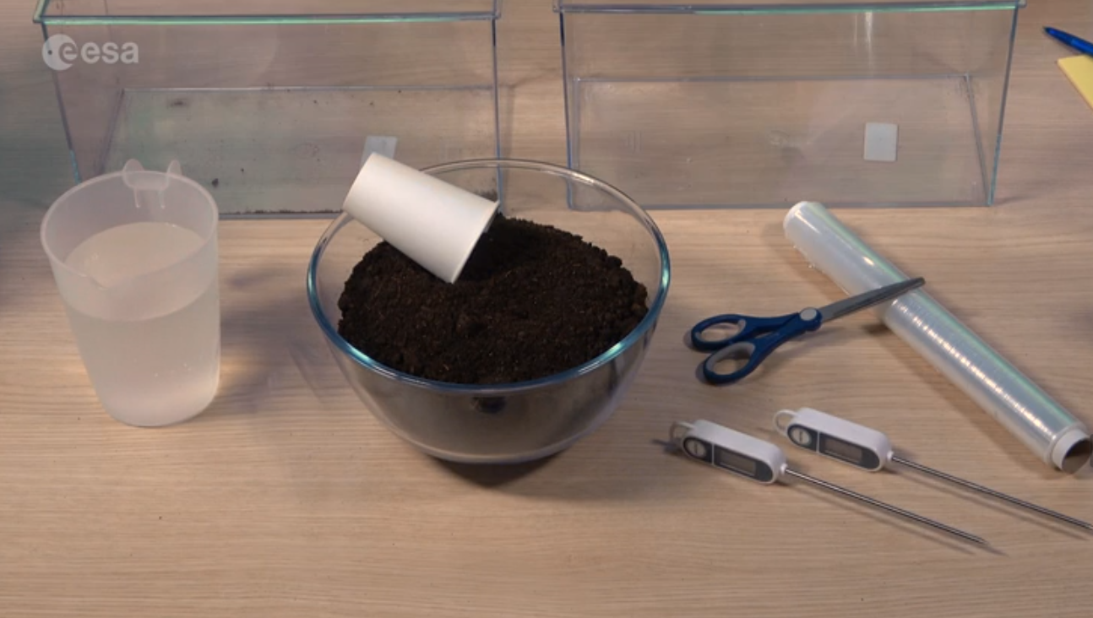
Credit: ESA - European Space Agency. ©ESA

Materials for the experiment
- 2 transparent containers
- Soil
- Water
- T-spoon
- 2 thermometers
- clear film
- scissors

EVALUATE

Q1. Which of the following statements is true regarding the greenhouse effect?
a) It only occurs on warm days
b) It is exclusive to Earth in the solar system
c) It cools down the Earth's surface
d) It is a natural process that warms the Earth
Answer: d

Q2. What role do greenhouse gases play in the Earth's atmosphere?
a) They reflect sunlight away
b) They trap heat and warm the Earth's surface
c) They cool down the atmosphere
d) They prevent the formation of clouds
Answer: b

Q3. How does the greenhouse effect contribute to the warming of the Earth's surface?
a) By reflecting sunlight away
b) By absorbing ultraviolet radiation
c) By trapping and re-radiating infrared radiation
d) By preventing the escape of visible light
Answer: c

Q4. Match each term or concept related to the greenhouse effect with its corresponding definition.

CONCEPT |  | DEFINITION
Greenhouse Effect □  Atmosphere □  Infrared Radiation □  Earth's Surface □ |  | □ The outermost layer of the Earth where living organisms exist, including the land and oceans.  □ Form of energy sub-emitted by the Earth after being heated by solar energy  □ The layer of gases surrounding the Earth, including greenhouse gases, that traps heat and maintains a suitable temperature for life.  □ The overall warming of the Earth due to the trapping of heat by certain gases in the atmosphere.
Answer: 1-D, 2-C, 3-B, 4-A

