|  |  |  |  |  |  |  |
| --- | --- | --- | --- | --- | --- | --- |
| **Project ID: 2021-1-CZ01-KA220-SCH-000034484**    **COURSE FOR ENVIRONMENTAL EDUCATION**  *e-Modules: Teaching Learning activities and their technology enhanced material set to develop*  ***DISCLAIMER***  *Funded by the European Union. Views and opinions expressed are however those of the author(s) only and do not necessarily reflect those of the European Union or the European Education and Culture Executive Agency (EACEA). Neither the European Union nor EACEA can be held responsible for them.*  Obsah obrázku symbol, Písmo, logo, Grafika  Popis byl vytvořen automaticky  **COURSE AUTHORS**   |  |  | | --- | --- | |  | Lubomír Hájek, Petra Garay | |  |  |   **COURSE SHARING LICENSE**   |  |  | | --- | --- | |  | You are free to:   * Share — copy and redistribute the material in any medium or format for any purpose, even commercially. * Adapt — remix, transform, and build upon the material for any purpose, even commercially. | |
|  |

|  |  |
| --- | --- |
| **MODULE 6** | **SUSTAINABLE DEVELOPMENT AND SOLUTIONS TO ENVIRONMENTAL PROBLEMS AND CLIMATE CHANGE** |
| **PART 1** | **SUSTAINABLE DEVELOPMENT** |
| **Lesson 2** | **SUSTAINABLE DEVELOPMENT, THE SGD GOALS, TOOLS TO MEASURE SUSTANABILITY** |

**SUMMARY**

1. COURSE TIME, TARGET AND TOPIC 3

2. COURSE OBJECTIVES 3

Competences promoted in this lesson: 3

Lesson objectives: 3

3. LEARNING – TEACHING PROCESSES 3

4. EVALUATION 3

5. DOCUMENTS 4

ENGAGE 4

*Sustainable development and the 2030 Agenda* 4

EXPLORE 5

*The SD goals* 5

EXPLAIN 6

*The 3 pillars and SD goals* 6

EXTEND 7

*Tools to measure sustainbility* 7

**EVALUATION** 8

# 1. COURSE TIME, TARGET AND TOPIC

* **Age of target students:** 15+
* **Teaching time:** 1 hour
* **Disciplines:** Biology, Geography, Human science, Economy,
* **Title:** Sustainable development, The SGD goals, Tools to measure sustainability

# 2. COURSE OBJECTIVES

## Competences promoted in this lesson:

* Communication in foreign languages competency
* Digital competency
* Social and citizenship-related competencies
* Cultural awareness
* Integrated problem-solving competency

## Lesson objectives:

* The students deepen their knowledge regarding the topics of the 17 SGD goals, tools to measure the sustainable development – carbon footprint
* The students are going to work on their awareness about the connection between the pillars and the SGD goals
* The students are going discuss the moral obligations in relation to sustainable development

# 3. LEARNING – TEACHING PROCESSES

There are 8 activities in this lesson:

1. **ENGAGE:** Sustainable Development and the 2030 Agenda
2. **EXPLORE:** The Sustainable Development Goals (SDGs)
3. **EXPLAIN:** The 3 pillars and SDGs
4. **EXTEND:** Tools to measure sustainability

# 4. EVALUATION

The evaluation is described in the last part of document.

# 5. DOCUMENTS

### ENGAGE

### *Sustainable development and the 2030 Agenda*

*The 2023 Agenda for Sustainable Development*

* se střední mírou spolehlivostiPREAMBLE:* This Agenda is a plan of action for people, planet and prosperity. It also seeks to strengthen universal peace in larger freedom. We recognise that eradicating poverty in all its forms and dimensions, including extreme poverty, is the greatest global challenge and an indispensable requirement for sustainable development. All countries and all stakeholders, acting in collaborative partnership, will implement this plan. We are resolved to free the human race from the tyranny of poverty and want and to heal and secure our planet. We are determined to take the bold and transformative steps which are urgently needed to shift the world onto a sustainable and resilient path. As we embark on this collective journey, we pledge that no one will be left behind. The 17 Sustainable Development Goals and 169 targets which we are announcing today demonstrate the scale and ambition of this new universal Agenda. They seek to build on the Millennium Development Goals and complete what these did not achieve. They seek to realize the human rights of all and to achieve gender equality and the empowerment of all women and girls. They are integrated and indivisible and balance the three dimensions of sustainable development: the economic, social and environmental.

The Goals and targets will stimulate action over the next fifteen years in areas of critical importance for humanity and the planet: *People, Planet, Prosperity, Peace and Partnership.*

**Task :** Read the preamble, try to formulate in your own words the main goals and actions covered by the agenda 2023

### EXPLORE

### *The SD goals*

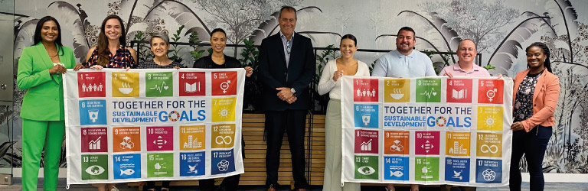

https://international.standardbank.com/international/personal/learn-more/why-we-are-raising-our-sdg-flag-this-september

[The 2030 Agenda for Sustainable Development,](https://sdgs.un.org/2030agenda) adopted by all United Nations Member States in 2015, provides a shared blueprint for peace and prosperity for people and the planet, now and into the future. At its heart are the 17 Sustainable Development Goals (SDGs), which are an urgent call for action by all countries - developed and developing - in a global partnership. They recognize that ending poverty and other deprivations must go hand-in-hand with strategies that improve health and education, reduce inequality, and spur economic growth – all while tackling climate change and working to preserve our oceans and forests.

**Task** : In pairs, use the worksheet (Appendix 1). These are the icons for the 17 goals and try to determine the title of each goal.

**Task** : Watch the following video, how many of the goals did you get right?

<https://www.youtube.com/watch?v=0XTBYMfZyrM>

**Task**: In pairs, choose the three most important goals for you, check with other students, determine which topics are the ones crucial for the students in your class.

https://issuu.com/unpublications/docs/sdg_yak_en

### EXPLAIN

### *The 3 pillars and SD goals*

**Task:** The three pillars of sustainable development have been mentioned in the previous lesson. In groups, try to link the 17 SGD goals to the appropriate pillar (economic, environmental, social).

Solution (Appendix 2)

**Task:** All of the pillars are dependant on each other, divide into 6 groups, choose one of the connections and try to come up with a specific example/information related to the particular connection (use the internet).What can be done ?

1. environment-economy (economic costs of environmental protection)
2. economy-environment (pressure on environmental resources, environmental investment)
3. environment - social (human welfare, health care by maintaining pure environment)
4. social - environmental (ecological responsibility, consumption patterns)
5. economy – social (providing jobs, good living, income)
6. social - economy (labor quantity and quality).

https://positiveplanet.uk/what-are-the-three-pillars-of-sustainability/

*Example of the answer : environment - economy*

In 2018, air pollution triggered a staggering cost of USD 2.9 trillion to the global economy, corresponding to 3.3 % of the world's GDP. In the same year, unhealthy air quality caused 1.8 billion days of work absences worldwide. Other estimates suggest that air pollution accounts for USD 5 trillion, annually, in welfare costs for the global economy”

### EXTEND

### *Tools to measure sustainbility*

*Moral obligation*

Companies and individuals are also required to do their part to contribute to a **sustainable development**. In particular companies has **a moral obligation** to adopt development policies that translate into sustainable development, for example like:

* Adoption of practices based on **circular economy principles;**
* Preservation and protection of the territory and bio diversities;
* Promotion of the renewable energy sources and **efficient use of resources;**·      Recycle and optimal waste management;
* Promotion of the **sustainable mobility;**
* Development of **innovative technologies for environment.**

Including the environmental sustainability in business growth strategies today represents a **competitive advantage** that allows the company to be perceived by the market as more reliable, less risky and **therefore able to produce value in the long term.**

*Measuring the sustainability*

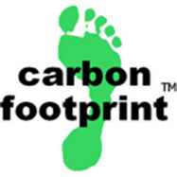One of the ways how to measure the impact of sustainability efforts is a carbon footprint calculator.

**Task:** Measure your carbon footprint

[**https://www.carbonfootprint.com/calculator.aspx**](https://www.carbonfootprint.com/calculator.aspx)

https://zerwaste.com/blog/10-tools-to-measure-the-impact-of-sustainability-initiatives/

**EVALUATION**

**Task:** Try out it this quiz relates to sustainable development

<https://www.eduki.ch/en/quizz/sustainable-development-goals-quiz>

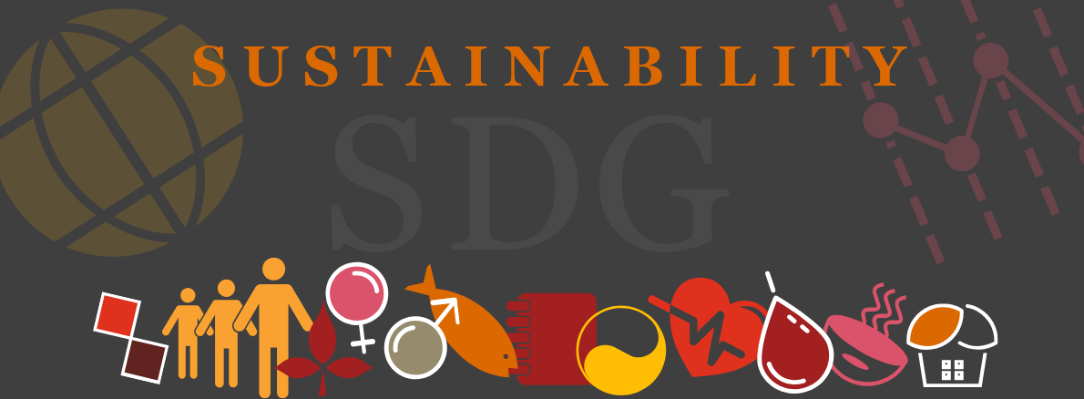

https://blog.pwc.lu/sdg-the-killer-quiz/

**Sources :**

**pictures without a source-pixabay**

<https://www.jus.uio.no/smr/english/research/projects/sdgs_hr_into_reality/>

<https://sdgs.un.org/2030agenda>

<https://sdgs.un.org/goals>

<https://www.researchgate.net/figure/The-Aggregation-of-SDGs-into-the-Three-Pillars_fig3_333294667>

<https://ideas.repec.org/a/aio/aucsse/v1y2012i40p168-173.html>

<https://www.clarity.io/blog/a-deep-dive-economic-impacts-of-air-pollution>

<https://www.bearing-news.com/environmental-sustainability-and-measurements-tools/>

Appendix 1 :

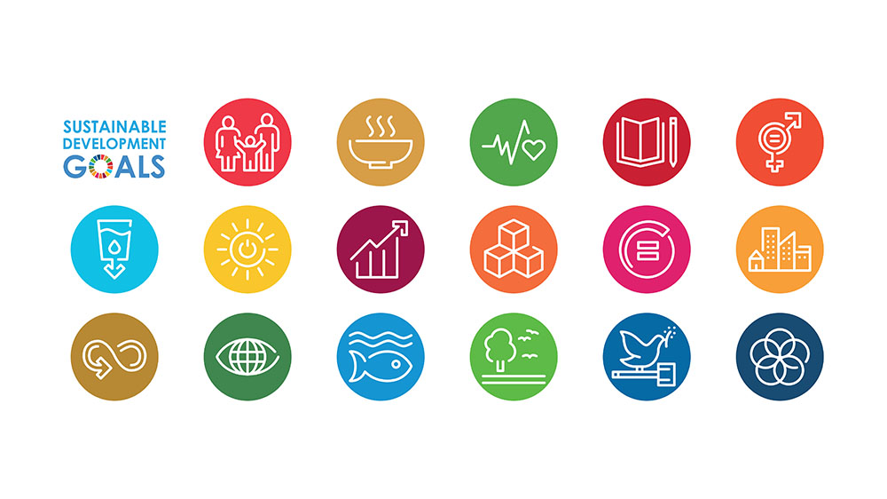

Appendix 2 :

