|  |  |  |  |  |
| --- | --- | --- | --- | --- |
| **Project ID: 2021-1-CZ01-KA220-SCH-000034484**    **COURSE FOR ENVIRONMENTAL EDUCATION**  *e-Modules: Teaching Learning activities and their technology enhanced material set to develop*  ***DISCLAIMER***  Obsah obrázku symbol, Písmo, logo, Grafika  Popis byl vytvořen automaticky*Funded by the European Union. Views and opinions expressed are however those of the author(s) only and do not necessarily reflect those of the European Union or the European Education and Culture Executive Agency (EACEA). Neither the European Union nor EACEA can be held responsible for them.*  **COURSE AUTHORS**   |  |  | | --- | --- | |  | Lubomír Hájek, Petra Garay |   **COURSE SHARING LICENSE**   |  |  | | --- | --- | |  | You are free to:   * Share — copy and redistribute the material in any medium or format for any purpose, even commercially. * Adapt — remix, transform, and build upon the material for any purpose, even commercially. | |
|  |

|  |  |
| --- | --- |
| **MODULE 3** | **NATURE AND CLIMATE CHANGE** |
| **PART 5** | **Climate system** |
| **Lesson 2** | **Factors influencing the climate system** |

**SUMMARY**

**1. COURSE TIME, TARGET AND TOPIC 3**

**2. COURSE OBJECTIVES 3**

**Competences promoted in this lesson: 3**

**Lesson objectives: 3**

**3. LEARNING – TEACHING PROCESSES 3**

**4. EVALUATION 3**

**5. DOCUMENTS 4**

**ENGAGE 4**

**EXPLORE 4**

**EXPLAIN 5**

**EXTEND 6**

**EVALUATE 7**

# 1. COURSE TIME, TARGET AND TOPIC

* **Age of target students:** 15+
* **Teaching time:** 1 hour
* **Disciplines:** Biology, Geography, Chemistry
* **Title:** Factors influencing the climate system

# 2. COURSE OBJECTIVES

## Competences promoted in this lesson:

* Communication in foreign languages competency
* Digital competency
* Mathematical competency
* Learning to learn competency
* Cultural awareness

## Lesson objectives:

* Students comprehend the factors influencing the climate system.

# 3. LEARNING – TEACHING PROCESSES

There are 4 activities in this lesson:

1. **ENGAGE:** Components of climate systems
2. **EXPLORE:** Feedback Mechanisms
3. **EXPLAIN:** Weather patterns and human activities; ocean currents
4. **EXTEND:** field trip studies and group discussions; hand-on experiments

# 4. EVALUATION

*Ask and answer questions.*

# 5. DOCUMENTS

### ENGAGE

**1. Watch this video to learn more about the Components of Climate Systems.**

* + - * Make **n**otes during watching.

[**https://www.youtube.com/watch?v=Y-2-QN5iKS4&ab_channel=GeographerOnline**](https://www.youtube.com/watch?v=Y-2-QN5iKS4&ab_channel=GeographerOnline)

* 1. Answer the following questions:
     1. What is altitude, latitude, and equator?
     2. Where are there more/fewer greenhouse gases?
     3. How much is the temperature increased in 2000 m if in 0 m there is temperature of 20 degrees?
     4. What can affect (lowers) the temperature loss per 100 m?
     5. Why is the temperature in the lower atmosphere higher?
     6. What types of the ocean currents are there?
     7. What is Maritime?
     8. What place in cooler in the summer and warmer in the wintertime?

### EXPLORE

* 1. **What is Feedback Mechanisms?**

Feedback mechanisms amplify or dampen climate changes. For example, melting Arctic ice reduces reflectivity, leading to more heat absorption and further ice melt.

* + 1. **Study the following picture to learn about feedback mechanisms.**

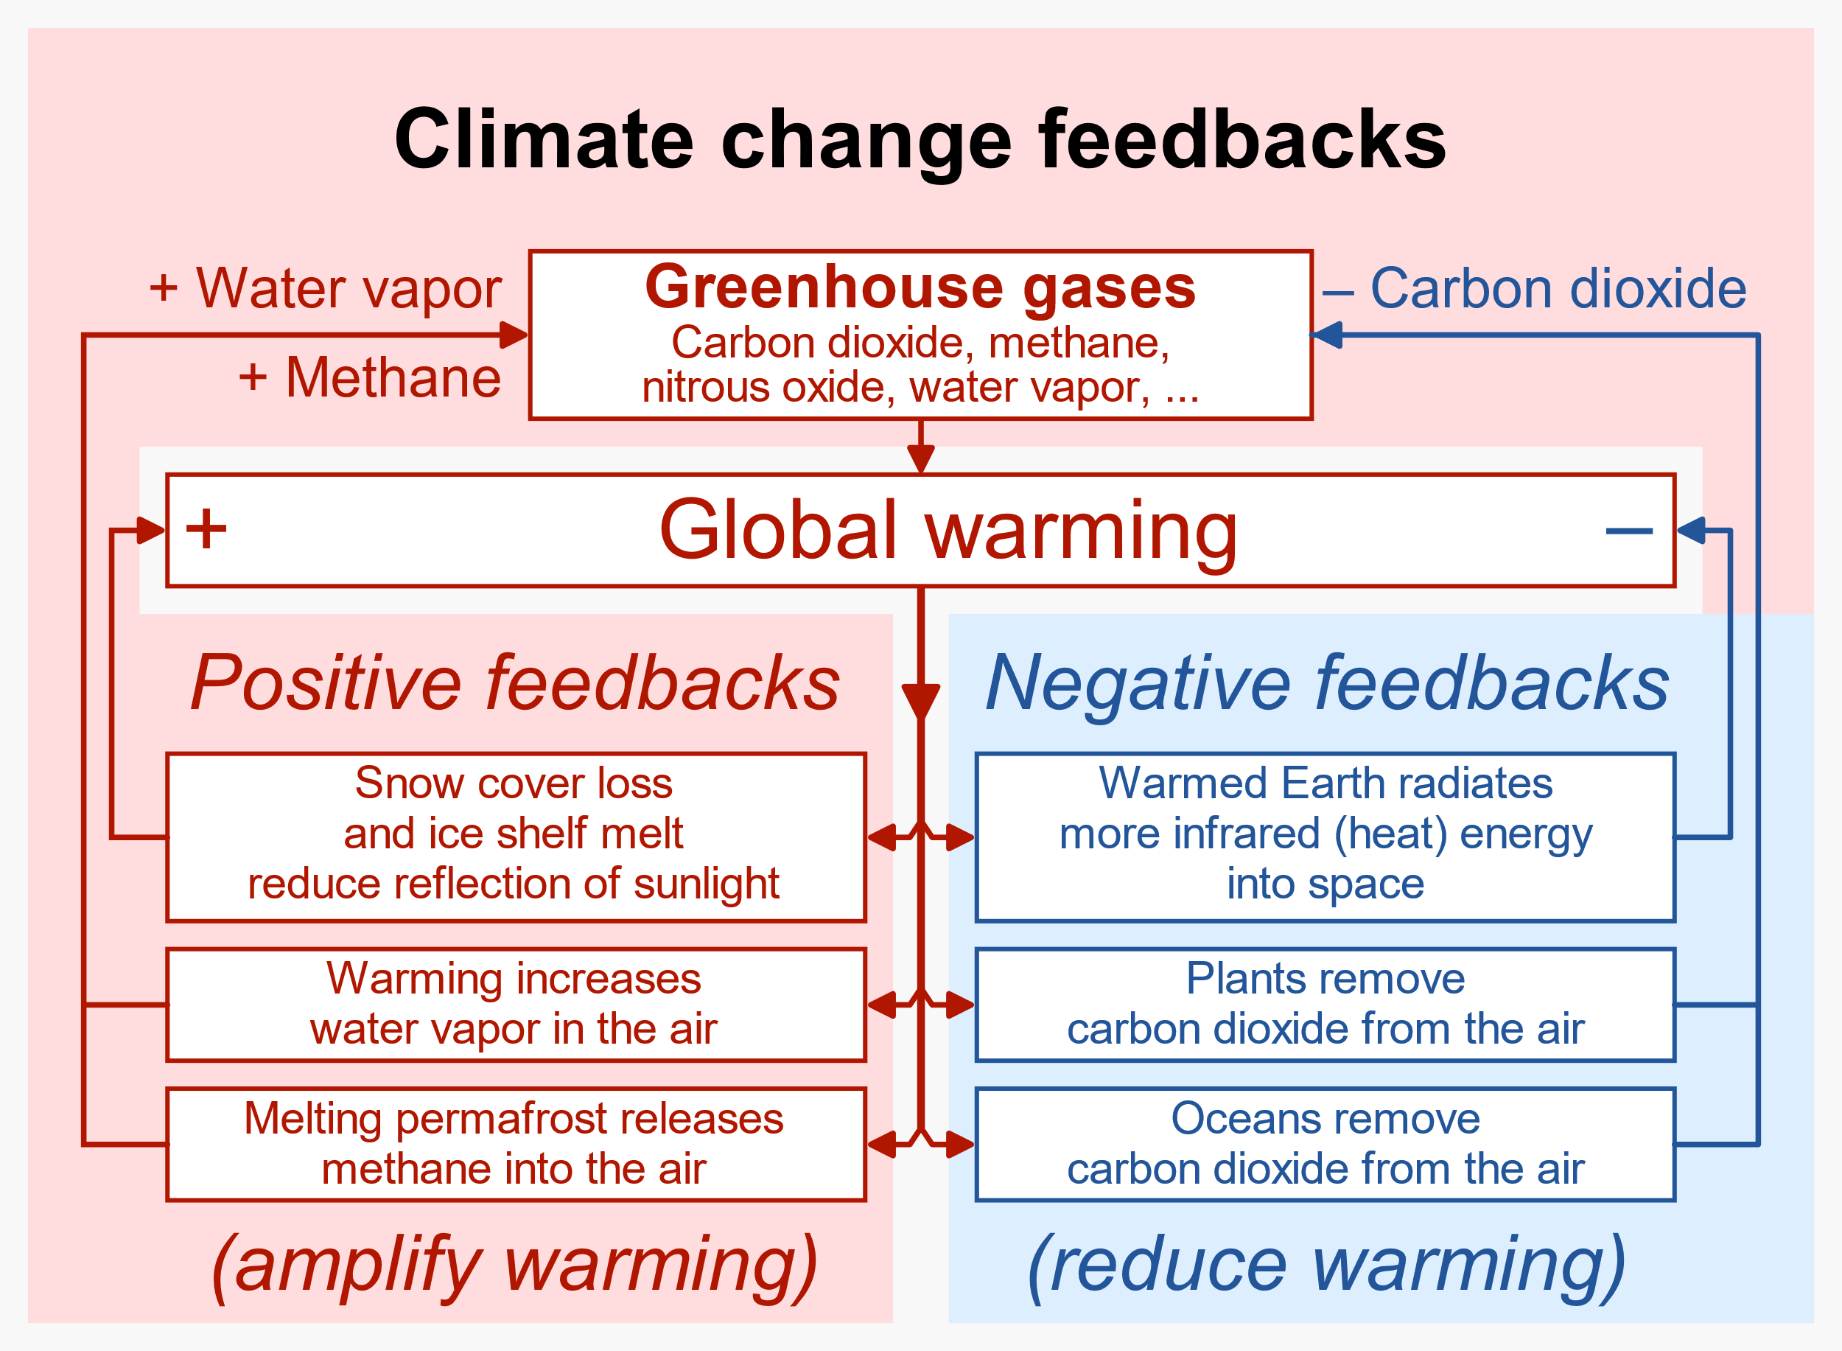

By RCraig09 - Own work, CC BY-SA 4.0, https://commons.wikimedia.org/w/index.php?curid=121130309

* + 1. **Study the following picture to learn about feedback mechanisms.**

1. Explain how positive feedback loops can amplify the greenhouse effect. Provide an example of a positive feedback mechanism involving greenhouse gases and its impact on global temperatures
2. Describe a negative feedback mechanism that helps regulate the greenhouse effect. How does this mechanism work to stabilize Earth's climate despite increasing greenhouse gas concentrations?
3. Discuss the role of water vapor as a feedback mechanism in the greenhouse effect. How does the increase in atmospheric temperature due to greenhouse gases affect water vapor levels, and what impact does this have on climate?
4. Examine the ice-albedo feedback mechanism and its relationship to the greenhouse effect. How does melting ice and changes in surface albedo contribute to further warming of the planet?
5. Explore feedback mechanisms triggered by human activities that exacerbate the greenhouse effect. What are some examples of anthropogenic activities that lead to positive feedback loops, and how do they contribute to climate change?

### EXPLAIN

* 1. **Weather pattern and human activities**

**Weather Patterns:**

Short-term atmospheric conditions, like weather patterns, are influenced by the interconnected dynamics of the climate system.

**Human Activities:**

Human activities, such as deforestation, industrial processes, and energy production, contribute to changes in the climate system.

* 1. **Watch this video and answer following questions.**

[**https://www.youtube.com/watch?v=lrPS2HiYVp8&ab_channel=MetOffice-UKWeather**](https://www.youtube.com/watch?v=lrPS2HiYVp8&ab_channel=MetOffice-UKWeather)

1. **What is the climate system driven by?**
2. **What can reflect the sun energy?**
3. **How does the Earth´s surface lose its heat?**
4. **Which greenhouse gases absorb the heat?**
5. **Could we survive without greenhouse gases?**
6. **How is the inequality of sun heat reaching the Earth balanced?**
7. **What kind of weather can you expect from higher/lower pressure?**
8. **What creates the ocean currents?**
9. **What is the strongest ocean current in the world?**
   1. **Ocean currents**

**Ocean currents** play a significant role in influencing climate systems by redistributing heat around the Earth. These currents are like giant **conveyor belts**, circulating warm water from the equator towards the poles and cold water from the poles back towards the equator. This process has several important effects on regional and global climates:

* + 1. **Temperature Regulation:**

Ocean currents help regulate temperatures by transporting warm water from the tropics to higher latitudes and cold water from polar regions toward the equator. This moderates the climate of coastal areas, preventing extreme temperature fluctuations.

* + 1. **Regional Climate Patterns:**

The direction and strength of ocean currents can influence regional climate patterns. For example, warm ocean currents, like the Gulf Stream in the North Atlantic, can raise temperatures in nearby coastal areas.

* + 1. **Effect on Precipitation:**

Ocean currents influence precipitation patterns by interacting with the atmosphere. Warm currents can enhance evaporation, leading to increased moisture in the air and potentially affecting rainfall in adjacent coastal regions.

* + 1. **Impact on Weather Events:**

Ocean currents can influence weather events, such as hurricanes and typhoons. Warm ocean water provides the energy needed for these storms to intensify. Changes in ocean currents can affect the frequency and intensity of these weather phenomena.

* + 1. **Sea Level Changes:**

Ocean currents contribute to sea level changes. Changes in the distribution of water masses due to variations in ocean currents can result in sea level anomalies, impacting coastal areas.

* + 1. **Biodiversity and Ecosystems:**

Ocean currents influence marine ecosystems by transporting nutrients, plankton, and larvae. Upwelling, caused by the upward movement of deep, nutrient-rich water, supports rich marine biodiversity in certain regions.

* + 1. **El Niño and La Niña Events:**

Ocean currents are connected to phenomena like El Niño and La Niña. El Niño, characterized by warmer-than-average sea surface temperatures in the central and eastern Pacific, can lead to widespread climate anomalies, including changes in precipitation patterns and temperatures.

* + 1. **Global Climate System:**

The interconnected nature of ocean currents contributes to the overall balance of the Earth's climate system. Changes in ocean circulation can have far-reaching effects, influencing weather patterns and climate on a global scale.

### EXTEND

1. **Field Trip to Local Ecosystems:**

* Take students on a field trip to nearby ecosystems, such as forests, wetlands, or coastal areas.
* Encourage students to observe and document factors that influence the local climate, such as vegetation, elevation, proximity to water bodies, and human activities.
* Have students collect data using instruments like thermometers, hygrometers, and anemometers to measure temperature, humidity, and wind speed.

1. **Hands-On Experiments:**

* Set up hands-on experiments outdoors to demonstrate the impact of various factors on climate.
* For example, create mini-greenhouse structures using plastic containers to illustrate the greenhouse effect and its role in temperature regulation.
* Set up stations to investigate albedo by comparing the temperature of different surface materials (e.g., soil, asphalt, grass) exposed to sunlight.

1. **Group Discussion and Analysis:**

* After the field trip and experiments, gather students for a group discussion to analyze their observations and findings.
* Facilitate a discussion about how factors like land use, vegetation, and human activities influence local climate patterns.
* Encourage students to brainstorm potential solutions or strategies for mitigating the effects of climate change in their community.

### EVALUATE

* 1. **Revision:**
  2. Describe the role of ocean currents in influencing global and regional climates. How do ocean currents regulate temperature and precipitation patterns? Provide examples of specific currents and their effects.
  3. What are feedback mechanisms in the context of climate systems? Provide examples of positive and negative feedback loops and explain how they contribute to climate change.
  4. Discuss the concept of climate anomalies and their impact on weather patterns. How do phenomena like El Niño and La Niña contribute to climate variability? Provide examples of regions affected by these anomalies.

Sources:

<https://www.noaa.gov/education/resource-collections/weather-atmosphere/weather-systems-patterns>

[https://media.cnn.com/api/v1/images/stellar/prod/210301101549-02-climate-change-ocean-currents weakening.jpg?q=w_1110,c_fill/f_webp](https://media.cnn.com/api/v1/images/stellar/prod/210301101549-02-climate-change-ocean-currents)