Project ID: 2021-1-CZ01-KA220-SCH-000034484
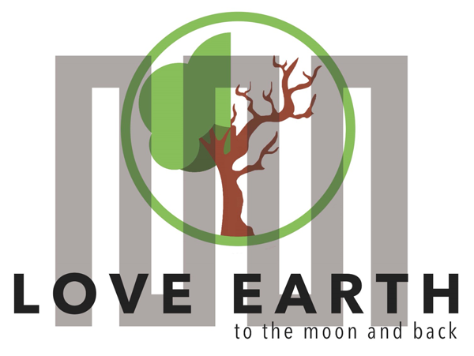

COURSE FOR ENVIRONMENTAL EDUCATION
e-Modules: Teaching Learning activities and their technology enhanced material set to develop

DISCLAIMER
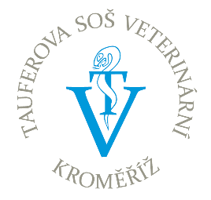
Funded by the European Union. Views and opinions expressed are however those of the author(s) only and do not necessarily reflect those of the European Union or the European Education and Culture Executive Agency (EACEA). Neither the European Union nor EACEA can be held responsible for them.

COURSE AUTHORS
Lubomír Hájek, Petra Garay

COURSE SHARING LICENSE
You are free to:
- Share — copy and redistribute the material in any medium or format for any purpose, even commercially.
- Adapt — remix, transform, and build upon the material for any purpose, even commercially.

MODULE 2 | CYCLICAL NATURE
PART 5 | Ultimate source of energy and the form of energy while leaving the  ecosystem
Lesson 2 | Living organisms and green energy

SUMMARY

1. COURSE TIME, TARGET AND TOPIC 3

2. COURSE OBJECTIVES 3
Competences promoted in this lesson: 3
Lesson objectives: 3

3. LEARNING – TEACHING PROCESSES 3

4. EVALUATION 3

5. DOCUMENTS 4
ENGAGE 4
EXPLORE 5
EXPLAIN 6
EXTEND 7
EVALUATE 8

1. COURSE TIME, TARGET AND TOPIC
Age of target students: 15+
Teaching time: 1 hour
Disciplines: Biology, Geography, Human sciences
Title: Living organisms and green energy

2. COURSE OBJECTIVES

Competences promoted in this lesson:
- Communication in foreign languages competency
- Digital competency
- Initiative and entrepreneurship competencies
- Social and citizenship- related competence
- Cultural awareness

Lesson objectives:
- The students deepen their knowledge regarding the green energy and the advantages to human well-being.
- The students learn to understand the circadian rhythm.
- They apply the knowledge to practical activities.

3. LEARNING – TEACHING PROCESSES
There are 4 activities in this lesson:
- ENGAGE: learn about the effects of the sun
- EXPLORE: the effects on living organisms
- EXPLAIN: the term of light pollution
- EXTEND: your knowledge on melanin

4. EVALUATION
Quiz, kahoot

5. DOCUMENTS

ENGAGE

Body clock

- WATCH the videos and answer the questions.
https://youtu.be/Mi8wDJipgS0 (2.23 min)
https://youtu.be/UbQ0RxQu2gM

- What kind of vitamin does our skin produce because of the sun?
- Have you ever heard about the circadian rhythm?
- Can the circadian rhythm cause some diseases of civilization?
- In your opinion, how could following a circadian rhythm help solve some of ecological problems?
- Think about all sources of energy and discuss the access to them (use picture 1).

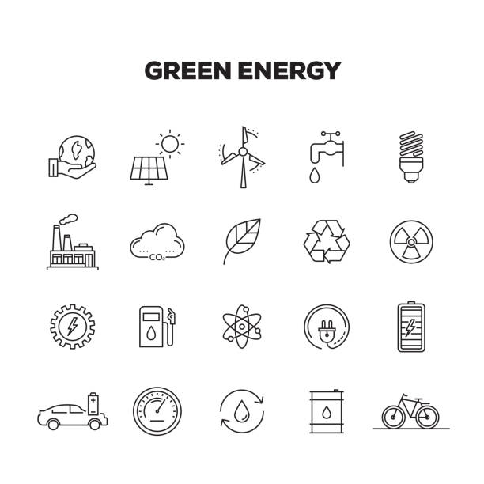

EXPLORE
Explore the effects on living organisms:
- Blue light is a short wavelength, which means it produces higher amounts of energy. Unlike other forms of light, the eyes cannot effectively filter blue light, so more can pass through the eye to the retina. Blue light produces both benefits and concerns for our eyes and overall health.
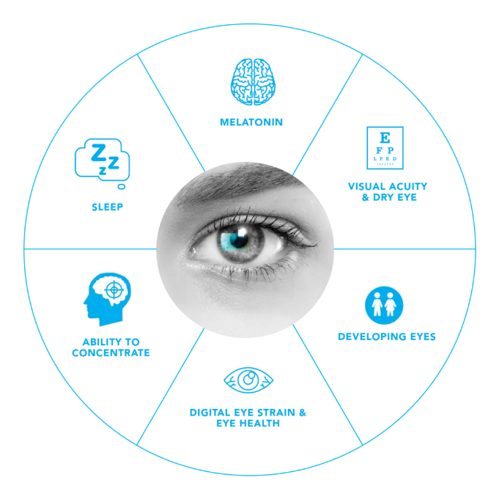
- ​​Circadian rhythms are physical, mental, and behavioural changes that follow a 24-hour cycle. These natural processes respond primarily to light and dark and affect most living things, including animals, plants, and microbes.
- Diseases of civilization large amounts of scientific evidence positively correlate Western diet to acne, obesity, diabetes, heart disease and cancer.

- Melanin provides pigmentation to your skin, eyes, and hair. The substance also absorbs harmful UV (ultraviolet) rays and protects your cells from sun damage.

- Solar energy is any type of energy generated by the sun. Solar energy is created by nuclear fusion that takes place in the sun. Fusion occurs when protons of hydrogen atoms violently collide in the sun’s core and fuse to create a helium atom.

TASK: Try on your own 1 day following circadian rhythm, make notes about positives and negatives of your normal day and a day following CR.
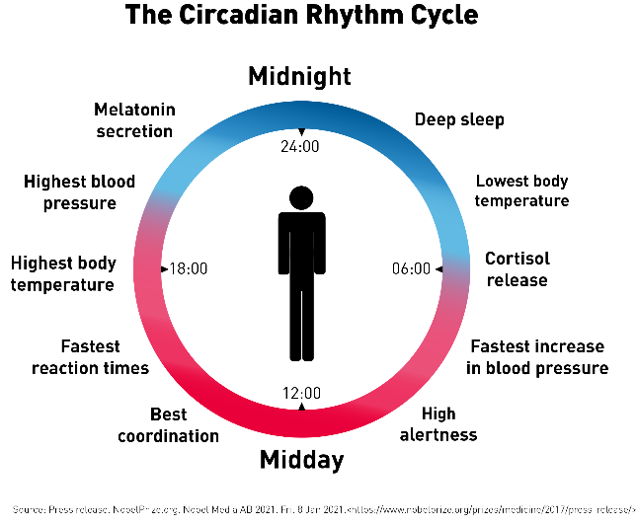

EXPLAIN
The ultimate source of energy (SUN):
- Sun is an unlimited and renewable supply of energy and our primary source of energy.
- The sun’s energy is essential for numerous activities, including photosynthesis, the water cycle, nuclear power, cloud formation, the creation of fossil fuels, and so on.
- It gives organisms the light they need for growth, everyday routines, daily regularity etc.
Light pollution:
- Is a pollution of artificial lightning in urban areas at nighttime causing many health and environmental issues.
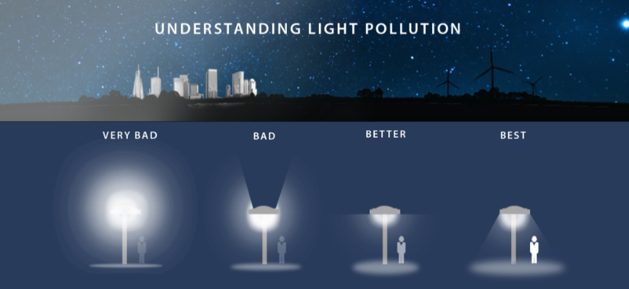
- Light pollution radiates blue light spectrum higher than it should be in the night and creates skyglow (diffuse brightness of the night sky).

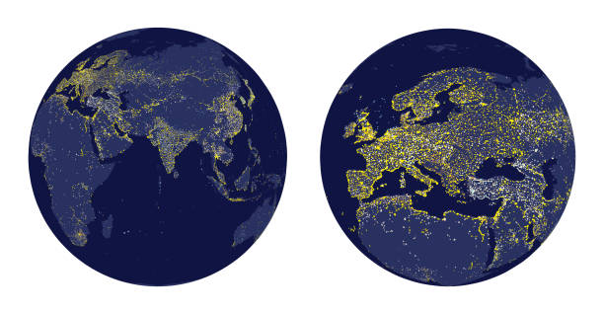
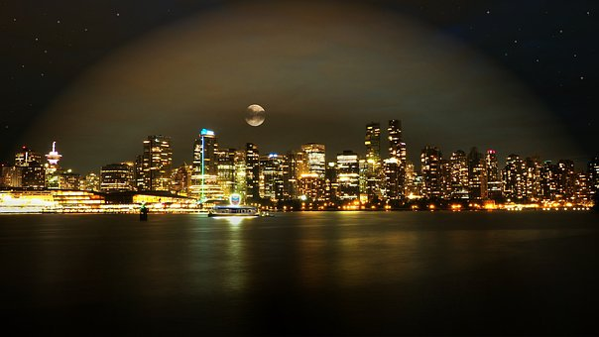
- This negatively affects the circadian rhythm or melatonin excretion of plants and vertebrates. Causing illnesses, extinction of insect, changes in natural reproduction of animals and life manifestations of plants.

TASK: Summarize the effects of the light pollution.

EXTEND
Melatonin is a hormone that your brain produces in response to darkness. It helps with the timing of your circadian rhythms (24hour internal clock) and with sleep. Being exposed to light at night can block melatonin production.
Melanin
The pigment that gives human skin, hair, and eyes their colour. Dark-skinned people have more melanin in their skin than light-skinned people have. Melanin is produced by cells called melanocytes. It provides some protection again skin damage from the sun, and the melanocytes increase their production of melanin in response to sun exposure.

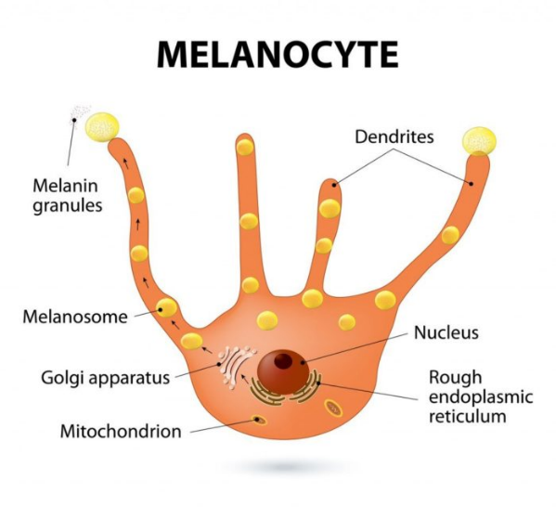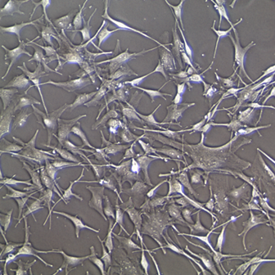

TASK: How much melanin do you have? Discuss with your friends about your hair, eyes, and skin colour. How easy is it for you to get sunburnt?

EVALUATE
- Answer the questions in the following quiz:

https://myem9jxobda.typeform.com/to/nrG39kH6
2.Play the kahoot:
https://create.kahoot.it/share/living-organism-and-green-energy/c5017f14-3333-4672-b139-bec4d4432394?fbclid=IwAR0oho7jdl-RW4NgnhYPZJ1_tTrOIwiIUSu80Ndcf_HLWIoXQsGqfL0NESQ

Sources:
https://education.nationalgeographic.org/resource/solar-energy/
https://nigms.nih.gov/education/fact-sheets/Pages/circadian-rhythms.aspx
https://eyesafe.com/bluelight/
https://my.clevelandclinic.org/health/body/22615-melanin
https://atlasbiomed.com/blog/what-is-a-circadian-rhythm/
https://unacademy.com/content/question-answer/biology/the-ultimate-source-of-our-energy-is/
https://pixabay.com/cs/
https://www.mdpi.com/2071-1050/11/22/6400
http://conxcorp.com/understanding-light-pollution/
https://www.medicinenet.com/melanin/definition.htm
https://www.nccih.nih.gov/health/melatonin-what-you-need-to-know
https://cosmofarmaintl.com/wp-content/uploads/2018/02/Melanocyte.jpg
https://www.lifelinecelltech.com/wp-content/uploads/2015/09/FC-0030-Adult-Melanocyte20X.png

