ё
Project ID: 2021-1-CZ01-KA220-SCH-000034484
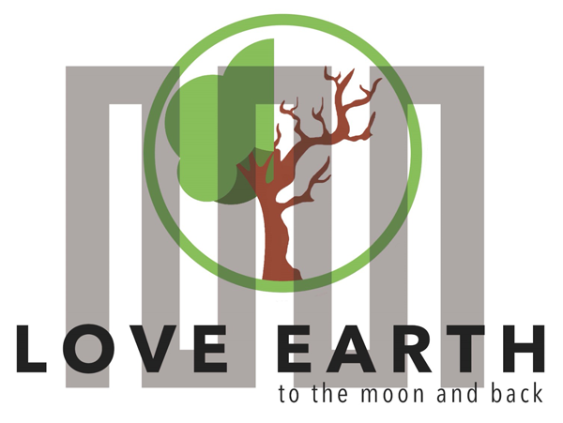

COURSE FOR ENVIRONMENTAL EDUCATION
e-Modules: Teaching Learning activities and their technology enhanced material set

DISCLAIMER
Funded by the European Union. Views and opinions expressed are however those of the author(s) only and do not necessarily reflect those of the European Union or the European Education and Culture Executive Agency (EACEA). Neither the European Union nor EACEA can be held responsible for them.

COURSE AUTHORS
Lydmila Zadorozhnya

MODULE 2 | CYCLICAL NATURE
PART 1 | Naming various natural resources within their qualifications
Lesson 1 | What is a natural resource ?

SUMMARY

1. COURSE TIME, TARGET AND TOPIC 3

2. COURSE OBJECTIVES 3
Competences promoted in this lesson: 3
Lesson objectives: 3

3. LEARNING – TEACHING PROCESSES 3

4. EVALUATION 3

5. DOCUMENTS 4
ENGAGE 4
EXPLORE 5
EXPLAIN 6
EXTEND 7
EVALUATE 8

1. COURSE TIME, TARGET AND TOPIC
- Age of target students: 15+
- Teaching time: 2 hour
- Disciplines: Geography, Human Sciences, Maths, Science, Art
- Title: What is a natural resource ? Explain the natural resources.

2. COURSE OBJECTIVES

Competences promoted in this lesson:
- Communication in foreign languages competency
- Digital competency
- Learning to learn competency
- Social and citizenship-related competencies

Lesson objectives:
- Students explain the natural resources.
- Students give examples to natural resources.
- Students compare the natural resources of different countries and make connections with their geographical features.

3. LEARNING – TEACHING PROCESSES
There are 4 activities in this lesson:
- ENGAGE: Define the natural resources.
- EXPLORE: Make researches on natural resources
- EXPLAIN: Explain the features of natural resources.
- EXTEND: Discuss and compare the natural resources in different countries and make connections with their geographical features.

4. EVALUATION
Students are asked to reflect on their presentations about natural resources. They are encouraged to expand their research and including various natural resources, they are asked to discover similarities and differences.
INSTRUCTION: Reflect on your presentations. Expand your research and including various more natural resources, discover and highlight the similarities and differences on the natural resources

5. DOCUMENTS

ENGAGE
Students are given a discussion question. They are told to tell about natural resources.
Suggestion: Make sure that students will define natural resources, their uses and features.
INSTRUCTION: Answer the questions below.
- What are the natural resources?
- What are they used for?
- Can you share examples of natural resources? Explain their features.

EXPLORE
Students are divided into small groups. Each group is assigned a specific aspect of daily life (transportation, energy use, diet, etc.). They are told to research and list natural resources that contribute to that aspect of life. Each group is asked to present their findings to the class, fostering a discussion on the different aspects of our lives that utilize natural resources.
INSTRUCTION: Each of you will study a specific aspect of daily life (transportation, energy use, diet, etc.). While making research, list natural resources that contribute to that aspect of life. Present your findings to the class, fostering a discussion on the different aspects of our lives that utilize natural resources.

EXPLAIN
Students are given a text on natural resources and introduced online videos. They are instructed to take notes based on the features of natural resources. They are asked to discuss their uses highlighting the different aspects of our lives.
Natural Resource | Types of Natural Resources | Renewable & Non-Renewable Resources (youtube.com)
Suggestion: Make sure that students will comprehend the natural resources, their features and benefits.
INSTRUCTION: Visit the website and use online video and the text delivered. List the features and uses of the natural resources for different aspects of life. Discuss the results as a class, highlighting the different aspects of life that utilize the natural resources.

OR-0689 - Helpful - Natural Resources Natural resources are materials from the Earth that are used - Studocu

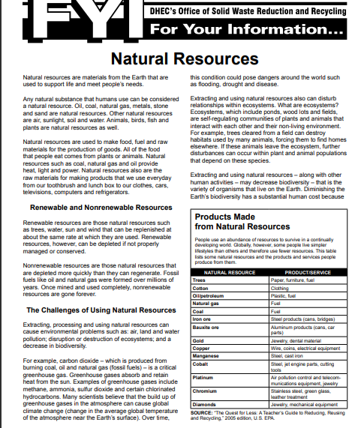

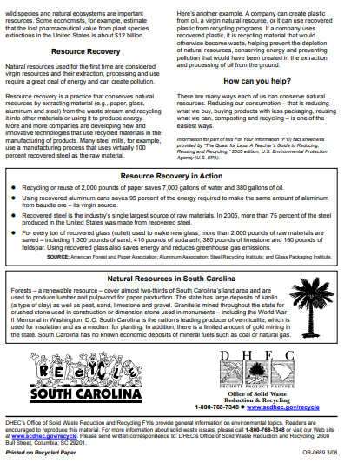

EXTEND
Students are asked to discuss and compare the natural resources in different countries and make connections with their geographical features.
INSTRUCTION: Discuss and compare the natural resources in different countries and make connections with their geographical features. Make research and present case studies on natural resources.

EVALUATE
Students are asked to reflect on their presentations. They are encouraged to expand their research and including various natural resources, they are asked to discover similarities and differences.
INSTRUCTION: Reflect on your presentations. Expand your research and including various more natural resources, discover and highlight the similarities and differences on the natural resources.

