Unit 1.3. How to select and embed digital tools that capture data on learner progress?
The previous sections dealt with how to set up courses in order to be able to track learners’ engagement (1.1) and with how to design learning activities to generate evidence (1.2). In this subunit, we will focus on the list of tools that can be used to support teaching and learning and generate data. Moodle tools are examples of tools that might be integrated in a Learning Management System (LMS) (1.3.1). Then, we will show possible external tools that can be used to enhance the possibilities of active learning (1.3.2).
After planning what learning resources and activities are included in the course, it is important to decide which digital tools or reports can generate data that can help track learning progress for both teachers and students. In other words, you should decide which learning resources and/or activities need to be used in order to receive data on the learning progress.
1.3.1. Selecting tools to support learning and generate data
After designing what students have to learn and what kind of evidence will show you that students have accomplished their learning goals, it is important to decide what digital tool will be used for the assignment or task. There are many different tools suggested by Moodle for activity designing, but you can choose external tools as well and use them in the course (see 1.3.2).
Moodle offers multiple tools for activity implementation, some of which are introduced here shortly.
Moodle assignment
For a task submission, Moodle assignment activity allows for the easy uploading of documents. You can monitor which students have submitted assignments and when, how many resubmissions there were and if students have given any additional feedback on a task. When designing an assignment activity, you should include all the key information about the task delivery, including the aim of the task, deadlines, submission requirements, assessment criteria, etc. This information may be useful for learners as a reminder of assignment requirements and inform them on what is expected to be delivered, when and why.
This activity generates data that can help teachers make informed decisions on teaching and learning design (read more in unit 2.2). Similarly, when configuring the availability, outcomes and activity completion settings (see 1.1.), this tool may inform students about the deadlines and the learning process.
Learn how to create Assignment in Moodle - Assignment in Moodle
Quiz
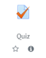A quiz activity may generate data that inform you about students’ behaviour while taking a quiz or exam, what were the most challenging questions, how much time students spent answering these questions, etc. To support learners’ SRL, you should provide clear and explicit feedback to incorrect answers, by providing links to the question-related course material, where students can review the material.
Since it is possible to create a question bank out of which questions can be selected for an exam or other test, you can invite students to contribute to the development of questions that would be included in the question bank. In such a way, students would think of their learning and reconsider the most important knowledge that should be included in the questions bank or quiz itself.
Learn how to create quiz in Moodle - Quiz in Moodle
H5P Interactive content
H5P Interactive Content activity allows the inclusion of more interactivity into the quiz, regardless of if it is a self-assessment or a final course test. To do this, with course editing turned on, you should add an activity or resource -> H5P Interactive content -> and then select the content type wanted. H5P offers multiple content types that can be used when designing the course content (fig. 1).
Figure 1. List of H5P Interactive content types on Moodle
You can check this example of a course presentation using H5P, which shows how some of the self-assessment questions are followed by a slide with explanations of that question (fig. 2). In such a way, learners can check their understanding and read a short explanation about the same question.
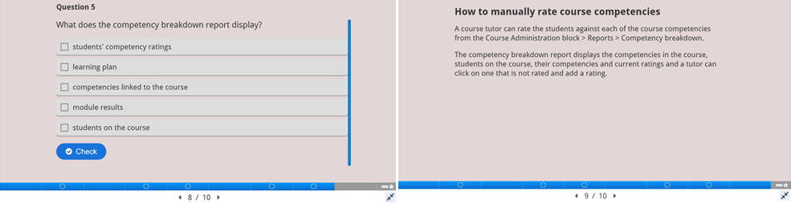
Figure 2. Example of H5P activity taken from https://h5p.org/h5p/embed/503704
Moreover, you can use the H5P tool to create an interactive video where self-assessment or self-check questions can be included at any point of the video. Teachers can decide whether students should (re)watch a recording of a theoretical presentation or any other video material and select the points where it is important to add questions that would help students to monitor their learning progress in a more interactive way.
Workshop activity
Workshop activity is a very useful tool to support learners’ SRL and engagement. When learners are engaged in the peer assessment process, they have to analyse their peers’ assignments critically and, at the same time, reflect on their own submission. Teachers have to pre-design rubrics for the peer assessment process with all the requirements and deadlines explained. When knowing that they will be able to assess colleagues’ assignments only after they submit their own assignment, students are expected to be more aware of the deadlines and plan their assignment submission and assessment delivery in advance (fig. 3).
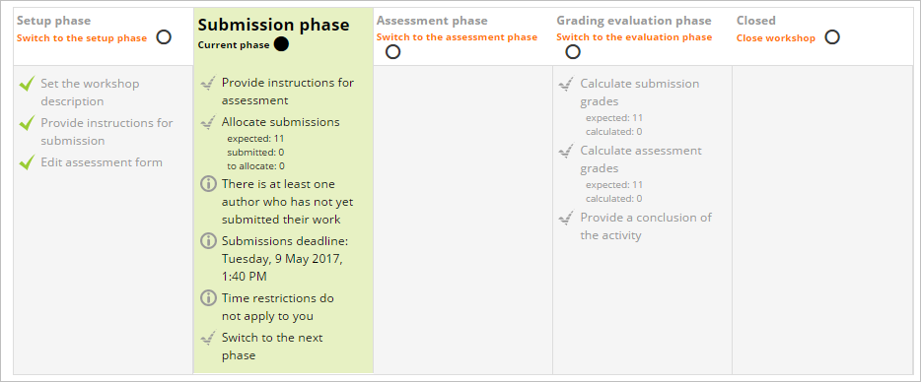
Figure 3. Example of peer assessment criteria and submission details (from https://docs.moodle.org/310/en/Workshop_activity)
Learn how to create a workshop in Moodle - Workshop in Moodle
Glossary
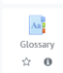 In order to foster learners’ engagement, you can invite students to co-create a course glossary. This activity collects data on how many times each student has accessed the activity. Under the teaching and learning design perspective, the concepts included in the glossary have to be interactive and hyperlinked throughout the course; which means that every time the concept is mentioned in the course, it has a direct link to its explanation in the glossary. This option supports learners’ SRL skills because they have to check if they are aware of the meaning of a specific concept.
Scheduler
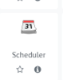An important Moodle activity that may help students to plan and monitor their learning is Scheduler which can also be added as any other activity when designing the course. You can set up time slots and students can select one of these on Moodle (fig. 4). You can also monitor the students who attended consultation (blue boxes next to profile picture) and those who did not (grey boxes).
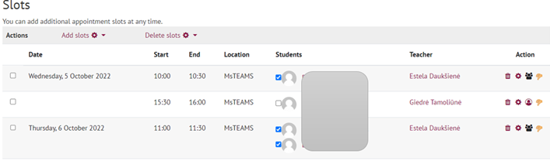
Figure 4. An example of a configured scheduler activity (Volungeviciene, Dauksiene & Tamoliune, MA study course “E.learning technologies”, 2022, Vytautas Magnus University)
The Scheduler activity is useful for two reasons:
- Firstly, it helps to plan synchronous or face-to-face meetings and consultations between the teacher and the student or a student group related to assignment questions, final thesis development or any other support issues.
- Secondly, it can be used when asking students to select a date and time slot for their assignment presentation or similar.
This activity empowers students to plan their own learning, by choosing the date and time slot that best fits their learning needs. Moreover, it allows you to send reminders to those students who have not made an appointment yet, or you can schedule the appointment for the student himself/herself.
Other tools like a discussion forum, group choice, choice, badges and feedback, that also collect data on learners’ progress, are presented in section 3.1, where the focus is on tools that support learners’ engagement.
1.3.2. Selecting external tools to support learning and generate data
There are multiple external tools that can support learners’ SRL. However, these tools do not always track learners’ engagement.
For example, you can start a prompt quiz by asking students to share their expectations, experience and knowledge of the course topic. To do this, you can use Moodle Quiz, Feedback or Choice activity (based on the question) or external and more interactive tools like Mentimeter, MsTeams Forms, Kahoot, Padlet, GoogleDocs.
If your aim is to collect a quick response during in-class activities or to design a summative assessment activity, you can adopt the Mentimeter tool, which is easy to set-up and use (fig. 5).
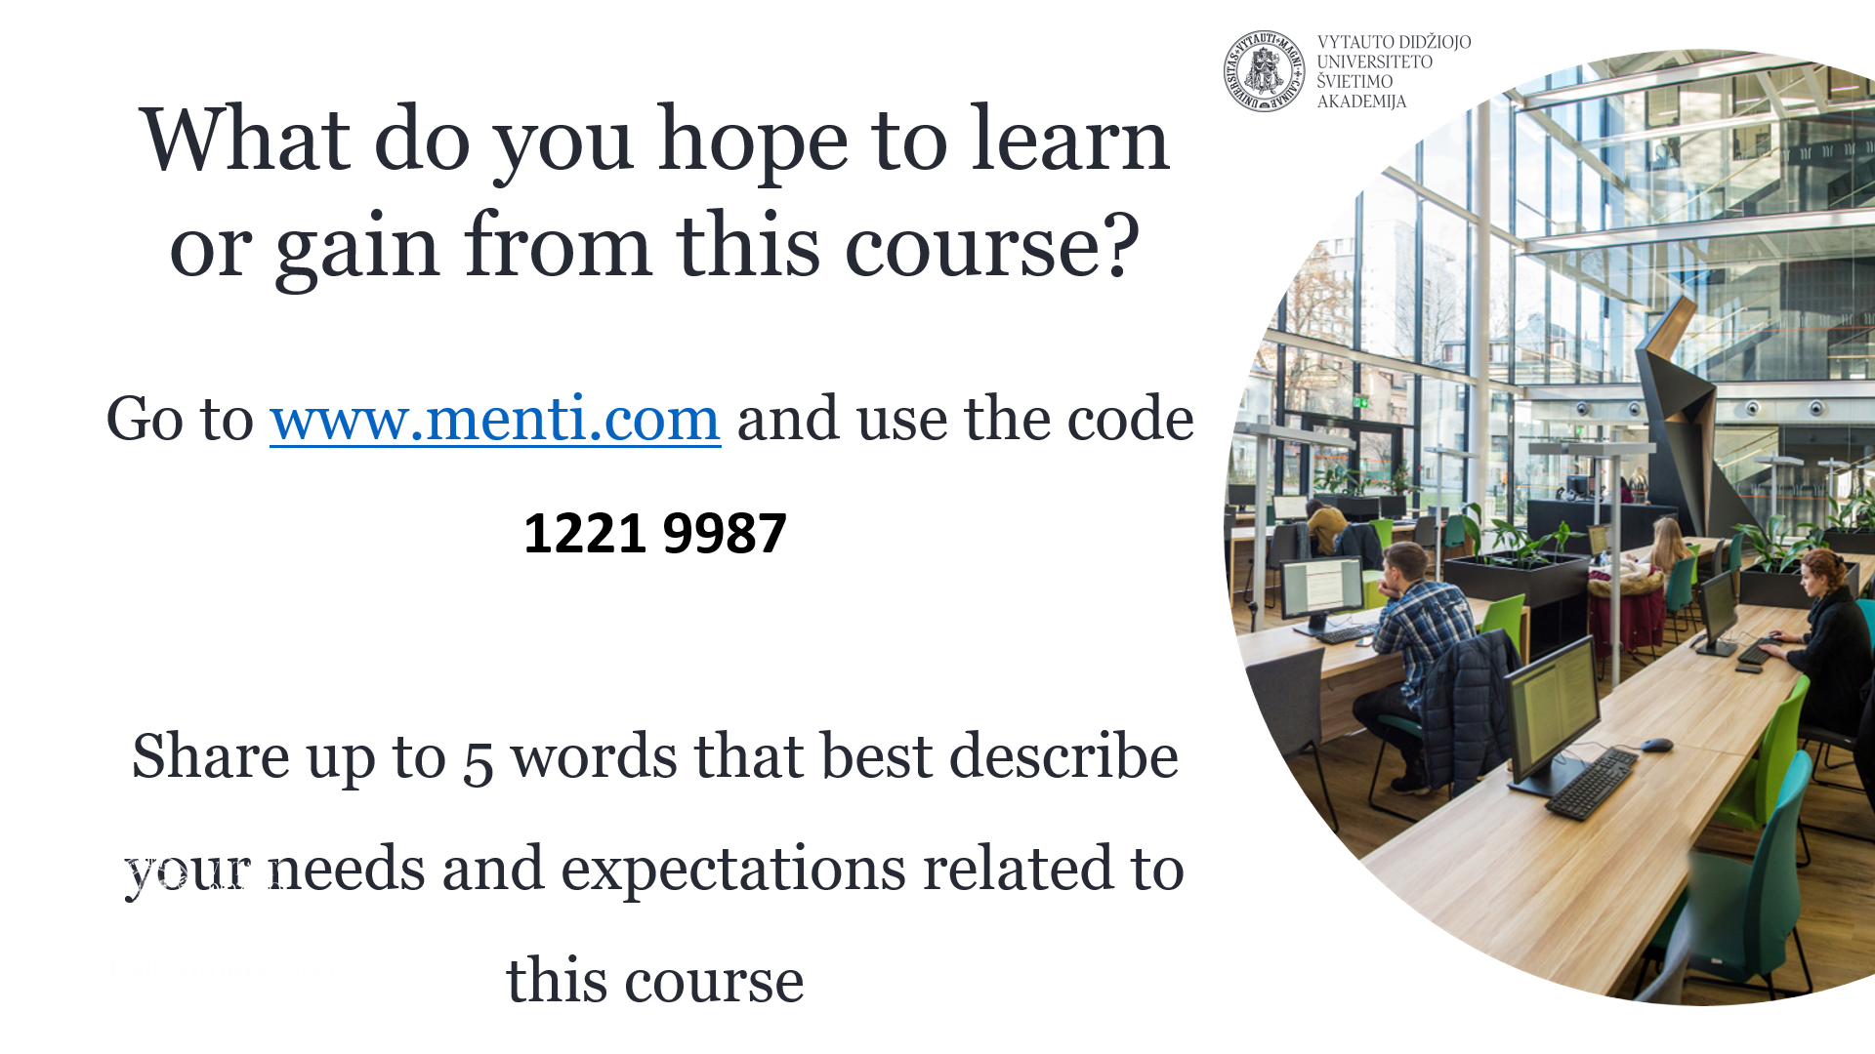
Fig. 5. An example of a question on learners’ expectations, using Mentimeter tool (Trepule & Tamoliune, MA study course “Concepts of adult education”, 2022, Vytautas Magnus University)
Learners’ answers can result in a word cloud, graphics or some other chosen visualisation that might inform teachers on expectations for the teaching and learning design and stimulate students’ reflection on their learning preferences and goals. The results’ visualisation can be embedded in an online learning environment and can be reviewed throughout the course, discussing and monitoring what has been achieved and what is still missing.
A Padlet tool can also be used when designing learning activities that require students to collaborate, share their ideas, suggestions, expectations, raise questions or introduce themselves depending on the goal of a pre-designed activity (fig. 6),
Figure 6. An example of a students’ introductory activity using Padlet tool (Volungeviciene et al., 2021, p. 151)
Other tools like GoogleDocs, Jamboard, etc. can be used to support learning activities and collect data on learners’ engagement and their own learning process. However, as it was emphasised, it is up to the teacher to decide what tools will not disrupt but, instead, will enhance the teaching and learning process, engage learners and at the same time foster self-regulation of their learning.
By aligning data from all the above presented activities and tools, you can collect multiple data representing a wider picture of the overall learning process and individual student’s learning behaviour.

Please take into account that this is an ever changing environment. These tools might disappear, might or might not be free, might or might not be open source, etc. In addition, they have different features with regard to the anonymity of data collected. Think of Mentimeter vs Moodle tools (where you know exactly who did what). In addition, Padlet has the limitation of three padlets for free accounts. In some countries, institutions are not allowed to use Google tools (UK struggles with this) because of data protection issues. They tend to use Microsoft tools instead. Therefore, each teacher has to explore the technological environment according to his/her own needs and the affordances provided.

N.B. Screenshot examples presented are retrieved from the following courses: MA course “E.learning technologies”, teachers A. Volungeviciene, E. Dauksiene, G. Tamoliune; and MA course “Concepts of adult education”, teachers E. Trepule, G. Tamoliune. Teachers’ approval has been received.
Best practice example
Title: Designing multiple assessment strategies to collect and compare data in online course.
University: Vytautas Magnus University (VMU), Trepule and Tamoliune, 2022, MA study course “Concepts of adult education”, Lithuania
Section of the framework: Considering, combining and evaluating different sources of evidence on learner progress (e.g. Teachers use data from Moodle Learning analytics to reflect on learning behaviour in comparison with learning results)
What competencies and learning outcomes of the DigicompEdu Framework are we addressing?

Competencies | Learning outcomes
Self-regulated learning  Assessment strategies  Analysing evidence  Actively engaging learners | PERFORMANCE - monitoring  - To use digital technologies to allow learners to collect evidence and record progress, e.g. audio or video recordings, photos.  - To use digital technologies (e.g. ePortfolios, learners’ blogs) to allow learners to record and showcase their work.  - To use digital assessment tools to monitor the learning process and obtain information on learners’ progress.  - To analyse and interpret available evidence on learner activity and progress, including the data generated by the digital technologies used.  - To put learners’ active uses of digital technologies at the centre of the instructional process.

Key issues: This practice presents a course on adult education delivered in a blended way. Since students choose this course themselves, it is important for a teacher to know what their expectations and needs are when taking this course. This helps to review learning design, update topics, revise in-class practical tasks, and group works. Since most students are working either as educators or as human resource professionals, most of the classes are delivered online. Therefore, it is possible to include and plan multiple activities throughout the semester and to monitor their learning progress online.
Part of the course focuses on the topic of open education and how it may foster lifelong learning.
Determining the level of knowledge before the class
Before introducing the concept of “open education”, teachers want to learn how advanced learners are and whether they consider themselves as novice, advanced, competent or expert in the topic of open education (Fig. 1). In order to accomplish this objective, MsTeams Forms tool can be used, allowing a quick real-time in-class voting. This tool allows teachers to diagnose and fix the initial level of learners’ knowledge.
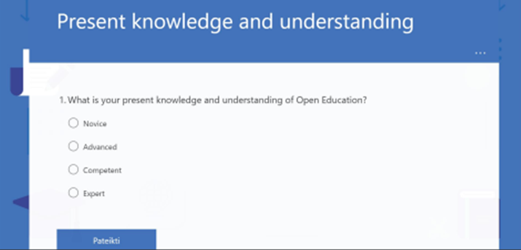
Figure 1. Quiz used to establish learners’ present knowledge

Assessing learners’ understanding of the key-concepts
In order to assess how learners understand key-concepts, another interactive tool is used (mentimeter.com) to collect key information on what open education means to them (Fig. 2). This activity allows teachers to see if learners share similar understanding, what the most popular answers are, if there are any non-typical or non-accurate answers that should be taken into consideration during the lecture or discussion time. The results might be used as guidelines for teaching and learning and help planning upcoming classes.
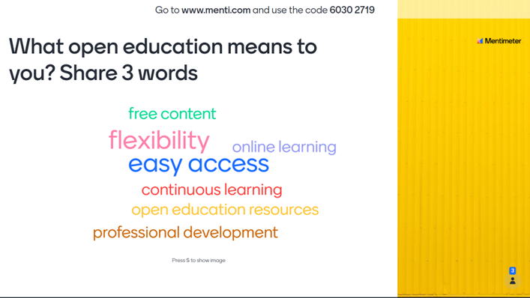
Figure 2. An example of an interactive task to assess learners’ understanding of the topic at the beginning of the class
In this way, further activities of the class are planned according to the aspects that learners have mentioned when sharing insights on what open education is.
Exit ticket 3-2-1
At the end of the class, learners were asked to fill in an exit ticket ‘3-2-1’ (using Google Forms), where they had to name 3 things that they learned in a todays’ class, 2 things they would like to learn more about and 1 questions that they feel left unanswered (fig. 3). This activity is planned in advance by the teacher, so that it would be easier to monitor and assess whether students have adopted the key information and if there is anything that should be clarified or explored in more details during further classes. At the same time, it helps to see whether their answers focus on different or the same aspects of open education that were mentioned at the beginning of the class.
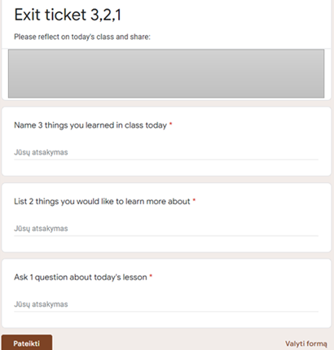
Figure 3. Exit ticket ‘3-2-1’ assessment activity at the end of the class
Collecting feedback at the end of the class
Another activity is used at the end of other classes to monitor and observe learners’ learning progress. Here students are asked to give feedback on that day's session (Fig. 4). This activity is used for diagnostic assessment purposes as well and helps assess learners' understanding of specific topics, allowing them to reflect on how they can apply new knowledge in their daily or professional practice. In addition, it helps teachers see what learning resources or assignments learners considered most useful. For this activity, Moodle Feedback tool is used.
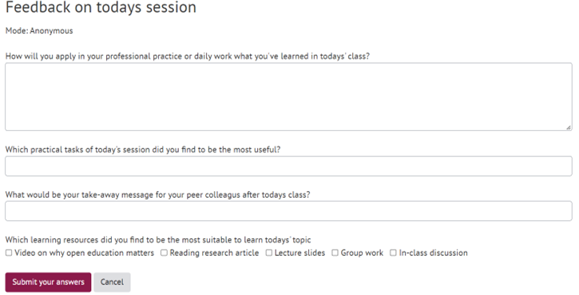
Figure 4. Feedback on today’s session used at the end of the class
The aforementioned examples show how different tools can be integrated and adopted to collect evidence-based data about learners' understanding and knowledge of the given topic. All the activities are uploaded on Moodle and designed in such a way that learners can mark the activity completion after the activity is done.
Monitoring students’ learning progress
For a wider picture of learners’ progress, the teacher uses the progress bar that is integrated in Moodle. Learners can mark which activities they have completed and, in such a way, monitor their own learning progress. Thanks to this tool, teachers can see if learners are consistent in their learning, if they are interested in monitoring their own learning, what resources they have opened and what assignments they have completed (Fig. 5).
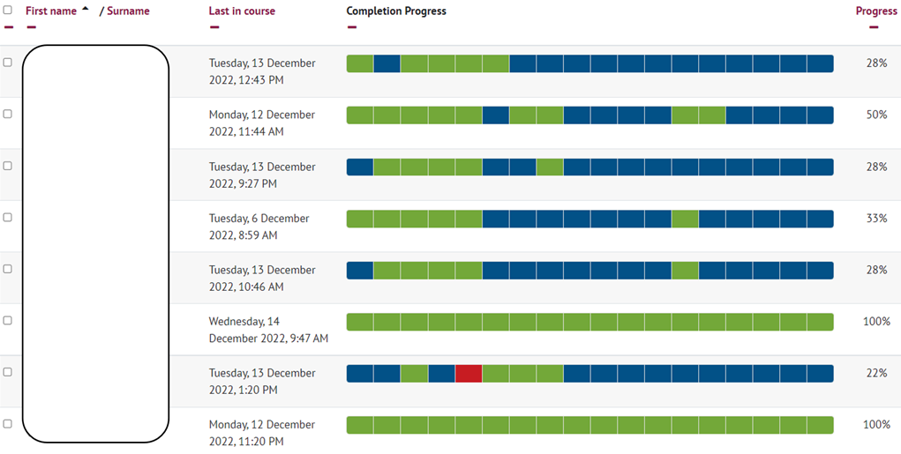
Figure 5. Monitoring student’s learning progress

Relevance for teachers: There are multiple tools and various activities that can be used to collect evidence on learners’ progress. In order to combine and collect different sources of evidence on learners’ progress, it is important to pre-plan activities that are consistent, fostering learners’ metacognition. As this specific case outlines, different tools and activities were used to collect evidence on learning progress by stating the level of knowledge of the given topic -> fixing the understanding of the key concept -> naming the main things that were learnt and what still needs to be learnt -> thinking on how this knowledge can be practically applied. Finally, an overall analysis of the progress bar is conducted allowing to monitor the learning from a wider perspective. Having this information, teachers can share insights and discuss with learners the overall progress, raise concerns about their engagement or participation, motivate them to monitor their own learning and discuss the needs for further learning to make sure it responds to learners' expectations and needs.

