Project ID: 2021-1-CZ01-KA220-SCH-000034484
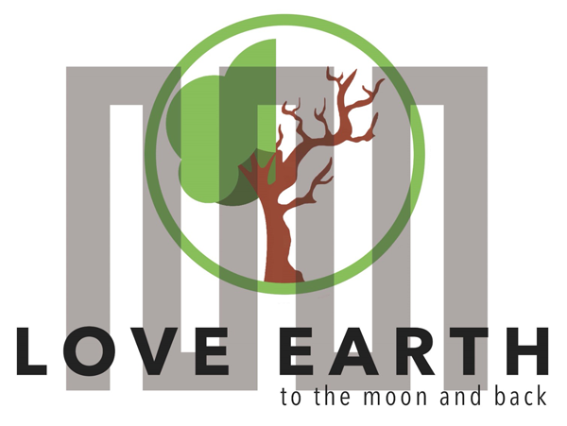

COURSE FOR ENVIRONMENTAL EDUCATION
e-Modules: Teaching Learning activities and their technology enhanced material set to develop

DISCLAIMER
Funded by the European Union. Views and opinions expressed are however those of the author(s) only and do not necessarily reflect those of the European Union or the European Education and Culture Executive Agency (EACEA). Neither the European Union nor EACEA can be held responsible for them.

COURSE AUTHORS
Anne CHIAMA, Paul FERNANDEZ, Frédéric GUILLERAY

COURSE SHARING LICENSE
You are free to:
- Share — copy and redistribute the material in any medium or format for any purpose, even commercially.
- Adapt — remix, transform, and build upon the material for any purpose, even commercially.

MODULE 2 | CYCLICAL NATURE
PART 4 | The differences between matter cycle and flow of energy in an ecosystem
Lesson | Cycling or flowing ?

SUMMARY

1. COURSE TIME, TARGET AND TOPIC 3

2. COURSE OBJECTIVES 3
Competences promoted in this lesson: 3
Lesson objectives: 3

3. LEARNING – TEACHING PROCESSES 3

4. EVALUATION 3

5. DOCUMENTS 4
ENGAGE 4
EXPLORE 8
EXPLAIN 9
EXTEND 10
EVALUATE 13

1. COURSE TIME, TARGET AND TOPIC
- Age of target students: 15+
- Teaching time: 1 hour
- Disciplines: Biology
- Title: Cycling or flowing ?

2. COURSE OBJECTIVES

Competences promoted in this lesson:
- Communication in foreign languages competency
- Digital competency
- Learning to learn competency
- Social and citizenship-related competencies

Lesson objectives:
- Explain that energy flows because usable energy is always lost as heat in biological processes, while matter cycles because matter is conserved.
- Explain that transfer of energy is not efficient and the effect of this on the length of food chains.
- Give examples about matter cycle.
- Make inferences about the effect of disruption in the matter cycle and flow of energy on natural life.

3. LEARNING – TEACHING PROCESSES
There are 4 activities in this lesson:
- ENGAGE: Energy Tango, the great Escape from the Organisms (discussion or modelling)
- EXPLORE: The journey of a Carbon atom (video or stop motion)
- EXPLAIN: Why matter cycles and energy flows? (poster)
- EXTEND: Pick a card (inferences)

4. EVALUATION
The evaluation is described in the last part of document.

5. DOCUMENTS

ENGAGE
Energy Tango, the great Escape from the Organisms

This moment is useful:
- for a first approach of the energy losses in a living organism
- and to think about the energy losses between trophic levels.
If you don’t have time, do the activity 1 and the Q1/Q2. If you have time, you can do the proposed modelling in activity 2.

1. ACTIVITY 1
Q1. From document 1, discuss the fate of organic matter absorbed by an organism. Conclude that much of the energy absorbed is lost.

A consumer eats around 40% of an organism (roots and bones, for example, are not consumed).
Q2. With reference to the photos in document 1 and the sentence above, calculate the amount of energy actually available to a fox eating the rabbit, compared with the 100% initially absorbed by the rabbit.
Answer:
The rabbit material available to the fox is around 25% (stored matter).
The fox eats 40% of the rabbit. So 40% of the 25% available is missing, i.e. 0.4x25 = 10%.
In other words, of the 100% matter ingested by the rabbit, only 10% is available for the next level in the trophic chain (in this case, the fox).
Conclusion: energy loss is 90% between two trophic levels.

Document 1: the fate of ingested matter
When an organism ingests another organism, the fate of the ingested matter is as follows:
- some of it is used to produce energy to power the organism (via cellular respiration),
- some is used to produce energy in the form of heat (through various metabolic reactions, such as fat burning),
- some is used to manufacture the organic matter needed to grow and renew our own cells,
- some is not digested and is excreted in the feces.
Reminder: in organic matter, energy is available in the form of chemical energy.

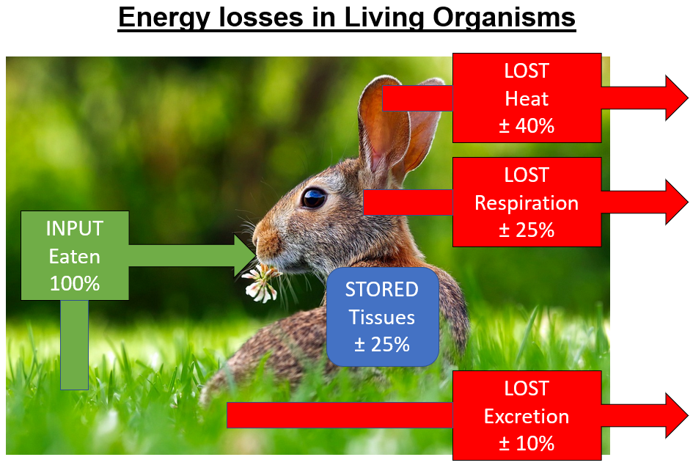

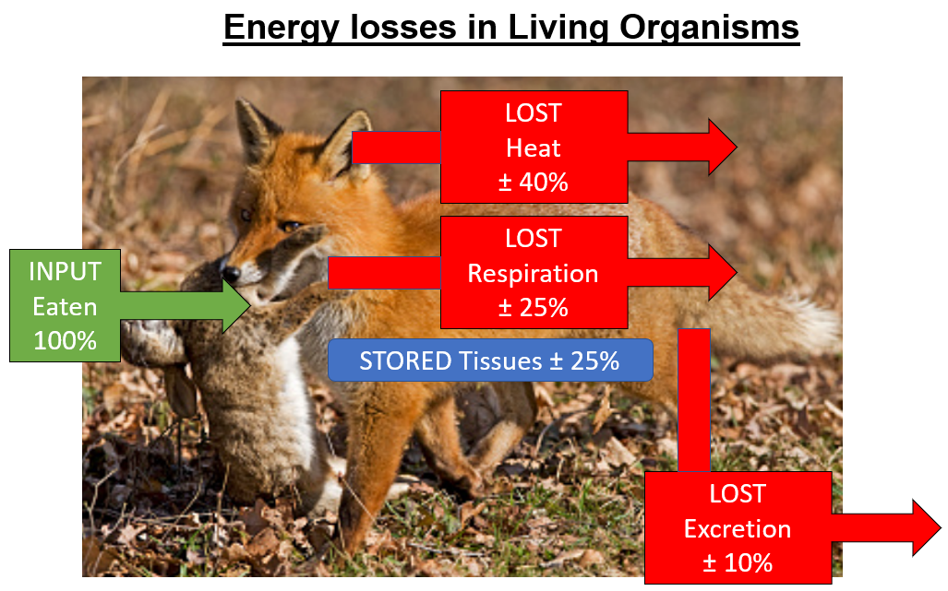

2. ACTIVITY 2: modelling
Material and organization:
- Use beans to represent organic matter.
- Divide students into groups of 2 or 3, with one picture of a rabbit and one of a fox for each group.
- Ask them to prepare the two images in the form of an end of a trophic chain, as in the image below:
- distribute the document below
Document: the fate of ingested matter
When an organism ingests another organism, the fate of the ingested matter is as follows:
- Around 25% of it is used to produce energy to power the organism (via cellular respiration),
- Around 40% is used to produce energy in the form of heat (through various metabolic reactions, such as fat burning),
- Around 25% is used to manufacture the organic matter needed to grow and renew our own cells,
- Around 10% is not digested and is excreted in the feces.
Reminder: in organic matter, energy is available in the form of chemical energy.

Attention: in a chain food, a consumer eats around 40% of an organism (roots and bones, for example, are not consumed).

- Finally, ask students to model the fate of the chemical energy contained in the 100% of grass eaten by the rabbit.
The beans represent matter and its fate. They can add labels to the photos to explain.

Pictures for the activity 2:

EXPLORE
The journey of a carbon molecule

From the document below, make a poster, a video or stop-motion film about the journey of a carbon atom. Your production must show that this journey is a cycle.
Note: the journey can take many different paths. Share your productions with others in the end.

Document: Carbon travel in the Ecosystem
Carbon plays a fundamental role in all aspects of terrestrial life, serving as the foundational material for the formation of various complex biomolecules, including carbohydrates, proteins, and DNA. In the atmosphere, it exists in the form of carbon dioxide (CO₂) The carbon cycle illustrates how carbon atoms naturally move between the atmosphere, living organisms, and the soil, passing through 3 main stages: photosynthesis, respiration and decomposition.

Photosynthesis represents the mechanism by which plants transform sunlight, water, and carbon dioxide into oxygen and energy stored in the form of glucose. This energy reserve is then used for the synthesis of different molecules essential for the plant's growth, thus promoting the development of its various organs such as roots, leaves, stem, and flowers.
Photosynthesis: 6CO₂ + 6H₂O → C₆H₁₂O₆+(glucose) + 6O₂ in the light

Respiration, on the other hand, involves releasing the stored energy in glucose by combining it with oxygen to produce carbon dioxide and water. The released CO2 can then be reused during the process of photosynthesis.
Respiration: C₆H₁₂O₆+(glucose) + 6O₂ → 6CO₂ + 6H₂O + energy

Decomposition, or decay, refers to the breakdown of dead organic matter into simpler molecules, whether organic or inorganic, such as CO2, water, simple sugars, and inorganic ions. This process is of paramount importance in the nutrient cycle, as it allows the recycling of organic matter into nutrients that can be reused by other living organisms, mainly plants. Upon the death of an organism, its body undergoes a rapid decomposition process, catalyzed by decomposing microorganisms, which break down complex biological molecules into simpler products. Thus, carbon stored as biomass gradually returns to the environment.

EXPLAIN
EXPLAIN: Why matter cycles and energy flows?

FOR MATTER | FOR ENERGY
- Choose a cycle except carbon cycle:  - oxygen cycle  - nitrogen cycle  - water cycle.  - Research the chosen cycle and find an image that illustrates the fact that the matter cycles in an ecosystem. | - Use the activity ENGAGE and the document called Energy Flow in an Ecosystem (link) from National geographic:

With all the documents, explain why matter cycles and energy flows by creating a poster based on the image below.
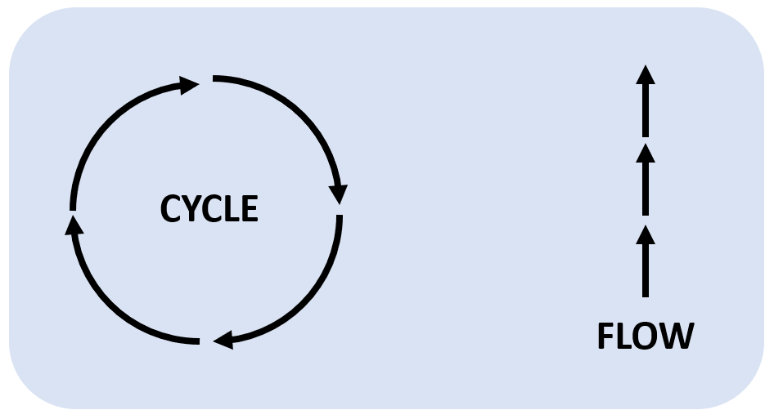

EXTEND
Print the following cards and use them with the student to discuss about the effect of disruption in the matter cycle and flow of energy on natural life.
To play, pick a card, read the title and discuss. Then turn the card and read the explanations.

Eutrophication

Deforestation

Excessive use of fertilizers in agriculture or runoff from urban areas introduces high levels of nutrients (such as nitrogen and phosphorus) into water bodies, causing algal blooms, oxygen depletion, and disruption of aquatic ecosystems.
Clearing large areas of forests for agriculture or logging disrupts the matter cycle by reducing organic matter input, nutrient cycling, and carbon sequestration, leading to soil erosion and loss of biodiversity.

Acid rain

Oil spills

Emissions of sulfur dioxide and nitrogen oxides from industrial activities and transportation contribute to acid rain, which acidifies soil and water, inhibits nutrient uptake by plants, and disrupts nutrient cycling in terrestrial/aquatic ecosystems.
Accidental release of oil into marine environments leads to the contamination of water, sediments, and organisms, disrupting the natural matter cycle and causing harm to aquatic life and coastal ecosystems.

Landfills

Invasive species

Improperly managed landfills contribute to the release of greenhouse gases, leachate contamination of soil and groundwater, and the accumulation of non-biodegradable waste, disrupting the natural matter cycle.
Non-native species introduced into ecosystems can outcompete native species for resources, disrupt food webs, and alter nutrient cycling dynamics, leading to ecosystem imbalance and reduced biodiversity.

Urbanization

Industrial pollution

Rapid urban development alters natural land cover, reduces infiltration capacity, and disrupts the water cycle, leading to increased runoff, decreased groundwater recharge, and changes in nutrient transport and availability.
Release of toxic chemicals and heavy metals into the environment contaminates soil, water, and organisms, interrupting nutrient cycling, impairing ecosystem functions, and posing risks to human and wildlife health.

Climate change

Overfishing

Rising temperatures and extreme weather events associated with climate change impact the availability and distribution of nutrients, disrupt phenological cycles, and affect the productivity and composition of ecosystems.
Excessive fishing pressure disrupts marine food webs and alters predator-prey relationships, affecting nutrient cycling dynamics in marine ecosystems and leading to population declines and ecosystem imbalances.

EVALUATE

1. Which of the following best explains why energy flows and matter cycles in biological systems?
□ Energy is conserved, while matter is constantly transformed.
□ Energy is efficiently transferred, while matter is lost in biological processes.
□ Energy is mainly lost, while matter is conserved.
□ Energy is stored, while matter is constantly exchanged.

2. How much energy escapes from consumer organisms and dissipates into the environment?
□ 50%
□ 75%
□ 90%
□ 100%

3. The transfer of energy in biological systems is not efficient. What is the primary reason for this inefficiency?
□ Loss of energy as heat in biological processes.
□ Limited availability of energy sources.
□ Inability of organisms to capture and utilize energy.
□ Excessive energy consumption by top predators.

4. Which of the following statements is true regarding the flow of energy and the length of food chains?
□ Longer food chains have more energy available to top predators.
□ Energy flows more efficiently in shorter food chains.
□ Longer food chains are more stable and resilient to disruptions.
□ Energy transfer is equally efficient across all food chain lengths.

5. Which of the following examples best represents a matter cycle in nature?
□ The combustion of fossil fuels, releasing carbon dioxide into the atmosphere.
□ The migration of birds, following their seasonal food sources.
□ The growth of plants, absorbing carbon dioxide from the air and releasing oxygen.
□ The water cycle, where water evaporates, forms clouds, and falls as precipitation.

6. Explain the concept of energy flow and matter cycling in biological systems. Provide one example for each concept.

7. Case Study:
A large-scale deforestation project is planned in a rainforest area to make way for agricultural activities. The project involves clearing vast areas of trees, disrupting the natural matter cycle and ecosystem dynamics.
Questions:
- How does deforestation impact the matter cycle in the rainforest ecosystem?
- Discuss two potential effects of this disruption on natural life and biodiversity.
- Based on your understanding of energy flow and matter cycling, make inferences about the potential long-term consequences of this deforestation project.

EVALUATION CORRECTION

1. Which of the following best explains why energy flows and matter cycles in biological systems?
□ Energy is conserved, while matter is constantly transformed.
□ Energy is efficiently transferred, while matter is lost in biological processes.
□ Energy is mainly lost, while matter is conserved.
□ Energy is stored, while matter is constantly exchanged.

2. How much energy escapes from consumer organisms and dissipates into the environment?
□ 50%
□ 75%
□ 90%
□ 100%

3. The transfer of energy in biological systems is not efficient. What is the primary reason for this inefficiency?
□ Loss of energy as heat in biological processes.
□ Limited availability of energy sources.
□ Inability of organisms to capture and utilize energy.
□ Excessive energy consumption by top predators.

4. Which of the following statements is true regarding the flow of energy and the length of food chains?
□ Longer food chains have more energy available to top predators.
□ Energy flows more efficiently in shorter food chains.
□ Longer food chains are more stable and resilient to disruptions.
□ Energy transfer is equally efficient across all food chain lengths.

5. Which of the following examples best represents a matter cycle in nature?
□ The combustion of fossil fuels, releasing carbon dioxide into the atmosphere.
□ The migration of birds, following their seasonal food sources.
□ The growth of plants, absorbing carbon dioxide from the air and releasing oxygen.
□ The water cycle, where water evaporates, forms clouds, and falls as precipitation.

6. Explain the concept of energy flow and matter cycling in biological systems. Provide one example for each concept.
Answer:
Energy flow refers to the movement of energy through an ecosystem, where usable energy is lost as heat in biological processes. Matter cycling, on the other hand, involves the continuous recycling of matter, such as nutrients, in an ecosystem as matter is conserved.
Example: In energy flow, solar energy is captured by plants through photosynthesis, but only a fraction of this energy is transferred to herbivores when they consume plants. In matter cycling, elements like carbon and nitrogen are continuously recycled between living organisms and the environment.

7. Case Study:
A large-scale deforestation project is planned in a rainforest area to make way for agricultural activities. The project involves clearing vast areas of trees, disrupting the natural matter cycle and ecosystem dynamics.
Questions:
- How does deforestation impact the matter cycle in the rainforest ecosystem?
- Discuss two potential effects of this disruption on natural life and biodiversity.
- Based on your understanding of energy flow and matter cycling, make inferences about the potential long-term consequences of this deforestation project.
Answers:

a) Deforestation disrupts the matter cycle in the rainforest ecosystem by removing trees that play a vital role in nutrient cycling. Without the trees, organic matter decomposition slows down, nutrient uptake by plants is hindered, and the recycling of nutrients is disrupted.

b) Two potential effects of this disruption on natural life and biodiversity include:
- Loss of habitat and food sources for various organisms, leading to population decline and potential species extinction.
- Soil erosion due to the removal of tree cover, causing nutrient depletion, reduced water retention capacity, and increased sedimentation in water bodies.

c) Based on energy flow and matter cycling, the long-term consequences of this deforestation project may include:
- Imbalances in nutrient availability, affecting the growth and survival of plants and other organisms in the ecosystem.
- Disruption of food chains and trophic interactions, resulting in cascading effects on the entire ecosystem.
- Increased vulnerability to environmental stressors, as the ecosystem's resilience and ability to recover may be compromised.

https://education.nationalgeographic.org/resource/energy-flow-ecosystm/#undefined

