Project ID: 2021-1-CZ01-KA220-SCH-000034484

COURSE FOR ENVIRONMENTAL EDUCATION
e-Modules: Teaching Learning activities and their technology enhanced material set to develop

DISCLAIMER
Funded by the European Union. Views and opinions expressed are however those of the author(s) only and do not necessarily reflect those of the European Union or the European Education and Culture Executive Agency (EACEA). Neither the European Union nor EACEA can be held responsible for them.

COURSE AUTHORS
Justyna Pająk-Jaroszewska, Martyna Florkowska-Kardasz

COURSE SHARING LICENSE
You are free to:
- Share — copy and redistribute the material in any medium or format for any purpose, even commercially.
- Adapt — remix, transform, and build upon the material for any purpose, even commercially.

MODULE 1 |  | HUMAN AND NATURE
PART 5 |  | Our responsibility for the development of attitudes and behaviours aimed at maintaining the natural balance
Lesson 1 |  | Producers and consumers in ecosystems

SUMMARY

1. COURSE TIME, TARGET AND TOPIC 3

2. COURSE OBJECTIVES 3
Competences promoted in this lesson: 3
Lesson objectives: 3

3. LEARNING – TEACHING PROCESSES 3

4. EVALUATION 3

5. DOCUMENTS 4
ENGAGE 4
EXPLORE 5
EXPLAIN 7
EXTEND 9
EVALUATE 10

1. COURSE TIME, TARGET AND TOPIC
- Age of target students: 15+
- Teaching time: 2 hours
- Disciplines: English, art, ICT, biology, social studies, geography
- Title: How to maintain the natural balance?

2. COURSE OBJECTIVES

Competences promoted in this lesson:
- Communication in foreign languages competence
- Digital competence
- Learning to learn competence
- Social and citizenship-related competencies
- Initiative and entrepreneurship competencies
- Cultural awareness and expression competences

Lesson objectives:
- The students recognize that they are responsible for the development of attitudes and behaviors aimed at maintaining the natural balance.
- They give examples of human actions destroying the natural balance
- They define the consequences of actions destroying the natural balance

3. LEARNING – TEACHING PROCESSES
There are 7 main activities in this lesson:
- ENGAGE: Working out a definition of ‘balance’
- EXPLORE: Drawing conclusions from the presented visuals (pictures, headlines, etc.) to discover the topic of the class
- EXPLAIN: Working with the song lyrics (‘Big Yellow Taxi’ by Joni Mitchell) ; having a discussion about the state of the planet, human influence; reading the article for detailed information; answering the questions in a survey
- EXTEND: summarizing students’ answers; students’ comments

4. EVALUATION
Working with the visuals to summarise the class

5. DOCUMENTS

ENGAGE

Definition
The students are supposed to give a definition of ‘balance‘ and share it on https://presenter.ahaslides.com/
The teacher may show them possible answers and ask for more meanings.

- a state in which all your weight is evenly spread so that you do not fall
- a state in which opposite forces or influences exist in equal or the correct amounts, in a way that is good
- the amount of money that you have in your bank account
source : balance | meaning of balance in Longman Dictionary of Contemporary English | LDOCE (ldoceonline.com)

EXPLORE

Lack of balance

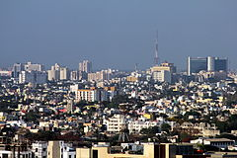
- The teacher shows three pictures: one with a rural area, another one with a typical overpopulated paved urban area and the third one with scales .

Kalkuta (https://www.bing.com/images)
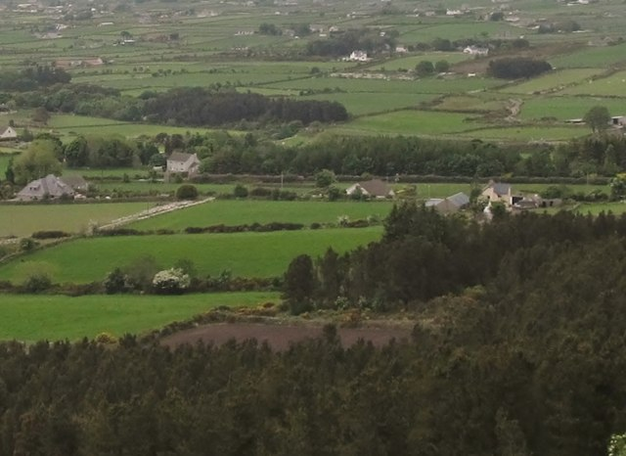
Rural settlement in the Rourke’s Park (©Eric Jones)
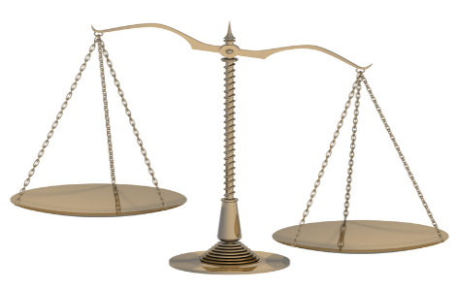

http://jorgesuberoisa.blogspot.com/2012/02/fragmentos-de-un-discurso-escrito-para_12.html

Then teacher asks: What are we going to discuss during our today’s class?

EXPLAIN

‘Big yellow taxi’

1.Students listen to/read the lyrics of the song entitled ‘Big Yellow Taxi’ by Joni Mitchell and complete the gaps with: paved DDT gone tree museum spots
They paved paradise (3-4 minutes)
And put up a parking lot
With a pink hotel *, a boutique
And a swinging hot spot
Don't it always seem to go
That you don't know what you've got
Till it's gone
They 1. __________ paradise
And put up a parking lot
They took all the trees
Put 'em in a 2 ___________________ *
And they charged the people
A dollar and a half just to see 'em
Don't it always seem to go
That you don't know what you've got
Till it's gone
They paved paradise
And put up a parking lot
Hey farmer farmer
Put away that 3. _________________ * now
Give me 4. _______________ on my apples
But leave me the birds and the bees
Please!
Don't it always seem to go
That you don't know what you've got
Till it's 5. ______________
They paved paradise
And put up a parking lot
Late last night
I heard the screen door slam
And a big yellow taxi
Took away my old man
Don't it always seem to go
That you don't know what you've got
Till it's gone
They paved paradise
And put up a parking lot
They paved paradise
And put up a parking lot
© January 7, 1970; Siquomb Publishing Corp

ANSWERS:
- paved 2. tree museum 3.DDT 4.spots 5.gone

- The students answer the questions: (3-4 minutes)

What is this song about?
What has happened in the place described in the song?
Could you enumerate the activities?

DDT - a chemical formerly used to kill insects that harm crops (https://www.ldoceonline.com/dictionary/harm)

- The teacher asks students two questions about factors affecting or destroying the natural balance (10 minutes)

Students work individually/in pairs. They come up with their ideas and look for some in the article
entitled: Humans exploiting and destroying nature on unprecedented scale – report | Environment | The Guardian

(https://www.theguardian.com/environment/2020/sep/10/humans-exploiting-and-destroying-nature-on-unprecedented-scale-report-aoe)

Question 1: What human actions affect the natural balance?

(e.g. deforestation, overfishing, noise/water/air pollution, overpopulation , burning fossil fuels, etc.)

Question 2: What are the consequences of these actions?

( wildfires, soil erosion, global warming, melting of glaciers/polar caps, smog, air pollution, harm to the health of humans/animals/plants, damage to buildings etc. (5-6minutes)

- Students share their ideas on https://presenter.ahaslides.com/ (7 minutes)

EXTEND

The results of the survey

- Summary of the students’ answers: students get familiar with the results of the survey consisting of 2 questions. They read out the answers and comment on them. (5 minutes)

EVALUATE

- Students name human actions affecting natural balance presented in the pictures. (5 minutes)

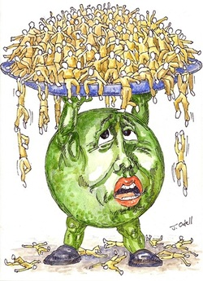
https://www.mrgscience.com/ess-topic-84-human-population-carrying-capacity.html

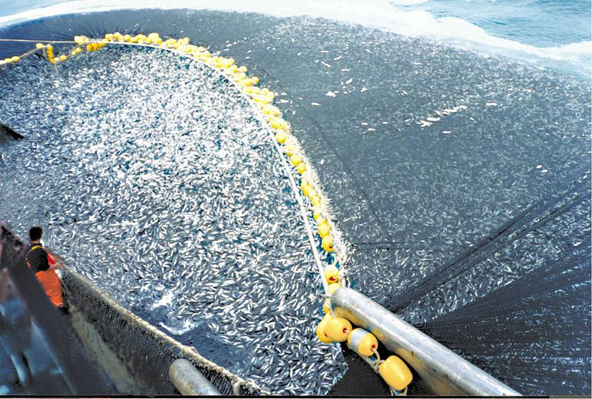
http://www.biologiamarina.eu/Saccheggio_pesce_in_Africa_p3.html

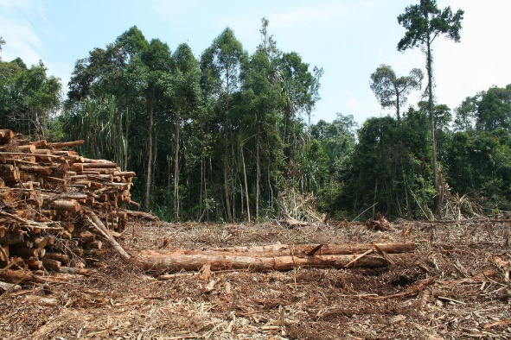

https://intercontinentalcry.org/new-evidence-shows-willful-destruction-of-the-brazilian-amazon/

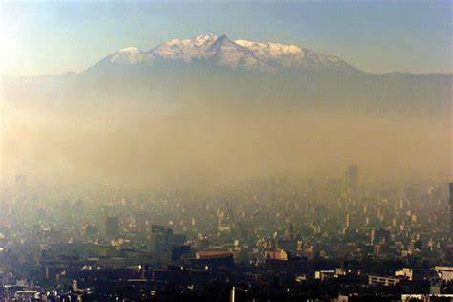

https://energycue.it/smog-citta-traffico-non-problema/17716/

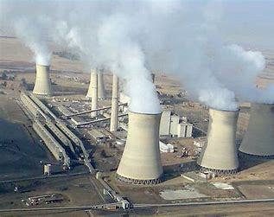

http://wagingnonviolence.org/feature/will-fossil-fuel-divestment-take-root-south-africa/

- Students name other harmful human actions not shown in the pictures.

- Students decide which problems seem to be urgent and should be immediately taken care of?

