Project ID: 2021-1-CZ01-KA220-SCH-000034484

COURSE FOR ENVIRONMENTAL EDUCATION
e-Modules: Teaching Learning activities and their technology enhanced material set

DISCLAIMER
Funded by the European Union. Views and opinions expressed are however those of the author(s) only and do not necessarily reflect those of the European Union or the European Education and Culture Executive Agency (EACEA). Neither the European Union nor EACEA can be held responsible for them.

COURSE AUTHORS
Güray Karakaya

COURSE SHARING LICENCE

You are free to:
- Share — copy and redistribute the material in any medium or format for any purpose, even commercially.
- Adapt — remix, transform, and build upon the material for any purpose, even commercially.

MODULE 3 | NATURE and CLIMATE CHANGE
PART 6 | Climate Variability vs. Climate Change
Lesson 1-2 | The differences between climate variability vs climate change

SUMMARY

1. COURSE TIME, TARGET AND TOPIC 3
2. COURSE OBJECTIVES 3
Competences promoted in this lesson: 3
Objectives: 3
Lesson objectives: 3
3. LEARNING – TEACHING PROCESSES 3
4. EVALUATION 3
5. DOCUMENTS 4
ENGAGE 4
EXPLORE 4
EXPLAIN 5
EXTEND 7
EVALUATE 7

1. COURSE TIME, TARGET AND TOPIC
- Age of target students: 15+
- Teaching time: 2 hour
- Disciplines: Geography, Human Sciences, Maths, Science, Technology
- Title: The effects of unplanned settlement, industrialization, transportation and other actions

2. COURSE OBJECTIVES

Competences promoted in this lesson:
- 1.Communication in foreign languages competency - CLIL -
- 2.Mathematical competency and basic competencies in science/technology – STEAM -
- 3.Social and citizenship-related competencies

Objectives:
Developing students’ Systems–thinking competence; anticipatory ( future thinking)competence; interpersonal competence - collaboration competence- ; critical thinking competence; integrated problem solving competence

Lesson objectives:
- Students discuss Climate change vs Climate variability
- Students investigate the examples of climate variability

3. LEARNING – TEACHING PROCESSES
There are 4 activities in this lesson:
- ENGAGE: Time-traveler
- EXPLORE: Questions for Discussion
- EXPLAIN: The Characteristics of La Niña and El Niño
- EXTEND: Ancient civilisations

4. EVALUATION
Students are asked some questions to check their comprehension of climate change and climate variability
- What is weather ?
- What is climate? (average over how long?) What fields are used to describe climate (temp & precip)?
- What affects climate in a particular location ( Proximity to oceans, latitude, elevation, mountains, land surface, etc...) ? What determines global average climate? What things are external to the climate system? What are internal factors affecting climate? How do they affect climate?
- What time frame do we use to distinguish short-term climate variability and long-term climate change ?
- Do you think ancient peoples were responding to short-term climate variability or long-term climate change?

5. DOCUMENTS

ENGAGE
Ice Breaker : Students are invited to play ‘Hope and Fears’.
INSTRUCTIONS: Write down your greatest hope (about the climate change) and then your greatest fear. Read all the hopes first and then the fears and discuss
Optional Tip: In a face-to-face class, the participants differentiate the answers by writing each answer on a sticky note of a different color. Online, Padlet or Lino, which allow participants to create virtual sticky notes of various colors can be used.
1-Engage:
Encourage the group to answer the following questions: "If you were able to travel through time, either forward or backward... :
- Where would you go? If backward, to which time period would you choose? Why? If forward, to which year would you travel? Why?
- Would you describe the weather and the climate then?

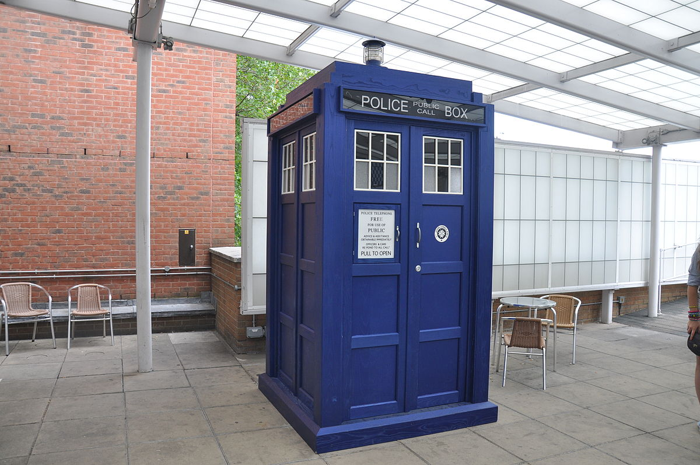

INSTRUCTION : You can be a time-traveler. Make a google search and decide when and where to go. Describe the weather and the climate then

EXPLORE
Students are given some dates and some places in 1999. They are asked to find out the important events on those dates there.
Questions for Discussion:
Year 1999-
9-16 April (Cauca, Columbia) ; 5-15 May (Peru) ; 30 August-11 September ( Cordoba) ; 12-29 September (Honduras) ; 12-19 December (Venezuela)

INSTRUCTION : There are some dates and places .Make an online survey and find out what happened then in those places ? What do you think they have in common ?
2. What caused those disasters? Look at the time scale and comment on the cause

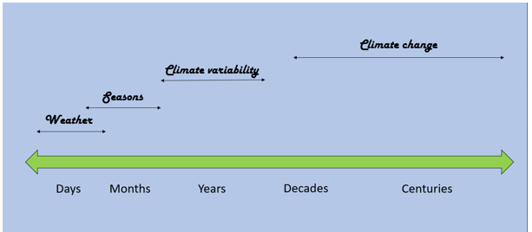

EXPLAIN
Students are asked to match the given characteristics with either La Niña or El Niño, the causes of climate variability. They are asked to visit the website of the National Ocean Service and skim and scan the website and study the multimedia (audio material) and the pdf text about El Niña and El Niño to check their answers.
Little Girl in Spanish ____________
Little Boy in Spanish ____________
Cooling of the water in the Pacific Ocean ____________
Less precipitation and decreased humidity ____________
Warming of the water in the Pacific Ocean ____________
Rain and Flooding along the Pacific Coast ____________
Unusually cold weather in Alaska ____________
Increased humidity ____________
Unusually warm weather in the rest of America ____________
Drought in the southwest regions ____________

Warm weather disrupting birds and fish’s lives ____________
Increased thunderstorms ın the southern United States ____________
Increased hurricanes in the Atlantic ____________
More frequently occuring event ____________

The Link Of the Online Document: VariabilityAndChange.pdf (weather.gov)
The link of the website of the National Ocean Service : What are El Nino and La Nina? (noaa.gov)
ANSWERS
La Nina Characteristic
Cooling of the water in the pacific ocean
Less precipitation
Decreased humidity
Unusually cold weather in alaska
Unusually warm weather in the rest of America
Drought in the South West
Higher than normal numbers of hurricanes in the Atlantic
Little Girl in Spanish
El Nino Characteristics
Little Boy in Spanish
Warming of water in the Pacific ocean
Rain and Flooding in pacific coast
Increased humidity
Warm weather disrupts birds and fish lives
Increase of thunderstorms ın the southern United States
Occurs more often
INSTRUCTION : Match the given characteristics with either La Niña or El Niño, the causes of climate variability. Visit the website of the National Ocean Service and skim and scan the website and study the multimedia (audio material) and the pdf text about El Niña and El Niño. Take notes and check your answers.

EXTEND
Students are asked to make researches about the ancient civilisations deeply impacted by the climate variability and /or climate change.
Optional Tip : Students are asked to make a research about the collapses of some ancient civilisations - the people of the Andes, the Mayans, and the Vikings in Greenland- and describe the impact of the climate variability / change on the collapse of those civilisations. They are also asked to give example of an impact of climate variability and one example of an impact of climate change in the modern world.
INSTRUCTION : 1. Make a research about the collapses of some ancient civilisations - the people of the Andes, the Mayans, and the Vikings in Greenland - and describe the impact of the climate variability / change on the collapse of those civilisations.
2. Give example of an impact of climate variability and one example of an impact of climate change in the modern world.

EVALUATE
Students are asked some questions to check their comprehension of climate change and climate variability
- What is weather ?
- What is climate? (average over how long?) What fields are used to describe climate (temp & precip)?
- What affects climate in a particular location ( Proximity to oceans, latitude, elevation, mountains, land surface, etc...) ? What determines global average climate? What things are external to the climate system? What are internal factors affecting climate? How do they affect climate?
- What time frame do we use to distinguish short-term climate variability and long-term climate change ?
- Do you think ancient peoples were responding to short-term climate variability or long-term climate change?
INSTRUCTION : Answer the questions and make further study if required.
ENDING THE LESSON :
Students are asked to explain more about the place and the year they traveled through the time machine ( in the Engage stage of the lesson ).
INSTRUCTION : Where and when did you travel by the time machine at the beginning of the lesson ?
- Would you give some more details about that place and the year; the architecture, life styles, important events ?
- Would you connect the architecture, life styles and important events with the weather conditions and /or climate ?
Optional Tip: For larger group sizes, divide the audience into smaller sub-groups of 3-4 people. Ask someone in the group with good graphic recording skills to record the answers visually and have a history gallery.

