Project ID: 2021-1-CZ01-KA220-SCH-000034484
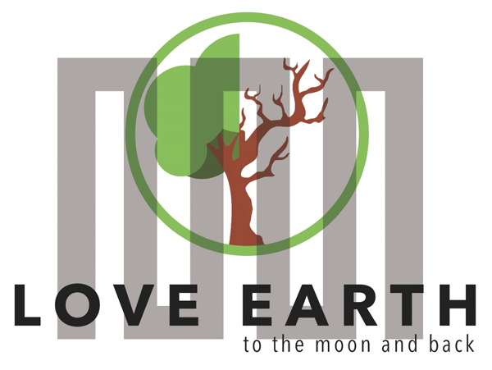

COURSE FOR ENVIRONMENTAL EDUCATION
e-Modules: Teaching Learning activities and their technology enhanced material set to develop

Thematic Units for Week-Long Workshop Sessions:
Inquiry-Based Integrated Learning Workshop Series
on the Intersection of Arts, Science, and Policy"

M3: Weather&Climate in Science&Arts
COURSE AUTHOR:
©Tatjana Christelbauer MA (TC)
Contributors: Dr. Geraldine Fitoussi-Hoffmann, Mag. Andrea Nagl
ACD Team, Austria

DISCLAIMER
Funded by the European Union. Views and opinions expressed are however those of the author(s) only and do not necessarily reflect those of the European Union or the European Education and Culture Executive Agency (EACEA). Neither the European Union nor EACEA can be held responsible for them.
COURSE SHARING LICENSE CC BY-NC-SA =
Canonical URL: https://creativecommons.org/licenses/by-nc-nd/4.0/

MODULE: 4

LESSONs bound for week-long workshops: Weather & Climate in Science & Arts:
- Tatjana Christelbauer introductory part, Weather & Climate metaphors and from experience of the blind meteorologist;
- Weather&Climate Crossword experinece by Dr. Geraldine Fitoussi-Hoffmann
- Dance arts workshops by Mag. Andrea Nagl
- Role play, Radioplay Orangefeatherflinghtcontrol by Tatjana Christelbauer

1. COURSE TIME, TARGET AND TOPIC
- Age of target students: 15+
- Teaching time: 2 hour+ workshops
- Disciplines: Meteorology, dance arts, perfoming arts, social sciences, English, ..
- Title: Weather and Climate in science and arts

2. COURSE OBJECTIVES

Competences promoted in this lesson:
- Communication in foreign languages competency
- Digital competency
- Creative thinking
- Dance arts, performing arts, social and natural sciences
- STEAM
- Symbolic interaction

Lesson objectives:
° explore weather and climate through interactive exercises guided by scientific insights
° nature and natural phenomena in dance arts
° Weather and Climate in symbolic interaction
° Weather and Climate from the experience of blind

3. LEARNING – TEACHING PROCESSES
There are 4 activities in this lesson:
- ENGAGE: Creative attempt to science
- EXPLORE: The Weather and Climate in science and arts
- EXPLAIN: Climate and Weather in relational cultures
- EXTEND: Role Play: Orangefeatherflightcontrol

4. EVALUATION
The evaluation is described in the last part of document.

Workshop1:
Weather & Climate in symbolic interaction, weather forecast from experience of the blind meteorologist

by Tatjana Christelbauer MA

      - Introductory guide
We all pay close attention to the daily weather forecast. It lets us know whether to put on shorts or leave the house in a winter coat or with an umbrella. But how do we know what the weather is going to be like? People who observe, study, and predict weather are known as meteorologists, and they use a wide range of tools and techniques to make predictions and forecasts. Climate, on the other hand, is the average weather in an area over long periods of time. Scientists are becoming increasingly interested understanding how climate is changing and how that affects the weather.

Both, weather and climate are also used metaphorically in human relations, when it comes to address emotional state and mood, social climate and relational “temperature” such as by posing the question “How is the weather by you today?, or by commenting some social relations “such a cold climate” , “hot atmosphere”, “a storm is in coming” when anger is expected …

Engage in reflection and discussion: What science is dealing with the atmosphere and its phenomena, including both- weather and climate? How is your experience with weather metaphors? Have you used such descriptions for your emotional state or for symbolically describing some relational “atmosphere? How may the “social climate” affect your emotional weather? How does weather in nature affects the social climate? How is weather predictable?

1.2. Weather forecast, Meteorology as a profession from the perspective of a blind meteorologist Engage by reading the web article of a blind meteorologist Sam Herron form North Carolina US: https://nfb.org/images/nfb/publications/fr/fr19/fr05si08.htm
°Summarize the text and highlight some most interesting insights you found in the article of Sam Herron.
°Discuss with your colleagues about the profession as a meteorologist.
Make research about how weather and climate correlate with human relations and how natural phenomena may have impact on the social climate.
°Create your weather & climate vocabulary with key terms collected, read the article about the climate change mitigation through weather modification: https://wmo.int/fr/node/22207

References:
National Oceanic and Atmospheric Administration (NOAA) - "What's the Difference Between Weather and Climate?" Link: https://www.noaa.gov/stories/whats-difference-between-weather-and-climate
United States Environmental Protection Agency (EPA) - "Climate Change and Human Health" Link: https://www.epa.gov/climate-indicators/climate-change-indicators-health
National Aeronautics and Space Administration (NASA) - "Cloud Types and Precipitation" Link: https://www.nasa.gov/audience/forstudents/k-4/stories/nasa-knows/what-are-clouds-k4.html
Climate.gov - "Art and Climate Science" Link: https://www.climate.gov/teaching/resources/art-and-climate-science, Cloud-book, weather, evaluation tool http://zunal.com/evaluation.php?w=164526

Workshop 2

Weather and Climate in Science

by Dr. Geraldine Fitoussi-Hoffmann

Creative attempts with a crossword

- Warming up question: Weather or Climate?
Please fill in the blanks to find the quote from Lorenz, American meteorologist (1982).
“WEATHER is what you --------, ------ is what you --------”
Possible words: SEE, GET, EXPECT, FEEL, CLIMATE, EXPECT, MOON

- Please fill in the crossword with the questions hereafter.

A/ WEATHER
What is Weather? What is Climate? Please watch the Video: Weather and Climate definitions.
Science Meteorology is using a lot of data, big calculators, numerical models in order tp predict weather. Data are collected on the ground or by satellites.
With which instrument can we measure the wind?  Meteorological instrumentation (Source NOAA) | Horizontal 8
What is the name of the first European satellite dedicated to Meteorology?  Weather and satellites (Source Wikipedia) | Vertical 6
For which activity sector are weather forecasts important?  (Tipp: the word start with A). | Horizontal 9

B/ CLOUDS

Clouds: Pieces of the puzzle. For thousands of years, mankind has learned to predict the weather using clues in nature. Clouds can give a good idea of the short-term weather.
Source from National Geographic: Clouds (Source National Geographic)
How are called large clouds with a flat bottom and fluffy tops (cotton clouds)? | Horizontal 7
What is the prefix used to name the "mid-level" clouds? | Horizontal 1
What kind of cloud predicts a thunderstorm? | Vertical 4

C/ CLIMATE
Our Climate has been changing much faster than from the past, exactly from which period? Copernicus Article 17 november 2023 (Source Copernicus) | Vertical 3
What is both useful and harmful for the planet, depending on the quantities?  Climate Change and Global Warming (Source ABC Science) | Horizontal 5
The increase in sea level is an indicator of climate change. TRUE or FALSE ? | Vertical 2
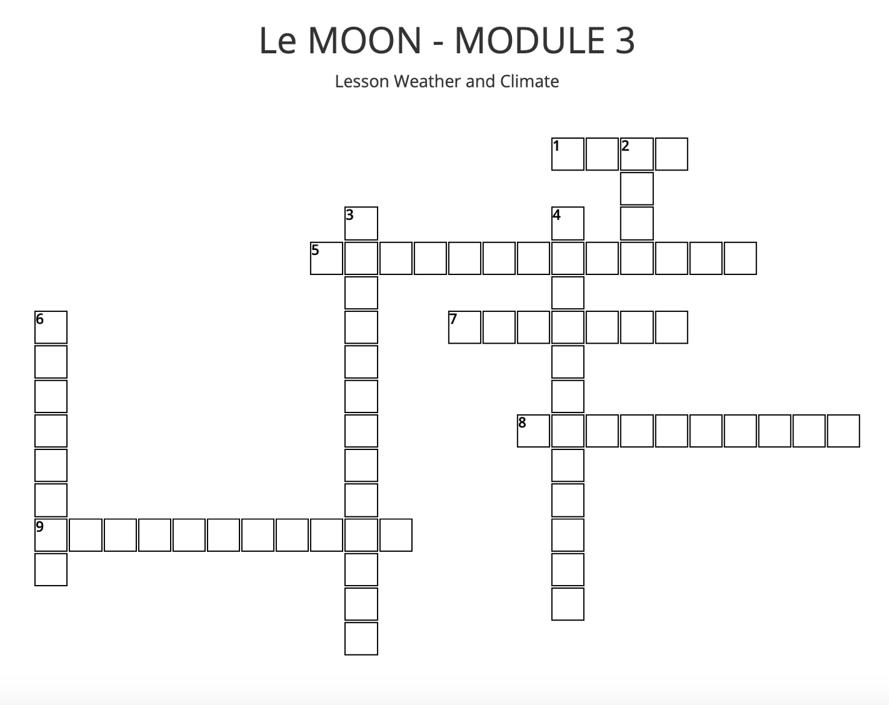

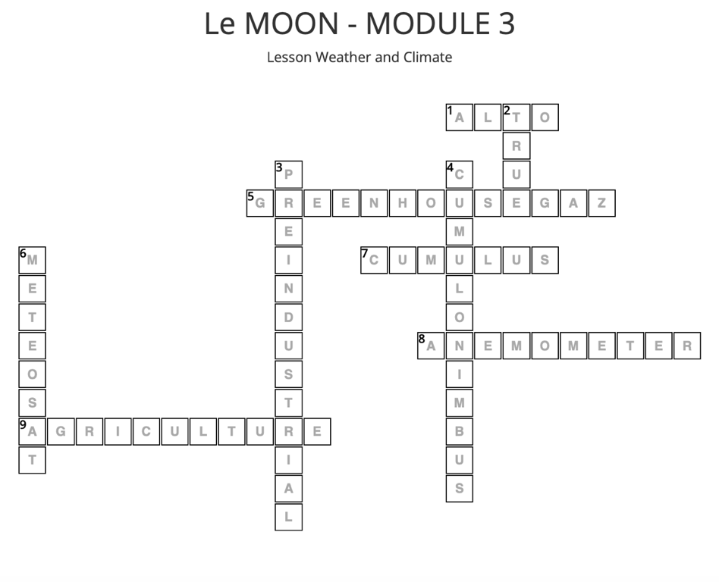

Workshop 3

Nature and Natural Phenomena in Dance arts

Lecture Nature in Motion - How to use release technique to gain deeper understanding of nature.
Author: Mag. Andrea Nagl
Introduction:
My choreographic approach is often inspired by natural phenomena. Currently I am working on the dance realization of different geological zones or landscape forms of Lower Austria in the context of an AR project ( XR[noe] | human nature ). One of my last stage piece was about the evolution or the formation of the earth (Forms of Life [Living Forms] ). Also important was a trilogy about the extinction of glaciers (EIS.stein).
The basis of my dance practice and teaching is to promote body awareness, sensitivity and authenticity through approaches of Release Techniques. When we feel ourselves clearly, we can meet the outside with greater openness. When we learn to pay attention to details within ourselves, we can also perceive them in the environment, as well as in nature. Gaining a deeper understanding of nature involves a widening of our inner horizons.
Thus, I dedicate my leisure time to pursuits such as gardening, practicing permaculture, and embarking on frequent hiking expeditions.
Another inspiration of my being is the occupation with cranio sacral body and energy work, for which I have made a training about 10 years ago. Here, too, the sensitivity and the ability to feel deeply is emphasized.
I believe that the most important thing in dance and movement, is to encourage awareness of one's own body / body awareness, of healthy, efficient, anatomically correct movement, in an atmosphere of togetherness, where there is room to explore and learn in safety. Sensitivity in dealing with one's own body is reflected in mindful interaction with nature therefore practicing dance and bodywork can at the same time inspire awareness of the wonders of nature and our planet as a whole.
Source:
XR[noe] | human nature https://andreanagl.wordpress.com/2022/04/20/xrnoe-human-nature/
Forms of Life [Living Forms] https://andreanagl.wordpress.com/2021/11/13/forms-of-life-living-forms/ EIS.stein (example) https://andreanagl.wordpress.com/2013/06/02/eis-stein-hohe-tauern-2012

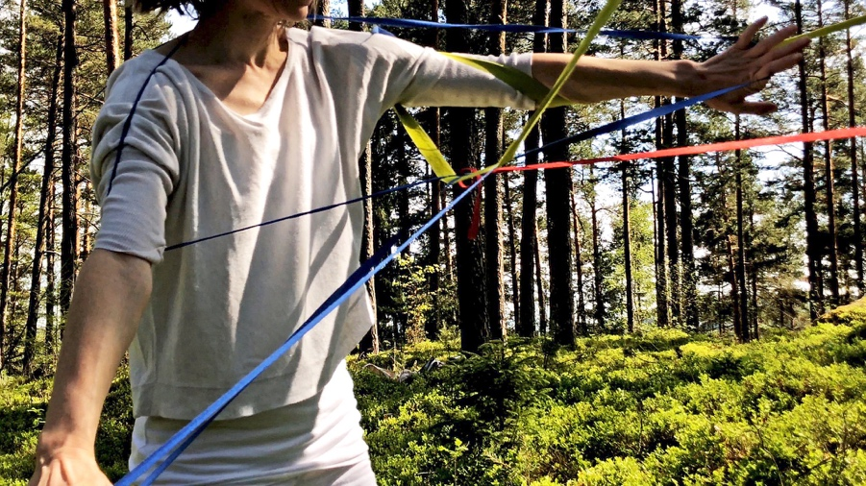
Andrea Nagl 2023 Nature in Motion
Exercise1 : Awareness - Body * mind * heart - imagery
1. Standing / walking
Best done outdoors and barefoot, eyes closed.
Standing in parallel with your feet underneath your hip sockets. If you like close your eyes. Feel the connection between the soles of your feet and the floor. Your heels, front of your feet, your toes... Let your feet sink into the floor, the soil, let them take root like a tree... Let the muscles of your belly go, let the front of your thighs go, let your buttocks go.
Your pelvis sits on your legs, easily balancing on them.
Allow your spine to lengthen and grow up towards the ceiling like a plant - a flower, your head is the blossom opening towards the sun.
Feel your breath flowing through your body and sense the connection between your feet, the earth and your roots (grounding) and the sky (your head).
Listen to the sounds around you - maybe birds are singing, the wind is whispering or you hear the distant noise of people talking.
Then gently open your eyes - and allow your impressions to sink into your eyes, don't judge, let everything flow through you, have a neutral gaze that sees everything that falls into its field of vision as equal - colors, forms, lights and shadows...
Start walking, let all the undersides of your body fall towards the floor (soles of your feet, buttocks, fingertips, back of your head, chin....). Allow your lower jaw to drop, your tongue is loose, your eyeballs sink heavily into their sockets, and yet be large like cartoon eyes, let your gaze rest on the Horizon.
Let your heart sink to your diaphragm.
How does it feel to walk in that mood and in that physicality?
Lift your shoulders a bit towards your ears and feel the difference that evolves out of the tension. Walk a few steps with your shoulders lifted and the let them go again, let them melt down onto your ribcage and enjoy the release.
Swing one of your arms as if it were a rope. How heavy does it feel?
Do the same with your other arm. Does it feel different? Heavier, lighter?
Try different ways of swinging your arm or lifting it gently and notice any changes.
- Imagine magic strings appearing on your middle finger that start to move your fingers, your hand, your whole arms, as if you were a puppet. Let the strings move you in an effortless way, you can stay completely relaxed, because you are being moved. After some time the strings on your fingers disappear again and some appear on your elbows. Or on your head. Or even on your knees or toes.
Experiment with different parts of your body, and gradually you may enter a state of physical quality that feels like floating or hovering. Weightless like jellyfish in the ocean. They drift effortlessly through the sparkling water, past beautiful underwater plants and creatures, sometimes softly illuminated by a ray of sunlight.
or: 2. Lying on the ground
Lie on the floor and drop your weight into the ground. Feel which parts of your body touch the ground. Imagine yourself sinking deeper and deeper, through the grass, through the earth, through the rock, to the center of the earth or as deep as you are comfortable with. Let your muscles melt from your bones, let them follow gravity.
Slowly imagine roots growing out of your body into the ground, maybe they are shallow along the ground or maybe they are deep tap roots. Imagine how they connect with the roots of the other people and plants around you until you all share a common root network. Take time to enjoy this connectedness and anchoring in the earth.
Allow your lower jaw to drop, your tongue is loose. Allow your eyeballs to sink heavily into their sockets.
Slowly roll your head to one side and allow your lower jaw and eyeballs to follow gravity and roll to that side as well. Give yourself completely to this most important organizing force on our planet. Enjoy this position before rolling your head back to the center and then moving it equally to the other side. Repeat this movement a few times, very slowly and consciously, until you have had enough and your head remains neutral in the center.
- Imagine magic strings appearing on your middle finger that start to move your fingers, your hand, your whole arms, as if you were a puppet. Let the strings move you in an effortless way, you can stay completely relaxed, because you are being moved. After some time, the strings on your fingers disappear again and some appear on your elbows. Or on your head. Or even on your knees or toes.
Experiment with different parts of your body, and gradually you may enter a state of physical quality that feels like floating or hovering. Weightless like jellyfish in the ocean. They drift effortlessly through the sparkling water, past beautiful underwater plants and creatures, sometimes softly illuminated by a ray of sunlight.
Source: https://andreanagl.wordpress.com/unterricht-2/
Exercise2:
Art: dancing with nature * inscribe yourself in nature
1. Inscribe yourself in nature
A creative approach to nature that promotes direct physical engagement with our environment is to inscribe ourselves into natural spaces. I have done this in numerous projects in various locations - from Iceland to the Austrian high mountains, from the Waldviertel to Berlin. The aim is to develop an emotional, physical, but also "architectural" relationship with a specific natural space: what kind of physical posture do I adopt on a rock, or in a forest? How do I achieve a "unity" with the surface, the relief, how can I merge with it, or alternatively, deliberately oppose it? This can also have an ironic component, for example using masks.
The task is to choose a location in nature that inspires you, a rock formation, a gnarled old tree, a patch of forest..., and consciously select your clothing - which color connects you best with the natural space or makes you stand out?
Experiment by your choice and ideas to physically approach the location, what feels right or exciting? Is it very dynamic or rather static? Do you crawl or roll on the ground, or do you jump through the air? How can you best establish a connection between your body and nature? What is the shape of the chosen location? Flat or towering? How do you physically react to it to create an interesting tension? You can also proceed completely freely and associatively, without really understanding why you are making these or those movements!
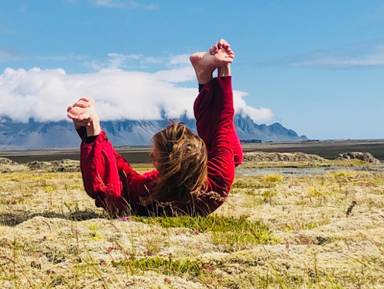
Andrea Nagl 2023 Nature in Motion
Please ask a colleague to photograph or film you with your smartphone while dancing. If you are doing more static positions, it would also be possible to scan your body and the surrounding nature with a mobile app such as Luma or Scaniverse.
2. Dancing with Nature
Another suggestion for dancing with nature and bringing it into the indoor space is to dance with a branch that you find in the forest. It should be between 1.5 and 2 meters long and will serve as your dance partner. I have also explored this intensively. You can place or lean the branch at various points in the room to define your relationship to the space. A space in which we dance is usually empty, and using an object can help to illustrate this emptiness. We can place the branch closer or farther from the walls, and we can stand or dance closer or farther from the branch in the room. That's one aspect.
The other aspect is that we can view the branch as a human body and experiment with the poses we can take together. We can carry it in different ways, lean against it, support it with our body, and build shapes with it and our body. It would also be great if someone could take photos, videos, or scans of this improvisation.
Sources:
Inscribing in nature - examples:
Dream Waters https://andreanagl.wordpress.com/2021/08/26/dream-waters/
Gullundi https://andreanagl.wordpress.com/2020/10/04/gulllundi/
Willkommen in Österreich https://andreanagl.wordpress.com/2020/09/30/willkommen-in-osterreich/
Albedo https://andreanagl.wordpress.com/2019/09/07/albedo/
Rolling across Iceland https://andreanagl.wordpress.com/2018/09/15/rolling-across-iceland/
Bergwesen oder Natternhemd https://andreanagl.wordpress.com/2016/09/02/bergwesen-oder-natternhemd/ Shinrin-yoku (Licht.Stück.Bad.Fabrik) https://www.flickr.com/photos/96915079@N08/albums/ 72157668014671327
Dancing with Nature (a branch):
Traces of a dream https://andreanagl.wordpress.com/2023/02/05/traces-of-a-dream/
Was bleibt https://andreanagl.wordpress.com/2022/11/21/was-bleibt/
W.A.L.D. https://andreanagl.wordpress.com/2022/10/03/w-a-l-d/
A.S.T. https://andreanagl.wordpress.com/2021/06/01/a-s-t/
In the silence forest https://andreanagl.wordpress.com/2020/12/31/in-the-silence-forest/
Mag. Andrea Nagl

Workshop 3
Weather and Climate in Human Relations
Symbolic interaction, role play

by Tatjana Christelbauer MA

In this workshop, we aim to explore weather & climate through metaphors and performing arts

Explore in a role play how a “stormy attempt” in mind played by a pilot could be maintained with a help of assistance provided by a radar communicator.
The play “Orange Feather Flight control” can be adapted for various number of participants, modified, and extended. The text can be spoken in various languages. The aim is to explore how disaster could be prevented, and safe landing enabled, while thinking consequences and overcoming an unbearable condition with a help of imagination. The “Orange Feather Flight control” has been written in 2021 as a 3-minutes radioplay and first time performed by a prominent actress Anan Sofrenovic on a gyrocopter. https://www.tatjana-christelbauer.com/en/feather-flight-radioplay
Recording is available on OKTO community TV portal:
https://www.okto.tv/de/oktothek/episode/619e240638298
Orange Featherflightcontrol play has been further explored by BVI students of the Vienna BBI institute in March 2023 and by ERASMUS+ LeMOON project tea members during the team meeting in Vienna, November 2023
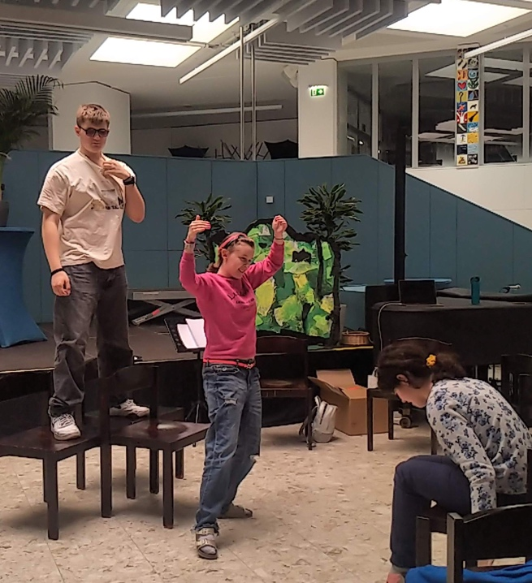
BBI Vienna Focus group students by Orangefeatherflight control Radioplay ©Tatjana Christelbauer MA
Explore, Experience:
Feather Flight Control Radio Play Fortification #1
Aim: maintaining fury attempts in mind, preventing verbal violence through respiratory exercise and playful guided imagination, adapting radar communication for performing arts and assertive communication skills;
Improving competencies: articulation, self-control, symbolical interaction, imaginative guide, active listening, self-reflection
Application: radar communicator for support by stormy weather in mind through the guided respiratory protection (Atemschutzeinsatz) exercise (BOS funk)
Play
Narrator: Welcome, dear listeners, to a unique radio experience!
Today, we present the "Feather Flight Control," a short radio play that takes you on a journey into the mind of a furry pilot facing a storm of emotions.
(Sound effects of a cockpit opening and the hum of an airplane engine)
(dramatic music starts playing)
Pilot: (frustrated) Blast it! I can't see a thing through this storm in my mind. Emotions are swirling like turbulent winds.
Music: Thunder rumbles in the background)
Radar communicator (reason): what Frequence?
Pilot: 121,5 MegaHerz1 Pan-Pan, Pan-Pan, Pan-Pan
Radar communicator: what Pan-Pan? Pilot: fury , furry, furry
Music 3-4 tacts: dramatic, crescendo, vibrating
Sound effects of radar beeping and communication signals) This can be done by voice: bip-bip-bip
A fury attempt in mind, feeling overwhelmed with anger, fingers are cramped, and the neck is
tight,
from the tiptoe to the top of the head, some burning desire to scream and hit the one who
made me so angry is overcoming, I feel out of control!!!!!
MAYDAY, MAYDAY, MAYDAY
Radar communicator: detect the Or-ange Fea-ther (speak in syllables) Say: P-E-R-O (spell each letter singulary, repeat three times
Pilot: P-E-R-O, P-E-R-O, P-E-R-O
1 Flugfunk-Notruffrenquenz
Radar communicator: what Altitude (distance measurement)? Pilot: 5.4133858268 feets
!!say like this: five point four one three three eight five eight two six eight feets
Radar communicator: follow the Orange Feather Route A-P-G-A-R Clearance limit, starting approach:
Music: slow piano, 3-4 tacts Pilot: mayday mayday mayday
Narrator: As the furry pilot waits for the radar communicator guide, a surprising helper appears. Soft, mysterious music
Orange Feather: (gentle voice) Hello, I am the Orange Feather, here to assist you in finding your way through the storm. Trust me, and we'll soar above these clouds of anger.
Sound effects of a feather gently floating
Pilot: (curious) An Orange Feather? How can you help? Cue uplifting, adventurous music
Orange Feather: (slow, clearly articulating) I am your radar communicator helper.
Breath deep in, hold for a moment. imagine the 150. 000000 alveoli moving across your lungwings
breath out on 8 counts through your mouth
Now, soften your fingers, bend your elbows move both arms toward your lung wings, lean your right hand on your left lungwing let go
Now stretch your feet on the ground,
lift your toes and put them down again move your head toward your chest, then up repeat it twice
Pilot: oooo, it stopped! The fury is gone, no one is hurt. I landed. Will talk. Will ask. Will listen. Will do so.
Soft, fading music 3 tacts
Adapt, translate, practice, prevent disasters, learn to maintain storms, land safely
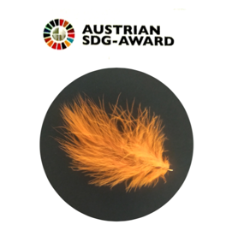
Tatjana Christelbauer MA

Atmung, Pulsfrequenz, Grundtonus, Aussehen, Reflex“: APGAR-Bakronyme. Quelle; David Wilton: Word Myths: Debunking Linguistic Urban Legends. Oxford University Press, 2008.

