Project ID: 2021-1-CZ01-KA220-SCH-000034484

COURSE FOR ENVIRONMENTAL EDUCATION
e-Modules: Teaching Learning activities and their technology enhanced material set to develop

DISCLAIMER
Funded by the European Union. Views and opinions expressed are however those of the author(s) only and do not necessarily reflect those of the European Union or the European Education and Culture Executive Agency (EACEA). Neither the European Union nor EACEA can be held responsible for them.

COURSE AUTHORS
Justyna Pająk-Jaroszewska, Martyna Florkowska-Kardasz

COURSE SHARING LICENSE
You are free to:
- Share — copy and redistribute the material in any medium or format for any purpose, even commercially.
- Adapt — remix, transform, and build upon the material for any purpose, even commercially.

MODULE 3 | NATURE AND CLIMATE CHANGE
PART 2 | Greenhouse gases
Lesson 1 | Greenhouse gases-their characteristics and impacts

SUMMARY

1. COURSE TIME, TARGET AND TOPIC 3

2. COURSE OBJECTIVES 3
Competences promoted in this lesson: 3
Lesson objectives: 3

3. LEARNING – TEACHING PROCESSES 3

4. EVALUATION 3

5. DOCUMENTS 4
ENGAGE 4
EXPLORE 6
EXPLAIN 7
EXTEND 8
EVALUATE 9

1. COURSE TIME, TARGET AND TOPIC
- Age of target students: 15+
- Teaching time: 2 hours
- Disciplines: biology, geography, chemistry
- Title: Exploring greenhouse gases and their impacts

2. COURSE OBJECTIVES

Competences promoted in this lesson:
- Communication in foreign languages competency
- Digital competency
- Learning to learn competency
- Social and citizenship-related competencies

Lesson objectives:
- Students understand the concept of greenhouse gases and their role in the Earth's atmosphere.
- Students identify and describe various greenhouse gases, including their characteristics and sources.
- Students explore the impacts of greenhouse gases on climate change and the environment.

3. LEARNING – TEACHING PROCESSES
There are 4 activities in this lesson:
- ENGAGE: Interpretation of the graph, introduction to the topic
- EXPLORE: Exploring the topic of greenhouse gases, greenhouse effect (pairwork/groupwork, presentation of the results)
- EXPLAIN: The impacts of greenhouse gases (discussion)
- EXTEND: Preparing a poster on the subject of greenhouse gases

4. EVALUATION
The evaluation is described in the last part of document.

5. DOCUMENTS

ENGAGE

What are greenhouse gases ?
The teacher begins the lesson with a thought-provoking question and encourages students to share their initial thoughts and ideas.
"Why is the Earth's climate changing, and what role do gases in the atmosphere play in this process?"
Students are shown charts and asked to draw some conclusions.
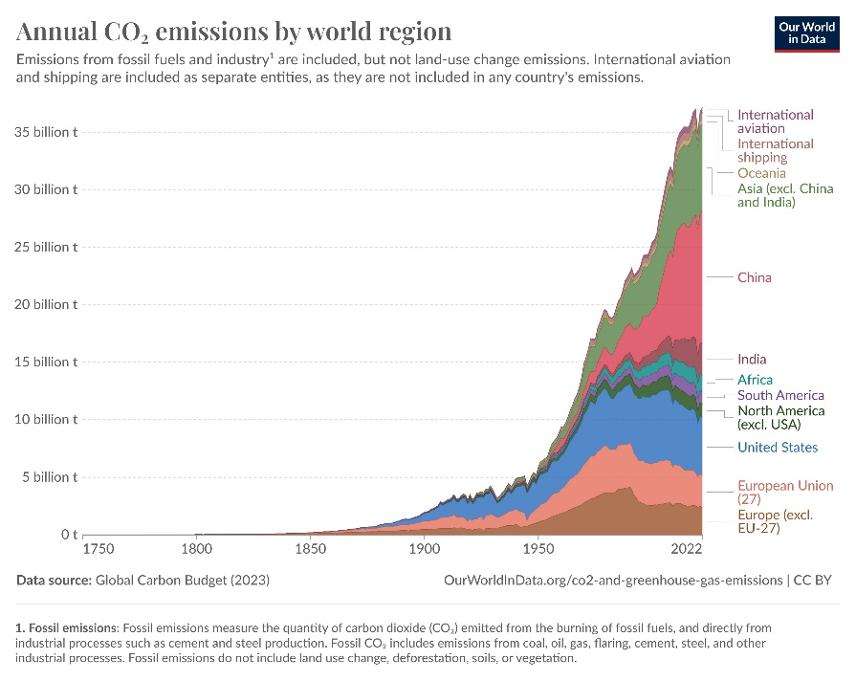

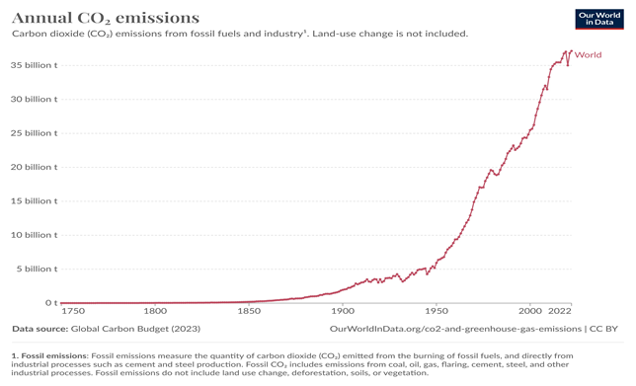
(https://ourworldindata.org/co2-emissions)

EXPLORE

Greenhouse gases, greenhouse effect

The teacher introduces the concept of:
- greenhouse gases and their importance in regulating the Earth's temperature.
- the greenhouse effect
The students work in groups and prepare information about greenhouse gases assigned by the teacher. They discuss the characteristics of each gas, including their chemical composition and sources.They are advised to use visuals and real-life examples to enhance understanding.
Then the students briefly present their findings.
It all leads to a discussion on the natural greenhouse effect and how it maintains a suitable temperature for life on Earth.

- Greenhouse gases:
They are a group of gases in the Earth's atmosphere that trap heat from the sun. They act like a thermal blanket, allowing sunlight to enter but preventing some of the heat from escaping back into space. This natural phenomenon is called the greenhouse effect.
- The Greenhouse Effect:
Let's think of the greenhouse effect like a warm hug from the atmosphere. When the sun's energy reaches the Earth, some of it is absorbed by the surface and warms the planet. The Earth then radiates heat back into space. However, greenhouse gases trap some of this outgoing heat, preventing it from escaping too quickly. This retention of heat is essential for maintaining temperatures suitable for life.
Common Greenhouse Gases:
- Carbon Dioxide (CO2) /ˌkɑː.bən daɪˈɒk.saɪd/ : the gas formed when carbon is burned, or when people or animals breathe out. A natural component of the atmosphere, but human activities, such as burning fossil fuels and deforestation, have significantly increased its concentration.
- Methane (CH4) /ˈmiːθeɪn $ ˈme-/ : produced by livestock, rice paddies/fields, and fossil fuel extraction. Methane is more effective at trapping heat than carbon dioxide, though it doesn't stay in the atmosphere as long.
- Nitrous Oxide (N2O) /ˌnaɪ.trəs ˈɒk.saɪd/: a gas with a faint sweet smell that can be breathed in with oxygen to reduce pain, for example during childbirth or medical examinations. It omes from agricultural and industrial activities, as well as the burning of fossil fuels.
- Fluorinated gases (F-gases,) are a group of synthetic gases that contain fluorine. These gases are human-made and do not have natural sources in significant quantities. They are used for various industrial applications, including as substitutes for ozone-depleting substances, refrigerants, and in the manufacturing of certain products

EXPLAIN

The impacts of greenhouse gases

Students are given a list of possible impacts of greenhouse gases on climate change and the environment. They discuss it in small groups.
- global warming
- changes in weather patterns
- melting ice and rising sea levels
- ocean acidification
- impact on ecosystems and biodiversity
- changes in agricultural productivity
- social and economic disparities
- global climate system changes, etc.

EXTEND

Title of the activity

Students prepare a poster containing basic information from the lesson. Beforehand, they agree on the key points and aspects that each poster need to contain.

EVALUATE

The students do a quiz prepared by the teacher.

