Project ID: 2021-1-CZ01-KA220-SCH-000034484
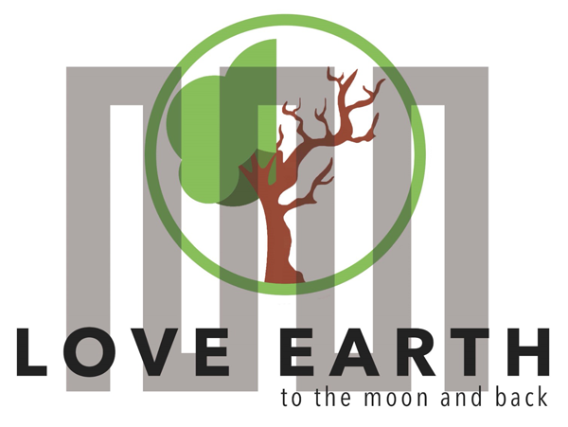

COURSE FOR ENVIRONMENTAL EDUCATION
e-Modules: Teaching Learning activities and their technology enhanced material set to develop

DISCLAIMER
Funded by the European Union. Views and opinions expressed are however those of the author(s) only and do not necessarily reflect those of the European Union or the European Education and Culture Executive Agency (EACEA). Neither the European Union nor EACEA can be held responsible for them.

COURSE AUTHORS
Anne CHIAMA, Paul FERNANDEZ, Frédéric GUILLERAY

COURSE SHARING LICENSE
You are free to:
- Share — copy and redistribute the material in any medium or format for any purpose, even commercially.
- Adapt — remix, transform, and build upon the material for any purpose, even commercially.

MODULE 1 | HUMAN AND NATURE
PART 4 | The roles of producers and consumers on the natural balance
Lesson 1 | Producers and consumers in ecosystems

SUMMARY

1. COURSE TIME, TARGET AND TOPIC 3

2. COURSE OBJECTIVES 3
Competences promoted in this lesson: 3
Lesson objectives: 3

3. LEARNING – TEACHING PROCESSES 3

4. EVALUATION 3

5. DOCUMENTS 4
ENGAGE 4
EXPLORE 5
EXPLAIN 6
EXPLAIN 10
EXTEND 12
EVALUATE 13

1. COURSE TIME, TARGET AND TOPIC
- Age of target students: 15+
- Teaching time: 1 hour
- Disciplines: Biology
- Title: Producers and consumers in ecosystems

2. COURSE OBJECTIVES

Competences promoted in this lesson:
- Communication in foreign languages competency
- Digital competency
- Learning to learn competency
- Social and citizenship-related competencies

Lesson objectives:
- The students discover the components of an ecosystem and the relationship between species in an ecosystem
- They discuss the roles of producers and consumers on natural balance.

3. LEARNING – TEACHING PROCESSES
There are 4 activities in this lesson:
- ENGAGE: Initial representation and recall
- EXPLORE: The Earth, a set of ecosystems (watch a video, if there is time, make Internet research and a short presentation)
- EXPLAIN: Ecosystems, communities of interacting living beings (work in group to complete a table)
- EXTEND: You’re an exobiologist (create an imaginary ecosystem)

4. EVALUATION
The evaluation is described in the last part of document.

5. DOCUMENTS

ENGAGE
Initial representation and recall

This moment is useful
- to bring out the students' mental models,
- and to reactivate certain notions.

1. ECOSYSTEM
Ask the students if they can define the word ecosystem and what it means.
Collect their initial representation and record it on the board.

2. TROPHIC CHAIN
Ask students if they ate sunshine this morning.
They will say no of course.
Then ask what they ate and list the main foods.
Discuss the origin of each. Most should come from plants (except for salty breakfast with eggs and bacon for example).
Then start with the plants and ask what they eat to make their matter.
Come up with the idea that they consume mineral matter (water, carbon dioxide, mineral salts) and energy from the sun. Then explain the definition of "Producer".
Then ask for animals, what they eat. The concepts of herbivore and carnivore should come out.
Come up with the idea that they consume organic (living) matter to make their own. Then explain the definition of "Consumer".
We can distinguish between Primary Consumers who feed directly on producers (called herbivores) and Secondary Consumers who feed on primary consumers (called carnivores). In an ecosystem, there can even be tertiary consumers feeding on secondary consumers.
Recall what are the decomposers: all organisms that feed on the dead matter and waste products of all other living things. It decomposes organic matter.
Finally, define a food chain or trophic chain: the set of relationships that develop between organisms based on how they feed. Includes producers (plants), primary consumers (herbivores), secondary consumers (carnivores), and decomposers.

EXPLORE
The Earth, a set of ecosystems

Q1. Watch this video explaining what is an ecosystem and what are the different types of ecosystems:
https://www.youtube.com/watch?v=H6PBtCfgcHo
(from the Youtube Channel Smile and Learn – English)

Q2. Choose an ecosystem and, with research on Internet, describe some components of its biotope and gives examples of species from its biocenosis (at least animals, plants)
• Desert
• Jungle
• Woodland
• Tundra
• Taiga
• Grassland
• Savanna
• River
• Lake
• Sea
• Ocean

EXPLAIN

Ecosystems, communities of interacting living beings

Q. For each type of relationship between organisms in a ecosystem, complete the table with:
- The good definition cut and paste the definition in the 2nd column
- The consequence for each species in a relationship neutral (0), with benefit (+) or with harm (-)
- A good example cut and paste the picture in the 5th column and explain in few word

DEFINITIONS
a symbiotic relationship where one organism benefits and one is harmed | when two or more organisms rely on the same environmental resource
a symbiotic relationship where one organism benefits and one does not benefit but is unharmed | behavior of one animal feeding on another
a symbiotic relationship where both organisms benefit

definition: www.nationalgeographic.org

EXAMPLES
Attention: one of the relations is in double... Choose only one of the two duplicate images for the corresponding relationship
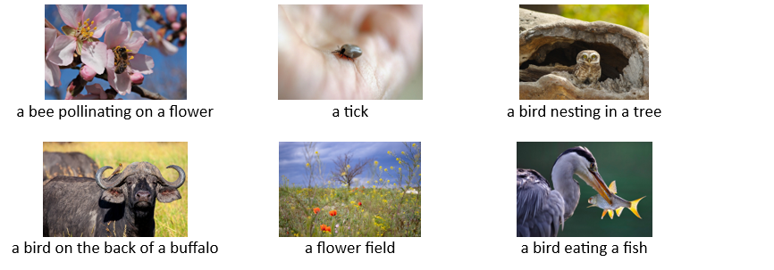picture: pixabay.com

BIOCCENOSIS INTERACTIONS
RELATIONSHIP TYPE | DEFINITION | SPECIES 1* | SPECIES 2* | EXEMPLE
Neutralism | When two or more organisms coexist without affecting each other | 0 | 0 | 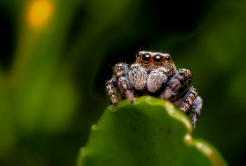  A spider and a plant have no interaction with each other
Commensalism |  |  |  | Paste a picture
Predation |  |  |  | Paste a picture
Mutualism |  |  |  | Paste a picture
Competition |  |  |  | Paste a picture
Parasitism |  |  |  | Paste a picture
* how to code the consequence for the species?

0 : indicate no effect to/on the species in this interaction -- + : indicate that this species has a benefit in this interaction - : indicate that this species is harmed in this interaction
BIOCCENOSIS INTERACTIONS (CORRECTION)
RELATIONSHIP TYPE | DEFINITION | SPECIES 1* | SPECIES 2* | EXEMPLE
Neutralism | when two or more organisms coexist without affecting each other | 0 | 0 | A spider and a plant have no interaction with each other
Commensalism | a symbiotic relationship where one organism benefits and one does not benefit but is unharmed | + | 0 | 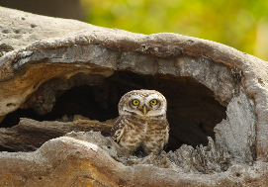  The bird benefits from nesting in the tree, but the tree gains nothing.
Predation | behavior of one animal feeding on  another | + | - | 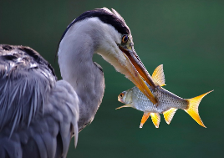  The predator feeds on the prey.
Mutualism | a symbiotic relationship where both organisms benefit | + | + | - The bee collects nectar which feeds it and the plant can reproduce.  - The bird eats the parasites on the buffalo which is thus protected.
Competition | when two or more organisms rely on the same environmental resource | - | - | 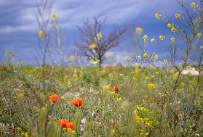  The different plants are in competition for resources : water, mineral salts.
Parasitism | a symbiotic relationship where one organism benefits and one is harmed | + | - | 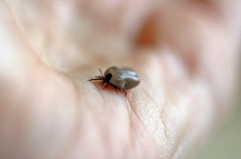  The tick is an external parasite of some animals

EXPLAIN

An ecosystem is a delicate natural balance

Q. In group, pick a card of a case study and discuss about it. To help you, you can use the reference document.
After the discussion, share with the classroom your conclusion.

REFERENCE DOCUMENT

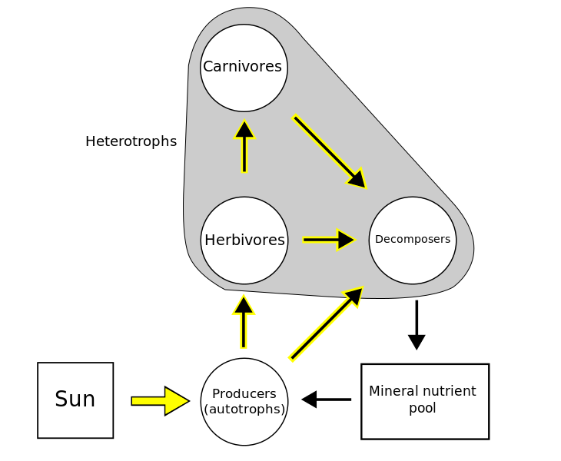
Author: User:Thompsma (original), User:Kayau (SVG), on Wikipedia – BY-SA licence

Producers: make their own matter with only mineral matter and energy of light
Consumers (herbivores/carnivores): make their own matter with the matter of other living beings
Decomposers: break down dead or decaying organisms and they make their own matter with them.

CASE STUDY
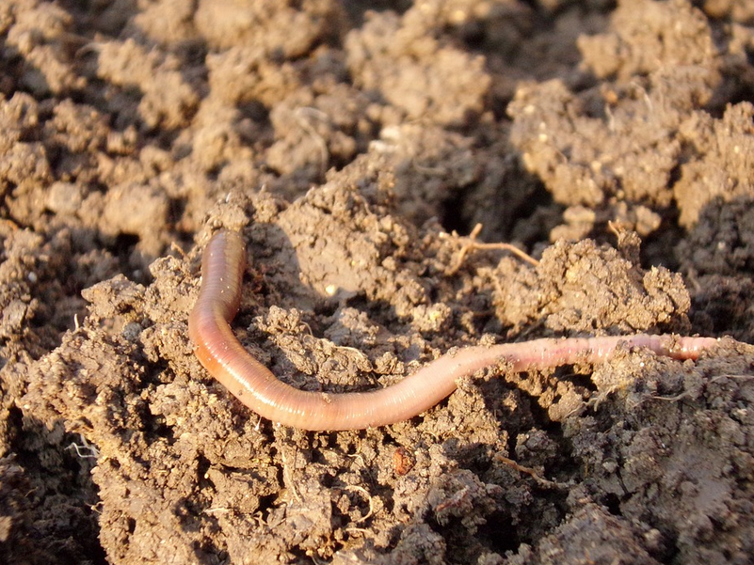
Intensive plowing in agriculture decreases the population of earthworms, which are decomposers.

What do you think is the impact on the ecosystem?
Discuss the effects on producers, on other consumers.
CASE STUDY
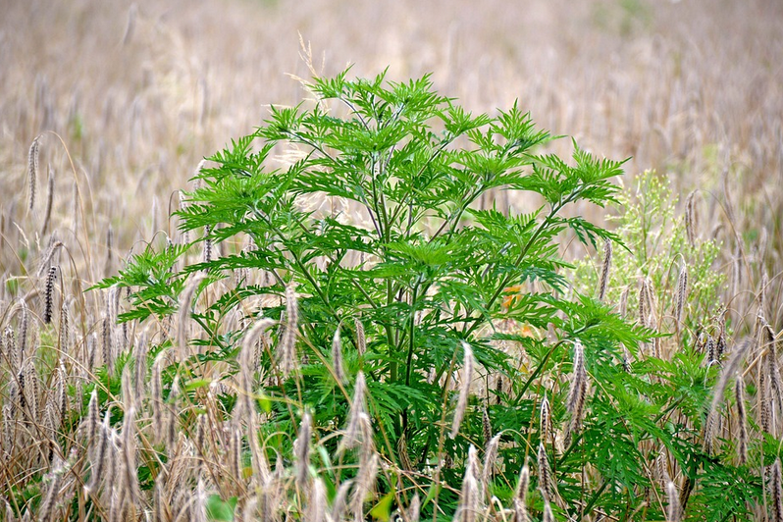
A plant species arrives in an environment and growths particularly well there. It covers more and more surface and consumes a large part of the nutrients present in the soil

What do you think is the effect on the ecosystem? Discuss the effects on the producers, on other consumers.

CASE STUDY
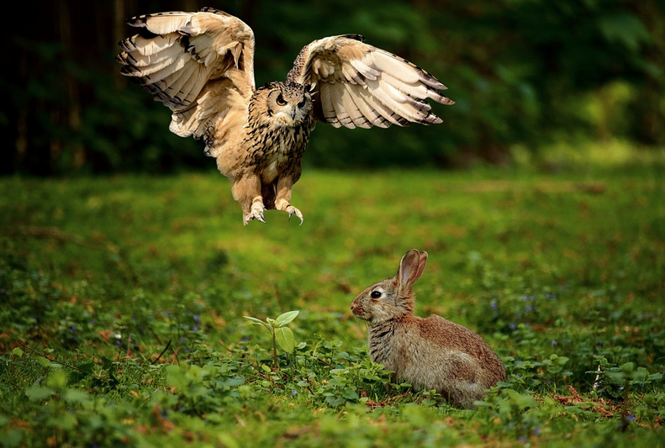
A carnivorous animal species thrives particularly well in an ecosystem.

What do you think is the effect on the ecosystem?
Discuss the effects on producers, on other consumers.

CASE STUDY
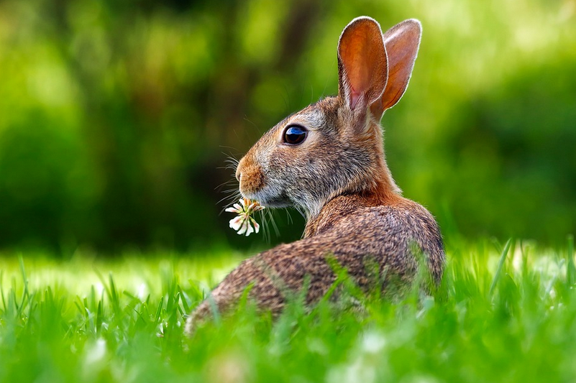
A herbivorous animal species thrives in an ecosystem.

What do you think is the effect on the ecosystem?
Discuss the effects on producers, on other consumers.

EXTEND

You’re an exobiologist

Q. In group, pick a card of a case study and discuss about it. To help you, you can use the reference document.
After the discussion
You are an exobiologist and you arrive on an unknown planet like for example the moon of Pandora (movie: Avatar).
You have to describe an ecosystem of this planet.

Your description must contain:
- a description of the biotope (example: temperature, light, pressure, gas, water, wind, climate, etc.)
- a description of the biocenosis including at least
  - somes species:
    - a producer species
    - one primary consumer species
    - a secondary consumer species
    - a tertiary consumer species
    - a decomposer species
  - interaction between species. You must also describe at least one example for each of the following relationships: mutualism, commensalism and parasitism

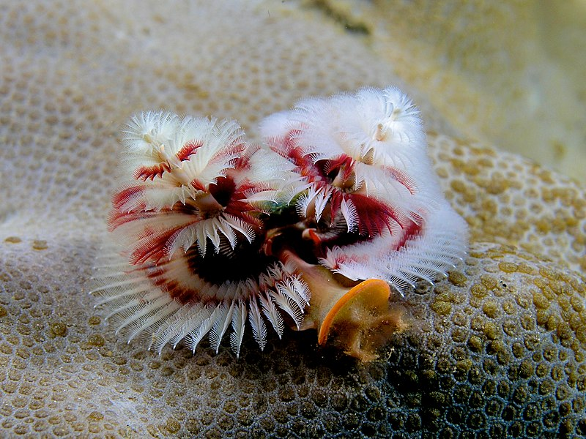
Author: Nhobgood Nick Hobgood, on Wikipedia – BY-SA licence

EVALUATE

What is an ecosystem?
□ The area or place where an organism lives in an ecosystem.
□ It is a community of organisms that live together in a particular habitat.
□ It is a community of organisms that eat other living things.
□ Is all the members of one species that live in an area of an ecosystem.

Link the name of the components of an ecosystem with its definition:
Biotope □ | □ abiotic factor (non-living factor)
 | □ living beings
Biocenosis □ | □ wheather
 | □ somes species

Organisms that can produce their own matter with mineral matter are called:
□ Biocenosis
□ Producers
□ Consumers
□ Decomposers

Organisms that can produce their own matter with organic matter (living matter) are called:
□ Biocenosis
□ Producers
□ Consumers
□ Decomposers

In the African savannah, some species of ants live in the spines of acacia trees where they defend the trees against herbivores, especially elephants. If the ants are removed, the tree is quickly defoliated and die. If the ants are transplanted to another tree, that tree is avoided by the elephants. This case is an example of:  □ Predation  □ Competition  □ Parasitism  □ Mutualism  □ Commensalism | 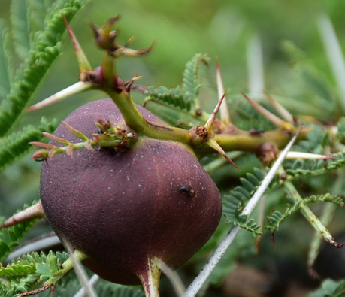

The opposite picture showing a lioness and a hyena fighting for prey is an example of:  □ Predation  □ Competition  □ Parasitism  □ Mutualism  □ Commensalism | 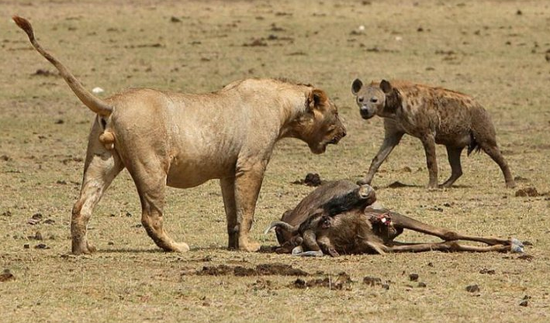

Remora are suction cup fish that can attach themselves to large shark species and feed on the remains of the shark's meals. The shark is not bothered by remora. This case is an example of:  □ Predation  □ Competition  □ Parasitism  □ Mutualism  □ Commensalism | 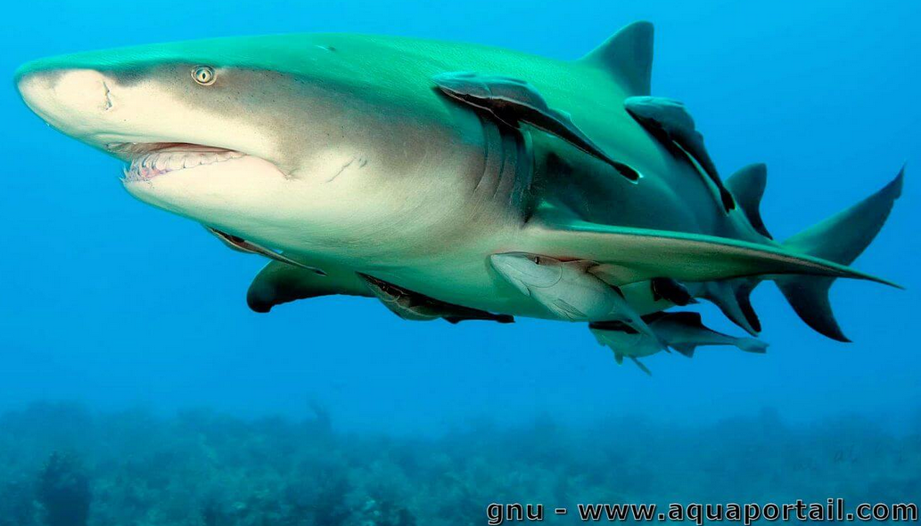

The mistletoe draws water and mineral elements from poplars, apple trees, lime trees or willows in particular that it colonizes. This case is an example of:  □ Predation  □ Competition  □ Parasitism  □ Mutualism  □ Commensalism | 