ё
Project ID: 2021-1-CZ01-KA220-SCH-000034484
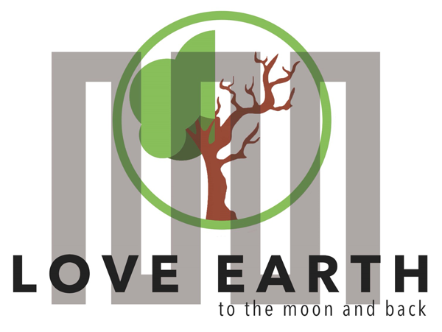

COURSE FOR ENVIRONMENTAL EDUCATION
e-Modules: Teaching Learning activities and their technology enhanced material set

DISCLAIMER
Funded by the European Union. Views and opinions expressed are however those of the author(s) only and do not necessarily reflect those of the European Union or the European Education and Culture Executive Agency (EACEA). Neither the European Union nor EACEA can be held responsible for them.
COURSE AUTHORS
Lydmila Zadorozhnya
COURSE SHARING LICENCE

You are free to:
• Share — copy and redistribute the material in any medium or format for any purpose, even commercially.
• Adapt — remix, transform, and build upon the material for any purpose, even commercially

MODULE 3 | NATURE and CLIMATE CHANGE
PART 1 | Ecological footprint.
Lesson 1-2 | How to calculate and reduce ecological footprint?

SUMMARY

1. COURSE TIME, TARGET AND TOPIC 3

2. COURSE OBJECTIVES 3
Competences promoted in this lesson: 3
Lesson objectives: 3

3. LEARNING – TEACHING PROCESSES 3

4. EVALUATION 3

5. DOCUMENTS 4
ENGAGE 4
EXPLORE 4
EXPLAIN 4
EXTEND 7
EVALUATE 7

1. COURSE TIME, TARGET AND TOPIC
- Age of target students: 15+
- Teaching time: 2 hour
- Disciplines: Geography, Human Sciences, Maths, Science, Art
- Title: How to calculate and reduce ecological footprint?

2. COURSE OBJECTIVES

Competences promoted in this lesson:
- Communication in foreign languages competency
- Digital competency
- Learning to learn competency
- Social and citizenship-related competencies

Lesson objectives:
- Students explain the ecological footprint .
- Students give examples to ecological footprint referring production- consumption.
- Students calculate and compare their ecological footprint ( using digital tools )

3. LEARNING – TEACHING PROCESSES
There are 4 activities in this lesson:
- ENGAGE: Define "carbon footprint"
- EXPLORE: Discuss the different aspects of our lives that impact the environment.
- EXPLAIN: Comprehend the global impact of individual carbon footprints.
- EXTEND: Make research and present case studies or success stories of individuals, communities, or businesses that have successfully reduced their carbon footprints. Make a class discussion on the feasibility and challenges of adopting these strategies.

4. EVALUATION
Students are asked to reflect on their own carbon footprint and propose at least one change they can make to reduce it. They are also asked to discuss their proposed changes with their families and report back on the feasibility and potential impact in the next class.
ENDING THE LESSON : Students are asked to create awareness posters or presentations for their school or community about the importance of reducing carbon footprints and practical steps to achieve this goal.

5. DOCUMENTS

ENGAGE
Students are given a discussion question. They are told to tell about climate change and its impact on the environment.
Suggestion: Make sure that students will define "carbon footprint" as the total amount of greenhouse gases, particularly carbon dioxide, that are emitted directly or indirectly by an individual, organization, event, or product.
INSTRUCTION: Answer the questions below.
- What are the impacts of climate change on the environment?
- What is carbon footprint?
- Can you share examples of activities that contribute to a person's carbon footprint (e.g., transportation, energy consumption, diet)?

EXPLORE
Students are divided into small groups. Each group is assigned a specific aspect of daily life (transportation, energy use, diet, etc.). They are told to research and list activities within their assigned category that contribute to a carbon footprint. Each group is asked to present their findings to the class, fostering a discussion on the different aspects of our lives that impact the environment.
INSTRUCTION: Each of you will study a specific aspect of daily life (transportation, energy use, diet, etc.). While making research, list activities within your assigned category that contribute to a carbon footprint. Present your findings to the class, fostering a discussion on the different aspects of our lives that impact the environment.

EXPLAIN
Students are given a text on carbon footprint and introduced online carbon footprint calculators. They are instructed to calculate their individual carbon footprints based on their daily activities. They are asked to discuss the results as a class, highlighting the activities that contribute the most to their carbon footprints.
Calculate flight emissions – flight CO2 calculator | myclimate
Carbon Footprint Factsheet | Center for Sustainable Systems (umich.edu)
Suggestion: Make sure that students will comprehend the global impact of individual carbon footprints.
INSTRUCTION: Visit the website and use online carbon footprint calculators. Calculate your individual carbon footprints based on your daily activities. Discuss the results as a class, highlighting the activities that contribute the most to their carbon footprints

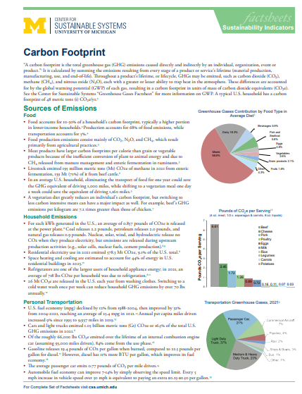

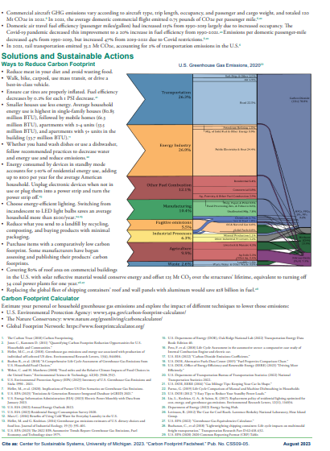

EXTEND
Students are asked to discuss various strategies and lifestyle changes that can help reduce carbon footprints (e.g., using public transportation, energy-efficient appliances, plant-based diets). They are asked to make research and present case studies or success stories of individuals, communities, or businesses that have successfully reduced their carbon footprints.They are told to have a class discussion on the feasibility and challenges of adopting these strategies.
INSTRUCTION : Discuss various strategies and lifestyle changes that can help reduce carbon footprints (e.g., using public transportation, energy-efficient appliances, plant-based diets). Make research and present case studies or success stories of individuals, communities, or businesses that have successfully reduced their carbon footprints. Make a class discussion on the feasibility and challenges of adopting these strategies.

EVALUATE
Students are asked to reflect on their own carbon footprint and propose at least one change they can make to reduce it. They are encouraged to discuss their proposed changes with their families and report back on the feasibility and potential impact in the next class.
INSTRUCTION : Reflect on your own carbon footprint and propose at least one change you can make to reduce it. Discuss your proposed changes with your families and report back on the feasibility and potential impact in the next class.
ENDING THE LESSON : Students are asked to create awareness posters or presentations for their school or community about the importance of reducing carbon footprints and practical steps to achieve this goal.

