Unit 2. Analysing and interpreting evidence-based data to inform teaching and learning (MONITORING / PERFORMANCE / TEACHING AND LEARNING PHASE)
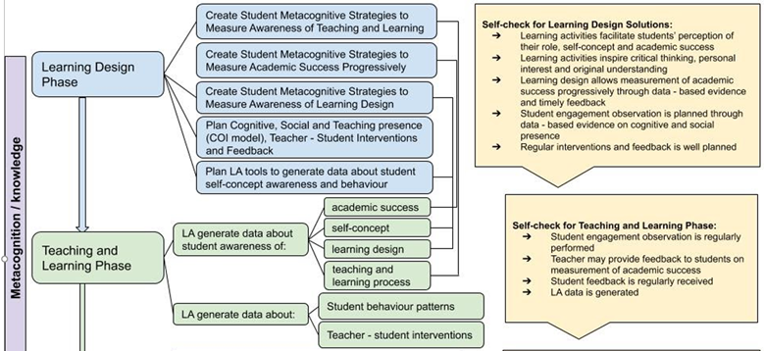
Figure 1. Learning Analytics as a Metacognitive Tool to Enhance Student Academic Success (Volungeviciene et al., 2021, p.175)
INTRODUCTION
According to the DigCompEdu Framework (Punie & Redecker, 2017), evidence analysis is a part of the assessment competence and means to generate, select, critically analyse and interpret digital evidence on learner activity, performance and progress in order to inform teaching and learning.
By applying learning analytics to look at the evidence, teachers can adjust and adapt the curriculum to address learners’ needs and abilities. Analytics are also useful for teachers to plan the readjustment of content and strategies during the course according to students' needs and making their learning process and interventions more personalised.
Learning analytics provide valuable information and insights not only for teachers but also for students. In fact, they raise awareness of learners’ cognitive skills and a stronger sense of community (Trespalacios & Perkins, 2016), fostering more active learners’ engagement. As Sclater et. al. (2016) mention, there are different ways to analyse and interpret evidence, such as the development of predictive models (see conceptual introduction), social network analysis, showing pattern interactions in discussion forums (Holmes et al., 2019), and the personalization of learning, by guiding learners in their learning pathway with recommendations and indications about their progress.
In relation to the third aspect, personalization of learning, learning design solutions are not consistent and sequential for all students. Rather, teaching is focusing on a broad topic that covers a lot of different resources and learners’ behaviour patterns are different from each other.
Important! In the interests of transparency, it is important that students know from the very first lecture that the teacher can access and monitor the data related to their engagement in the virtual learning environment. It is also important to inform them what data is accessed, analysed, what it is used for and how data protection is ensured.
Topics
2.1. How to analyse and interpret available evidence on learner activity and progress to support engagement?
2.2. How to make data-informed teaching and learning interventions through reports ?
Outcomes
- To use digital technologies to provide targeted and timely feedback to learners.
- To adapt teaching strategies and to provide targeted support, based on the evidence generated by the digital technologies used.
- To generate, select, critically analyse and interpret digital evidence on learner activity, performance and progress, in order to inform teaching and learning.
- To use digital technologies to enable learners to reflect on and self-assess their learning process.

DEFINITIONS (Glossary tool)
Learning progression: Learning progress describes increasing levels of difficulty and complexity in the acquisition of knowledge , skills and attitudes in a given domain. Teachers have to be able to identify when and how to intervene to move students’ learning forward. Learner performance: A measure of how well students are learning in terms of knowledge and skills development.
STRATEGIES AND RECOMMENDATIONS ON HOW TO ANALYSE AND INTERPRET EVIDENCE
- Pedagogical point of view:
  - Consider and decide what data on learners’ behaviour and learning process and progress is important for you to analyse;
  - Decide which data is important to be analysed during the semester and which one at the end of semester/learning period;
  - Inform students on what is generated and monitored and analysed by you and which data they can analyse themselves;
  - Analyse learners' activity reports that demonstrate how many times each learning resource or activity has been accessed by learners. This may help to understand and learn about students’ learning styles and preferred formats of learning resources;
  - Reflect on what changes should be made regarding learning design, learning material, activities, assignments or assessment strategies based on digital evidence;
  - Provide feedback to students on their learning progress.

- Technical point of view:
  - Set-up and plan activities and assignments that would help to collect the data wanted;
  - Integrate VLE-supported or external digital tools that foster learners active participation (e.g., Moodle Mind-map, Mentimeter, Padlet, Jamboard, Google Docs);
  - Use digital tools to provide oral or written feedback to students.

MATERIALS FOR FURTHER READING (OPTIONAL)
Bodily, R., & Verbert, K. (2017). Review of research on student-facing learning analytics dashboards and educational recommender systems. IEEE Transactions on Learning Technologies, 10(4), 405-418. DOI: 10.1109/TLT.2017.2740172
Charleer, S., Moere, A. V., Klerkx, J., Verbert, K., & De Laet, T. (2017). Learning analytics dashboards to support adviser-student dialogue. IEEE Transactions on Learning Technologies, 11(3), 389-399. DOI: 10.1109/TLT.2017.2720670
Emplit, P. and Zhang, T. (2020). Evidence-based approaches to learning and teaching, Learning and Teaching Paper #11, Thematic peer group report, EUA. https://eua.eu/downloads/publications/eua%20report%20evidence-based%20approaches_web.pdf f
Er, E., Dimitriadis, Y. & Gasevic, D. (2021). Collaborative peer feedback and learning analytics: theory oriented design for supporting class-wide interventions, ASSESSMENT & EVALUATION IN HIGHER EDUCATION, VOL. 46, NO. 2, 169–190 https://doi.org/10.1080/02602938.2020.1764490
Holmes, W., Nguyen, Q., Zhang, J., Mavrikis, M., & Rienties, B. (2019). Learning analytics for learning design in online distance learning, Distance Education, https://doi.org/10.1080/01587919.2019.1637716

Kitto, K., & Knight, S. (2019). Practical ethics for building learning analytics. British Journal of Educational Technology, 50(6), 2855-2870. https://doi.org/10.1111/bjet.12868
Matcha, W., Gašević, D., & Pardo, A. (2019). A systematic review of empirical studies on learning analytics dashboards: A self-regulated learning perspective. IEEE Transactions on Learning Technologies, 13(2), 226-245. DOI: 10.1109/TLT.2019.2916802
Punie, Y., editor(s), Redecker, C., European Framework for the Digital Competence of Educators: DigCompEdu , EUR 28775 EN, Publications Office of the European Union, Luxembourg, 2017. Retrieved from: https://op.europa.eu/en/publication-detail/-/publication/fcc33b68-d581-11e7-a5b9-01aa75ed71a1/language-en Schumacher, C., & Ifenthaler, D. (2018). Features students really expect from learning analytics. Computers in human behavior, 78, 397-407.
Sclater, N., Peasgood, A., and Mullan, J. (2016). Learning Analytics in Higher Education. Bristol: JISC.
Sedrakyan, G., Malmberg, J., Verbert, K., Järvelä, S., & Kirschner, P. A. (2020). Linking learning behavior analytics and learning science concepts: Designing a learning analytics dashboard for feedback to support learning regulation. Computers in Human Behavior, 107, 105512.
https://doi.org/10.1016/j.chb.2018.05.004
Silvola, A., Näykki, P., Kaveri, A., & Muukkonen, H. (2021). Expectations for supporting student engagement with learning analytics: An academic path perspective. Computers & Education, 168, 104192. https://doi.org/10.1016/j.compedu.2021.104192
Trespalacios, J., & Perkins, R. (2016). Sense of community, perceived learning, and achievement relationships in an online graduate course. Turkish Online Journal of Distance Education, 17(3), 31–49. DOI:10.17718/tojde.12984 Volungevičienė, A. (2021). Data Analysis of Case Study Examples. In Learning Analytics: a Metacognitive Tool to Engage Students (pp. 73-170). Sciendo. https://doi.org/10.2478/9788366675643-005. https://www.sciendo.com/pl/chapter/9788366675643/10.2478/9788366675643-005

