Project ID: 2021-1-CZ01-KA220-SCH-000034484

COURSE FOR ENVIRONMENTAL EDUCATION
e-Modules: Teaching Learning activities and their technology enhanced material set to develop

DISCLAIMER
Funded by the European Union. Views and opinions expressed are however those of the author(s) only and do not necessarily reflect those of the European Union or the European Education and Culture Executive Agency (EACEA). Neither the European Union nor EACEA can be held responsible for them.

COURSE AUTHORS
Céline CORNEILLE, Paul FERNANDEZ, Frédéric GUILLERAY, Marine ROBINI and Ervan ROUSSEL.

COURSE SHARING LICENSE
You are free to:
- Share — copy and redistribute the material in any medium or format for any purpose, even commercially.
- Adapt — remix, transform, and build upon the material for any purpose, even commercially.

MODULE 3 | NATURE AND CLIMATE CHANGE
PART 3 | Greenhouse effect
Lesson 2 | Radiation balance and radiative forcing

SUMMARY

1. COURSE TIME, TARGET AND TOPIC 3

2. COURSE OBJECTIVES 3
Competences promoted in this lesson: 3
Lesson objectives: 3

3. LEARNING – TEACHING PROCESSES 3

4. EVALUATION 3

5. DOCUMENTS 4
ENGAGE 4
EXPLORE 7
EXPLAIN 9
EXTEND 10
EVALUATE 11

1. COURSE TIME, TARGET AND TOPIC
- Age of target students: 15+
- Teaching time: 2 hours
- Disciplines: Biology
- Title: Radiation balance and radiative forcing

2. COURSE OBJECTIVES

Competences promoted in this lesson:
- Communication in foreign languages competency
- Digital competency
- Learning to learn competency
- Social and citizenship-related competencies

Lesson objectives:
- Students explain radiation balance of the earth and radiative forcing.

3. LEARNING – TEACHING PROCESSES
There are 4 activities in this lesson:
- ENGAGE: Why does the Earth’s temperature remain stable? (calculate and discussion)
- EXPLORE: The two faces of radiative forcing (read and make a diagram)
- EXPLAIN: Pick a card of radiative forcing factors (discussion and explanation)
- EXTEND: A technological project based on aerosols (Internet research and presentation)

4. EVALUATION
The evaluation is described in the last part of document.

5. DOCUMENTS

ENGAGE
Why does the Earth’s temperature remain stable?
The pictures of Engage part are from National Oceanic and Atmospheric Administration
https://www.noaa.gov/jetstream/atmosphere/energy

This moment is useful:
- to understand the radiation balance.

Q1. Ask the following question to the students:
Why is Earth's temperature relatively stable, despite receiving energy from the Sun?

Q2. Then, present the picture below and ask them to compare the incoming energy from the sun At the top of the atmosphere with the outgoing energy from the Earth.
Using 100 units of energy from the sun as a baseline the energy balance is as follows:
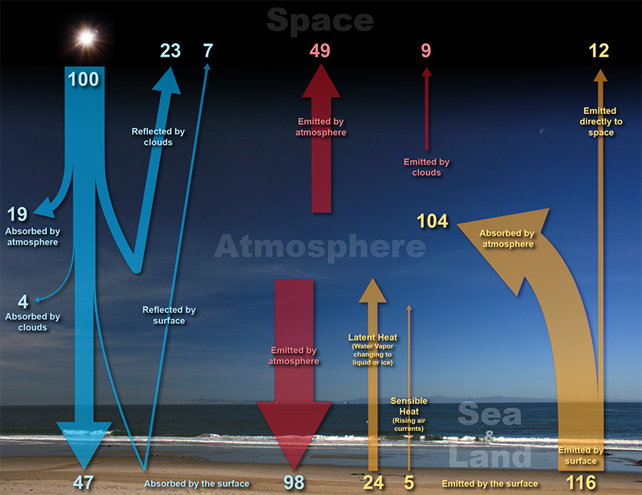

If you want, you can ask the same question for the atmosphere itself and for the Earth’s surface.

Answer:
At the top of the atmosphere - Incoming energy from the sun is balanced with outgoing energy from the Earth.
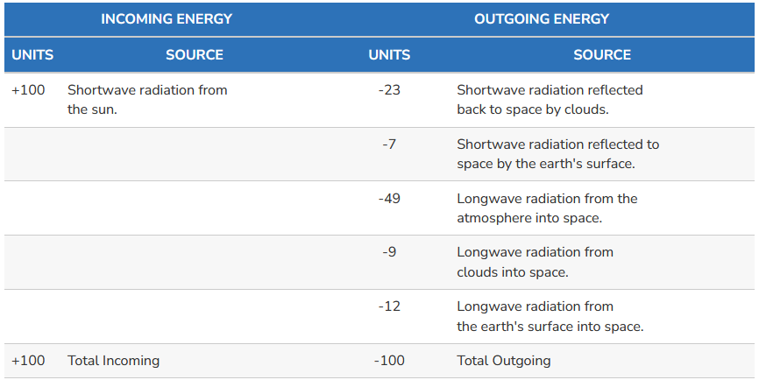

The atmosphere itself - Energy into the atmosphere is balanced with outgoing energy from atmosphere.
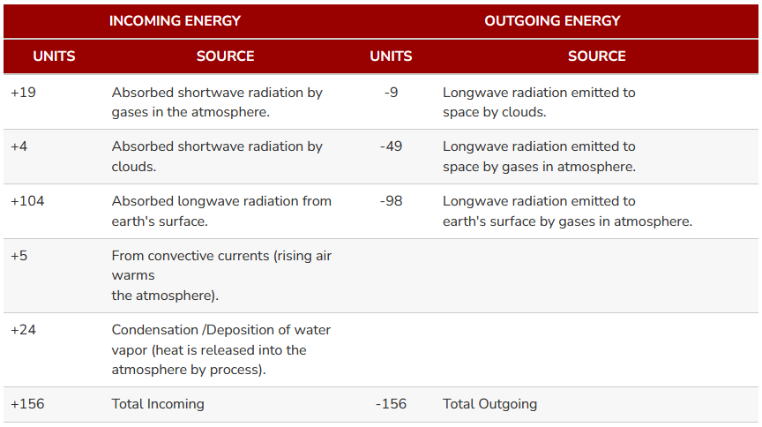

At the Earth's surface - Energy absorbed is balanced with the energy released.
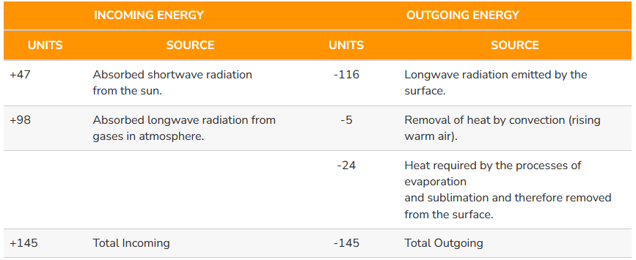

Conclusion:
The earth-atmosphere energy balance is the balance between incoming energy from the Sun and outgoing energy from the Earth. Energy released from the Sun is emitted as shortwave light and ultraviolet energy. When it reaches the Earth, some is reflected back to space by clouds, some is absorbed by the atmosphere, and some is absorbed at the Earth's surface.
The earth-atmosphere energy balance is achieved as the energy received from the Sun balances the energy lost by the Earth back into space. In this way, the Earth maintains a stable average temperature and therefore a stable climate.

EXPLORE
The two faces of radiative forcing

Q1. Read the document explaining the radiative forcing.
Document: The two faces of radiative forcing
A variety of physical and chemical changes can affect the global energy balance and force changes in the Earth’s climate. Some of these changes are natural, while others are influenced by humans. These changes are measured by the amount of warming or cooling they can produce, which is called “radiative forcing.” Changes that have a warming effect are called “positive” forcing, while changes that have a cooling effect are called “negative” forcing. When positive and negative forces are out of balance, the result is a change in the Earth’s average surface temperature.
Radiative forcing is the change in energy flux in the atmosphere caused by natural or anthropogenic factors of climate change.
The Earth’s energy balance (EEB) is calculated as follows: Incoming Solar energy (ISE) – Outgoing Infrared Energy (OIE).
EEB = ISE – OLE

If Earth's incoming energy flux is larger than the outgoing energy (EEB > 0), then the planet will gain net heat energy and it will warm up. This is positive radiative forcing.
If Earth's incoming energy flux is smaller than the outgoing energy (EEB < 0), then the planet will lose net heat energy and it will cool down. This is negative radiative forcing.

Text from the Unitd states Environmental Protection Agency
https://www.epa.gov/climate-indicators/climate-change-indicators-climate-forcing

Q2. Instructions:
- Working in groups, students draw a balanced and an unbalanced energy balance diagram of the Earth.
- The imbalance must be a positive or negative radiative forcing.
- Students are asked to explain their representation.

Possible answer:
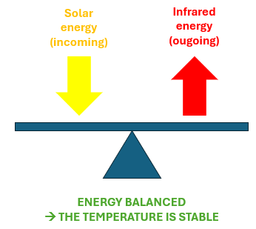

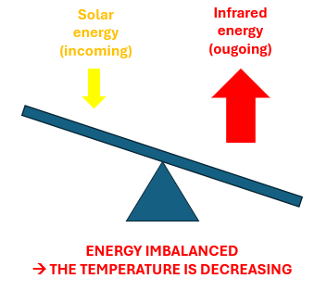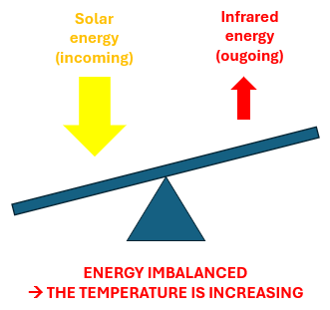

EXPLAIN
Pick a card of radiative forcing factors

Q1. Instructions:
- Divide the students into groups.
- Distribute the 6 cards below.
- Students must classify the factors written on each card into two categories:
- those that lead to positive radiative forcing
- those that lead to negative radiative forcing
Each group then presents its classification and justifies its choices.

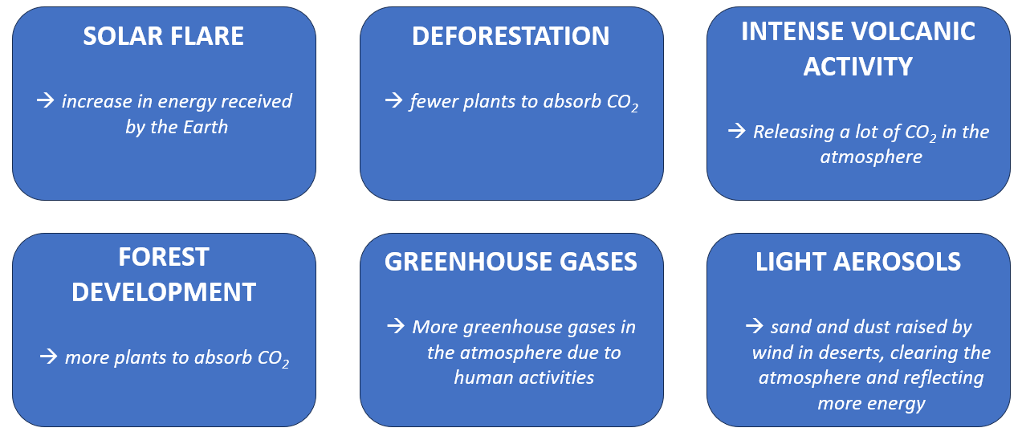

Answer:
Factors causing a negative radiative forcing | Factors causing a positive radiative forcing
- Forest development  - Light aerosols in the atmosphere | - Solar flare  - Deforestation  - Intense volcanic activity  - Greenhouse gases

Q2. Conclude on the impact of human activity on radiative forcing
Answer:
Human activity is causing positive radiative forcing, notably through the production of greenhouse gases and deforestation. This radiative forcing leads to global warming.

EXTEND
A technological project based on aerosols

The picture below shows how high-altitude balloons can be used to inject some light aerosols in the atmosphere.
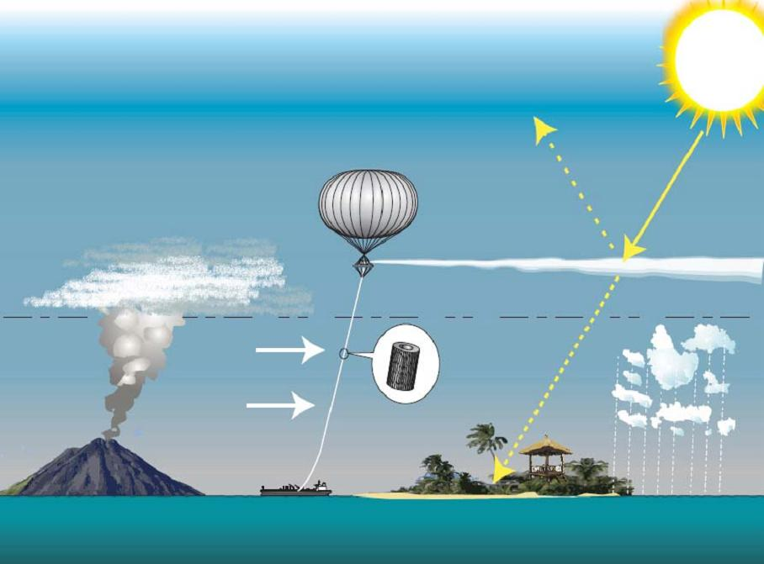
Image author : Hughhunt, shared on Wikipedia, with BY-AC creative common licence
Instructions:
- Make a Internet research about aerosols injection into the atmosphere as a technological solution to reduce global warming.
- Present the project and how it can reduce global warming.

EVALUATE

Q1. What is radiative forcing?
a) The process of radiation escaping Earth's atmosphere
b) The imbalance between incoming and outgoing radiation in the Earth's atmosphere
c) The absorption of solar radiation by the Earth's surface
Answer: b

Q2. Which of the following contributes to negative radiative forcing?
a) Increased concentrations of greenhouse gases
b) Expansion of forested areas
c) Eruption of a volcano
Answer: b

Q3. What is a primary cause of positive radiative forcing?
a) Deforestation
b) Increased reflective aerosols
c) Higher concentrations of greenhouse gases
Answer: c

Q4. In the Earth's energy balance, what is the primary source of energy for the planet?
a) Geothermal energy
b) Solar radiation
c) Nuclear energy
Answer: b

Q5. How can volcanic eruptions influence Earth's energy balance?
a) They contribute to negative radiative forcing
b) They release greenhouse gases, contributing to positive radiative forcing
c) They temporarily reflect sunlight, causing cooling
Answer: b

Q6. Which of the following is an example of an anthropogenic activity that contributes to positive radiative forcing?
a) Burning fossil fuels
b) Reforestation
c) Ozone depletion
Answer: a

Q7. What role does the greenhouse effect play in the Earth's energy balance?
a) It enhances the cooling of the Earth's surface
b) It increases the absorption of solar radiation
c) It traps heat in the atmosphere, warming the Earth's surface
Answer: c

