Project ID: 2021-1-CZ01-KA220-SCH-000034484

COURSE FOR ENVIRONMENTAL EDUCATION
e-Modules: Teaching Learning activities and their technology enhanced material set to develop

DISCLAIMER
Funded by the European Union. Views and opinions expressed are however those of the author(s) only and do not necessarily reflect those of the European Union or the European Education and Culture Executive Agency (EACEA). Neither the European Union nor EACEA can be held responsible for them.

COURSE AUTHORS
©ACD Team Austria: Dr. Geraldine Fitoussi-Hoffmann (GFH)

COURSE SHARING LICENSE
You are free to:
- Share — copy and redistribute the material in any medium or format
- The licensor cannot revoke these freedoms as long as you follow the license terms.
Canonical URL
https://creativecommons.org/licenses/by-nc-nd/4.0/

MODULE 1 | HUMAN AND NATURE
PART 3 | Environmental Ethics & Dilemmas
Lesson 1 | Awareness of the dilemmas of human activities through space images

SUMMARY

1. COURSE TIME, TARGET AND TOPIC 3

2. COURSE OBJECTIVES 3
Competences promoted in this lesson: 3
Lesson objectives: 3

3. LEARNING – TEACHING PROCESSES 3

4. EVALUATION 3

5. DOCUMENTS 4
ENGAGE 4
EXPLORE 5
EXPLAIN 6
EXTEND 7
EVALUATE 8

1. COURSE TIME, TARGET AND TOPIC
- Age of target students: 15+
- Teaching time: 15 minutes
- Disciplines: space education, environmental ethics
- Title: Awareness of the dilemmas of human activities through space images

2. COURSE OBJECTIVES

Competences promoted in this lesson:
- Communication in foreign languages competency
- Social and citizenship-related competencies
- anticipatory (future thinking) competence; normative competence;
- critical thinking competency

Lesson objectives:
Awareness of the dilemmas of human activities through space images. Example-exercise: The Aral Sea seen by satellite. Left in 2006, right in 2009 (Images Credits GeoVille Information Systems)

3. LEARNING – TEACHING PROCESSES
There are 4 activities in this lesson:
- ENGAGE: Initial representation and recall : Brief introductory to the Space Environment

- EXPLORE: watch videos and read articles about environmental ethics in space
- EXPLAIN: A human-induced natural disaster: the water that fed the lake was diverted for cotton cultivation:
- EXTEND: To go further, look for examples using satellite images (Space Images Search: www.esa.int) of changes in the size of forests and large cities and think about the economic, ecological, and human consequences.

4. EVALUATION
The evaluation is described in the last part of document.

5. DOCUMENTS

ENGAGE

KARIFilm contribution: Joint crossover Environmental and Space Education

Awareness of the dilemmas of human activities through space images. Example-exercise: The Aral Sea seen by satellite. Left in 2006, right in 2009 (Images Credits GeoVille Information Systems)

Duration: 15 min
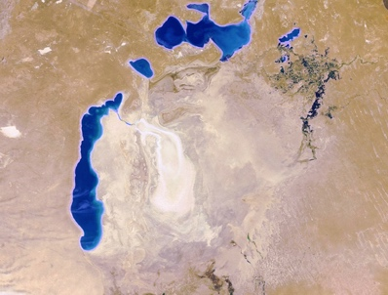
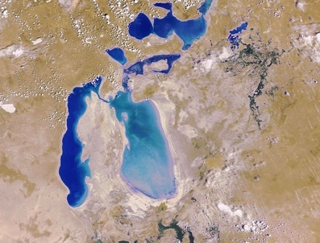
A human-induced natural disaster: the water that fed the lake was diverted for cotton cultivation. The size of the lake has been considerably reduced. The consequences: disappearance of fish and birds, loss of economic activity for fishermen and inhabitants, displacement of the population, health problems linked to the polluted desert.

- Observe the two images and see the changes
- Reflect on the choices made. Understand the impacts. What do we understand from these images?
We understand that water resources are not inexhaustible, and we reflect on the economic benefits of cotton crops / disastrous ecological, human, and economic consequences.

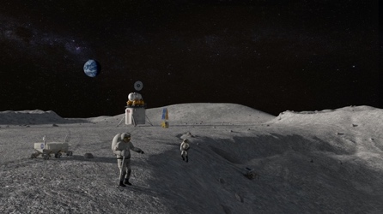
EXPLAIN

- Space exploration and its benefits: Is it ethical to go to the Moon to get water?

Is it ethical to send people into space?
to build a lunar base as a training ground for going to Mars? @NASA

Reflect on this question considering that space techniques are a source of technological innovations that have an
impact on sustainable ecological practices, that the costs are huge, that the problems in the world are also huge.

EXTEND
We understand that water resources are not inexhaustible, and we reflect on the economic benefits of cotton crops / disastrous ecological, human, and economic consequences.
- To go further, look for examples using satellite images (Space Images Search: www.esa.int) of changes in the size of forests and large cities and think about the economic, ecological, and human consequences.
https://www.esa.int/Education/Teachers_Corner/European_Space_Education_Resource_Office
https://www.nasa.gov/missions/station/inspiring-youth-with-science-in-space/
Dr. Geraldine Fitoussi-Hoffmann enterprise KariFilm https://www.karifilm.media

EVALUATE

Create an online quiz, extend questions from this lesson part with further insights connected with environmental ethics in space
https://www.canva.com/create/quizzes/
Create a role play, relating to the topic of environmental ethics in space environment.
Refer to challenges briefly introduced in this lesson part. Extend with your additional observations, include the topic in some of your seminar works
Reflect on what you could learn from this brief introduction about ethics in space environment, create a MindMap while using the key terms and include the UN SDG which relate3s to the topic
https://quiz.sdgzone.com/

ACD-Agency for Cultural Diplomacy association Spaces academy https://www.acdvienna.org/sdg-learning/parlamint-planetarythinking/ partner Dr. Geraldine Fitoussi-Hoffmann with her enterprise KariFilm https://www.karifilm.media

