Project ID: 2021-1-CZ01-KA220-SCH-000034484

COURSE FOR ENVIRONMENTAL EDUCATION
e-Modules: Teaching Learning activities and their technology enhanced material set to develop

Thematic Units for Week-Long Workshop Sessions:

M1, Part 2: Environmental Ethics & Dilemmas

COURSE AUTHOR:
Mag.Tamara Tomašević (T.T)
©ACD Team Austria

DISCLAIMER
Funded by the European Union. Views and opinions expressed are however those of the author(s) only and do not necessarily reflect those of the European Union or the European Education and Culture Executive Agency (EACEA). Neither the European Union nor EACEA can be held responsible for them.
COURSE SHARING LICENSE CC BY-NC-SA =
Canonical URL: https://creativecommons.org/licenses/by-nc-nd/4.0/

MODULE: 1

LESSON: Environmental Ethics & Dilemmas

1. COURSE TIME, TARGET AND TOPIC
- Age of target students: 15+
- Teaching time: 10+ min introductory part + 20+ min scenario play
- Disciplines: Psychology, Environmental Ethics, English, …
- Title: Environmental Ethics & Dilemmas

2. COURSE OBJECTIVES

Competences promoted in this lesson:
- Communication in foreign languages competency
- Social and citizenship-related competencies
- anticipatory (future thinking) competence; normative competence;
- interpersonal competence, collaboration competency;
- critical thinking competency
- self-awareness competency; integrated problem-solving competency;
- Ethics & Integrity

Lesson objectives:
Discussing behaviours that adversely affect the natural balance through environmental ethics
Understanding and commenting on behaviours that will adversely affect the natural balance in the context of environmental ethics

3. LEARNING – TEACHING PROCESSES
There are 4 activities in this lesson:
- ENGAGE: Initial representation and recall: Brief introductory to Environmental ethics & ethical dilemmas

- EXPLORE: Reflect on current environmental issues in your school/classroom, make note using the key
terms, research in web and social media if any blog articles, concerns, comments on topics
you noticed as important.

- EXPLAIN: Make interviews with your schoolmates, discuss with teachers, about the issues you find important to be maintained

- EXTEND: Draw your idea, share with your classmates and teachers, invite them to co-design the action, create a poster / mind map

4. EVALUATION
The evaluation is described in the last part of document.

ENGAGE
Brief introductory to Environmental ethics
Environmental ethics (author: Mag. Tamara Tomašević TT) Duration: 30 min. or longer by need
Guiding intro
Guiding exercise on decentration with 9 dots
Objective
This is a classic exercise used by trainers to demonstrate how pre-existing ways of thinking can prevent us from seeing new ways of doing things. It can be substituted for a longer warm-up exercise when time is a factor or can be used at any time during this or other training units to encourage creative thinking.
Time required: 15 minutes
If you want to have different results, you need to include different thoughts.
Process
Display on newsprint the pattern of nine dots as shown below. Ask participants to reproduce the pattern on a sheet of their own paper. Give them the task of connecting all nine of the dots by drawing four straight, continuous lines without lifting their pencils or retracing a line.

• • •
• • •
• • •

Solution:?
Source:
https://www.nzdl.org/cgi-bin/library?e=d-00000-00---off-0hdl--00-0----0-10-0---0---0direct-10---4-------0-0l--11-en-50---20-about---00-0-1-00-0--4----0-0-11-10-0utfZz-8-00&cl=CL1.3&d=HASH01d2eeec7eeb46909f2b938e.5.2&gt=1

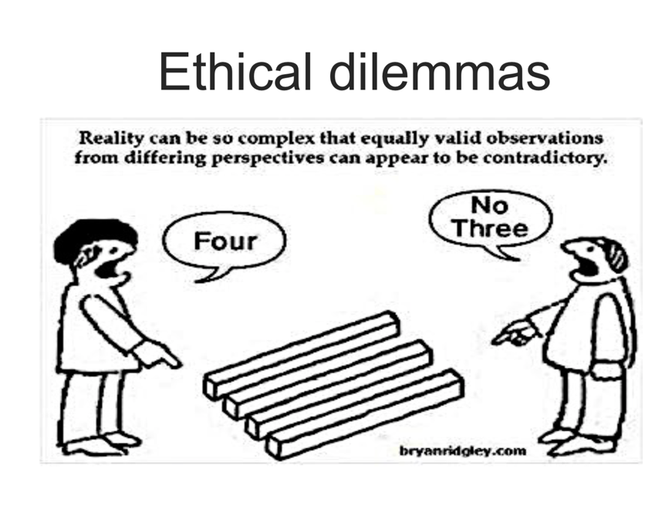

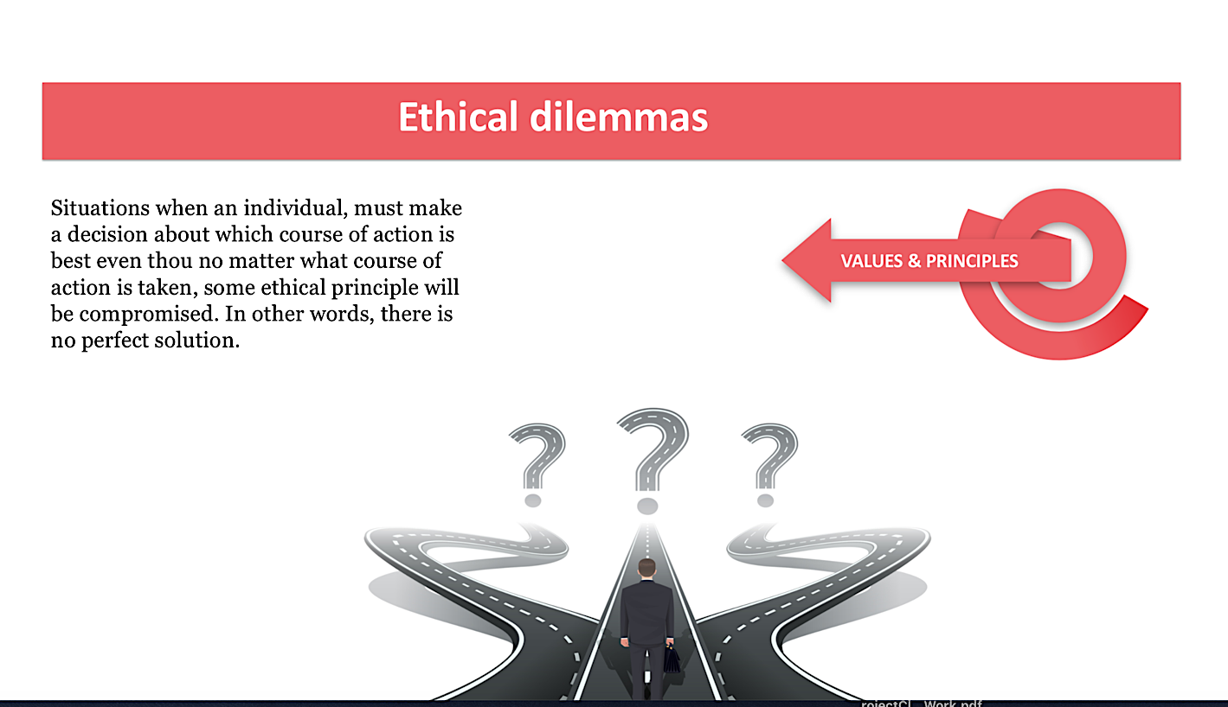

Core pillars in decision making process

What affects our process of thinking when we have to make a choice?
- Ethical principles-prepositional statements (standards) that are used to determine what the right course of action in a situation is. They rely on logical and rational criteria to reach a decision, an essentially cognitive process.
- Values- describe ideas that we value or prize
- Morals-describe a behavioral code of conduct to which an individual ascribes. They are used to negotiate, support, and strengthen our relationships with others
- Laws and policies, codes of conduct- make people legally, or ethically, as a member of institution, obligated to take a particular course of action.

Ethical competences:
- Competence for recognizing ethical dimension of the problem-naming things
- Competence for ethical reasoning
- Competence for ethical decision making

Ethical Codes and Codes of conduct can also guide us from the perspective of our professional (institutiona role). They define our duties related to our work or to our satus in institution, but also relation in between all that are part of the same institution or profession.
They can help us in choosing the course of the action.
School have their on Codes of conduct, and values that might be compromised in practice should be recognized and defined by suggested way of behaving in risk situation /ethical dilemmas.

Ralf Potters box, for ethical reasoning and decision-making process in three steps

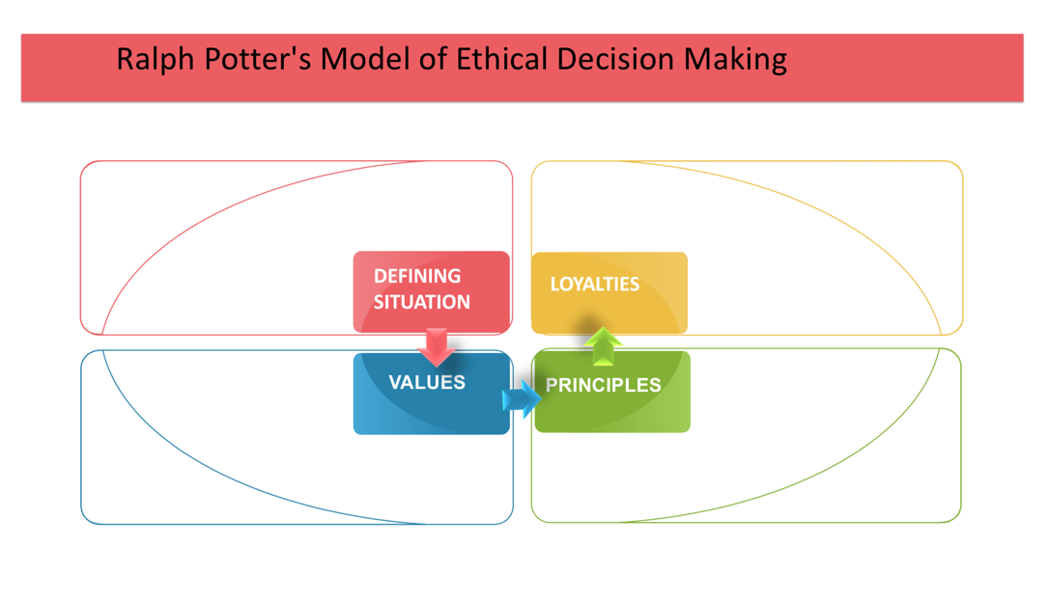

EXPLORE
Ralf Potters box, for ethical reasoning and decision-making process in three steps

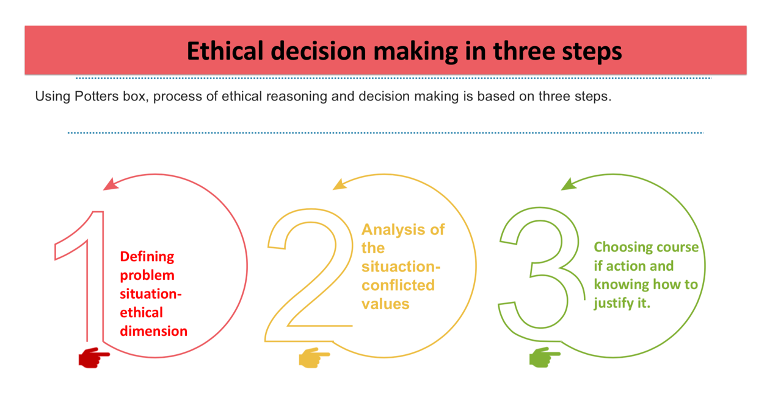
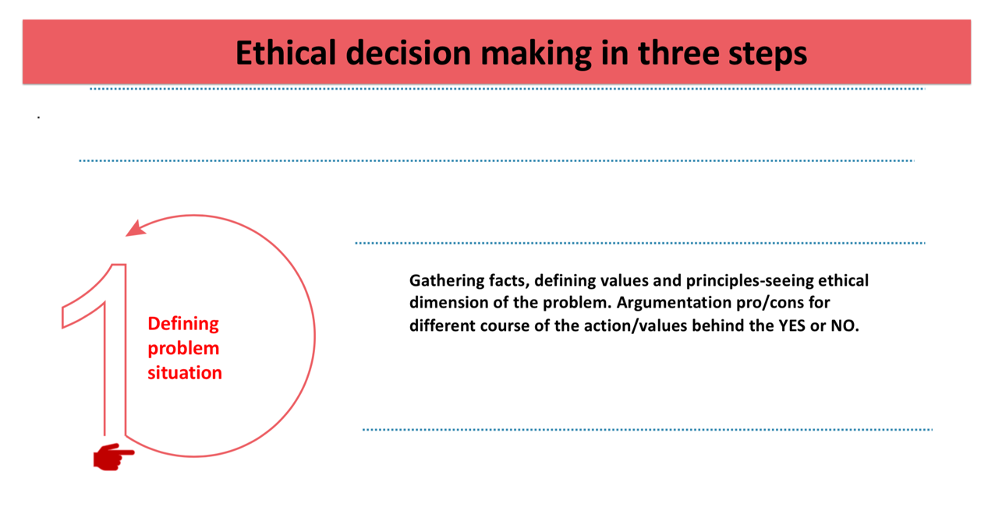
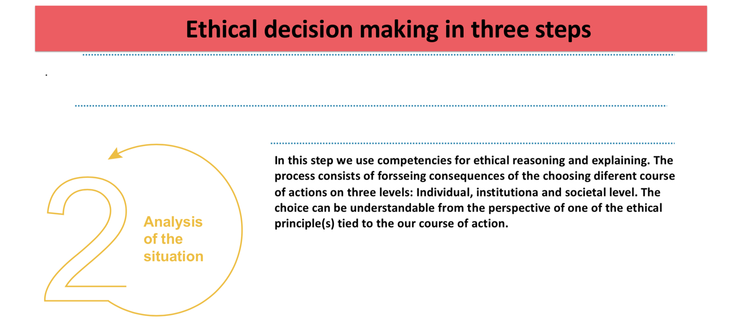

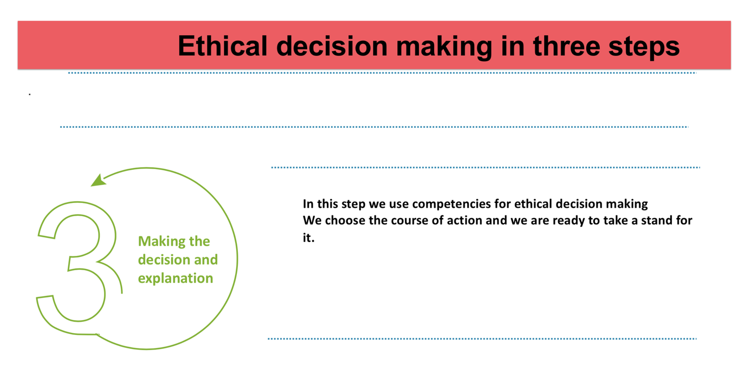

Applying on 2 Ethical principles

Imannuel Kant

Immanuel Kant: Deontological principle (deon in Greek, duty).
The moral worth of an action is determined by the human will, which is the only thing in the world that can be considered good without qualification. Good will is exercised by acting according to moral duty/law. Moral law consists of a set of maxims, which are categorical in nature – we are bound by duty to act in accordance with categorical imperative ” Act only according to that maxim whereby you can at the same time will that it should become a universal law without contradiction.”

Jeremy Bentham defined as the foundation of his Utilitarian philosophy teleological principle
“it is the greatest happiness of the greatest number of people that is the measure of right and wrong”
oriented on question of common good and well- being.

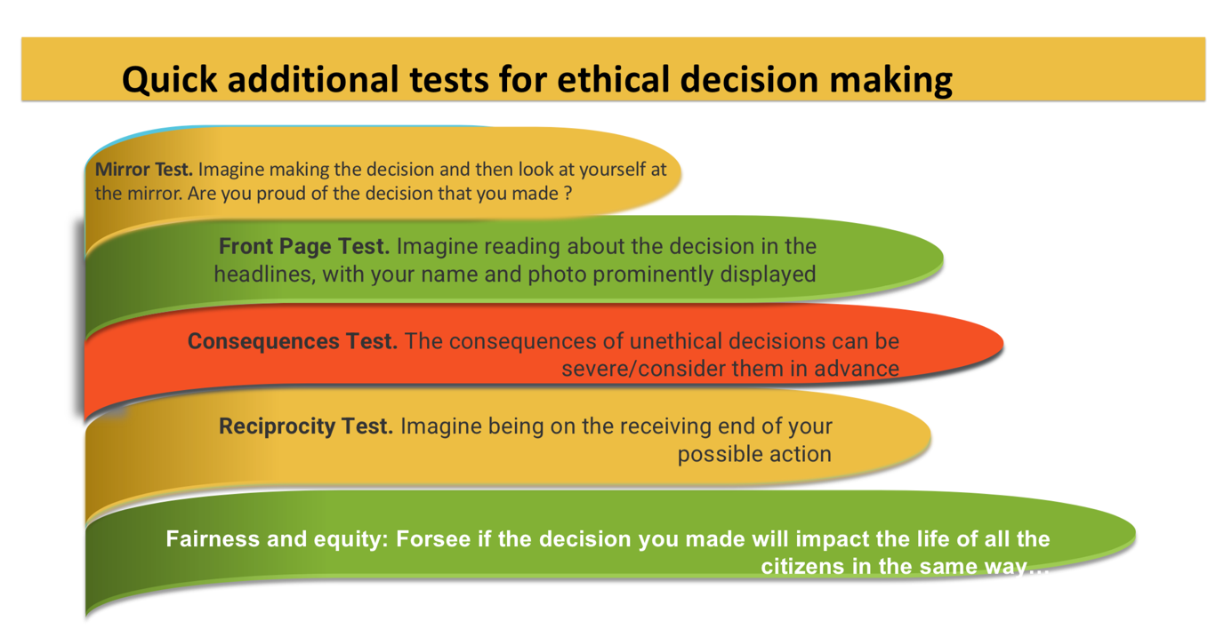

EXPLAIN
Resolving ethical dilemmas with students
Case scenario, exploring ethical dilemma (T.T)
Imagine…
Director of one high school organized ecological action, as a part of a project. Idea was to plant a 100 poplar trees as a part of a high school yard. Pupils will be engaged in this ecological action. In an invitation letter for students, director explained that school received donation of 100 seedlings of poplar tree from one country who was their partner on project. Iva, one of the pupils from school whose class will participate in this action, took a part a year before in research named” Trees in our region who are triggers for the allergy”, and she is well informed that a poplar tree is on the list of trees who are triggers for allergy. Many children in her school and many others in town deal with the same allergy, which happens when immune system sees poplar tree pollen as a potential threat. Instead of ignoring the harmless pollen, it attacks with antibodies and other chemicals like histamine. This causes allergy symptoms like coughing, sneezing, runny nose, and itchy eyes to occur. Iva refused to participate in this action, and she organized a protest in school since director rejected her written proposal in which she presents the results of the research about the % of people who suffer from this kind of allergy, and proposed director to change the tree seedlings for ecological action. Director informed Iva that he understands a given reasons, but that he is also accountable for the given donation, and therefore he needs to organize this action and make a video reportage about it. He wrote to her that there is enough space in school yard for other seedlings and it is also questionable if all the seedlings will even grow, but in a case, they do not plant it as a part of planned ecological action, that might compromise relation with their project partner and made the donation of their country questionable.

Was the decision of the director, and choice that he made right or wrong?
Step by step analysis
Duration: 10 minutes
First step:
Prepare two chairs in front of the students. Paste a paper with a word YES written on it on a first chair in a way that is visible to students. Do the same with a second chair just put the word NO on it. Prepare flipchart or white board behind so you can write down everything that is needed to be written during the process of ethical decision making. Write a T table (on a top of the left part write down YES and on a right part write down NO).
Second step:
Tell the students that you will share with them one of the stories /ethical dilemmas.
Explain that this is situation when it is not easy to make a decision because each course of the action that is possible to choose is tied to some principle of values and usually our decision means that we need to choose only one of them.
Explain that after you read the story, they should one by one pick one of the chairs based on their thinking and choice of action they believe it is right in described situation.
Everyone who would like to share their opinion needs to take a stand, by taking the floor sitting on one of the chairs (either YES or NO), and explain their reasons of choice. It is not possible to share their point of views by remaining on the place where they sit regularly/they need to come up front and pick a chair.
Third step: Read the story out loud and slowly (slide number 3). Ask students while listening to memorize all the facts. Offer to read once more if they missed some of the data.
Fourth step: When some of the students picks a chair and explains their choice, ask them to try to recognize values that are baseline of their choice.
After the coming out of few students who participated in process you will have enough values written down on both sides of the table.
Fifth step: Ask students to think about the consequences of each course of action on individual level (consequences of doing for that person and her nearest surrounding/family setting, peers etc.), institutional and societal level.
Discussion

Ask if anyone would now change the decision and if yes to explain why.

EXTEND
Further research in the classroom, family, friend circle, web, on ethics and dilemmas
by your choice
Share your MindMap on Ethics & Dilemmas with students from other schools, organize an virtual and/on-site meeting to the topic
Mag. Tamara Tomašević expert in ethics&Integrity; psychologist; ACD team member
https://www.linkedin.com/in/tamara-tomasevic-b6983111/

Sources: https://en.wikipedia.org/wiki/Potter_Box , https://www.open.edu/openlearncreate/mod/page/view.php?id=148399

