Natural Resources Of Iceland

Móðurmál

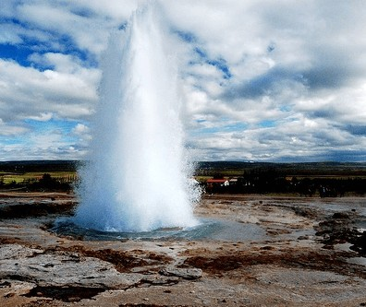

The Land of Fire and Ice

Iceland is a country of extreme contrasts. It is a land of ﬁre and ice, where geothermal activity and glaciers coexist. The country is also known for its stunning natural beauty, with waterfalls, geysers, and volcanoes dotting the landscape.

Geothermal Energy

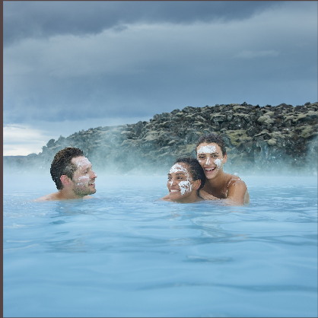Iceland is a leader in geothermal energy. The country uses this renewable resource to heat homes, swimming pools, and even greenhouses. Visitors can take a dip in the Blue Lagoon, a geothermal spa where the water is rich in minerals and said to have healing properties.

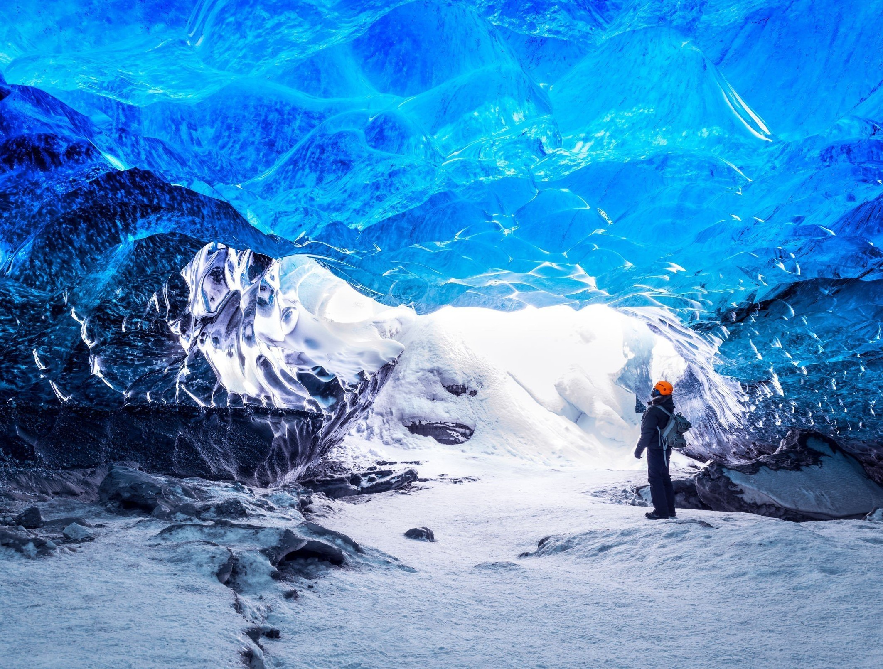

Glaciers

Iceland is home to some of the largest glaciers in Europe, including Vatnajökull and Langjökull. These massive ice caps are constantly changing and offer a unique opportunity for adventure, such as glacier hiking and ice cave exploration.

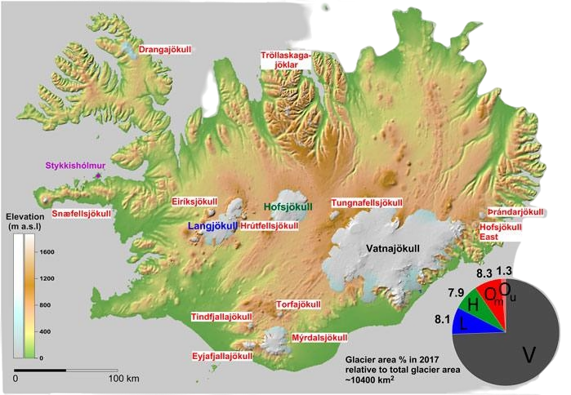

Waterfalls

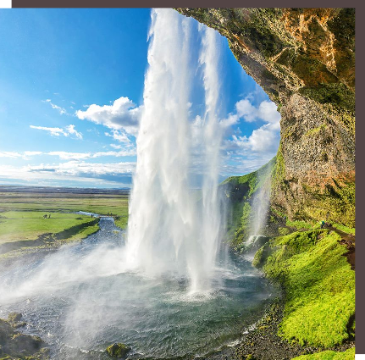Iceland is known for its spectacular waterfalls. Among the most famous are Gullfoss, Seljalandsfoss, and Skógafoss. These natural wonders are not only beautiful, but also provide a source of renewable energy through hydroelectric power.

Northern Lights

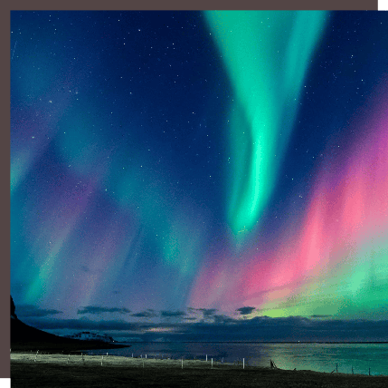The Northern Lights, or Aurora Borealis, are a natural phenomenon that can be seen in Iceland during the winter months. The lights are caused by charged particles from the sun colliding with the Earth's atmosphere. Viewing the Northern Lights is a once-in-a-lifetime experience.

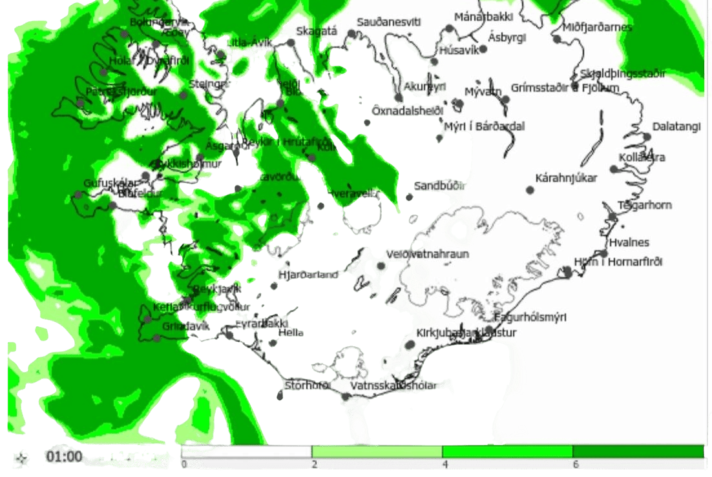
This way you can highlight Aurora's movements on the Iceland Map

Volcanoes

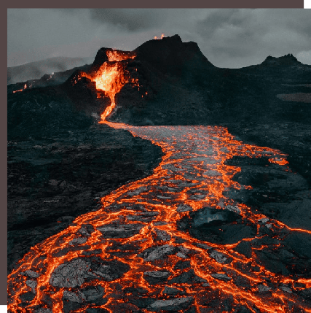Iceland is home to over 30 volcanoes, some of which are still active. The most famous eruption in recent history was that of Eyjafjallajökull in 201, which caused widespread disruption to air travel. Despite the potential danger, volcanoes are an important part of Iceland's geological history and attract many visitors.

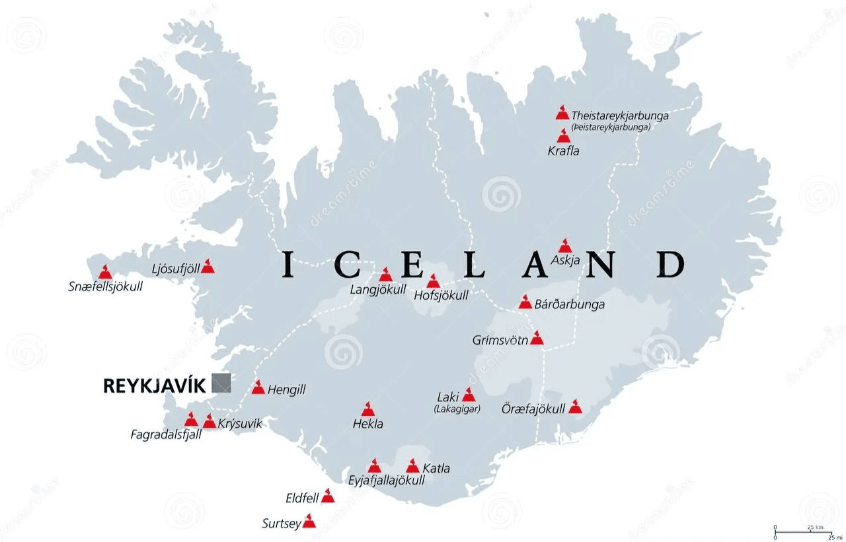

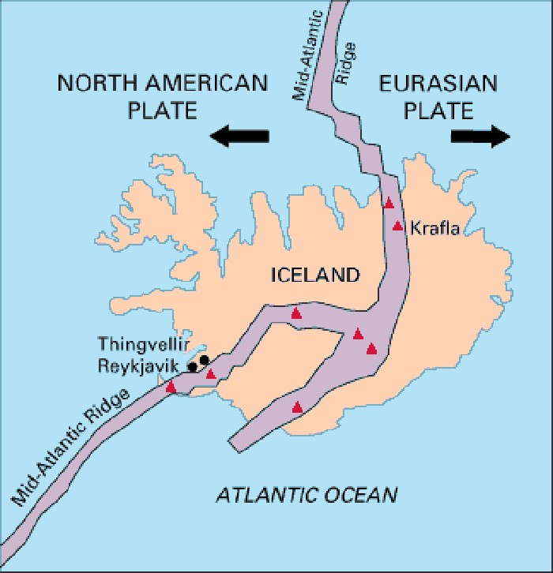

When a volcano begins or plans to erupt, numerous shaking/earthquakes occur. Here is a clear e ample of where earthquakes most often occur.

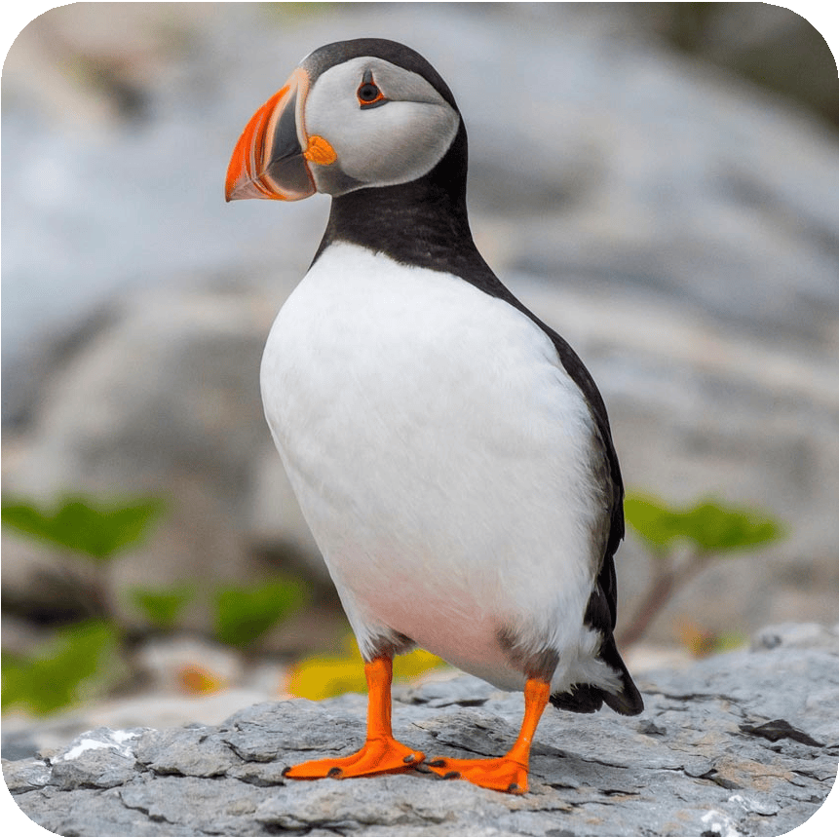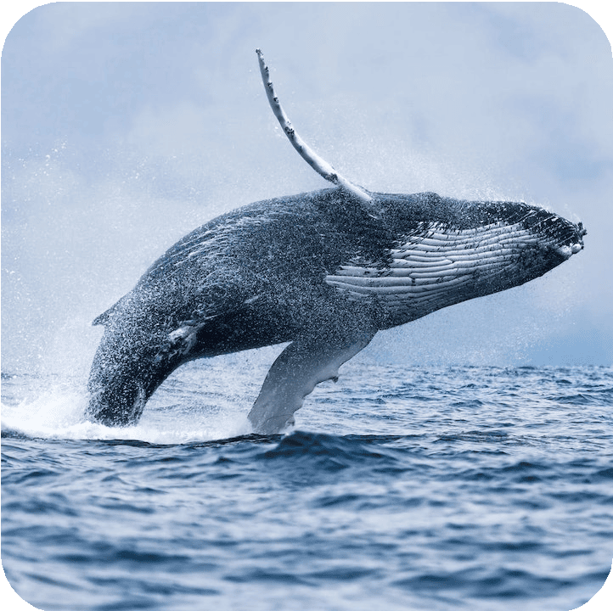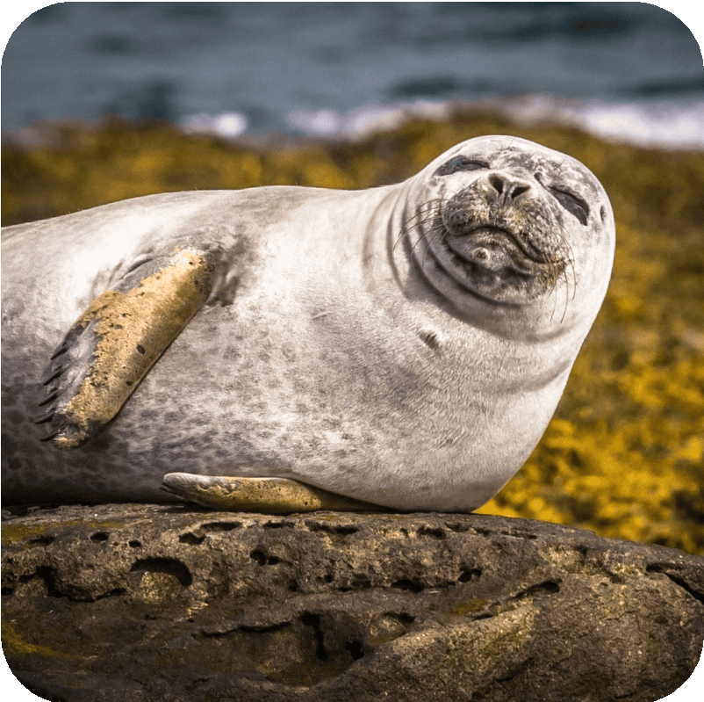Iceland is home to a variety of wildlife, including pufﬁns, whales, and seals. The country's waters are also a popular spot for ﬁshing. Visitors can take a whale watching tour or visit a pufﬁn colony to see these unique creatures up close.

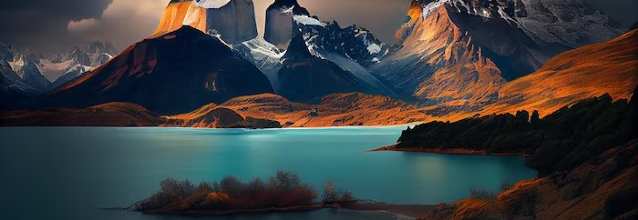Iceland has three national parks: Þingvellir, Vatnajökull, and Snæfellsjökull. These protected areas are home to some of Iceland's most stunning natural wonders, such as geysers, waterfalls, and glaciers. Visitors can explore the parks on foot or by car.

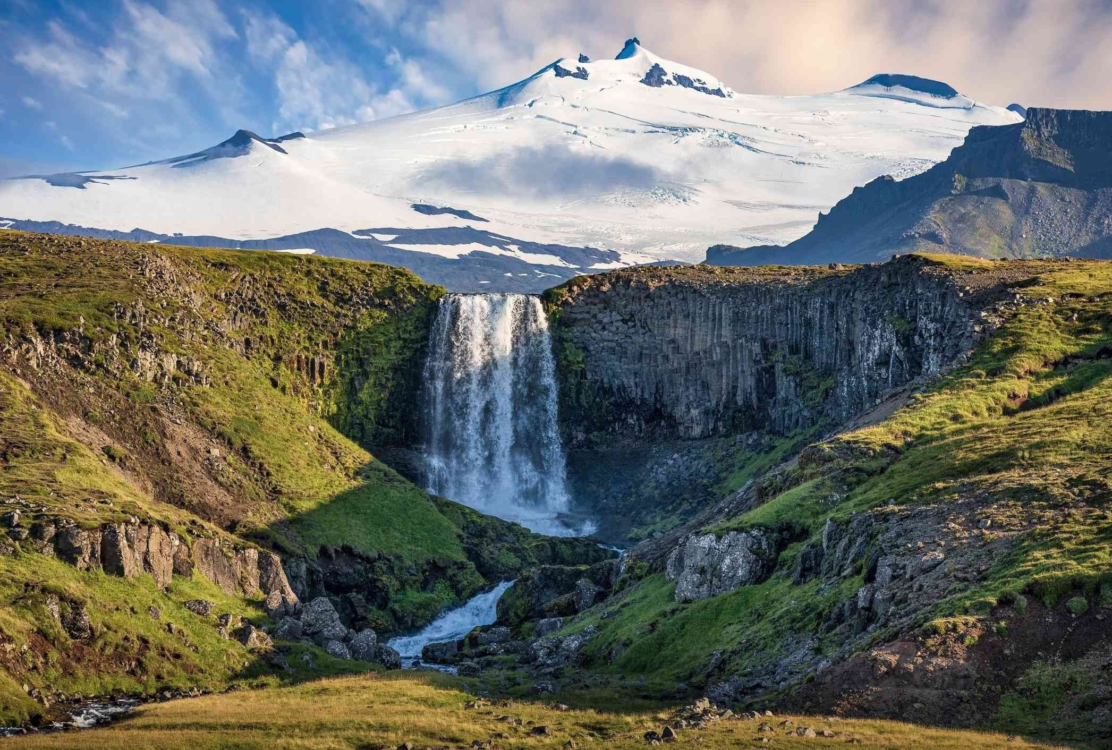
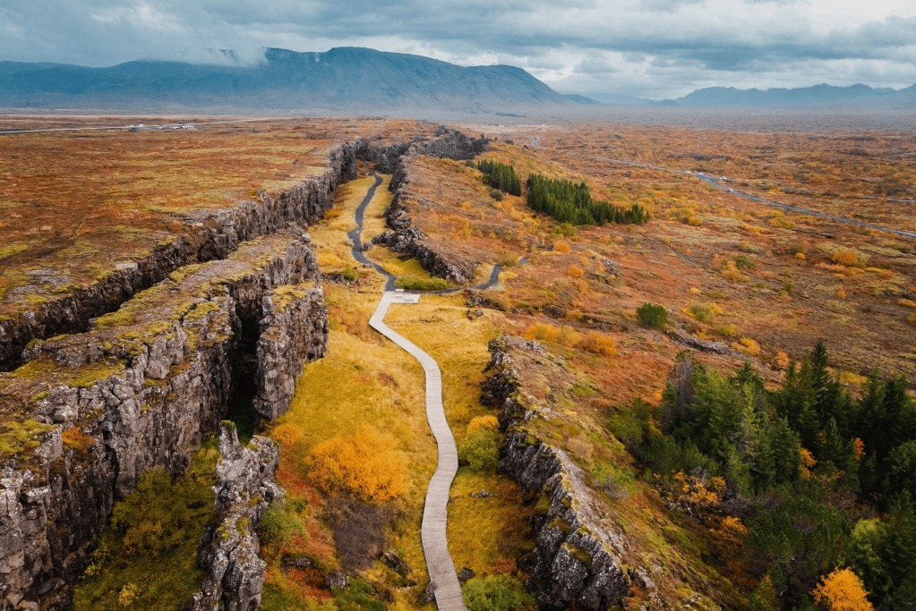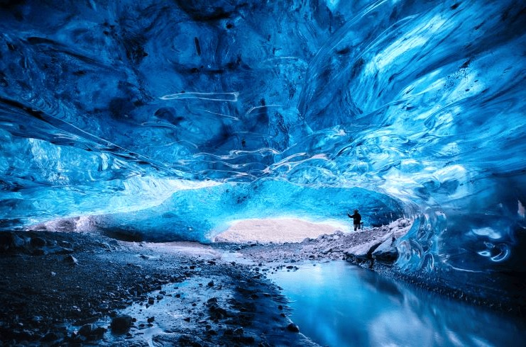
Þingvellir
Vatnajökull
Snæfellsjökull

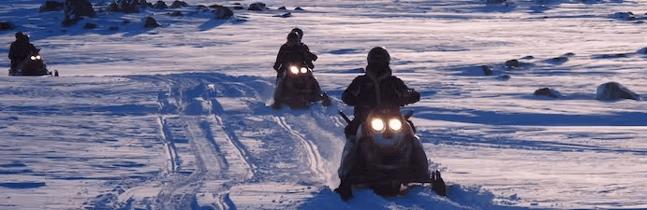Iceland is a destination for adventure-seekers. Visitors can go whitewater rafting, snowmobiling, and dog sledding. The country's rugged terrain and extreme weather conditions make it a challenging but rewarding destination for those who love the outdoors.

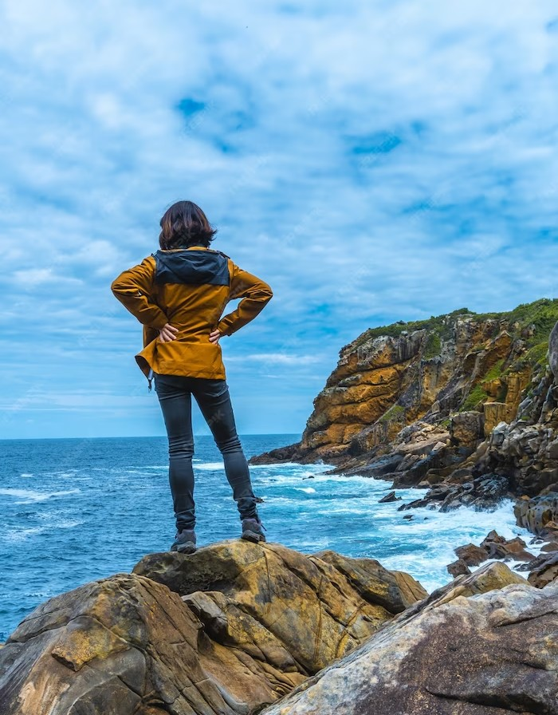
Conclusion

Iceland is a unique destination that offers a wealth of natural wonders, cultural experiences, and adventure opportunities. Whether you're interested in hiking on a glacier, soaking in a geothermal spa, or sampling local cuisine, Iceland has something for everyone.

