MRP I SYSTEMS AND MRP II SYSTEMS
SUGGESTED EXERCISE-2

We want to make the Material Requirements Planning for the following products:

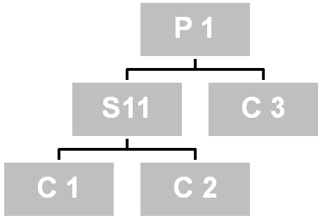  1  1  1  1  2 | 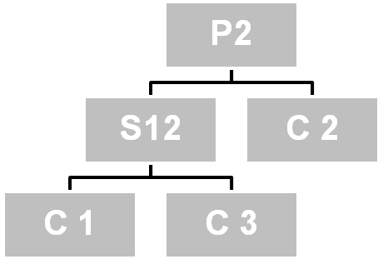  1  2  2  1  1

P1, P2 and C3 are independent demand products; that is, they are manufactured under external customers’ demand. P1 and P2 are finished products and C3 is a component sold as a spare part.

The production plan is the following:

Products\Date | 01-Apr | 08- Apr | 15- Apr | 22- Apr
P1 | 100 | 80 | 100 | 120
P2 | 200 | 200 | 200 | 250
C3 | 0 | 100 | 100 | 0

Besides, we know the available stock and the safety stock of each product, their manufacture term, the percentage of failures manufactured and the manufacture lot, shown in the following chart:

PRODUCTS | SFT STOCK | MANUF. TERM | % FAILURES | AVAIL STOCK | LOT
P1 | 50 | 1 | 0 | 70 | LbL
P2 | 100 | 1 | 0 | 120 | LbL
S11 | 0 | 2 | 0 | 20 | M 100
S12 | 0 | 2 | 0 | 20 | M 50
C1 | 100 | 1 | 10 | 50 | LbL
C2 | 100 | 1 | 10 | 50 | LbL
C3 | 100 | 1 | 10 | 150 | M 100

Complete the files for each component and define the launches or manufacture orders for each one.
In this case, we have two final products and we will do the same as in the above example, but the sequence in this case is:
The production schedule sets the gross requirements of the Level 0 products with the stock, safety stock and failures we determine the net launches. These are exploited to calculate the gross requirements of the Level 1 components. The same way, we determine the Level 1 net launches and so on until the components in the last level of the Program.
When an assembly or component is included in two different levels, this component or assembly will be placed in its lowest level for the calculation of the launches of manufacture orders.
LEVEL 0
Gross requirements
Available stock
Net requirements
Launches

Gross requirements
Available stock
Net requirements
Launches

LEVEL 1
Gross requirements
Available stock
Net requirements
Launches

Gross requirements
Available stock
Net requirements
Launches

LEVEL 2
Gross requirements
Available stock
Net requirements
Launches

Gross requirements
Available stock
Net requirements
Launches

Gross requirements
Available stock
Net requirements
Launches
We want to calculate the manufacturing capacity in the working centres for the established production schedule.

Determine the workload for each working centre (assembly, C100, C200, C300 and C400), indicating the dates when overtime is necessary to meet the production schedule established, if in each working centre, we start in the following conditions:

PRODUCT | No STAGE | W.LOAD | TERM | LOT | PREP T. (hours). | OPER T. (minutes).
P1 | 1 | Assembly | 1 | 200 | 4 | 20
P2 | 1 | Assembly | 1 | 200 | 3 | 14
S11 | 1 | c100 | 1 | 100 | 1 | 4
 | 2 | c200 | 1 | 100 | 5 | 4
S12 | 1 | c100 | 1 | 100 | 1 | 4
 | 2 | c200 | 1 | 100 | 5 | 6
C1 | 1 | c300 | 1 | 200 | 2,5 | 5,5
C2 | 1 | c300 | 1 | 200 | 1 | 7
C3 | 1 | c400 | 1 | 200 | 2,75 | 4,5

Besides, represent graphically the results got.

P1 | ASSEMBLY
P2
S11 | C100
 | C200
S12 | C100
 | C200
C1 | C300
C2 | C300
C3 | C400

ASSEMBLY
CA. MAX
C100
CA. MAX
C200
CA. MAX
C300
CA. MAX
C400
CA. MAX

