Project ID: 2021-1-CZ01-KA220-SCH-000034484
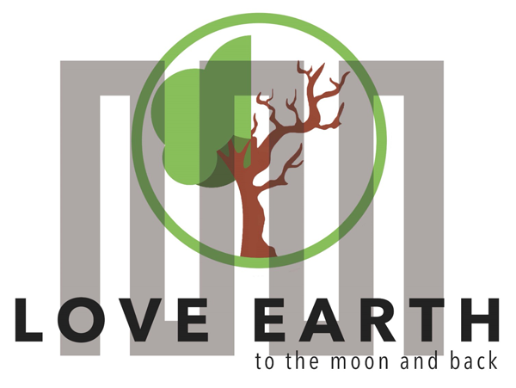

COURSE FOR ENVIRONMENTAL EDUCATION
e-Modules: Teaching Learning activities and their technology enhanced material set to develop

DISCLAIMER
Funded by the European Union. Views and opinions expressed are however those of the author(s) only and do not necessarily reflect those of the European Union or the European Education and Culture Executive Agency (EACEA). Neither the European Union nor EACEA can be held responsible for them.

COURSE AUTHORS
Martyna Florkowska-Kardasz, Justyna Pająk-Jaroszewska

COURSE SHARING LICENSE
You are free to:
- Share — copy and redistribute the material in any medium or format for any purpose, even commercially.
- Adapt — remix, transform, and build upon the material for any purpose, even commercially.

MODULE 1 | HUMAN AND NATURE
PART 5 | Maintaining the natural balance
Lesson 2 | Designing a social-awareness-for-the-natural-balance project

SUMMARY

1. COURSE TIME, TARGET AND TOPIC 3

2. COURSE OBJECTIVES 3
Competences promoted in this lesson: 3
Lesson objectives: 3

3. LEARNING – TEACHING PROCESSES 3

4. EVALUATION 4

5. DOCUMENTS 5
ENGAGE 5
EXPLORE 5
EXPLAIN ..…………………………………………………………………………………………………………………………………………………..5
EXPLORE 6
EXTEND 6
EVALUATE 7

1. COURSE TIME, TARGET AND TOPIC
- Age of target students: 15+
- Teaching time: 1 hour
- Disciplines: English, art, ICT, biology, social studies, geography
- Title: Social awareness and natural balance – designing a project.

2. COURSE OBJECTIVES

Competences promoted in this lesson:
- Communication in foreign languages competency
- Digital competency
- Learning to learn competency
- Social and citizenship-related competencies
- Initiative and entrepreneurship competencies
- cultural awareness and expression competences

Lesson objectives:
- The students design a project that creates social awareness for the protection of the natural balance.

It is vital to understand that the students are encouraged and invited to come up with their own ideas of a project as it has to be something relating to their own culture best. Some groups might choose to organize a social campaign involving spreading leaflets, creating an online book whose superhero protects the nature and its sustainability and, in the end turns out to be a common, regular teenager whose everyday actions do wonders for the planet protection. However, in this lesson it is proposed that the students should design a project in the form of an Instagram or tik-tok account. The task is thought to be an engaging and highly developing activity for the students themselves and it is crucial to allow them to maintain independence in choosing certain solutions or ideas, e.g. if the students decide to create an online book/comic book then they might use the following free tools in the process:
Free Comic Strip Maker - Create Comic Strips Online | Canva
Create Comics Online, it’s Fun & Free at MakeBeliefsComix!
Pixton | Free Comic & Avatar Maker
Free Online eBook Maker: Design a Custom eBook in Canva
Top FlipBook Maker & Digital Publishing Platform - FlipHTML5

3. LEARNING – TEACHING PROCESSES
There are 5 activities in this lesson:
- ENGAGE: Initial representation and recall
- EXPLORE: What is environmental sustainability? (students: come up with a definition, do research on significant numbers and the U.S. Environmental Protection Agency’s of environmental sustainability, discuss what can be done in order to live in accordance with this rule: “meeting today’s needs without compromising the ability of future generations to meet their needs.”)
- EXPLAIN: Inform about the project and its aims and outcomes

- EXPLORE: group work (creating a social media account, a name, a logo, tasks, deadlines, target audience)
- EXTEND: Project execution

4. EVALUATION
The evaluation is described in the last part of document.

5. DOCUMENTS

ENGAGE
In this initial stage of the lesson students are asked to recall the conclusions drawn at the end of the previous lesson:
- they are the ones responsible for spreading awareness
- a change has to start now and locally
- people’s attitudes towards nature and themselves can be changed and shaped through education
- a project has to be designed

EXPLORE
- In order to make sure the students know what environmental sustainability is, the teacher writes a number: 24% on the board and asks the students what it refers to. There might be some answers but if none of them is correct, the learners need to be informed that this is the number of avoidable deaths around the world that can be traced back to environmental factors. (https://www.who.int/docs/default-source/documents/publications/quantification-of-the-disease-burden-attributable-to-environmental-risk-factors.pdf?sfvrsn=dbac7e7e_1)
- The teacher asks what people need to live (clean air to breathe, fresh water to drink, safe, not affected by pollution places to leave).
- The students are shown the U.S. Environmental Protection Agency’s (https://www.epa.gov/report-environment/sustainability-and-roe) definition of environmental sustainability: “meeting today’s needs without compromising the ability of future generations to meet their needs.” As a conclusion: the teacher asks what each of us can do everyday to lead a life in accordance with this definition. Students are supposed to number just 3 or 4 things to show their understending of the issue.

EXPLAIN
- In this stage of the lesson, the learners are informed that as the main part of their project they will be setting up a tik-tok account in which they are going to provide and promote daily activities helping to sustain natural balance.

EXPLORE
- Depending on the number of students, they will be divided into pairs or groups. The teacher gives out shapes that fit together and asks the students to find the people they can make a rectangle with. The rectangles or other shapes stand for a team.

- Each team is asked to come up with 3 activities/actions that their peers might find engaging and interesting to do every day in order to start caring about their mental well-being and natural sustainability. They will have to be recorded and then uploaded to tik-tok. These might be such challenges as going to school or back home on foot once a week. It is also each team’s responsibility to suggest how the followers or tik-tok users might be rewarded for joining in. It would be of vital importance to invite school communities to join the project. Thanks to that the scope of the project would be widened and would contribute to creating a community of the teenagers involved and joined by the common purpose and bond. Not to mention the fact that the reward system could be introduced and linked with the school grading system.

Making a thorough plan of the project. The students need to decide about the deadlines, the way they will introduce the information about the project to the tik-tok users (the logos, the name, the leaders, the goals), how long each challenge or task will last, who will be responsible for managing the account and who this person will be assisted by.

EXTEND

Students start setting up the account and fulfilling the initial steps.

EVALUATE

The overall evaluation will be based on a total of 105 points, with a holistic assessment of creativity, feasibility, engagement, presentation skills, collaboration, and overall impact.
I. Evaluation criteria:
1. Creativity (20 points)
- uniqueness of campaign ideas
- creativity in designing logos and TikTok content
2. Feasibility (15 points)
- realistic and achievable campaign goals and challenges
- consideration of potential obstacles and solutions
3. Engagement (20 points)
- ability to engage the target audience on TikTok
- thoughtful consideration of activities that promote well-being and sustainability
4. Presentation skills (15 points)
- clarity in presenting the campaign plan
- effective communication of goals and objectives
5. Collaboration (15 points)
- evidence of effective teamwork within each group
- openness to feedback and adaptation of ideas
6. Overall impact (15 points)
- The potential impact of the campaign on the school community and beyond
- Alignment with the broader goals of promoting mental well-being and natural sustainability.

