Project ID: 2021-1-CZ01-KA220-SCH-000034484
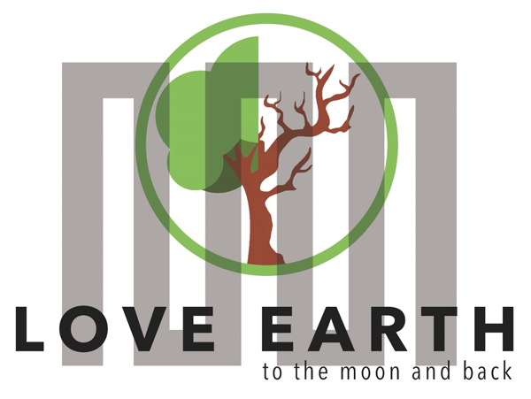

COURSE FOR ENVIRONMENTAL EDUCATION
e-Modules: Teaching Learning activities and their technology enhanced material set to develop
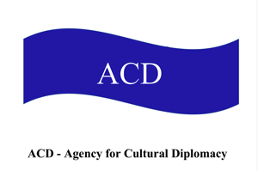
Thematic Units for Week-Long Workshop Sessions:
Inquiry-Based Integrated Learning Workshop Series
on the Intersection of Arts, Science, and Policy

M1: Humans&Nature. Part 2:
Environmental ethics introductory

COURSE AUTHOR:
©Tatjana Christelbauer MA (TC)
ACD Team, Austria

DISCLAIMER
Funded by the European Union. Views and opinions expressed are however those of the author(s) only and do not necessarily reflect those of the European Union or the European Education and Culture Executive Agency (EACEA). Neither the European Union nor EACEA can be held responsible for them.
COURSE SHARING LICENSE CC BY-NC-SA =
Canonical URL: https://creativecommons.org/licenses/by-nc-nd/4.0/

MODULE 1, Part 2

LESSON: lesson bond “Environmental ethics”

1. COURSE TIME, TARGET AND TOPIC
- Age of target students: 15+
- Teaching time: 2 hours+ workshops or longer project
- Disciplines: Fine Arts, International Relations, Ethics, English, Environmental Education, …
- Title: Environmental Ethics on the nexus of arts_sciences_policy

2. COURSE OBJECTIVES

Competences promoted in this lesson:
- Communication in foreign languages competency
- Digital competency
- Social and citizenship-related competencies
- anticipatory (future thinking) competence; normative competence;
- interpersonal competence, collaboration competency;
- critical thinking competency
- self-awareness competency; integrated problem-solving competency;
- STEAM; creativity;
- digital literacy

Lesson objectives:
Discussing behaviors that adversely affect the natural balance through environmental ethics
Understanding and commenting on behaviors that will adversely affect the natural balance in the context of environmental ethics.
Creating a document (art Manifesto/mind map) discussing the environmental ethics and dilemmas using the literature of relevant studies.
Using AI tools such as Wombo AI art tool and Braille Art for creation of mind map and linguistic landscape consisting of key terms in a multilingual setting, creating sound-based interactive discussion while including BVI students

3. LEARNING – TEACHING PROCESSES
There are 4 activities in this lesson:
- ENGAGE: Initial representation and recall: Brief introductory to Environmental ethics & ethical dilemmas
Watch the introductory videos of the United Nations and /or listen to get introduced to Sustainable Development Agenda2030, get inspired by art for understanding environmental ethics

- EXPLORE: Reflect on current environmental issues in your school/classroom, make note using the key
terms, research in web and social media if any blog articles, concerns, comments on topics
you noticed as important.

- EXPLAIN: Make interviews with your schoolmates, discuss with teachers, about the issues you find important to be maintained

- EXTEND: Draw your idea, share with your classmates and teachers, invite them to co-design the action, create a poster / mind map; create an Artmanifest together inspired by environmental artist Hundertwasser; share your work with school directors, major, policy makers, connect with the EU and UN Youth platforms and present/share your findings, invite for collaboration;

4. EVALUATION
The evaluation is described in the last part of document.

ENGAGE
Brief introductory to Environmental ethics
Guiding intro
What is Environmental Ethics?
Environmental ethics is the discipline in philosophy that studies the moral relationship of human beings to the environment and its non-human contents.
How can arts support the understanding of environmental ethics?
The evidence of arts in sustainable development discourse has been recognized by UNESCO and has been included in the UNESCO document “Towards 2030: creativity matters for sustainable development.” Guided by the visionary art of the Austrian-born painter, environmental architect and activist Friedensreich Hundertwasser, this lesson part proposes an approach to understanding environmental ethics through the prism of sustainability as the ability to practice
“life in harmony with the laws of nature (..) as its guests.
In 2015, the United Nations proclaimed Agenda 2030 as a call upon concerted efforts toward building an inclusive, sustainable, and resilient future for people and the planet. The UN Agenda 2030 with the 17 Sustainable Development Goals, offer the most practical and effective pathway to tackle the causes of violent conflicts, human rights abuses, climate change, and environmental degradation. Sustainable development is also a core principle of the Treaty on European Union and a priority objective for the EU's internal and external policies. The term sustainability dates back from sylviculture (or forestry, a concept of sustainable forestry, introduced in the work of Hans Carl von Carlowitz´s „Sylvicultura Oeconomica‟ from 1713. Later, in the Report from 1987 “Our Common Future”, the UN Commission on Environment and Development (Brundtland Commission) provided a definition of sustainable development as development that
"meets the needs of the present without compromising the ability of future generations to meet their own needs"
The United Nations Agenda 2030 and the 17 Sustainable Development Goals (SDGs) which reveals a relationship to ethical issues, ethical questions and concerns raised by scholars, political leaders, citizens, practitioners, and philosophers over the years on key human development and environmental issues (United Nations, 2015).
Why environmental ethics matters and how?
Watch/listen the UN videos:
https://www.youtube.com/watch?v=7V8oFI4GYMY
https://www.un.org/en/sustainable-development-goals
Watch/Listen the EU youth cinema video to European Union Green Deal policy:
https://www.euyc.green/en
Further tasks:
Watch the Rainyday movie on YouTube to get introduced to Hundertwasser´s artistic approach to environmental ethics
https://www.youtube.com/watch?v=OZnq9074MbI&t=1s
Read the UNESCO document on how youth may engage in environmental ethics and support the sustainable development process:
https://www.un.org/esa/socdev/unyin/documents/ch05.pdf
ENGAGE: How much you can individually contribute to the improvement of conditions connected with current challenges in sustainable development process? One of the measures is to calculate your Carbon Foot Print: https://www.un.org/en/climatechange/youth-in-action

Discuss the » Laws of nature » with your classmates and teachers, exchange your understanding of Hundertwasser’s premise to « life in the harmony with the laws of nature as its guests »
What it takes to be a good guest?
How you experience the hospitality of nature?
How are environmental ethics understood within social environment?

Look for an local artist engaged in promoting environmental ethics,
Get in touch, connect, learn with,
act together

EXPLORE
What matters in your social and natural environment?
What challenges connected with environmental ethics could you recognize while watching the videos of the United Nations?
Reflect on current environmental issues in your school/classroom, make notes, research in web and social media if any blog articles, concerns, comments on topics you noticed as important.
Make interviews with your schoolmates, discuss with teachers, about the issues you find important to be maintained
Get inspired by recognized artist and ecological activist Hundertwasser read the text:
Tree tenants: occupants of a building in Alserbachsrtrasse, Vienna Austria: https://hundertwasser.com/en/texts/an_die_bewohner_wien-alserbachstrasse

More about “Tree tenants”:
https://hundertwasser.com/en/texts/baummieter_sind_botschafter_des_freien_waldes_in_der_stadt
Read the document composed by Hundertwasser “Peace Treaty with Nature”
Weblink: https://hundertwasser.com/en/original-graphic/847_a_hwg93_peace_treaty_with_nature_14

Forestation of the city
by Friedensreich Hundertwasser 1971/72
https://hundertwasser.com/en/texts/verwaldung_der_staedte

Further inspirations for understanding of current challenges and how environmental ethics matters:
Earth song Michael Jackson 1995: https://www.youtube.com/watch?v=XAi3VTSdTxU
https://en.wikipedia.org/wiki/Earth_Song
Severn Cullis-Suzuki 1992 Rio de Janeiro, Greta NY 2019: https://www.youtube.com/watch?v=ZOp5ATk_rlM

Task:
Youth composes their Statement for Policy makers
Follow the example:
UNICEF: Making Climate and Environment Policies for & with Children and Young People-doc for reading for students, in preparation for their individual, national and multilateral discussions on policy https://www.unicef.org/media/109701/file/Making-Climate-Policies-for-and-with-Children-and-Young-People.pdf

Read following pages: 1,2,3, 14-17
Create your artwork, speech, draw with your classmates a policy recommendation paper, take action together, improve the conditions, contact policy makers and other relevant entities for the support, keep your critical eye on media, compare diverse sources from various regions, countries, information providers, make your own picture, engage in local/regional activities, co-create opportunities, unite with likeminded people 4 better conditions, leaving no one behind
Create your “Love letter to Earth”, see here an example created by students, participants in the E+ project LeMOON:

Contribution of the Vienna partner school The Institute for Blind & visually impaired in the ERASMUS+ Project Le_MOON for the Module1 lecture on “Ethics & dilemmas” shared by Focus group high school students for the discussion on Environmental safety challenges for blind & visually impaired

„In traffic, people sometimes leave their e-scooters wherever they want and then it could be difficult for blind people because if they touch it the alarm goes off. To solve the problem there should maybe be parking spots for e-scooters so that they are not in the middle of the way.“

Task:
Read experiences shared by blind students (age 14+ ), include them into discussion on improvement of mobility & road safety, urban environment ethics & dilemmas (scooters); share your suggestions for the improvement of conditions; investigate on conditions, talk with blind students in your local area about challenges they are meeting and also their suggestions for their improvement, develop together innovative solutions

Note: read by your interests the UNESCO EEP: ethics education program:
https://en.unesco.org/themes/ethics-science-and-technology/ethics-education
Powertalk weblink: https://fullmeasure.co.uk/powertalk/
Wombo AI: https://dream.ai/create , explore Braille Art: https://www.pathstoliteracy.org/just-fun-braille-designs/

EXPLAIN

Creating an ArtManifest

ENGAGE, Connect&Act: Draw your ideas for the improvement of conditions, share with your classmates and teachers, invite them to co-design the action, create a poster / mind map, compose collected notes into Art Manifest in a digital format including sound and diverse languages, to widen the scope and to enable understanding of the content for wider audiences.
Explain what is important for you to be considered by environmental ethics, how it matters and why;
See an example created by students who participated in the ERASMUS+project LeMOON workshop on policy learning, Humanitarian diplomacy led by Tatjana Christelbauer during the mobility travel in Manisa, Turkiye
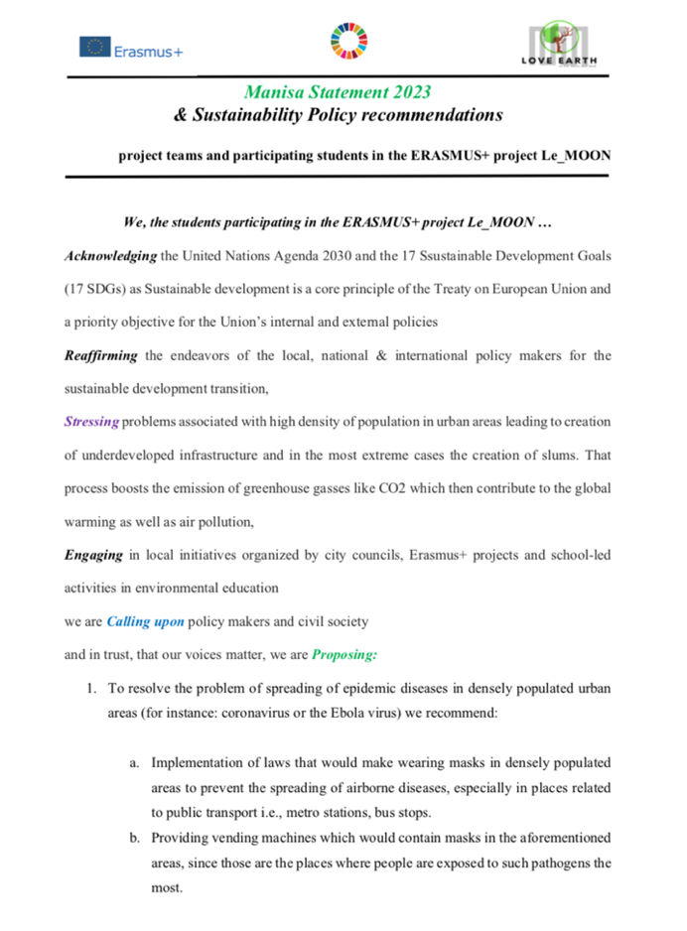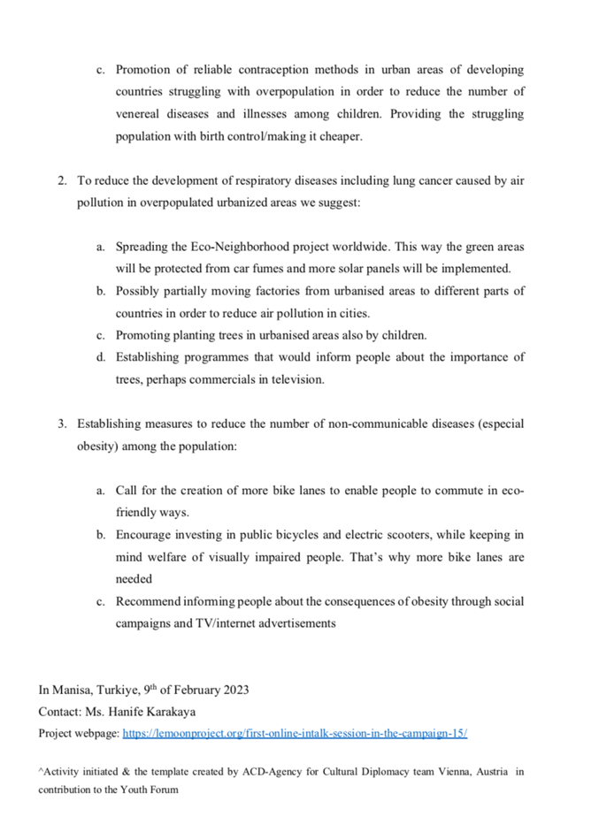

Useful tools: use the Powertalk as a tool as it includes assistive technologies for the blind and visually impaired. Use the Wombo AI art tool for creation and design of images by using key terms in a multilingual setting; record voice messages, reach out to BVI students and exchange with them ideas on environmental ethics; set environmental ethical guidelines in your classroom,
Note: read by your interests the UNESCO EEP: ethics education program:
https://en.unesco.org/themes/ethics-science-and-technology/ethics-education

EXTEND

Connect with your local and with international Youth initiatives related to Sustainable Development

Share your findings, attend virtual and on-site meetings, international conferences, organize meeting and/or conference at your school, include art methodology for the inquiry, for the presentation and for dissemination of good practices, posed questions, ideas for the improvement ..

Weblinks to connect with EU & UN youth portals:
https://tools.youthforum.org/policy-library/sustainable-development/
Connect with the United Nations /UNICEF/UNECE/your regional dialogue platforms, create Youth Dialogue Platform with your schoolmates : https://unece.org/info/events/event/373517
https://sdgs.un.org/sites/default/files/2022-06/Youth%20and%20Environment%20Europe.pdf
https://www.undp.org/publications/fast-facts-youth-partners-implementation-sdgs
https://youth.europa.eu/solidarity/placement/28076_no
Tools for Ai art and communication:
Powertalk weblink: https://fullmeasure.co.uk/powertalk/
Wombo AI: https://dream.ai/create
Braille online: https://www.un.org/youthenvoy/2013/08/unep-and-youth/
Sound / podcast creator: https://www.soundtrap.com/edu/

References useful weblinks for further informations:
ACD-Agency for Cultural Diplomacy association Spaces academy https://www.acdvienna.org/sdg-learning/parlamint-planetarythinking/; ERASMUS+ projects: https://www.acdvienna.org/w-%C3%B6-eu/erasmus-projects/ ; Humanistic education, sustainable development approach: https://www.acdvienna.org/futures-of-education/
Ethics, definition:https://plato.stanford.edu/entries/ethics-environmental/
´Weblink, UN Agenda 2030: https://sdgs.un.org/2030agenda
Ecological art activism of Hundertwasser: https://hundertwasser.com/en/ecology ; https://www.kunsthauswien.com/en/about-us/green-museum/ecological-commitment/
John Howkins: Creative ecology
https://www.creativityatwork.com/john-howkins-on-creative-economy-ecologies/
UNESCO EEP: ethics education programme:
https://en.unesco.org/themes/ethics-science-and-technology/ethics-education

ACD-Agency for Cultural Diplomacy team:
Tatjana Christelbauer president, art_sci edu , Hundertwasser artImpact2030: https://www.tatjana-christelbauer.com/en/hundertwasser-artimpact2030-kunstvermittlung

EVALUATE

Create Mind Maps with True False Questions on ethics in environmental education
Compose Environmental ethics diary with case studies from your school/classroom/family
Create collective artwork to the environmental issue of importance for you & your classmates, consisting of single works entitled in English+ your local languages used at school, compounded in a poster
Compose the pool of questions, create a quiz, crossword puzzle
Mind map example: https://www.mindomo.com/de/mindmap/environmental-education-mind-map-c525c1ae17797925165fd2dc3bf5b960
https://www.semanticscholar.org/paper/Mind-Maps-and-Scoring-Scale-for-Environmental-Gains-Kele/7c6ca5583c1df08a5f83bc85035d0ba1fde905d5

Keep practicing, engage, connect & act

Source: https://unesdoc.unesco.org/ark:/48223/pf0000246746
Friedensreich Hundertwasser Webpage: https://hundertwasser.com/en/ecology
Notes from Hundertwasser Peace Treaty with Nature, point 5,6: https://hundertwasser.com/en/texts/friedensvertrag_mit_der_natur
Weblinks: UN Agenda2030: https://sdgs.un.org/2030agenda , https://www.un.org/sustainabledevelopment/development-agenda/
Weblink Report PDF: https://sustainabledevelopment.un.org/content/documents/5987our-common-future.pdf
Read more about ecological art activist Hundertwasser: https://hundertwasser.com/en/ecology ; https://www.kunsthauswien.com/en/about-us/green-museum/ecological-commitment/
Powertalk weblink: https://fullmeasure.co.uk/powertalk/
Wombo AI: https://dream.ai/create

