ё
Project ID: 2021-1-CZ01-KA220-SCH-000034484
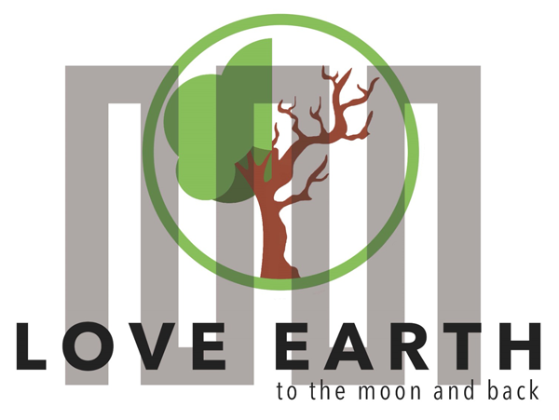

COURSE FOR ENVIRONMENTAL EDUCATION
e-Modules: Teaching Learning activities and their technology enhanced material set

DISCLAIMER
Funded by the European Union. Views and opinions expressed are however those of the author(s) only and do not necessarily reflect those of the European Union or the European Education and Culture Executive Agency (EACEA). Neither the European Union nor EACEA can be held responsible for them.

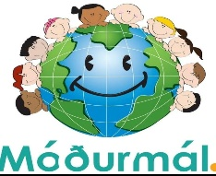

COURSE AUTHORS
Lydmila Zadorozhnya

COURSE SHARING
LICENCE

You are free to:
- Share — copy and redistribute the material in any medium or format for any purpose, even commercially.
- Adapt — remix, transform, and build upon the material for any purpose, even commercially.

MODULE 1 | HUMAN AND NATURE
PART 1 | The interaction between humans and nature
Lesson 1-2 | Is there an interaction between humans and nature?

SUMMARY

1. COURSE TIME, TARGET AND TOPIC 3

2. COURSE OBJECTIVES 3
Competences promoted in this lesson: 3
Lesson objectives: 3

3. LEARNING – TEACHING PROCESSES 3

4. EVALUATION 3

5. DOCUMENTS 4
ENGAGE 4
EXPLORE……………………………………………………………………………………………………………………………………….……….4
EXPLAIN 5
EXTEND 6
EVALUATE 7

1. COURSE TIME, TARGET AND TOPIC
- Age of target students: 15+
- Teaching time: 1 hour
- Disciplines: Geography, Human Sciences, Maths, Science, Art
- Title: Is there an interaction between humans and nature?

2. COURSE OBJECTIVES

Competences promoted in this lesson:
- Communication in foreign languages competency
- Digital competency
- Learning to learn competency
- Social and citizenship-related competencies

Lesson objectives:
- Students realise that they are part of the environment they live in. Students give examples of the interaction between humans and nature based on their observations,
- Students provide examples of this interaction by visiting out-of-school learning environments (national parks, botanical gardens, natural monuments, etc.).
- Students discuss the positive and negative aspects of the interaction between humans and nature.
Other Goals and objectives:
-Familiarize students with environmental rules; explore the inconsistency of human impact on the natural environment; give an idea of the natural basis of human life. Educate the desire to take care of nature and the need to comply with the norms of environmental behaviour.

3. LEARNING – TEACHING PROCESSES
There are 4 activities in this lesson (it can be split in 2 lessons):
- ENGAGE: Discover the interaction between humans and nature.
- EXPLORE: Comment on the diagram
- EXPLAIN: Explain 'the interaction between humans and nature.
- EXTEND: Discuss the results of the negative impact of humans on nature

4. EVALUATION
Students are taken out-of-school learning environments (national parks, botanical gardens, natural monuments, etc.), and they are asked to observe the interaction between humans and nature and answer the evaluation questions up to their observations.
Suggested Questions:
- What are the consequences of human impact on the natural environment?
- Give positive and negative examples. -Which of the interaction models seems to you the most fair?
- Where do you see the paradox of the relationship between humans, nature and society?
5. DOCUMENTS

ENGAGE
Students are given the topic and asked some questions. They are guided to discover the interaction between humans and nature.
INSTRUCTION: Our topic is the interaction between us and nature. NATURE is our habitat, so what do you think about the role it plays in our lives? How should we treat our natural environment? -Let’s talk about it.

EXPLORE
Students are given a diagram and asked to study and comment on the diagram to explore the topic of 'The Interaction between Humans and Nature '.

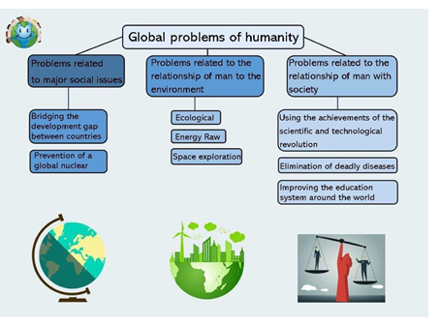
Caption: Global problems of humanity © Lydmila Zadorozhnya CC BY 4.0
INSTRUCTION: Study the diagram and comment on it.

EXPLAIN
Students are given a text regarding the topic of ' The Interaction between Humans and Nature'. The text describes the interaction between humans and nature.
The reading text:
HUMAN IN NATURE – The Interaction Between Humans and Nature -
For a long time, human impact on nature had practically no negative consequences. Nature's natural harmony aroused admiration and a desire to imitate it. The ideal was considered to be life in harmony with the environment, and one of the main tasks was comprehending the laws of nature. However, society's underdeveloped material forces did not allow nature to be treated as the goal of transformative activity.
A sharp change in the relationship between society and nature occurred in modern times. During this period, the natural sciences are rapidly developing, and the experimental activity of humans is becoming more complicated. The most important task of science is not only the knowledge of the secrets and laws of nature, but also the establishment of dominance over it. Such an attitude towards nature is most clearly expressed in the famous formula of other times:
“We cannot wait for favours from nature; it is our task to take them from her.”
With the transition to automobile production, mankind received such means of influencing nature, which later led to acute environmental problems.
The term “ecology” was first used by German biologist E. Haeckel. Ecology is the science of the interaction of living organisms with the environment. Its name is derived from the Greek word “oikos”, which means “house”, “dwelling”, or “place of residence”. Nature is the house in which we live. We must protect it and respect all who live in it.
Think about:
- How does a person build his relationship with nature?
Think about:
- What are the different models of human interaction with nature?
“Nature is a workshop”. A person must act at his own will and discretion, transforming the natural environment in the way he considers necessary and reasonable.
“Nature is a source of pleasure for humans”. Human enjoys the gifts of nature. For example, you can come to the forest by car, listen to the birds, cut down a tree for a fire, and cook food on the fire.
“Nature is a temple”. Humans must idolise nature and admire it. It should not change anything and affect the environment.
“Nature is the progenitor of all living things, the mother of all creatures living on Earth”. Humans take care of the natural environment. Realising his goals, he must not harm nature.

“Nature is an evil element with which a person enters into a struggle”. Human is the king and crown of nature, therefore he must conquer it.
“Nature is a model for a human”. A person should abandon all technical achievements, return to nature's bosom, and lead a natural lifestyle.
INSTRUCTION: Read the text, consider the questions, and take some notes about the topic. Discuss your notes in groups and explain 'the interaction between humans and nature’.
Suggested Questions to consider while keeping notes:
- What features of the natural world and the human world are similar to each other?
- Why can´t human culture exist in isolation from nature?
- What moral rule should be the main one in the relationship of man with nature?

EXTEND
The class is divided into groups. Each group is given a different task and asked to present the results of their work.
Task for the first group: Working with natural materials – to show the contact of nature and humans with culture and a creative approach to nature – use various information sources and discuss the results of the positive impact of humans on nature. The result of the task is a poster themed 'NATURE is the main thing for humans, and human is the main thing for nature'.
INSTRUCTION: Use open information sources and discuss the positive impact humans have on nature. Working with natural materials, create a poster themed 'NATURE is the main thing for humans, and humans are the main thing for nature'.
Task for the second group: Working with the teacher and studying the teacher´s presentation „ Healthy lifestyle and nature, hardening elements”, consulting various information sources, and discussing the results of the negative impact of humans on nature.
INSTRUCTION: Study the teacher´s presentation on 'Healthy lifestyle and nature, hardening elements'. Consult various online open information resources and discuss the results of the negative impact of humans on nature.
Task for the third group: Organize a workshop: working with natural materials, “rich resources of Iceland”, create a message ”My profession does not harm nature“ to deliver.
INSTRUCTION: Use natural materials and create your own thing without harming the nature.

EVALUATE
Students are asked to visit out-of-school learning environments (national parks, botanical gardens, natural monuments, etc.) and observe the interaction between humans and nature. Then, they are asked to answer the evaluation questions.
INSTRUCTION: Visit out-of-school learning environments (national parks, botanical gardens, natural monuments, etc.) and observe the interaction between humans and nature. Answer the evaluation questions based on your observations. Suggested Questions:
-What are the consequences of human impact on the natural environment?
-Give positive and negative examples.
-Which of the interaction models seems to you the most fair? Justify your opinion.
-Where do you see the paradox of the relationship between humans, nature and society?

