Unit 3. Supporting and engaging learners through evidence-based data. (SELF-REFLECTION PHASE)
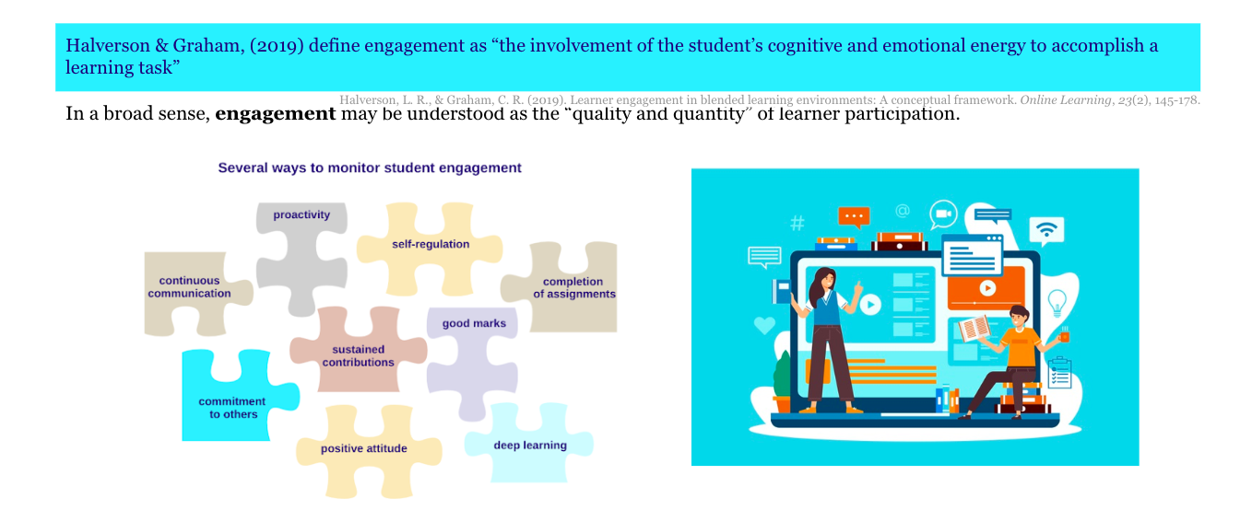
INTRODUCTION

Student engagement is promoted through active learning both in offline and online environments. This means that students are actively involved in assigned tasks, collaborate with their peers and deliver assignments on time. Learning design strategies to foster learners’ engagement include, but are not limited to, question-and-answer sessions, peer review and feedback, discussion, prompt questions, interactive lectures (in which students respond to or ask questions), quick writing assignments, hands-on activities, and experiential learning.

When designing a course, it is important to think of student support strategies. For instance, students should receive feedback about their learning progress, have the possibility to ask questions in a discussion forum and be introduced to the overall course structure. The course structure should clearly show learning resources and activities so that learners can follow their progress. Moreover, when students are asked to provide feedback on separate topics, learning material, assignments, or the overall course, not only do they provide valuable information for improvement but they also feel more committed to the course.

Thus, teachers are encouraged to design and integrate activities at various stages of the course so that they can collect data on their learners’ engagement (see unit 2). And, according to the data gathered, teachers reflect on why students prefer one learning resource or activity to another. How can this information inform teaching and learning? What kind of interventions might be needed to deliver learning support and increase learners’ engagement?

According to the DigCompEdu Framework (Redecker, 2017) to actively engage learners means:
- To use digital technologies to foster learners’ active and creative engagement with a subject matter.
- To use digital technologies within pedagogic strategies that foster learners’ transversal skills, deep thinking and creative expression.
- To open up learning to new, real-world contexts, which involve learners themselves in hands-on activities, scientific investigation or complex problem solving, or in other ways increase learners’ active involvement in complex subject matters.
While there are different types of support that are important for online learners, in this training material we will focus on the elements that the teacher may pre-design and integrate into the course, taking into account VLEs, learning analytics and the importance for students to enhance their SRL skills.
Topics
3.1. How to foster student engagement?
3.2. How to increase students’ engagement through customizable dashboards?

Outcomes
- To use digital technologies to visualise and explain new concepts in a motivating and engaging way, e.g. by employing animations or videos.
- To employ digital learning environments or activities which are motivating and engaging, e.g. games, quizzes.
- To put learners’ active uses of digital technologies at the centre of the instructional process.
- To use digital technologies to allow learners to actively engage with the subject matter at hand, e.g. using different senses, manipulating virtual objects, varying the problem set up to enquire into its structure, etc.
- To select appropriate digital technologies for fostering active learning in a given learning context or for a specific learning objective.
- To reflect on how suitable the different digital technologies used are in increasing learners’ active learning and to adapt strategies and choices accordingly.

Definitions (Moodle Glossary)
- According to The Glossary of Education Reform, learner engagement “refers to the degree of attention, curiosity, interest, optimism, and passion that students show when they are learning or being taught, which extends to the level of motivation they have to learn and progress in their education.” This definition does not concern only students but also school leaders, educators and any other external factors that might “engage” learners in the design and in the decision-making process about their learning. Learners’ engagement is concerned with the relation between the time and effort that has been invested in optimising the learning experience. Engagement can be found in behaviours, thinking processes and signs of emotion. In other words, engagement is perceived as a behavioural, cognitive and emotional dimension.
- Learning Analytics Dashboard: Learning Analytics Dashboards are an important subset of learning analytics and refer to the visual representation of the data automatically generated by the system. LADs are data visualisation tools displaying and representing information in a user-friendly way and providing “meaningful and actionable insights at a glance” (Pokhrel & Awasthi, 2021:93).
- Social engagement: discipline-specific knowledge and higher-order thinking skills, motivation, sense of belonging and well-being, improved relationships through peer learning and collaboration.

STRATEGIES AND RECOMMENDATIONS ON HOW TO SUPPORT AND ENGAGE LEARNERS
Pedagogical point of view:
- Set expectations of learners’ engagement at the very beginning of the course
- Ensure that learning resources and activities are presented in a clear, structured way and that students can find them easily
- Review the course structure in VLE to see whether it shows the learning path
- Encourage real-time interaction
- Provide the adequate number of content pieces
- Where possible, include a short description on what resources and activities they should engage with and why
- Give prompt feedback on assignments and/or learning progress
- Ask students for a feedback on learning resources, activities or a course to ensure the timely decision-making or design changing if needed
- Ensure the presence of a teacher
- Decide on what data related to learners’ engagement might be important to access and analyse when needed
- Analyse data on the teaching and learning process and make informed decisions on what changes need to be made
Technical point of view:
- Use of customizable dashboards
- Link learning activities with learning outcomes so that learners could be aware of their learning progress
- Use open-ended questions
- Favour the use of discussion forums
- Explore the VLE’s affordances related to SRL

VIDEO – Engaging learners in VLEs (optional)

Betts, S.; Simons, S.; Liogier, V. (2020). Engaging learners in VLES. 25th of March, 2020, ETFOUNDATION.CO.UK/EDTECH). (YouTube) Online Webinar.

This is a 1-h webinar and its main aim is to support practitioners to use VLE tools to engage learners online. The webinar introduces the tools and the pedagogical approaches to motivate learners, it deals with Enhance Digital teaching Platform and supporting modules, it also deals with the badging process and the submissions. Some of these topics are not present in these learning materials. However, this optional webinar is a good way to increase your knowledge about online engagement and VLE.
https://www.youtube.com/watch?v=CJ8qBKC5QP4&t=1s

MATERIALS FOR FURTHER READING (OPTIONAL)
Halverson, L. R., & Graham, C. R. (2019). Learner Engagement in Blended Learning Environments: A Conceptual Framework. Online Learning, 23, 145-178.
https://doi.org/10.24059/olj.v23i2.1481

Herodotou, C.; Sharples, M.; Gaved, M.; Kukulska-Hulme, A.; Rienties, B.; Scanlon, E. and Whitelock, D. (2019). Innovative Pedagogies of the Future: An Evidence-Based Selection. Front. Educ. 4:113. https://doi.org/10.3389/feduc.2019.00113

Jivet, I.; Wong, J.; Scheffel, M.; Valle Torre, M.; Specht, M. and Drachsler, H. (2021). Quantum of Choice: How learners’ feedback monitoring decisions, goals and self-regulated learning skills are related. In LAK21: 11th International Learning Analytics and Knowledge Conference (LAK21), April 12–16, 2021, Irvine, CA, USA. ACM, New York, NY, USA, 12 pages. https://doi.org/10.1145/3448139.3448179
https://repository.tudelft.nl/islandora/object/uuid%3Ae89174ea-eb89-4a2a-a5a0-8bd1e30359cd
Naujokaitienė, J. & Tamoliune, G. & Volungeviciene, A. & Duart, J. (2020). Using learning analytics to engage students: Improving teaching practices through informed interactions. Journal of New Approaches in Educational Research. 9 (2). https://doi.org/10.7821/naer.2020.7.561

Pokhrel, J. & Awasthi, A. (2021). Effectiveness of Dashboard and Intervention Design. In Sahin, M. & Ifenthaler, D. (eds.), Visualizations and Dashboards for Learning Analytics, Advances in Analytics for Learning and Teaching. Chapter 5, pp. 93-116. Retrieved from https://link.springer.com/chapter/10.1007/978-3-030-81222-5_5

Redecker, C. (2017). European Framework for the Digital Competence of Educators: DigCompEdu. Punie, Y. (ed). EUR 28775 EN. Publications Office of the European Union, Luxembourg. Retrieved from: https://op.europa.eu/en/publication-detail/-/publication/fcc33b68-d581-11e7-a5b9-01aa75ed71a1/language-en

Rets, I., Herodotou, C., Bayer, V. et al. (2021). Exploring critical factors of the perceived usefulness of a learning analytics dashboard for distance university students. Int J Educ Technol High Educ 18: 46. https://doi.org/10.1186/s41239-021-00284-9.

