Project ID: 2021-1-CZ01-KA220-SCH-000034484

COURSE FOR ENVIRONMENTAL EDUCATION
e-Modules: Teaching Learning activities and their technology enhanced material set to develop

DISCLAIMER
Funded by the European Union. Views and opinions expressed are however those of the author(s) only and do not necessarily reflect those of the European Union or the European Education and Culture Executive Agency (EACEA). Neither the European Union nor EACEA can be held responsible for them.

COURSE AUTHORS
Lubomír Hájek, Petra Garay

COURSE SHARING LICENSE
You are free to:
- Share — copy and redistribute the material in any medium or format for any purpose, even commercially.
- Adapt — remix, transform, and build upon the material for any purpose, even commercially.

MODULE 3 | NATURE AND CLIMATE CHANGE
PART 5 | Climate system
Lesson 1 | Components of the climate system

SUMMARY

1. COURSE TIME, TARGET AND TOPIC 3

2. COURSE OBJECTIVES 3
Competences promoted in this lesson: 3
Lesson objectives: 3

3. LEARNING – TEACHING PROCESSES 3

4. EVALUATION 3

5. DOCUMENTS 4
ENGAGE 4
EXPLORE 4
EXPLAIN 5
EXTEND 6
EVALUATE 7

1. COURSE TIME, TARGET AND TOPIC
- Age of target students: 15+
- Teaching time: 1 hour
- Disciplines: Biology, Geography, Chemistry
- Title: Components of the climate system

2. COURSE OBJECTIVES

Competences promoted in this lesson:
- Communication in foreign languages competency
- Digital competency
- Mathematical competency
- Learning to learn competency
- Cultural awareness

Lesson objectives:
- Students ask and answer about the climate system.
- Students explain the major components of the climate system
- Students comprehend the factors influencing the climate system.

3. LEARNING – TEACHING PROCESSES
There are 4 activities in this lesson:
- ENGAGE: Introduction to climate systems
- EXPLAIN: discuss the key role of each climate system
- EXPLORE: deepen the understanding of climate systems.
- EXTEND: field studies and home projects

4. EVALUATION
Ask and answer questions

5. DOCUMENTS

ENGAGE
- Ask and answer these questions in pairs/groups.

- What do you know about climate change?
- Have you ever wondered what influences our weather patterns?
- Why is understanding climate systems important for our world today?
- How do natural processes and human activities contribute to the climate system?
- Can you name the components(spheres) of the Earth's climate system?
- Watch the introductory video and learn more about the climate systems:
https://www.youtube.com/watch?v=LHkEW22M5Vg&t=14s&ab_channel=DuttonInstitute
- Work in pairs. Name the components of Climate systems you have seen in the video. The definition of the systems might help you.
- ________________ (the thin layer of gases surrounding the earth)
- ________________ (the land surfaces such as soil and rocks, and human-made surfaces such as roads and buildings)
- ________________ (the Earth’s liquid water in oceans, rivers, lakes and underground)
- ________________ the frozen water in ice and snow)
- ________________ (the living things such as plants and animals including humans).

EXPLORE
- Discuss the role of each component in regulating climate and maintaining the Earth's overall balance and complete the missing words in the picture you have seen in the video.
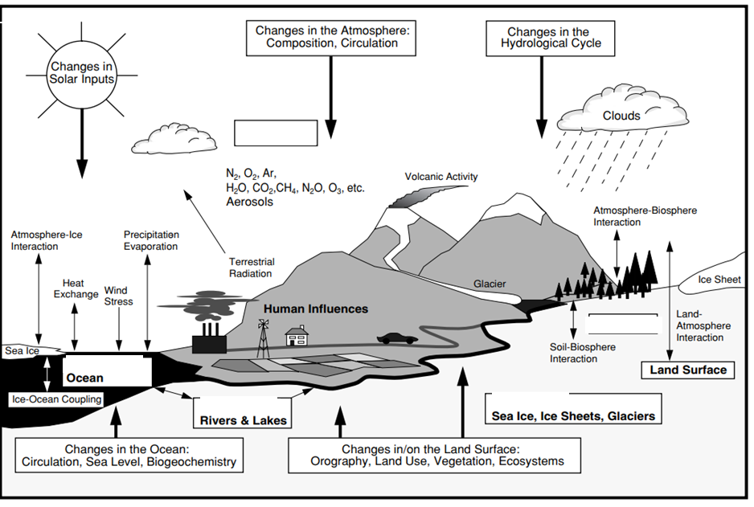

EXPLAIN

Complete each system with the missing word given.
  - The Atmosphere
The atmosphere is the thin layer of ________ surrounding the Earth. The atmosphere is important for regulating the Earth’s ________.
The types and amounts of gases in the atmosphere can change how much heat and light can pass through. Some gases can trap ________. These gases are called greenhouse gases and include ________ ________ and methane.
Human activities such as burning ________________ are rapidly increasing the amount of greenhouse gases in the atmosphere. This is causing our climate to warm.
Missing words: carbon dioxide; fossil fuels; temperature; gases; heat
  - The Lithosphere
The lithosphere is the land surfaces such as ________ and rocks, and human-made surfaces such as roads and buildings. The different materials that make up the lithosphere absorb different amounts of ________ from the sun, while mountains can slow or redirect ________ and affect where ________ falls.
Missing words: winds; energy; rain; soil

  - The Hydrosphere
The hydrosphere is all of the Earth’s ________ water found in oceans, rivers, lakes and underground. Oceans help regulate Earth’s ________ by absorbing and releasing heat from the sun. This heat is transported around the world through ocean ________ like the East Australian Current.
Water ________ from oceans and waterbodies and collects as water ________ in the atmosphere. The process of ________ helps keep climate close to these water bodies cooler and the water vapour can also fall as rain.
Missing words: temperature; liquid; evaporation; vapour; evaporates; currents
  - The Cryosphere
The cryosphere is the frozen water in ice and snow. The cryosphere is mostly made up of sea ice in the Arctic and Southern oceans, and the land-based ice sheets of Greenland and Antarctica. It also includes the ice and snow in many ________ regions across the globe.
Ice and snow help ________ climate, as their white colour ________ energy from the sun back into space. The seasonal freezing and melting of snow and ice helps ocean water ________ around the world.
Missing words: regulate; reflects; circulate ;elevated
  - The Biosphere
The biosphere refers to the livings things that are found on Earth. Life plays an important role in the Earth's climate over short (seasonal) and long time-scales (millions of years). For example, plants absorb ________ ________ from the atmosphere which helps regulate the global climate and ________ the rate of global warming.
‘Under the right conditions and over thousands to millions of years, plants lock away carbon dioxide through the formation of ________ and coal.
Missing words: peat; reduces; carbon dioxide

EXTEND
- Field Observation and Documentation:
  - Organize a guided nature walk around the school campus, focusing on observing natural features that can influence climate, such as bodies of water, vegetation, and topography.
  - Have students take notes and photographs of these features, paying attention to their effects on temperature, humidity, and wind patterns.
- Discussion and Reflection:
  - Facilitate a group discussion where students reflect on their outdoor observations and data analysis.
  - Encourage students to share their insights on how local climate systems are influenced by factors like geography, vegetation, and human activity.
  - Discuss the importance of understanding local climate systems in the context of global climate change.
- Presentation and Sharing:
  - Instruct students to prepare a short presentation summarizing their findings from the outdoor activity.
  - Each group should share their observations, analysis, and conclusions with the class.
  - Encourage peer feedback and discussion to deepen understanding and critical thinking about climate systems.
Home Project: Climate System Investigation
For the home project, students can conduct further research and investigation into climate systems. Here's a suggested plan:
- Select a Climate System Topic:
  - Encourage students to choose a specific aspect of climate systems that interests them, such as atmospheric circulation patterns, ocean currents, or the greenhouse effect.
- Research and Data Collection:
  - Instruct students to gather information from reliable sources, such as scientific articles, books, and online databases, related to their chosen topic.
  - Encourage them to collect data and examples to support their understanding, such as temperature maps, ocean current diagrams, or greenhouse gas emissions data.
- Analysis and Interpretation:
  - Guide students through analyzing the data and information they have collected.
  - Encourage them to identify key trends, relationships, and potential impacts of their chosen climate system on global climate patterns.
- Presentation of Findings:
  - Ask students to create a visual presentation (e.g., PowerPoint, poster) summarizing their research findings.
  - Encourage them to include clear explanations, data visualizations, and real-life examples to enhance understanding.
- Reflection and Discussion:
  - Facilitate a class discussion where students can share their findings and insights from their home projects.
  - Encourage peer feedback and discussion to deepen understanding and encourage critical thinking about climate systems.
By engaging in both an outdoor activity and a home project, students can gain hands-on experience and deepen their understanding of climate systems, fostering a holistic approach to learning about this complex topic.

EVALUATE
- Final revision – ask and answer these questions in pairs/groups.
- What are the key components of the Earth's climate system?
- How do they interact with each other? Provide examples of these interactions.
- Explain the impact of human activities on climate systems.
- How do factors such as deforestation, industrial emissions, and urbanization contribute to changes in the climate?

Sources:
https://www.climatechange.environment.nsw.gov.au/basics-climate-change/global-climate-system
https://www.youtube.com/watch?v=LHkEW22M5Vg&t=14s&ab_channel=DuttonInstitute

