MRP I SYSTEMS AND MRP II SYSTEMS
SUGGESTED EXERCISE-1

Let us plan the material requirements of the following products:

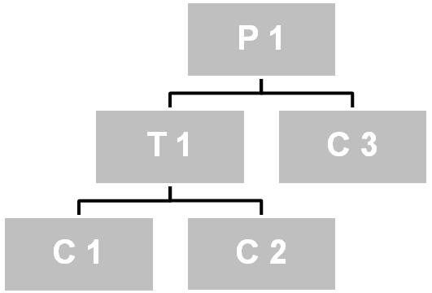
1

3
1

3
2

P1 and C3 are independent demand products; that is, they are manufactured under external customers’ demand. P1 is a finished product and C3 is a component sold as a spare part.

The production schedule is the following:

Products\Date | 01-Apr | 08-Apr | 15-Apr | 22-Apr
P1 | 80 | 95 | 87 | 99
C3 | 150 | 145 | 160 | 130

Besides, we know the available inventory and the safety stock for each product, their manufacture term, the percentage of failures and the manufacture lot, shown below:

PRODUCTS | SFT STOCK | REP TERM | % FAILURES | AVAIL STOCK | LOT
P1 | 10 | 1 | 0 | 10 | LBL
T1 | 0 | 2 | 5 | 25 | M10
C3 | 10 | 1 | 5 | 10 | M25
C1 | 15 | 1 | 10 | 15 | M25
C2 | 15 | 1 | 12 | 15 | M50

Data:

M 25 Multiple of 25 lots
M 50 Multiple of 50 lots
M 10 Multiple of 10 lots
LBL Lot by lot (we order only what is required)

Complete each component’s files and define the launches or manufacture orders for each one.

LEVEL 0

Gross requirements
Available stock
Net requirements
Launches
LEVEL 1

Gross requirements
Available stock
Net requirements
Launches
Gross requirements
Available stock
Net requirements
Launches
LEVEL 2

Gross requirements
Available stock
Net requirements
Launches
Gross requirements
Available stock
Net requirements
Launches

We want to calculate the manufacturing capacity in the working centres for the established production schedule.

Determine the workload for each working centre (assembly, C100, C200, C300 and C400), indicating the dates when overtime is necessary to meet the production schedule established, if in each working centre, we start in the following conditions:

PRODUCT | NoSTAGE | W.LOAD | TERM | LOT | PREP T. (hours). | OPER T. (minutes).
P1 | 1 | Assembly | 1 | 100 | 6 | 22
T1 | 1 | c100 | 1 | 100 | 4 | 5,5
 | 2 | c200 | 1 | 150 | 5 | 14
C1 | 1 | c300 | 1 | 100 | 1 | 4
C2 | 1 | c300 | 1 | 200 | 1 | 4
C3 | 1 | c400 | 1 | 100 | 1 | 9

Besides, represent graphically the results got.

P1 | ASSEMBLY
T1 | C100
 | C200
C1 | C300
C2 | C300
C3 | C400

ASSEMBLY
CA. MAX
C100
CA. MAX
C200
CA. MAX
C300
CA. MAX
C400
CA. MAX

