Unit 1.2. How to set course activities’ settings to track learners’ engagement?

As emphasised in the conceptual introduction, designing courses with digital technologies and tools, whether it is for assessment purposes or other teaching and learning purposes, generates a wide range of data. Therefore, it is very important for teachers to know how to configure a learning management system (LMS) and set up learning activities that would generate the type of digital evidence they require.

When designing a course, make sure that the course structure is consistent and clear, students can easily follow and recognise the learning pathway on Moodle and the learning resources are described as compulsory or supplementary. Course assignments should generate data evidence (more in 1.2.1) and be linked to the course outcomes based on a course grade book (more details in 1.2.2). Such alignment and configuration allow students to understand how their learning will occur and what the key criteria and requirements for successful course completion are. Learners will grasp what resources need to be analysed, what activities are delivered to learn the subject and how each assignment contributes to the completion of learning outcomes.

In this subunit, we will share recommendations on the important settings to take into consideration when designing learning activities in the LMS. Firstly, we will observe the main settings that should be configured when designing learning activities aimed at tracking learners’ progress and supporting SRL. Secondly, we will deal with the settings of the discussion forum and attendance activity. Finally, we will present how to add and align learning outcomes with learning activities. Following these recommendations, we will also explain why these settings are important when thinking of data analysis and learners’ engagement.

1.2.1. Setting up activity completion to track students’ progress and support SRL
The activity completion setting allows students to keep track of their learning progress in Moodle. At the same time, teachers can monitor how learning progress is happening.
Activity completion can be tracked for both learning activities and learning resources. Since most of the courses have multiple learning resources and activities that can be included, it is up to the teacher to decide which of them to deliver and analyse. After deciding this, you should ensure that the activity completion for these learning resources and activities is set-up. How?

When designing a Moodle Assignment activity, you should make sure that the following sections are completed:

- Availability section
In the Availability section teachers may enable and specify dates and times when they expect students to deliver assignments.
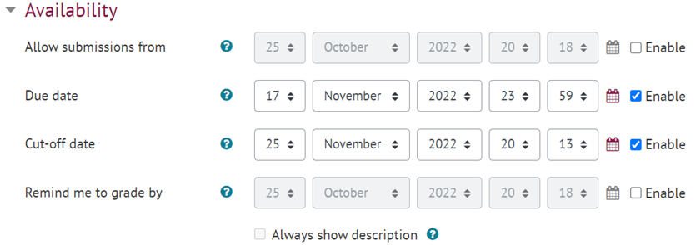
Figure 1. An example of Moodle Assignment availability settings

When assignment dates are set and enabled, they appear in a calendar automatically, so students may check and see the upcoming assignments at any time (fig. 2). Furthermore, students can see assignment dates on the homepage when they log-in to Moodle.
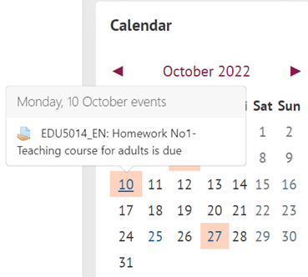
Figure 2. An example of a course calendar after availability dates are set

Setting up Availability section may help students to plan their own learning, since after the dates are set, students and teachers receive reminders of the upcoming events and deadlines.

- Feedback section
Configuring a Feedback section is also very important since it depends on these settings if students will be able to provide additional personal comments when submitting an assignment (which supports their reflection and self-assessment). It also depends on these settings if a teacher will be able to insert comments or upload additional files when marking assignment submission (fig. 3). Selected Feedback comments will allow both teachers and students to post comments on each submission.
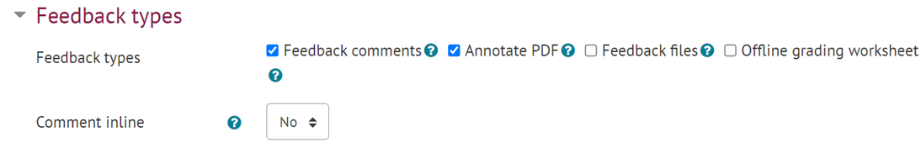
Figure 3. An example of the feedback types on the assignment

- Activity completion
Another Assignment section that is very important to configure in order for the data to be generated is the Activity completion section. When this section is configured, it generates data on the learning progress and allows teachers and students to see which activities are completed and which are not.
It is important to note that activity completion can be set up for both learning activities and learning resources. There are 3 activity completion tracking options available:
(1) Do not indicate activity completion
(2) Students can manually mark the activity as completed
(3) Show the activity as complete when conditions are met
According to teaching strategies and learning goals, you should decide which option is the most appropriate for the task. For example, in the case of supplementary learning materials that do not have to be analysed, it is better to select the ‘do not indicate activity completion’ option, just to ensure that the activity completion bar is not overloaded with activities which are not compulsory in this course. Then, if there is a lecture recording uploaded that students need to watch, a teacher can choose to allow students to mark the completion of this activity manually.

You can also choose to set the conditions for the activity to be completed (fig. 4). In such a case, after the conditions are met, the activity completion is ticked as completed automatically.
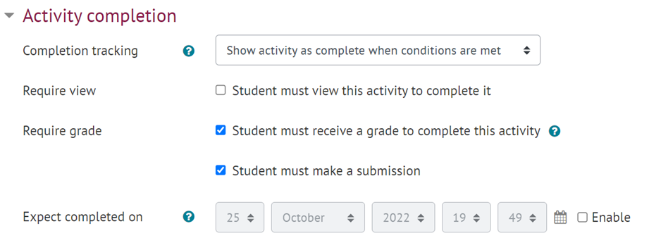
Figure 4. List of conditions that need to be met for the activity to be completed

Finally, the teacher may set a date for the expected completion, which would be included in the calendar automatically and send reminders to students of the upcoming assignments which support learners’ self-regulated learning.
Please check the video tutorial on activity completion: Activity completion

1.2.2. Setting up a discussion forum and attendance activities
Another Moodle tool that could be used for tracking learners’ engagement and supporting their self-regulated learning is the discussion forum. It is important to configure its settings correctly so that learners monitor their own learning, are aware of the most recent discussion and can engage in discussions. It is up to you to decide if you want a discussion forum to generate digital evidence. If you want to analyse learners’ social and cognitive engagement through participation in discussion forums, and at the same time support learners’ SRL, then when adding a new forum to a course, you should pay attention to the following settings:

- Availability, where the due date and cut-off dates can be set up, after which students can no longer post. After the dates are set and enabled, they are displayed in the calendar and so students stay informed that they need to contribute to the discussion and how much time they have left to do this.
- Subscription and tracking. When course participants are subscribed to the forum, they receive notifications of every new post. When designing a forum activity, a teacher needs to decide the subscription mode, whether it will be optional, forced, auto or disabled (fig. 5).
- 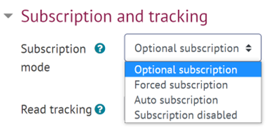
Figure 5. Forum subscription settings
When subscription mode is set as optional, course participants can choose if they want to be informed of new postings or not. However, if a teacher wants to foster learners’ engagement in some specific forum and support students’ self-regulated learning by encouraging them to reflect on their own engagement and plan their learning by timely contribution to discussions on a given topic, he/she may select a forced subscription. In such a case, all course participants will be subscribed automatically. This mode might be useful at the very beginning of the course when a teacher expects all students to be aware of posts that are related to course content or the overall learning process. Similarly, it might be useful when a forum activity is used for learning purposes so that all learners are aware of the ongoing discussion on a given topic.
Moreover, by setting up read tracking as optional, students see and monitor which posts have not been read yet (fig. 6).
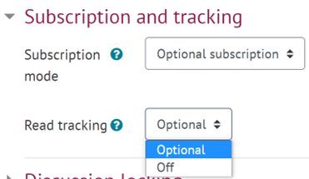
Figure 6. Forum read tracking settings

Finally, activity completion should also be set-up according to the aim of the forum and its contribution to learning progress. Please check the video tutorial on setting-up a Forum in Moodle - Forum in Moodle.
Another setting for data collection and learning monitoring is Attendance, which can be used for a twofold reason: (1) teachers monitor and take attendance during classes and (2) students monitor their own attendance. This setting generates data either for the entire group or for an individual student. Teachers can specify if the attendance regards lectures, workshops, seminars, labs or units.
1.2 .3. Link the learning outcomes with the learning activities and setting up a grade book
After course assignments and activities are designed, it is recommended to align them with the course learning outcomes. Aligning activities with the learning outcomes provides support to students by informing them how each activity contributes to the development of a particular competence. To do this, the teacher needs to turn on course editing and in the Administration block select Outcomes. Learning outcomes might be added manually or imported from other files (fig. 7).
Figure 7. An example of the course learning outcomes

After learning outcomes are inserted, the teacher can select which of the inserted learning outcomes will be achieved after completing the activity and align learning outcomes with the activity accordingly (fig. 8).
Figure 8. An example of learning outcomes linked to a specific learning activity

A grade book

Finally, after you add an assessed item to a Moodle course, a grade book automatically creates spaces for grades and adds them as soon as they are generated either by the teacher or by the system (fig. 9). Grade items refer to course activities, e.g., an assignment, a peer review, a quiz, or learning outcomes. Therefore, teachers need to consider what data is important and need to be included in the grade book. You need to make sure that each assignment is linked with specific learning outcomes and that the assignment grading is set appropriately.
Figure 9. An example of a grade book report

The course grade settings can be found in the Administration block -> Gradebook setup.
The grade book setup shows the teacher what assignments and learning outcomes are included in the grade book and which tasks are linked with each learning outcome. The grade book is useful for several reasons: it allows you to monitor and reflect on whether the pre-planned learning assignments are sufficient to achieve learning outcomes. If designed well before starting the course, it may generate reports with digital evidence showing whether students have achieved the foreseen outcomes and showing which students have achieved given outcomes.

N.B. Screenshot examples presented are retrieved from the course “Concepts of adult education”, teachers E. Trepule, G. Tamoliune. Teachers’ approval has been received.

Best practice example
Title: Reflective Learning, Teaching, and Assessment Based on Learning Analytics (Volungeviciene et al., 2021)
University: Vytautas Magnus University (VMU), Lithuania
Section of the framework: C - Metacognitive strategies to measure awareness of learning design
What competencies and learning outcomes of the DigicompEdu Framework are we addressing?
Competencies | Learning outcomes
Self-regulated learning  Assessment strategies  Actively engaging learners  Analysing evidence | - To use digital technologies (e.g. blogs, diaries, planning tools) to allow learners to plan their own learning.  - To use digital technologies to enable learners to reflect on and self-assess their learning process.  - To critically reflect on the appropriateness of digital assessment approaches and adapt strategies accordingly.  - To put learners’ active uses of digital technologies at the centre of the instructional process.  - To design and implement learning activities which generate data on learner activity and performance.

Key issues: This case is based on analysis of a specific Moodle course and presents examples on how a course teacher applies metacognitive strategies when designing teaching and learning.
Each lecture introduces students to the theoretical and practical background needed for assignment implementation. Assignment implementation tools maintain the indicators and criteria that are linked with the theoretical and practical references and should be applied by students during the assignment implementation process.
To make sure that students are aware of their cognition, learning strategies and management of their learning process, there is a study guide, which is developed by the course teacher prior to the beginning of the course. In this study guide, together with other important information related with the course, students can see the sequence of tasks and assignments, as well as expectations of their performance. The study guide presents the sequence of assignments and their link with the theory and learning strategy planning (see fig. 1). At the same time, students can see the time and place their attendance is needed.
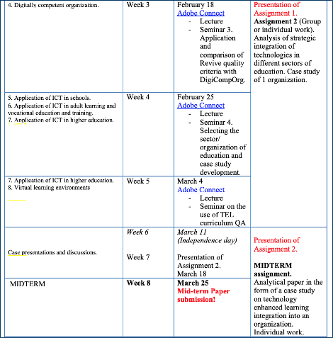
Figure 1. Excerpt from a study guide (Volungeviciene et al., 2021, p. 164).
By knowing in advance how each theoretical presentation and topic relates to the assignments, learners are expected to become more aware of how they have to plan their learning to deliver assignments on time and keep up with the overall learning process in the course. Each assignment is described in detail in the study guide as well as in Moodle, indicating the time for submission, the evaluation criteria and the format expected (e.g., essay, presentation, video, mindmap).
In this way, the description of the assignments and the expected learners’ performance is clarified at the very beginning of the course. Teachers and students can also see:
(1) assignments linked with the course calendar (setting reminders for students) (fig. 2)
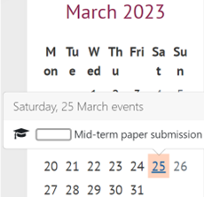
Figure 2. The course calendar (adapted from Volungeviciene et al., 2021, p.165 ).
(2) assignments integrated with the progress bar used in Moodle course (fig. 3)
Figure 3. Assignment and learning progress integration in Moodle (Volungeviciene et al., 2021, p. 166).
(3) activity completion tool (Fig. 4), and (4) assignments linked with learning outcomes.
Figure 4. Self-Assessment for Assignment and Learning Implementation Using Activity Completion Tools in Moodle (Volungeviciene et al., 2021, p. 166).
After setting up tools that generate data, teachers can track learners’ engagement and monitor learning process and student performance by noticing delays or problems.
Relevance for teachers: As the example shows, you have to make sure that there is consistency and clarity between the learning design solutions and the course activity configuration. You can develop a study guide prior to the beginning of the course to show the learning pathway, the assignments’ due-dates and the activity completion settings. Then, you can add these dates to the calendar and align learning activities with learning outcomes. Early provision of information in the study guide should also include a clear description of the tasks, assessment criteria and the expectations of students’ performance. These measures will allow you to collect data of students’ learning and engagement. By being aware of what is expected from them and how the learning process is organised, it will be easier for students to become more engaged and develop their self-regulation skills. At the same time, these measures help teachers make timely and data-based evidence decisions for the improvement of learning design.

References
Volungeviciene, A., Tereseviciene, M., & Trepule, E. (2021). Learning Analytics: a Metacognitive Tool to Engage Students. Research study. Sciendo. https://doi.org/10.2478/9788366675643

