Project ID: 2021-1-CZ01-KA220-SCH-000034484

COURSE FOR ENVIRONMENTAL EDUCATION
e-Modules: Teaching Learning activities and their technology enhanced material set to develop

DISCLAIMER
Funded by the European Union. Views and opinions expressed are however those of the author(s) only and do not necessarily reflect those of the European Union or the European Education and Culture Executive Agency (EACEA). Neither the European Union nor EACEA can be held responsible for them.

COURSE AUTHORS
Lubomír Hájek, Petra Garay

COURSE SHARING LICENSE
You are free to:
- Share — copy and redistribute the material in any medium or format for any purpose, even commercially.
- Adapt — remix, transform, and build upon the material for any purpose, even commercially.

MODULE 1 | HUMAN AND NATURE
PART 3 | The positive and negative effects of nature on human being ; The natural and artificial environment
Lesson 1 | The positive and negative effects of nature on human being

SUMMARY

1. COURSE TIME, TARGET AND TOPIC 3

2. COURSE OBJECTIVES 3
Competences promoted in this lesson: 3
Lesson objectives: 3

3. LEARNING – TEACHING PROCESSES 3

4. EVALUATION 3

5. DOCUMENTS 4
ENGAGE 4
EXPLORE 5
EXPLAIN 6
EXTEND 7
EVALUATE 8

1. COURSE TIME, TARGET AND TOPIC
- Age of target students: 15+
- Teaching time: 2 hours
- Disciplines: Biology, Human sciences, Chemistry
- Title: The positive and negative effects of nature on human being - Lithosphere and Atmosphere

2. COURSE OBJECTIVES

Competences promoted in this lesson:
- Communication in foreign languages competency
- CLIL
- Digital competency
- Learning to learn competency.
- Initiative and entrepreneurship competencies
- Social and citizenship- related competence
- Cultural awareness

Lesson objectives:
- The students deepen their knowledge regarding the varieties of fertilizers.
- The students deepen their knowledge about the importance of the trees.
- They apply the knowledge for practical activities.

3. LEARNING – TEACHING PROCESSES
There are 4 activities in this lesson:
Lithosphere:
- ENGAGE: answer the questions, watch the video
- EXPLAIN: elements in chemical fertilizers
- EXPLORE: Chemical fertilizers x Natural fertilizers (watch the videos)
- EXTEND: Tasks for students – vermi-composter, growing beans

4. EVALUATION
Lithosphere- advantages and disadvantages of chemical
Atmosphere-urban tree benefits

5. DOCUMENT

ENGAGE

Area of focus: Chemical fertilizers x Natural fertilizers
Q: Try to answer the following questions:
- What kind of natural and chemical fertilizers do you know?
- Did you know the difference between chemical and natural fertilizers?
- If you fertilize at home, what kind of fertilizers do you use?
- Are all fertilizers beneficial to the soil?

Watch the video:
https://www.youtube.com/watch?v=vm7e9lZlG54
What did you learn from the video?

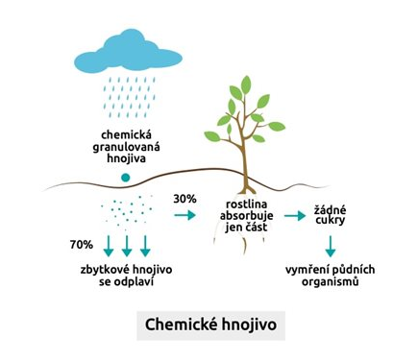
EXPLORE
Caption: Chemical fertilizers (c) Source :(https://www.zahrady-hastik.cz/hnojiva-pure-travnik/) CC BY 4.0
Chemical fertilizers
Residual fertilizer is washed away
Extinction of soil organisms
No sugars
The plant absorbs onlly a part
Chemical granular fertilizers
Q: Watch the video: How does fertilizer work?
https://www.youtube.com/watch?v=n7nG-gHcv4I&t=29s

Q: Watch the video: 8 Natural and Organic Fertilizers to Grow Big Plants
https://www.youtube.com/watch?v=lofNYAtHYu4&t=115s
What did you learn from the video?

EXPLAIN
Chemical fertilizers
Q: What elements are most often included in chemical fertilizers?
Find what NaNO₃ is:
Complete the equation to produce this fertilizer:
NO + NO₂ + Na₂CO₃ + O₂ →

EXTEND
TASK 1: Find out what is vermicomposter and what is it good for?
Make your own vermicomposter.
We will need 3 buckets or boxes. Cut a large hole in the bottom bucket. Stick it to the bottom of the next bucket. Fit the bottom of the middle bucket with holes using a drill. The liquid component will flow through them into the lower bucket. Then follow the same procedure for joining the lid of the middle container and the bottom of the top bucket. Then just puncture the lid of the top bucket and you are done. In the end, all you must do is add dirt where the earthworms can live and water it.
TASK 2:
Plant one bean in 3 cups of soil. The first cup manure chemical fertilizer, the second cup manure natural fertilizer and the third cup doesn’t fertilize at all. Watch which will grow the fastest and which the slowest. Review your progress each week and document it.

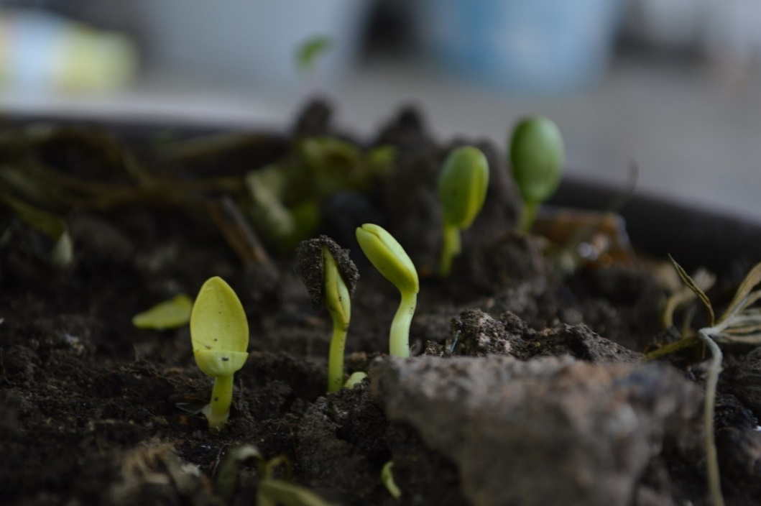
Caption: Green Sprouts grown (c) Source: (https://www.wallpaperflare.com/green-sprouts-grown-up-born-earth-nature-soil-moisture-wallpaper-wngcx) CC BY 4.0
picture: pixabay.com

EVALUATE

Q: List advantages and disadvantages of chemical fertilizers

Possible answers:
Advantages:  - Precisely given ratios of nutrients  - Soluble in water faster nutrient access  - Cheap | Disadvantages:  - Produced from non-renewable resources oil.  - It kills the soil the soil loses organic matter and microbial ecosystem.  - Danger of over fertilization  - Excess mineral salts can accumulate to toxic levels

Sources:
- https://www.swardman.com/cz/navody/srovnani-organickych-a-chemickych-travnich-hnojiv/
- https://www.pokojovky.co/blogs/blog/chemicke-vs-prirodni-hnojiva
- https://cs.wikipedia.org/wiki/Pr%C5%AFmyslov%C3%A1_hnojiva
https://www.idnes.cz/hobby/dilna/jak-vyrobit-vermikomposter-svepomoci.A140909_120832_hobby-domov_mce

