Project ID: 2021-1-CZ01-KA220-SCH-000034484
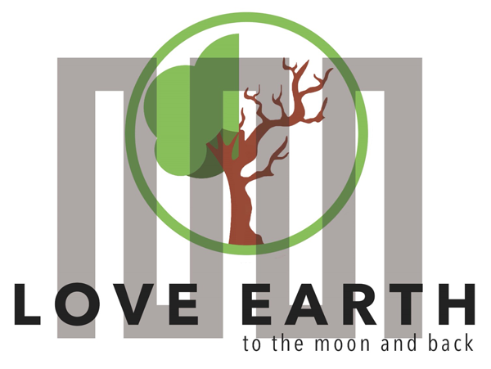

COURSE FOR ENVIRONMENTAL EDUCATION
e-Modules: Teaching Learning activities and their technology enhanced material set to develop

DISCLAIMER
Funded by the European Union. Views and opinions expressed are however those of the author(s) only and do not necessarily reflect those of the European Union or the European Education and Culture Executive Agency (EACEA). Neither the European Union nor EACEA can be held responsible for them.

COURSE AUTHORS
Céline CORNEILLE, Paul FERNANDEZ, Frédéric GUILLERAY, Marine ROBINI and Ervan ROUSSEL.

COURSE SHARING LICENSE
You are free to:
- Share — copy and redistribute the material in any medium or format for any purpose, even commercially.
- Adapt — remix, transform, and build upon the material for any purpose, even commercially.

MODULE 6 | SUSTAINABLE DEVELOPMENT AND SOLUTIONS TO ENVIRONMENTAL PROBLEMS AND CLIMATE CHANGE
PART 3 | Mitigation and Adaptation Strategies
Lesson 1 | I am part of my local environment

SUMMARY

1. COURSE TIME, TARGET AND TOPIC 3

2. COURSE OBJECTIVES 3
Competences promoted in this lesson: 3
Lesson objectives: 3

3. LEARNING – TEACHING PROCESSES 3

4. EVALUATION 3

5. DOCUMENTS 4
ENGAGE 4
EXPLORE 5
EXPLAIN 6
EXTEND 7
EVALUATE 8

1. COURSE TIME, TARGET AND TOPIC
- Age of target students: 15+
- Teaching time: 1-2 hours
- Disciplines: Biology
- Title: I am part of my local environment

2. COURSE OBJECTIVES

Competences promoted in this lesson:
- Communication in foreign languages competency
- Digital competency
- Learning to learn competency
- Social and citizenship-related competencies

Lesson objectives:
- Students experience and interpret the local environment and consider the changes over time.
- Students explain the changes in the local environment within the climate change

3. LEARNING – TEACHING PROCESSES
There are 4 activities in this lesson:
- ENGAGE: My footprint in my local environment (calculation and identification of actions)
- EXPLORE: The world has changed (interviews to identify changes over time and actions around me)
- EXPLAIN: I'm in a network (interviews of school administration and policy makers)
- EXTEND: What can I do? (choice of actions to take among 35)

4. EVALUATION
The evaluation is described in the last part of document.

5. DOCUMENTS

ENGAGE
My footprint in my local environment

Q1. Calculate your environmental footprint with the WWF footprint calculator.
https://footprint.wwf.org.uk


Report here your result:
My environmental footprint: ………… tonnes

Q2. Get into a group. Think about the elements of your score that depend on your local environment: family, school, city, country.
For example: the source of your home's electricity, the temperature of your school in winter, the modes of transport available in your town, the stores available in your country, etc.

Q3. Finaly, get In The lets break it down box, click on Reduce this score for the 4 themes: home, food, travel, stuff.
What tips are applicable in your local environment?

FIELD | Tips applicable FOR ME IN ME ENVIRONMENT
HOME
FOOD
TRAVEL
STUFF

EXPLORE
The world has changed

Q. You have to discuss with other students of your age (at least 4) and to members of your family (at least 4).
Ask them to identify:
- changes in their habits over the past 5 years.
- actions they have taken to combat climate change
With their answers, complete the table below:

FIELD | CHANGES OVER TIME (habits, actions)
HOME
FOOD
TRAVEL
STUFF

EXPLAIN
I'm in a network

Q1. You must divide into 3 groups. Each group will conduct interviews about the environmental footprint in our local environment.
Here are the people to interview:
- teachers at least 3 interviews
- at least one school administrator at least 2 interviews
- at least one person from the town at least 2 interviews

Example of an interview grid for the school administrator:
- Can you introduce yourself and explain your role within the school?
- How aware are you of environmental and climate issues?
- How does the school manage its energy consumption (electricity, heating, etc.)?
- Have you taken any steps to reduce energy consumption (e.g. LED bulbs, thermal insulation)?
- Does the school encourage sustainable modes of transport such as car-sharing, cycling or public transport?
- Does the school canteen offer vegetarian or low-carbon footprint meals?
- Are efforts being made to reduce food waste within the school?
- Do you use local or organic produce for school meals?
- What is the school's waste management policy?
- Have you set up recycling or composting programs?
- What steps have been taken to raise awareness of waste reduction among students and staff?
- What initiatives have been taken to reduce paper consumption (e.g., digitization of documents, use of digital tools)?
- Are measures in place to encourage the use of eco-responsible IT equipment?
- What initiatives are in place to raise awareness of environmental issues among students and staff?
- What measures are in place to raise awareness of environmental issues among students and staff?
- How do you assess the impact of your actions on reducing the school's carbon footprint?
- In your opinion, what would be the three most effective actions to reduce our school's carbon footprint?
The grid can be adapted for each target.
Each group must prepare a summary of its interviews

Q2. Pool the answers from each group and build a mind map of your local environment. This map should show what has already been done to combat global warming, and where there is room for improvement.

EXTEND
What can I do?

Q. Read the article “The 35 Easiest Ways to Reduce Your Carbon Footprint” and choose at least 5 actions to implement that you're not already doing.
Then, promote them around you...

Link to The 35 Easiest Ways to Reduce Your Carbon Footprint:
https://news.climate.columbia.edu/2018/12/27/35-ways-reduce-carbon-footprint/

EVALUATE

Q. For each of the fields below, list at least 3 actions that can be taken to combat climate change.

FIELDs | actions to combat climate change
HOME | 1.  2.  3.
FOOD | 1.  2.  3.
TRAVEL | 1.  2.  3.
STUFF | 1.  2.  3.

