|  |  |  |  |  |
| --- | --- | --- | --- | --- |
| **Project ID: 2021-1-CZ01-KA220-SCH-000034484**    **COURSE FOR ENVIRONMENTAL EDUCATION**  *e-Modules: Teaching Learning activities and their technology enhanced material set to develop*  ***DISCLAIMER***  *Funded by the European Union. Views and opinions expressed are however those of the author(s) only and do not necessarily reflect those of the European Union or the European Education and Culture Executive Agency (EACEA). Neither the European Union nor EACEA can be held responsible for them.*  Obsah obrázku symbol, Písmo, logo, Grafika  Popis byl vytvořen automaticky  **COURSE AUTHORS**   |  |  | | --- | --- | |  | Lubomír Hájek, Petra Garay |   **COURSE SHARING LICENSE**   |  |  | | --- | --- | |  | You are free to:   * Share — copy and redistribute the material in any medium or format for any purpose, even commercially. * Adapt — remix, transform, and build upon the material for any purpose, even commercially. | |
|  |

|  |  |
| --- | --- |
| **MODULE 6** | **SUSTAINABLE DEVELOPMENT AND SOLUTIONS TO ENVIRONMENTAL PROBLEMS AND CLIMATE CHANGE** |
| **PART 1** | **SUSTAINABLE DEVELOPMENT** |
| **Lesson 1** | **SUSTAINABLE DEVELOPMENT, THE PILLARS, RESPECTING THE NATURE** |

**SUMMARY**

**1. COURSE TIME, TARGET AND TOPIC 3**

**2. COURSE OBJECTIVES 3**

**Competences promoted in this lesson: 3**

**Lesson objectives: 3**

**3. LEARNING – TEACHING PROCESSES 3**

**4. EVALUATION 3**

**5. DOCUMENTS 4**

**EXPLORE 4**

**ENGAGE 5**

**EXPLAIN 6**

**EXTEND 7**

**EVALUATE 8**

# 1. COURSE TIME, TARGET AND TOPIC

* **Age of target students:** 15+
* **Teaching time:** 1 hour
* **Disciplines:** Biology, Geography, Human Science, Chemistry, Economy
* **Title:** Sustainable development, The Pillars, Respecting the nature

# 2. COURSE OBJECTIVES

## Competences promoted in this lesson:

* Communication in foreign languages competency
* Digital competency
* Learning to learn competency
* Social and citizenship-related competencies
* Cultural awareness
* Integrated problem-solving competency

## Lesson objectives:

* The students deepen their knowledge regarding the topics of sustainable development, ESG pillars, the renewable resources
* The students are going to work on their awareness related to the future of our planet
* The students are going discuss the benefits and attributes of nature

# 3. LEARNING – TEACHING PROCESSES

There are 7 activities in this lesson:

1. **EXPLORE:** 3 SDG Pillars
2. **ENGAGE:** The 4th pillar
3. **EXPLAIN:** Respect the nature: renewable and non-renewable sources
4. **EXTEND:** Respect the nature: David Attenborough

# 4. EVALUATION

The evaluation is described in the last part of document.

# 5. DOCUMENTS

### EXPLORE

### *3 ESG pillars*

**What are the main pillars of sustainable development ?**

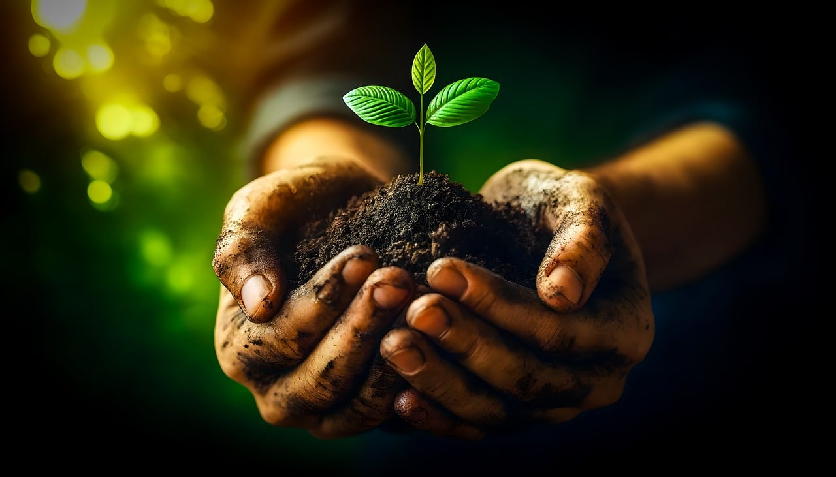

When we talk about **sustainability**, we’re talking about **a development model that can meet the needs of the present without compromising the ability of future generations to meet their own**. It’s a holistic approach that considers the social, environmental and economic impacts of actions and decisions taken today.

From a historical perspective, the concept of sustainability was formulated at the first United Nations Conference on the Environment in 1972, but it has only really taken shape since 1987, when the publication of the so-called **Brundtland Report**("Our Common Future") clarified the goals of sustainable development.

The same report introduced the three pillars or principles of **environmental, social and economic sustainability**, also known as ESG (Environmental, Social, Governance).

**Task**

1. In groups, brainstorm all the possible agendas connected to the three pillars of the sustainable development. Each group chooses the different pillar to discuss.
2. Watch the following video. Have you mentioned any of the agendas in the video ? Which ones have you missed ?

<https://www.youtube.com/watch?v=AkbGz3CYvqE>

### 

### ENGAGE

### *The 4th Pillar*

There’s another pillar of sustainability, which we could imagine as the midpoint of a triangle connecting the other three. The **ethical pillar** consists of the core set of fundamental guidelines that underpin the practical actions provided for in the other three: these include integrity, transparency, fairness, respect for diversity and promotion of collective welfare.

<https://www.train2sustain.eu/the-four-pillars-of-sustainability/>

**Task**:

1. Within the class, discuss the meaning of the words in italics: integrity, transparency, fairness, respect for diversity and promotion of collective welfare.

2. Can you discuss possible ethical issues related to the following topics :

* Privacy and confidentiality
* Employment discrimination
* Healtth insurance discrimination
* Individual responsibility
* Race and ethnicity

### EXPLAIN

### *Respect the nature : renewable and non-renewable sources*

Natural resources are materials or things that people use from the earth. There are two types of natural resources. The first are renewable natural resources. They are called renewable because they can grow again or never run out. The second are called nonrenewable natural resources. These are things that can run out or be used up. They usually come from the ground.

**Task:** Answer the following questions:

* Are ears of corn a renewable or nonrenewable resource?
* What about coal? Is it renewable or nonrenewable?
* Are rocks and minerals renewable or nonrenewable resources?
* Is wood a renewable or a nonrenewable resource

**Task**: Discuss the following statement, how do you understand it?

Only 10% of energy used in the U.S. comes from renewable sources—mostly hydroelectric energy. Worldwide, 85% of the energy comes from non-renewablsources. These sources, such as oil, natural gases and coal, will eventually be depleted.

## Task: Can renewable energy replace fossil fuels in the future? In pairs, search the internet, what information have you found? Compare the notes.

### 

### EXTEND

### *Respect the nature : David Attenborough*

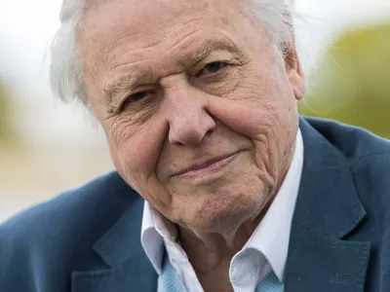

<https://www.britannica.com/biography/David-Attenborough>

*Learn about David Attenborough*:

**Sir David Attenborough has inspired millions by bringing the natural world into our homes and classrooms.**

But thanks to a life marked by a tenacious desire to explore, innovate and enlighten, his impact is even more surprising than you might expect.

The writer, broadcaster and naturalist, Sir David Attenborough was born on 8 May 1926. He was educated at Clare College, Cambridge and after working at an educational publishing house, started working as a trainee at the BBC in 1952. As controller of BBC Two, he oversaw the first ever-colour broadcasts in Europe.

We recognise him as the voice of natural history programmes for the past 70 years. He has brought the natural world into our living rooms and classrooms through award-winning natural history programs such as [**Life on Earth**](https://www.bbc.co.uk/iplayer/episodes/b01qjcmb/life-on-earth), [**The Private Life of Plants**](https://www.bbc.co.uk/iplayer/episodes/b01qbw1w/the-private-life-of-plants) and [**The Blue Planet**](https://www.bbc.co.uk/iplayer/episodes/b008044n/the-blue-planet). With over 40 animals and plant species named after him, and a constellation, he has explored uncharted land and met the remotest people on Earth, inspiring viewers with an interest in [**the natural world**](https://www.bbc.co.uk/bitesize/topics/zqq4rwx).

We look back at some of the incredible ways Sir David has helped shape our lives and understanding of the natural world.

*His opinion about the future of our planet:*

**David Attenborough says nature is in crisis but ‘we have the solutions’**

**Task :** Watch the following video and find out what are the four things we need to do to save our planet. Did any of the information in the video shock you ? Which one ?

<https://www.youtube.com/watch?v=0Puv0Pss33M>

### EVALUATION

**Task :** The teacher asks their students the following questions :

1. Why is nature so important to human being ?
2. How is nature important in terms of human happiness and well- being ?

The students create a mind map or collage from their answers.

(Find an example of the answers put together into a wheal below)

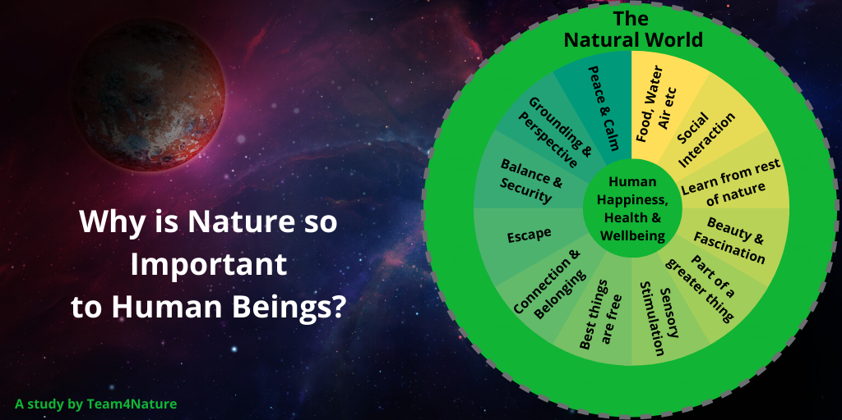

[**https://www.team4nature.co.uk/blog/campaigns/31-why-is-nature-so-important-to-human-beings**](https://www.team4nature.co.uk/blog/campaigns/31-why-is-nature-so-important-to-human-beings)

**Sources :**

**pictures without a source-pixabay**

***Lesson 1***

<https://www.enel.com/company/stories/articles/2023/06/three-pillars-sustainability>

<https://www.altenergymag.com/article/2019/07/what-is-the-future-of-non-renewable-resources/31346>

<https://extension.psu.edu/renewable-and-nonrenewable-resources>

<https://www.theguardian.com/tv-and-radio/2023/mar/13/david-attenborough-warns-nature-is-in-crisis-but-we-have-the-solutions>

<https://www.bbc.co.uk/teach/articles/z4k2kmn>