|  |  |  |  |  |  |  |
| --- | --- | --- | --- | --- | --- | --- |
| **Project ID: 2021-1-CZ01-KA220-SCH-000034484**    **COURSE FOR ENVIRONMENTAL EDUCATION**  *e-Modules: Teaching Learning activities and their technology enhanced material set to develop*  ***DISCLAIMER***  Obsah obrázku symbol, emblém, logo, Písmo  Popis byl vytvořen automaticky*Funded by the European Union. Views and opinions expressed are however those of the author(s) only and do not necessarily reflect those of the European Union or the European Education and Culture Executive Agency (EACEA). Neither the European Union nor EACEA can be held responsible for them.*  **COURSE AUTHORS**   |  |  | | --- | --- | |  | Lubomír Hájek, Petra Garay |   **COURSE SHARING LICENSE**   |  |  | | --- | --- | |  | You are free to:   * Share — copy and redistribute the material in any medium or format for any purpose, even commercially. * Adapt — remix, transform, and build upon the material for any purpose, even commercially. | | | |
|  | | |
| **MODULE 4** | | **THE IMPACTS OF THE ENVIRONMENTAL PROBLEMS AND CLIMATE CHANGE** |
| **PART 4** | | **Freshwater ecosystems** |
| **Lesson 1** | | **Hydrology, water cycle, water use** |

**SUMMARY**

**1. COURSE TIME, TARGET AND TOPIC 3**

**2. COURSE OBJECTIVES 3**

**Competences promoted in this lesson: 3**

**Lesson objectives: 3**

**3. LEARNING – TEACHING PROCESSES 3**

**4. EVALUATION 3**

**5. DOCUMENTS 4**

**ENGAGE 4**

**EXPLORE 5**

**EXPLAIN 6**

**EXTEND 7**

**EVALUATE 8**

# 1. COURSE TIME, TARGET AND TOPIC

* **Age of target students:** 15+
* **Teaching time:** 1 hour
* **Disciplines:** Biology, Geography, Human science, Physics, Chemistry
* **Title:** Hydrology, water cycle, water use

# 2. COURSE OBJECTIVES

## Competences promoted in this lesson:

* Communication in foreign languages competency
* Digital competency
* Learning to learn competency
* Social and citizenship-related competencies
* Cultural awareness

## Lesson objectives:

* The students deepen their knowledge regarding the topic of hydrology
* The students are going to work on their awareness about water resources in the world
* The students are going discuss their social responsibilities

# 3. LEARNING – TEACHING PROCESSES

There are 10 activities in this lesson:

1. **ENGAGE:** What is Hydrology? The benefits of water for human body
2. **EXPLORE:** Water for everybody
3. **EXPLAIN:** Water cycle and other terminology
4. **EXTEND:** The usage of water

# 4. EVALUATION

The evaluation is described in the last part of document.

# 5. DOCUMENTS

### ENGAGE

### *What is Hydrology ?*

### *The benefits of water for human body*

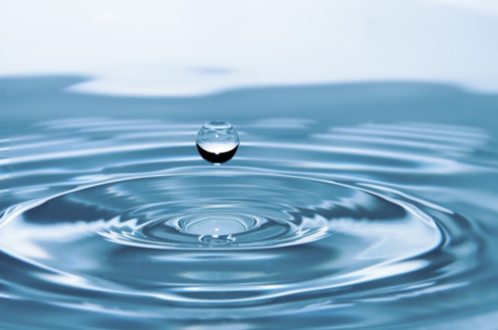Hydrology is an extremely important field of study, dealing with one of the most valuable resources on Earth: water. All aspects of the Earth’s available water are studied by experts from many disciplines, from geologists to engineers, to obtain the information needed to manage this vital resource. Hydrologists rely on their understanding of how water interacts with its environment, including how it moves from the Earth’s surface, to the atmosphere, and then back to Earth. This never-ending movement is called the hydrologic cycle, or the water cycle..

The field of hydrology consists not only of studying the natural distribution and movement of water, it is also concerned with the impact of human activities on water quality and with problems in water management. People use water for many purposes. In their homes, people use water for drinking, cooking, cleaning, and bathing. Many industries have a great need for water. In agriculture, water is used for the irrigation of farmland and for livestock. Water in many dams is used to produce hydroelectric power. The list of human uses for water is virtually endless.

Daily intake of water is crucial to the survival of people. Based on various aspects of the individual a human can survive without water about 3 days.

**Task** : Study the following link and other links of you choice and state the 10 most crucial benefits of water for human body. Discuss your choice in pairs or groups. Discuss your personal intakes of water.

<https://www.medicalnewstoday.com/articles/290814>

**Task** : Try the following quizz – Are you getting enough water ?

<https://www.csl.com/we-are-csl/vita-original-stories/2022/quiz-are-you-getting-enough-water>

### EXPLORE

### *Water for everybody*

**Task :** Watch the video : Water doesn´t come from a tap. In the video a 13- year old girl in Ethiopia spends 8 hours a day to get water for her family.

https://www.youtube.com/watch?v=teX2l_E40mw&t=52s

**Task :** Discuss the life of the girl, what is, in your opinion, the hardest aspect of her daily routine ? Can you imagine living like this ? Which countries suffer the most from the lack of clean freshwater ?

**Task :** Workin 4 groups, check out the link and perhaps other sources and state how is it possible to save the water : at home, in kitchen, at school and in garden.

https://neoakruthi.com/blog/how-to-save-water-in-kitchen.html

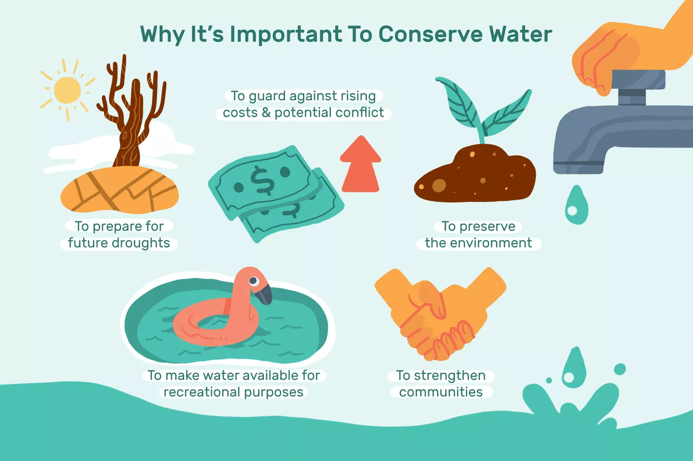

https://www.liveabout.com/conservation-efforts-why-should-we-save-water-3157877

### EXPLAIN

### *Water cycle*

### *Terminology*

**What is the water cycle?**

The water cycle describes where water is on Earth and how it moves. Water is stored in the atmosphere, on the land surface, and below the ground. It can be a liquid, a solid, or a gas. Liquid water can be fresh or saline (salty). Water moves between the places it is stored. Water moves at large scales, through watersheds, the atmosphere, and below the Earth's surface. Water moves at very small scales too. It is in us, plants, and other organisms. Human activities impact the water cycle, affecting where water is stored, how it moves, and how clean it is.

**Task:** Watch the video to get a clearer idea about water cycle

<https://www.youtube.com/watch?v=ct7WE8wJURQ>

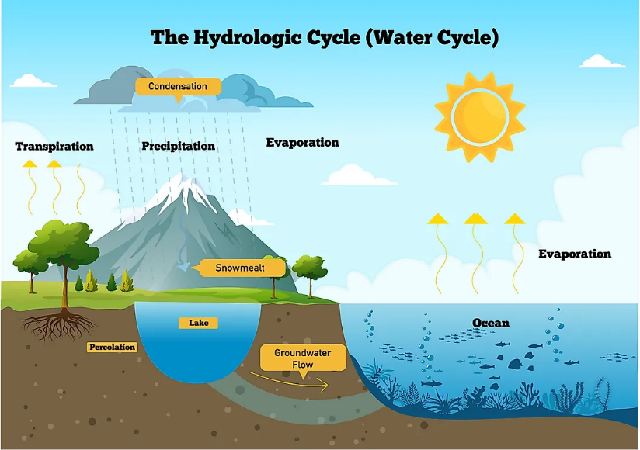

https://www.worldatlas.com/the-water-cycle.html

Water resources problems are also the concern of meteorologists, oceanographers, geologists, chemists, physicists, biologists, economists, political scientists, specialists in applied mathematics and computer science, and engineers in several fields. However the most work is done by hydrologists who study the fundamental **transport processes** to be able to describe the quantity and quality of water as it moves through the cycle, namely [**evaporation**](https://www.usgs.gov/special-topic/water-science-school/science/evaporation-and-water-cycle)**,**[**precipitation**](https://www.usgs.gov/special-topic/water-science-school/science/precipitation-and-water-cycle)**,**[**streamflow**](https://www.usgs.gov/special-topic/water-science-school/science/streamflow-and-water-cycle)**,**[**infiltration**](https://www.usgs.gov/special-topic/water-science-school/science/infiltration-and-water-cycle)**,**[**groundwater flow**](https://www.usgs.gov/special-topic/water-science-school/science/groundwater-flow-and-water-cycle), and other components

**Task :** Study the link provided and explain the above mentioned tranport processes to your classmates. Try to list some other components. You can write in the definitons in the sheet provided (Appendix 1)

<https://www.usgs.gov/special-topics/water-science-school/science/what-hydrology>

### 

### EXTEND

### *The usage of water*

Based on the time you have left in the class and interests of the students, chose one of the following activities for your class

**Task** : Each student will calculate approximate usage of water per his/her household for a year.

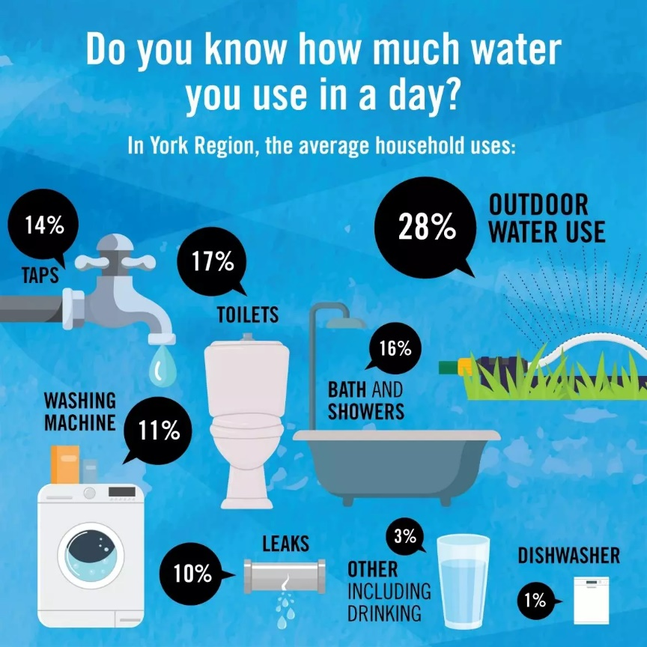

<https://www.york.ca/conserving-water>

**Task :** Divide the class into 3 groups and ask the groups to list the pros and cons of : tap water, filtered tap water, bottled water. Ask the students to consider the medical, economical and environmental aspects of the different types of water.

### EVALUATE

**Task**: Students will use the worksheet (Appendix 2) to sum up and revise their knowledge on water cycle.

**Sources :**

Pictures without a source – pixabay

<https://education.nationalgeographic.org/resource/hydrology/>

<https://neoakruthi.com/blog/how-to-save-water-in-kitchen.html>

<https://en.islcollective.com/download/english-esl-worksheets/water-cycle/52436>

**Appendix 1 :**

|  |  |  |  |  |  |  |  |  |  |  |  |  |  |  |  |  |  |  |
| --- | --- | --- | --- | --- | --- | --- | --- | --- | --- | --- | --- | --- | --- | --- | --- | --- | --- | --- |
| |  |  | | --- | --- | | **Water transport processes — Vocabulary and Definitions** | | | [evaporation](https://www.usgs.gov/special-topic/water-science-school/science/evaporation-and-water-cycle) |  | | [precipitation](https://www.usgs.gov/special-topic/water-science-school/science/precipitation-and-water-cycle) |  | | [streamflow](https://www.usgs.gov/special-topic/water-science-school/science/streamflow-and-water-cycle) |  | | [infiltration](https://www.usgs.gov/special-topic/water-science-school/science/infiltration-and-water-cycle) |  | | [groundwater flow](https://www.usgs.gov/special-topic/water-science-school/science/groundwater-flow-and-water-cycle) |  | | other components |  | | other components |  | | other components |  | |

**Appendix 2 :**

