Project ID: 2021-1-CZ01-KA220-SCH-000034484


COURSE FOR ENVIRONMENTAL EDUCATION
e-Modules: Teaching Learning activities and their technology enhanced material set to develop

DISCLAIMER
Funded by the European Union. Views and opinions expressed are however those of the author(s) only and do not necessarily reflect those of the European Union or the European Education and Culture Executive Agency (EACEA). Neither the European Union nor EACEA can be held responsible for them.

COURSE AUTHORS
Céline CORNEILLE, Paul FERNANDEZ, Frédéric GUILLERAY, Marine ROBINI and Ervan ROUSSEL.

COURSE SHARING LICENSE
You are free to:
- Share — copy and redistribute the material in any medium or format for any purpose, even commercially.
- Adapt — remix, transform, and build upon the material for any purpose, even commercially.

MODULE 4 | THE IMPACTS OF THE ENVIRONMENTAL PROBLEMS AND CLIMATE CHANGE
PART 1 | Ecosystems
Lesson | Ecosystem Complexity

SUMMARY

1. COURSE TIME, TARGET AND TOPIC 3

2. COURSE OBJECTIVES 3
Competences promoted in this lesson: 3
Lesson objectives: 3

3. LEARNING – TEACHING PROCESSES 3

4. EVALUATION 3

5. DOCUMENTS 4
ENGAGE 4
EXPLORE 5
EXPLAIN 7
EXTEND 10
EVALUATE 15

1. COURSE TIME, TARGET AND TOPIC
- Age of target students: 15+
- Teaching time: 2 hours
- Disciplines: Biology
- Title: Ecosystem complexity

2. COURSE OBJECTIVES

Competences promoted in this lesson:
- Communication in foreign languages competency
- Digital competency
- Learning to learn competency
- Social and citizenship-related competencies

Lesson objectives:
Students explain ecosystem complexity: roles, relationships, population dynamics

3. LEARNING – TEACHING PROCESSES
There are 4 activities in this lesson:
- ENGAGE: Who wins? (discover the complexity of ecosystems)
- EXPLORE: Endangered kudus (use a model about population dynamics)
- EXPLAIN: A tweet from James Bullock (explain the link between complexity and functions)
- EXTEND: Bugs in abundance (calculate the complexity of ecosystems)

4. EVALUATION
The evaluation is described in the last part of document.

5. DOCUMENTS

ENGAGE
Who wins?

Ecosystem resilience: ability of a system to recover after a change or disturbance.
Disturbance: any event that disrupts the balance of communities within an ecosystem.

Q1. According to you, which one would be more resilient to the loss of a species? Explain why.
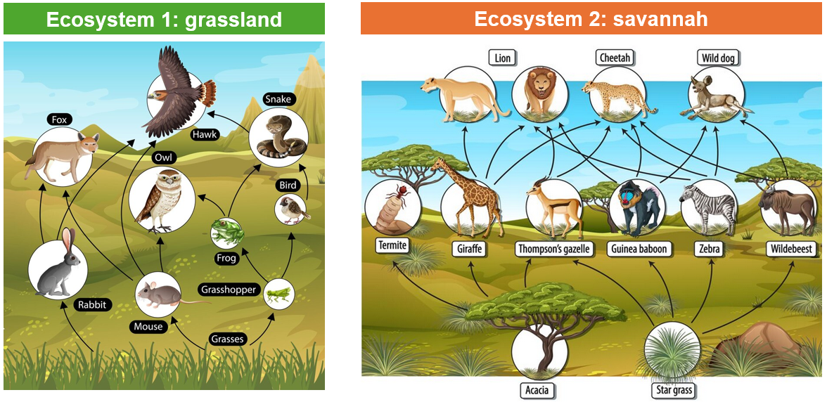
Source: freepik.com

One factor determining the complexity of an ecosystem is species diversity, which takes into account species richness as well as the relative number of individuals within each species. An ecosystem that is dominated by a single species is typically considered less diverse (and less complex) than an ecosystem with a more even distribution of species (more complex).
Q2. Explain why it is important to preserve the complexity of ecosystems.

EXPLORE
Endangered kudus

This activity guides students through an exploration of the Click & Learn “Population Dynamics” to learn how the exponential and logistic growth models can be used to describe how populations change over time.
Direct link to the online app Population Dynamics:
https://media.hhmi.org/biointeractive/click/populationdynamics/?_gl=1*1lk9r0i*_ga*MTU5NTQyMTQyOS4xNzA5ODE1OTU0*_ga_H0E1KHGJBH*MTcxMTcyMzUzMy4zLjEuMTcxMTcyMzY1MS4wLjAuMA..#/logistic/simulator

Q1. What values does the x-axis represent?
The x-axis shows time through the generations of individuals.

Q2. What values does the y-axis represent?
The y-axis shows population size.

Q3. Now place the growth rate at r = 0.5. How does the population growth vary if it starts from a small initial value (N0 = 5 individuals) versus a larger initial value (N0 = 100 individuals)?
When the population starts at a small value, the initial population growth rate is slow, with an almost zero slope. Gradually, this rate increases and curves upward more rapidly. In the larger initial population, the population immediately grows very quickly, without the slow ramp-up. Note: You can have students design a very small-scale experiment in which they vary N0 and record the slope of the line at t = 5 and make claims based on evidence for how changes in N0 affect slopes at different points in time.

Carrying capacity: As any population increases in size, the same resources must be shared by a greater and greater number of individuals. The decreasing supply of resources may lower the population’s birth rate, increase its death rate, or both - until birth and deaths are in balance. At that point of balance, and as long as the resource supply remains constant, the population should stabilize at some equilibrium size. Ecologists call this balance point of a population’s equilibrium the carrying capacity of the environmental system inhabited by that particular species. So the carrying capacity defines the maximum population of a particular species that a given area of habitat can support over a given period of time.

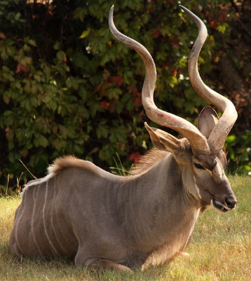
Kudu are an antelope species found in eastern and southern Africa.
Male kudu have dramatically spiraled horns, which makes them a target of trophy hunters.
Assume that the carrying capacity in a park is 100 kudu.
Parameters: k = 100, r = 0.26, N0 = 10.

Q4. At what time do kudu populations reach their carrying capacity? (You may need to change the max value of t and adjust the max value of k to optimize the graph display.)
Around t = 29.

Q5. What happens to the growth rate of a kudu population as it reaches its carrying capacity?
The growth rate slows as the population approaches its carrying capacity

Q6. Assume a new plot of land is added to the park, increasing the carrying capacity to 250 kudu. How will the population size change?
The population will grow until it reaches its new carrying capacity of 250 kudu.

Source: https://www.biointeractive.org/sites/default/files/PopulationDynamics-Educator-CL.pdf

EXPLAIN
A tweet from James Bullock

Q1. Read the tweet below of James Bullock.
 | What is ecological #complexity? We derive a practical multiscale definition: number of components & connections in a system. Components, eg species, height classes, functional groups, habitats. Connections, eg spp interactions, energy flows among species, connectivity of patches.

Q2. Based on the definition of James Bullock, choose an ecosystem and try to describe its complexity.

SOME ANSWERS
James Bullock's definition of ecological complexity emphasizes the number of components and connections within a system. Let's apply this definition to describe the complexity of a tropical rainforest ecosystem.
- Components:
  - Species Diversity: Tropical rainforests are known for their incredibly high species diversity. They are home to a vast array of plant, animal, and microbial species, ranging from towering trees to tiny insects.
  - Height Classes: Within the vertical structure of the rainforest, there are various height classes, including emergent trees, canopy trees, understory shrubs, and forest floor vegetation. Each height class supports unique species adapted to its specific light and nutrient conditions.
  - Functional Groups: Different species within the rainforest ecosystem fulfill various ecological roles or functions, such as primary producers (plants), herbivores, carnivores, decomposers, and mutualists.
- Connections:
  - Species Interactions: Tropical rainforests are characterized by complex networks of species interactions, including predation, herbivory, parasitism, mutualism, and competition. For example, pollinators interact with flowering plants, predators hunt prey species, and decomposers break down organic matter.
  - Energy Flows: Energy flows through the rainforest ecosystem via intricate food webs and nutrient cycles. Producers (plants) harness solar energy through photosynthesis, which is then transferred through various trophic levels as organisms consume each other.
  - Connectivity of Patches: Tropical rainforests consist of interconnected patches of habitat, each with its own unique environmental conditions and species assemblages. These patches may vary in size, shape, and ecological characteristics, influencing species dispersal, gene flow, and community dynamics.
Overall, the complexity of a tropical rainforest ecosystem is immense, encompassing a vast number of species and intricate ecological interactions across multiple spatial and temporal scales. Understanding and conserving this complexity is crucial for maintaining the stability and resilience of these biodiverse ecosystems in the face of environmental change.

Q3. From the document below, explain the link between the complexity of an ecosystem and its properties.

Document: Emergent properties of ecosystems
Emergent properties of an ecosystem refer to the collective characteristics or behaviors that arise from the interactions among individual components within the system. These properties are often not predictable solely from the characteristics of the individual components but emerge from the complex interactions and relationships within the ecosystem as a whole. Examples of emergent properties: Biodiversity, Stability and Resilience, Ecosystem Productivity, Nutrient Cycling, Energy Flow, Resistance to Invasions, Water and Soil Retention, Carbon Sequestration, Regulation of Climate, Ecosystem Services.

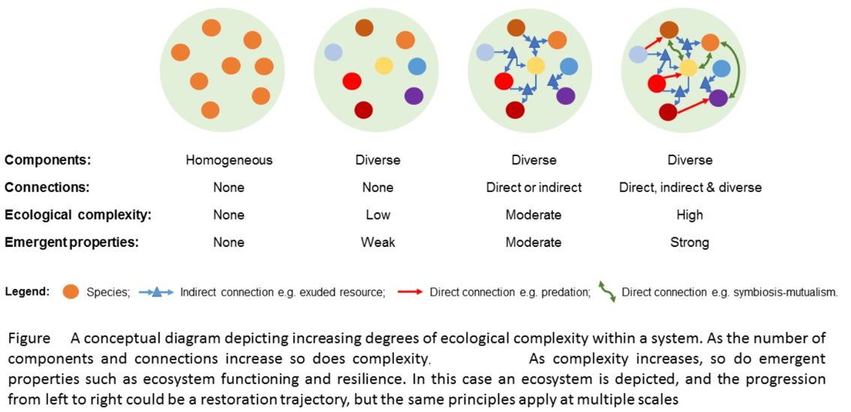

Bullock, J.M., Fuentes-Montemayor, E., McCarthy, B., Park, K., Hails, R.S., Woodcock, B.A., Watts, K., Corstanje, R. and Harris, J. (2022), Future restoration should enhance ecological complexity and emergent properties at multiple scales. Ecography, 2022

SOME ANSWERS
The link between the complexity of ecosystems and their emergent properties can be explained as follows:
Interactions Among Individual Components: Ecosystems are composed of numerous individual components, including species, abiotic factors, and ecological processes. These components interact with one another in intricate ways, forming complex networks of relationships and dependencies.
Complex Interactions and Relationships: The interactions among individual components within an ecosystem are multifaceted and often nonlinear. These interactions give rise to emergent properties that cannot be fully understood by examining the characteristics of individual components in isolation.
Collective Characteristics and Behaviors: Emergent properties of ecosystems are collective characteristics or behaviors that arise from the interactions among individual components. These properties, such as biodiversity, stability, productivity, and nutrient cycling, emerge from the complex interplay of species interactions, environmental factors, and ecological processes within the ecosystem.
Unpredictability Based on Individual Components: Emergent properties are often not predictable solely from the characteristics of the individual components. While the traits and behaviors of individual species or abiotic factors may be known, their collective impact on the overall functioning and behavior of the ecosystem may lead to unexpected emergent properties.
Complexity Enhancing Emergent Properties: The complexity of ecosystems, resulting from the diversity of species, interactions, and environmental conditions, enhances the emergence of properties such as stability, resilience, and ecosystem services. Complex ecosystems tend to exhibit greater functional diversity, redundancy, and adaptive capacity, contributing to their ability to withstand disturbances and maintain ecosystem functioning.

EXTEND
Bugs in abundance

One way to approach the complexity of an ecosystem is to calculate the Simpson's Diversity Index.
Simpson's Diversity Index is a measure of diversity. In ecology, it is often used to quantify the biodiversity of a habitat. It takes into account the number of species present, as well as the abundance of each species.

Simpson's index (D)
Simpson's Index (D) measures the probability that two individuals randomly selected from a sample will belong to the same species (or some category other than species). There are two versions of the formula for calculating D. Either is acceptable, but be consistent.
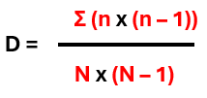
Where :
- n = the total number of organisms of a particular species
- N = the total number of organisms of all species

The value of D ranges between 0 and 1.
With this index, 0 represents infinite diversity and 1, no diversity. That is, the bigger the value of D, the lower the diversity.
This is neither intuitive nor logical, so to get over this problem, D is often subtracted from 1 to give Simpson's Index of Diversity.

Simpson's Index of Diversity = 1 – D
The value of this index also ranges between 0 and 1, but now, the greater the value, the greater the sample diversity. This makes more sense.

EXAMPLE
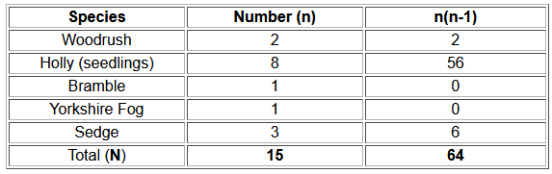
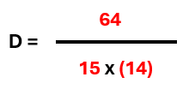
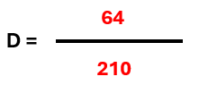

D = 0.3

Then :
Simpson's Index of Diversity = 1 - D = 0.7

Document based on http://www.countrysideinfo.co.uk/simpsons.htm

EXERCICE
Q. Calculate Simpson's diversity index for the three ecosystems shown in the next images. Determine the most complex ecosystem.
You can use this template:
SPECIES | Number (n) | N x (n – 1)
TOTAL (N)

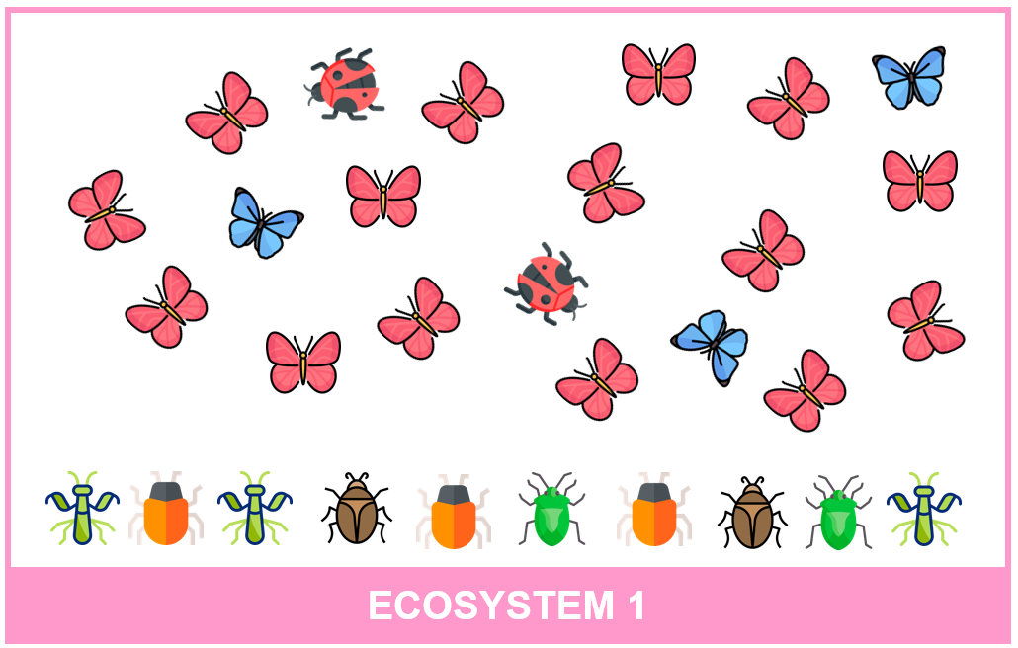

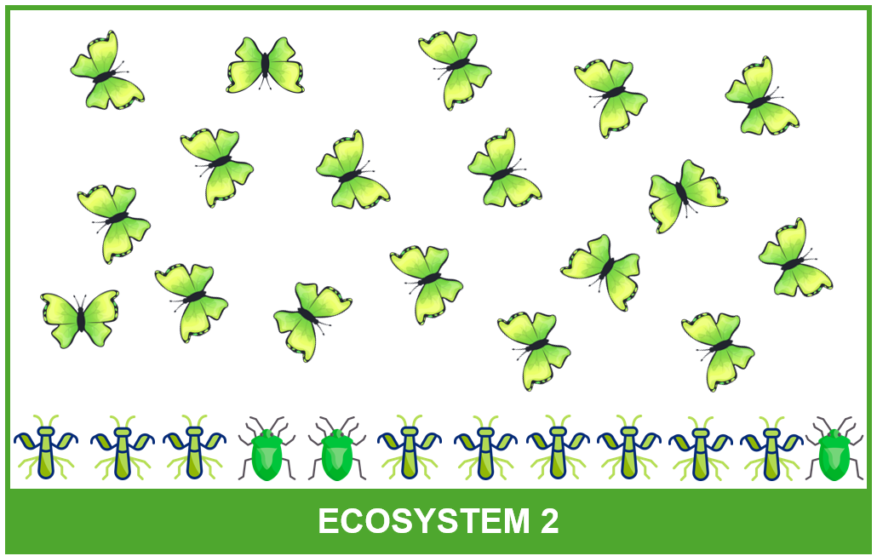

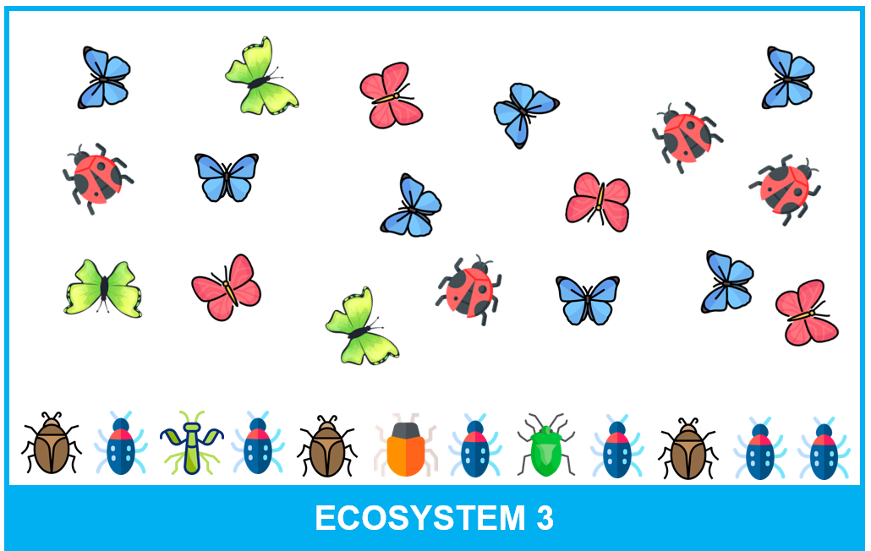
Source of icons: flaticon.com

CORRECTION
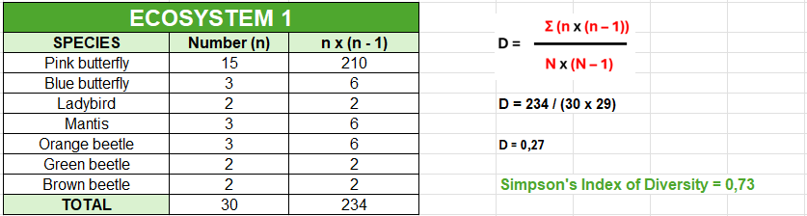

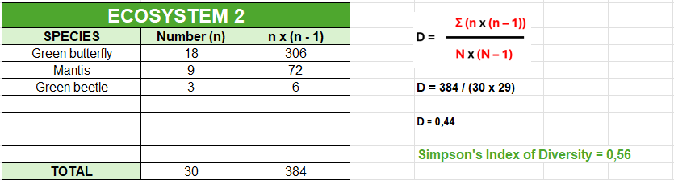

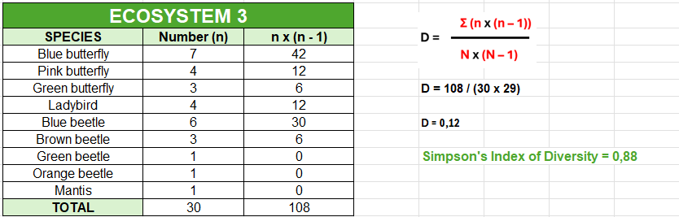

EVALUATE

Q1. What does ecosystem resilience refer to?
a) The maximum population size an area can support
b) The ability of a system to recover after a change or disturbance
c) The number of different species in an ecosystem
d) The measure of diversity in a habitat
Answer: b

Q2. How is disturbance defined in the context of ecosystems?
a) The process of energy flow within a trophic level
b) The interconnectedness of species and their interactions
c) The measure of ecosystem productivity
d) Any event that disrupts the balance of communities within an ecosystem
Answer: d

Q3 What is the main factor that contributes to the complexity of an ecosystem?
a) Species diversity
b) Predator-prey relationships
c) Climate variability
d) Soil composition
Answer: a

Q4. Which term refers to the collective characteristics or behaviors that arise from the interactions among individual components within an ecosystem?
a) Species richness
b) Abundance
c) Ecosystem productivity
d) Emergent properties
Answer: d

Q5. How can volcanic eruptions influence Earth's energy balance?
a) They contribute to negative radiative forcing
b) They release greenhouse gases, contributing to positive radiative forcing
c) They temporarily reflect sunlight, causing cooling
Answer: b

Q6. What does Simpson's Diversity Index measure?
a) The probability that two individuals randomly selected from a sample will belong to the same species
b) The number of trophic levels in an ecosystem
c) The carrying capacity of an ecosystem
d) The abundance of resources in an ecosystem
Answer: a

